Title: Christianity and Christmas

Key Questions: What events in history have shaped how the world is today? Can we always be proud of the past? What can followers of T* learn from events from the history of their tradition? What events associated with the history of T* need to be avoided in the future? What things in life make us joyful? What things in life make us happy or joyful? How do followers of T* express joy? What do t* teach about the difference between happiness and joy? Why is it a good idea to express joy? Why is it a good idea to express happiness and joy? Is joy a feeling or a choice? Are there times when I choose to be joyful even if I don’t feel happy?

Key Concepts: The origins and meanings of festivals

Learning objectives | Activities | Resources
To understand the importance of Christmas and how it is celebrated. | Starter  Pair up students, and give each pair a letter A and B.  Students sit back to back  - Describes the image  - Draws the image  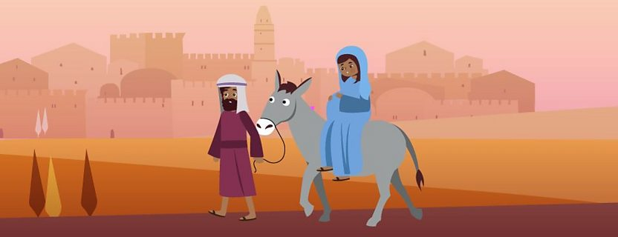  OR Who, What, Where, When and Why?  The story of Christmas.  1. Create a storyboard of the key events that happen in the Christmas story about the birth of Jesus.  2. What do Christians learn from this story?  3. What impact might it have on someone living today in the 21st century?  Key concepts to highlight from the story  Jesus  Mary  Joseph  Nazareth  Angel  Bethlehem  Carol  Celebrate  Advent  Gospels of Matthew and Luke  Discussion point. This can be done by showing a variety of different images about Christmas celebrations.  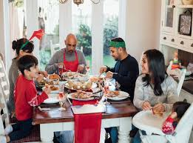  1. What makes Christmas day different from any other day for believers?  2. Write a list of keywords/concepts associated with Christmas. (Love, family, nativity, Christingle)  Western Church – 25th December  Eastern Church- 6th January.  Christmas is seen as a time for generosity and for thinking about the needs of others.  Churches run events to provide food and temporary shelter to people in need.  Students need to watch the clip and make detailed notes on the clip. Students need to write down 20 KEYWORDS.  OR  - Write THREE things you have found interesting  - Write down 2 pieces of factual information.  - Write THREE emotions linked with the clip.  “Christmas has lost its true meaning in 2022”  How could someone AGREE with this?  How could someone DISAGREE with this?  Secular  Commercialised | Images can be obtained from google image search.  This can be obtained from a variety of different places. Online search for GCSE Bite size – Christmas.  Jesus was born to a woman called Mary who was engaged to Joseph, a carpenter in the town of Nazareth in Galilee.  Mary was visited by an angel who told her that she would give birth to a baby called Jesus. Jesus was born in Bethlehem because Joseph and Mary had travelled there to take part in a census which the Roman rulers had ordered  When Mary and Joseph arrived in Bethlehem, the local inn was full with people returning for the census. The innkeeper let them stay in the rock cave below his house, which was used as a stable for animals. It was here that Mary gave birth to Jesus.  The Arts Society, Birmingham, has made films, richly illustrated print resources and activities for KS4, available free of charge.  School Visits to Places of Worship in Birmingham.  In the first film, the presenter explains how the windows of Birmingham Cathedral tell the Christmas story.  https://birmingham-faith-visits.theartssociety.org/christian  Images can be obtained from google image search.  True tube clip  https://www.truetube.co.uk/resource/christmas-in-a-gutter/  Christmas in a Gutter – TrueTube takes to the streets to ask if Christmas makes people think more about those who live in poverty. The general public answer questions concerning how guilty they feel around the seasonal celebrations for the homeless, those less fortunate and the poor.

