Title: Buddhist Holy Places

Key Questions: What events in history have shaped how the world is today? What can followers of T*learn from events in the history of their tradition? Can we always be proud of the past? Why is it good when people work together well? Why is it good when people have similar beliefs? How do followers of T* create a sense of unity? Why is it good for me to create unity? How should I respond when T* appear to create discord?
When do we need to show self-discipline? Is it always easy? How do followers of T* develop self-discipline and contentment? What strategies can I learn from T* that will help me to be more self-disciplined and content? Should I always be content in my situation-are there times when I have to fight for change? Where are we temperate (avoiding excess) in our own lives? How do followers of T* show temperance? When do I need to shoe temperance in my own life? Should I always be temperate – are there times when I should not show self –restraint?

Key Concepts: The role of pilgrimage; associated purposes, practices and sacred sites.
Learning objectives | Activities | Resources
To examine why Buddhists go on pilgrimages.  To understand the significance of Lumbini, Bodhgaya and Stupas.  To reflect on how going on a pilgrimage affects the life of a Buddhist. | Starter  Watch the films on Buddhism in Birmingham.  1. Write down THREE things you have found interesting.  2. What are the main reasons given for visiting Bodhgaya?  3. How does visiting Bodhgaya help Buddhists?  4. In what ways does it change them?  2. Stupas – research  Students to spend time researching on Stupas, focusing on significance and symbolism of the structures.  1. Explain what a Stupa is.  2. Find out and explain what is so special about the stupa at Borobudur in Java?  3. What do the stupas remind Buddhists about?  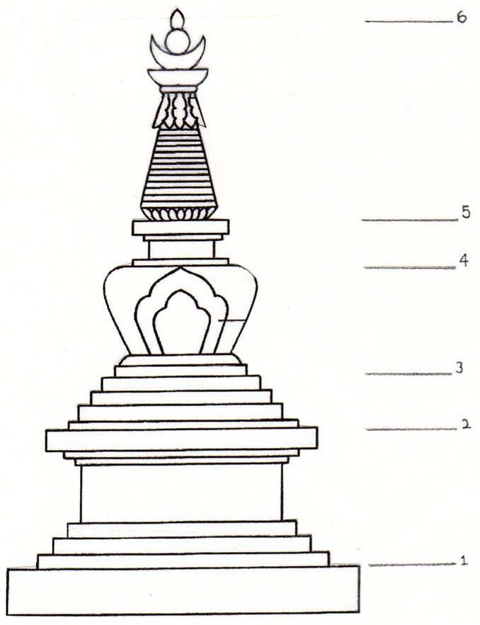  3. Sri Prada  Buddhist pilgrims often visit Sri Prada. This mountain is particularly important as Buddhists believe the Buddha visited this place several times. They believe his footprint can be seen here.  1. List all the reasons why Buddhists might find Sri Prada to be so sacred?  2. Do you think visiting this place will benefit a Buddhist? Explain in detail.  3.’There is no evidence these are even footprints therefore this place is meaningless’  Do you agree or disagree? Show that you have thought about different point of views.  Plenary -  ‘Places visited by pilgrims have no value today as the person associated with the place is no longer alive. There is no point in visiting these places.’  Do you agree or disagree? Show that you have thought about different point of views. | These films, new for 2022, explain Buddhism through the eyes of the community in Newtown, Birmingham.  https://birmingham-faith-visits.theartssociety.org/buddhism  The Arts Society, Birmingham, has made films, richly illustrated print resources and activities for KS4, available free of charge.  School Visits to Places of Worship in Birmingham  Clear Vision  Living Buddhism  The holy site of Bodhgaya  Buddhist Art and Architecture  http://www.buddhanet.net/stupa.htm

