Title: Sikh Views on God.

Key Questions: What would we like to find out more about?
How do followers of T* show curiosity?
How would my life improve if I were more curious?
Is curiosity a good thing?
Why is it good to be knowledgeable?
How do the followers of T* show they value knowledge?
What knowledge from T* do I think is valuable?
How do I respond when the views of different knowledgeable people conflict with each other?

Key Concepts: Atheism, Agnosticism, Theism, arguments, belief, practice, faith.

Learning objectives | Activities | Resources
LO: to consider Sikh views on God and the teaching of the Mool Mantar. | In pairs ask students to discuss:  How many Gods do Christians and Muslims believe in?  Do you think they worship the same God? Why?  Explain that today we are going to look at Sikh Views on God. Belief in one God is central to Sikhism.  Sikhs are monotheists (they only believe in one God).  They believe it is important to keep the name of God in their mind and live their life as God would wish.  Look at the quote from the Guru Granth Sahib:  “You are Father, Mother, Friend, Brother, with you as support everywhere, what fear can I have?”  Guru Granth Sahib 103  Ask students to discuss in groups:  What do you think this means?  Feedback  Using textbook information ask students to answer the following questions:  1) Explain what Waheguru means?  2) Draw and label three images which represent three aspects of God’s character according to Sikh belief.  You might choose to represent ideas such as :  The Divine Father  The All-powerful God  The fact that God understands people  The fact that God listens  3) Copy the Mool Mantar into your book in the middle of the page. Around the edge annotate it to explain its meaning and what it teaches Sikhs about God.  Explain that we are now going to consider how we find God.  - Whilst Sikhs are monotheists this does not mean they believe theirs is the only path to God. They believe that whichever religion you are following it will lead you to God.  - Christians and Muslims are also Monotheists but most believe that their own religion is the only way to God. They believe that the other paths are dead ends.  - Atheists believe there is no God at all. They say that all the paths are dead ends.  Imagine God is the top of a mountain. Draw three mountains in you books to explain each of the above ideas. Label them with who believes it and what they believe. Then add a paragraph to explain which mountain you identify with and why.  Ask students to consider the start question again – Do all religious people worship the same God?  What would a Christian or a Muslim say?  What would a Sikh say?  What do you think? Why? | The author finds New Steps in RE book 3 by Michael Keene a good resource for this task.  Dictionaries or word lists  http://www.bradfordgurdwara.com/intro-to-sikhism/mool-mantar/  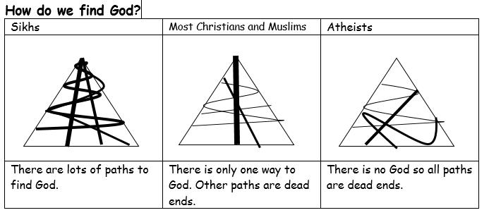  For Example

