Title: Hindu Views on Money

Key Questions: When do I need to show fairness/justice to others? Is it sometimes helpful to know that justice may come at a later point? Why do Hindus think integrity is important? How do they show this? Who do the followers of Hinduism believe they are acoountable to? Why?

Key Concepts: money, wealth, accountability, poverty, generosity, charity.

Learning objectives | Activities | Resources
LO: to understand Hindu views on money and the role of Hindu gods in this. | Explain to students that in this lesson they will consider Hindus attitude to wealth and look at different gods and goddess linked to money. Remind them that Hinduism is a very old and diverse religion that is followed in different ways by different Hindus.  Ask the students to draw a table in the books with the four headings:  - Four Purposes For Life  - Four Varnas  - Four Stages of Life  - Attitude to Wealth  Put up information around the room and ask students to read it and make notes in their table. There are a number of websites and textbooks that could be used here.  Feedback:  - What are the Four Purposes for Life?  - What are the Four Varnas  - What are the Four Stages of Life  - What do these teach Hindus about Money and wealth?  - What is the Hindu attitude to wealth? How might this be different at different times for different Hindus?  Explain to students that they are now going to find out about different Hindu gods and goddess linked to money and wealth. Hindus may look to different gods and goddess depending on the time of year or where they are from in India.  Put students into groups of four. Then ask each group member to investigate a different good or goddess:  Kuber  Ganesha  Lakshmi  Lord Venkateswara of Tirupati  Then ask students to return to their original groups and feedback what they have learnt. All students make notes so they have recorded information on all four gods and goddess.  Feedback  Ask students to write a conversation between three different Hindus explaining their different views on money and wealth.  Feedback. | 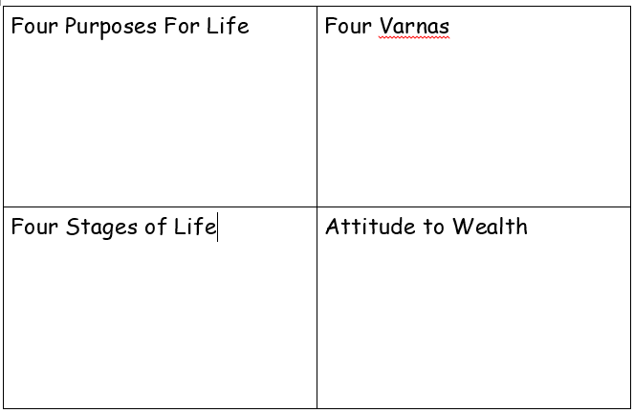  https://www.bbc.co.uk/bitesize/guides/zrfjvk7/revision/3  You may need to edit this information depending on the ability of your students.  https://en.wikipedia.org/wiki/Kubera  https://en.wikipedia.org/wiki/Ganesha  https://en.wikipedia.org/wiki/Lakshmi  https://en.wikipedia.org/wiki/Venkateswara  The Arts Society, Birmingham, has made films, richly illustrated print resources and activities for KS3, available free of charge.  School Visits to Places of Worship in Birmingham  https://birmingham-faith-visits.theartssociety.org/hindu

