Title: Buddhism – So What?

Key Questions: What things in life make us joyful? What things in life make us happy or joyful? How do the followers of Buddhism demonstrate thankfulness? How do followers of Buddhism put their thankfulness into action?

Key Concepts: Joy, Changes, Transformation, Inspiration, Impact.

Learning objectives | Activities | Resources
LO: to discover how belief in Buddha has affected people lives. | Pupils feedback what they can remember about the teachings of the Buddha.  Using this knowledge pupils fill in the Buddha outline in the centre of their worksheet with the characteristics a Buddhist should have.  They will then look at the example of four Buddhists and how their lives and actions are affected by Buddhism. They make notes on this on the worksheet (Name: Lived: Effects of Buddhism on their Life :)  Example One: Dalai Lama  Example Two: Padmakumara (a Buddhist in Birmingham)  Example Three: Catherine a Western Buddhist  Example four: Richard Gere  Question – Can you be a Buddhist without it affecting the way you live? Should it make a difference?  What qualities seen in a Buddhist do you admire? Why? What can you learn from this? | 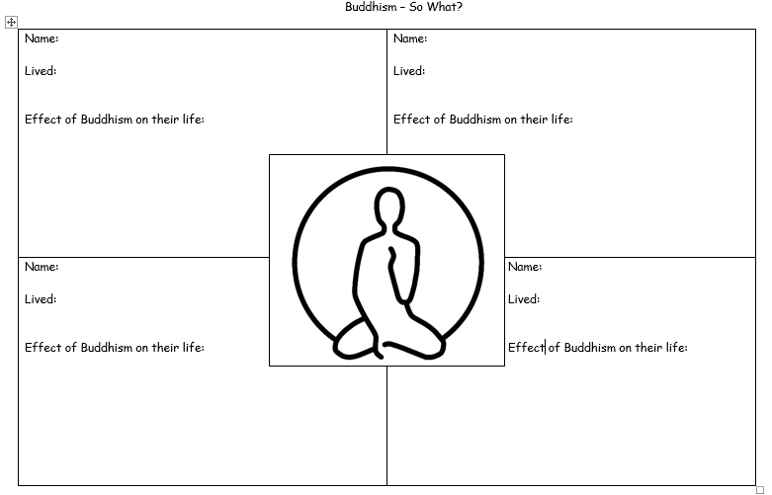  Worksheet  https://en.wikipedia.org/wiki/Dalai_Lama  Example 2.  Video download with this lesson  KS3_14_6_6_ VIDEO_Padmakumara  Example 3  https://www.truetube.co.uk/film/choosing-your-faith-buddhism  Example 4: https://www.youtube.com/watch?v=_OASbnKFXUE

