Title: Christian Responses to Suffering.

Key Questions: What examples of suffering have we seen recently? What examples of suffering have we seen or experienced recently?

Key Concepts: Suffering, the problem of evil and suffering, illusion, God’s will, free will.

Learning objectives | Activities | Resources
LO: to consider Christian responses to suffering and if the students find them convincing or not. | Ask students what they can remember about the story of Job and it’s teaching on suffering.  Explain that as the story of Job is in the Old Testament Christians also learn from its teaching about suffering.  However Christians also learn about suffering from the New Testament.  Ask students to start a mind map called  “Christian Responses To The Problem of Evil.”  Add a section to it called “The Suffering of Job”. Then explain what this story teaches Christians about suffering.  Now add a section called “The Fall”  Ask students what they know about the Bible story of Adam and Eve. (Point out that many Christians do not believe this is literally how the world was made but that the story teaches them important ideas.)  Watch or read the story of the fall.  In pairs ask students to discuss:  What does this teach Christians about Free Will?  What does it teach about what has happened to the perfect world?  What does this teach Christians about suffering?  Individually ask students to add this information to their mind map.  Now add a section called “The Suffering of Jesus”  (You may wish to show a clip of Jesus being beaten and killed. Be aware that many are very gory and may not be appropriate for young students.)  Read Mathew 27:15-44 and 1 Peter 2:18-23.  In pairs discuss:  How did Jesus suffer?  What can Christians learn from this?  Individually ask students to add this information to their mind map.  Read or watch the poem Footprints.  Discuss what this teaches Christians about suffering. How might this comfort a Christians who was facing a difficult time?  Individually ask students to add this information to their mind map.  Write a conversation between a Church minister and a member of their church who has come to ask why God is letting them suffer. | 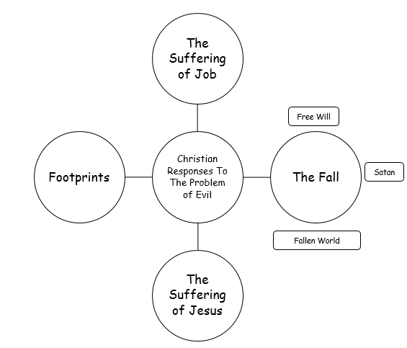  https://www.biblegateway.com/passage/?search=genesis+3&version=NIV  https://www.youtube.com/watch?v=5sbBYWu612k  Help to explain this can be found here  http://www.bbc.co.uk/education/guides/zhmhgk7/revision/2  http://www.bbc.co.uk/education/guides/zhmhgk7/revision/3  https://www.biblegateway.com/passage/?search=Matthew%2027&version=ERV  https://www.biblegateway.com/passage/?search=1+peter+2&version=ERV  http://www.wowzone.com/fprints.htm  https://www.youtube.com/watch?v=noCLFTXkuR0

