# **Letter**

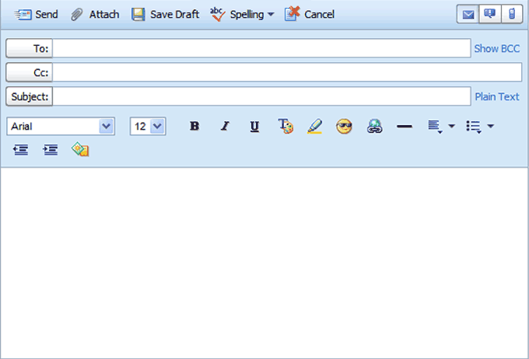

My name is Sangit. I am in Year 8 at school.

I have never cut my hair and so I wear a turban. I am the only practicing Sikh in my year group and sometimes feel a bit out of place. Some older students have called me names and one boy threatened to cut my hair.

I have a good group of friends in my year who treat me with respect and we have fun together. They all have shorter hair which they gel into different styles. I am wondering if I should cut my hair too – that way I won’t stand out so much and it may stop the bullying. It may help me to make other friends too.

What do you think? I am confused!

Sanjit