Title: Hindu Puja

Key Questions: How do followers of T* show that they belong to their tradition? What do T* teach about the necessity of including others? Why is it important to show to others what groups I belong to? How can I ensure that everyone experiences a sense of inclusion? How do I make sure that I don’t exclude people who are not part of the groups that I belong to? How should I respond when T* appear to exclude others? Is there more to life than we experience in the physical world? Is there a God worth listening to? How do followers of T* listen to and respond to God, to people or to things that are precious? Why is it of benefit to me to develop my spiritual and attentive nature? How can following teaching and guidance of T* improve society? Are there times when it is important to concentrate on the physical world? How do I respond when following the will of God or views held precious by my tradition conflict with society’s views?

Key Concepts: Worship, Commitment, Faith, Equality, Respect
Worship, community, Mandir, statues, murti, prayer, arti, shrine

Learning objectives | Activities | Resources
To explore why Hindu’s perform puja and how they do this.  To examine whether worship is better carried out at home or in a holy building. | Watch the clip  Q1. What are the advantages of worshipping in a mandir rather than at home?  Make a list.  Look at the different images of the shrines.  Compare and contrast between the shrines at home and mandirs. List some of the differences you notice.  Create an image of what you think a shrine would look like in a Hindu home. Use the picture to help you. Explain reason for your choices.  In pairs discuss and explain what is similar and different for Hindu’s when they worship in a mandir and at home.  The Puja Tray  Focus on the significance of the items. Students need to draw and explain the significance of each item on the puja tray.  1) A ghant (bell) to summon the essence of the gods and to let them know that you intend to begin worship.  2) A diva lamp to honour the gods and receive blessings.  3) Water in a cup which, once it is offered to the gods, becomes holy water.  4) Powder, which has a different meaning depending on its colour. For example, red powder symbolises prosperity and good health, and yellow is for purifying. These powders are offered to the gods.  5) Incense sticks to clean and purify the air with a pleasant smell.  A modern Puja tray  Working in small groups, students need to make a list of 5 items that they would include on a modern puja tray. Students need to explain reasons for their choice.  (For example, sweet fruit, photo of loved ones)  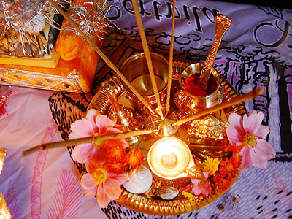  Would you rather worship in public or in private?  Or do you prefer not to worship at all? Explain your answer giving reasons to support what you write. | Truetube clip  https://www.truetube.co.uk/film/holy-cribs-mandir  Online search for pictures required.  Images can be obtained from a wide variety of websites.  http://www.bbc.co.uk/religion/religions/hinduism/worship/worship.shtml  The Arts Society, Birmingham, has made films, richly illustrated print resources and activities for KS3, available free of charge.  School Visits to Places of Worship in Birmingham. Published 2022.  https://birmingham-faith-visits.theartssociety.org/hindu/hindu-worship-temple

