Making a model sukkah
A sukkah needs at least 3 ‘walls’, so use a box with one side removed, or fold stiff card to create 3 sides that will stand up. You may also need:
- String
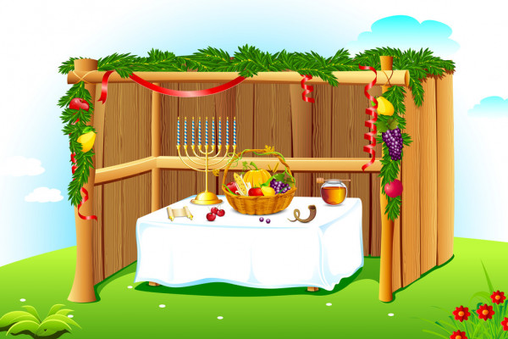
- Ribbon
- Glue
- Drawing materials
- Fabric
- lollipop sticks
- Material for modelling fruit
- Stickers or pictures cut from magazines

You may want to decorate the walls with paper or fabric.

Create the roof with lollipop sticks, or string or ribbon, or even sticks and grass. Remember that there must not be a solid ceiling to the sukkah, so it must be possible to see light through whatever method is used.

Many sukkahs have decorations on the walls or hanging from the beams on the ceiling. In some, fruit and flowers are used for decoration.

You may wish to add a table and chairs and small world people.

Pupils could make these individually or in groups.

