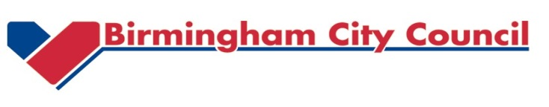
To: Head Teachers of Primary, Secondary and Special Schools Operating the Full Cheque Book Scheme

Letter of Assurance for the 2018/19 Year End Accounts Process

Section A:
We seek your assurances that the following steps will be taken by your school to ensure year end workbooks are completed and submitted by closedown deadline as set out below and in the attached Cash Advances letter:
- All relevant school staff involved in the closedown process are aware of the deadline date.

- Your provider of financial services to the school (if you have one) is aware of the deadline date and that any support is arranged to enable the completion of the accounts by Thursday 4thApril 2019. Responsibility for ensuring completion and compliance with the deadlines lies with the school and not the providers.

- Your school will have internal arrangements in place to complete the financial returns and submit these to the LA by Thursday 4thApril 2019.

Section B:
If the school are not able to give the reassurance, please outline the reasons in this section:

Please sign here: _______________________
Head Teacher Name: _______________________
School Name: _______________________
Date: _______________________
Please scan the signed letter and return to LA via the mailbox: FullCBSMailbox@birmingham.gov.uk by 31st May 2018 and state clearly the school name in the subject box with subject “Reassurance Return”.
Thank you for your co-operation.

