


The Administration of Medicines
in Schools and Settings:
A Supplemental Guidance
Document - February 2018


Preface
This guidance document has been written to supplement the Department for Education’s statutory guidance “Supporting pupils at school with medical conditions: Statutory guidance for governing bodies of maintained schools and proprietors of academies in England” DfE December 2015 (reissued August 2017) (the Statutory Guidance) and both documents should be read together.
Appropriate Authorities (governing bodies of maintained schools, proprietors of academies and management committees in Pupil Referral Units) must always have regard to the statutory guidance, i.e. take account of the guidance, consider it and comply with it unless there is good reason not to.
The Statutory Guidance states that schools must develop policies for supporting children in school who have a medical condition. This supplemental guidance aims to support schools with the development of one aspect of that policy, namely the management and administration of medication in school, and it has been reviewed by a multi-disciplinary panel, including:
- Clinical Lead – Birmingham School Health Advisory Services
- School Nurses
- Education Department, Birmingham City Council
- Nurse specialists in asthma, epilepsy, diabetes and anaphylaxis
- Community pharmacist
- Clinical Lead & Team Leader for Special School Nurse Service

This document will be available on the school safeguarding website (www.birmingham.gov.uk/schoolsafeguarding) to all schools in Birmingham regardless of designation or status.
In this document the term:
- ‘Child’ refers to all children and young people;
- ‘Pupil’ refers solely to children and young people in schools;
- ‘Parent’ refers to parents, carers, legal guardians and may also include the Local Authority if a Care Order is in place for the child;
- ‘School’ refers to schools, academies, pupil referral units and other educational settings; and
- ‘Schools’ policies’ or a ‘school’s policy’ refers to the schools policy on supporting pupils in school with medical needs, which should have a specific section which explains the schools stance and procedures on administering medication in school.
**IF IN DOUBT OR IN AN EMERGENCY ALWAYS SEEK MEDICAL ADVICE**

Contents
Pg 4 | Introduction
Pg 5 | Safeguarding
Pg 6  Pg 6  Pg 6  Pg 6  Pg 6  Pg 7  Pg 8  Pg 8  Pg 8  Pg 9 | 1 Responsibilities and Requirements  1.1 Governing Bodies, Proprietors & Management Committees  1.2 The Employer  1.3 The Local Authority  1.4 Parent/Carer  1.5 Pupil  1.6 School/Setting Staff  1.7 OFSTED  1.8 Training  1.9 Emergency Procedures
Pg 9 | 2 Record Keeping
Pg 10  Pg 10 | 3 Storage  3.1 Disposal of any sharp items
Pg 11 | 4 School Trips, Visits and Sporting Events
Pg 11 | 5 Over the Counter Medicines (OTC)
Pg 12  Pg 12  Pg 12  Pg 12 | 6 Specific Types of Medication  6.1 Analgesics (Painkillers)  6.2 Methylphenidate (e.g. Ritalin, Metadate, Methylin)  6.3 Antibiotics
Pg 13 | 7 Emergency Medication
Pg 14 | 8 Return of Medication
Pg 14  Pg 15  Pg 15 | 9 First Aid Boxes  9.1 First Aid Box Contents per 50 people  9.2 Traveling First Aid Kit
Appendices | - Good Practice Points:
Pg 16 | - Asthma
Pg 18 | - Administration of Auto Adrenaline Injectors
Pg 20  Pg 21  Pg 22 | - Management of Diabetes  - Managing Hypoglycaemia  - Blood glucose monitoring
Pg 24 | - Managing Eczema
Pg 25  Pg 26 | - Epilepsy  - Administration of Buccolam (midazolam)
Pg 28 | C. Consent form to administer medicine on and off site
Pg 29  Pg 30 | D1 School Record of medication administered  D2 Special School Nurse Medicines Administration Form
Pg 31  Pg 32  Pg 33 | D. Example Healthcare plans  D1 – Example - Asthma Healthcare Plan  D2 – Example - Anaphylaxis Healthcare Plan  D3 – Example - Personal Alert Card
Pg 35 | E. Sample letter, to parent, to review medication
Pg 36 | F. Training record
Pg 37 | G. Reviewing School’s Provision

Introduction
The purpose of this document is to provide supplemental guidance to schools on managing medication in school, which is one aspect which must be considered when establishing effective systems to support pupils at school with medical conditions.
The Law
Schools’ ‘appropriate authorities’ (governing bodies of maintained schools, proprietors of academies and management committees in Pupil Referral Units) have a duty under section 100 of the Children and Families Act 2014 to make arrangements to support pupils at school who have medical conditions. Appropriate authorities must also have regard to the Statutory Guidance, which should be read alongside this document.
In addition, the Equality Act 2010 (the Act) prohibits discrimination on the grounds of a protected characteristic such as disability, defined under section 6 of the Act, which may include some children with medical needs.
The Public Sector Equality Duty (PSED), as set out in section 149 of the Act, came into force on 5 April 2011 replacing the Disability Equality Duty and requiring public bodies to have due regard in the exercise of their functions to the need to:
- Eliminate unlawful discrimination, harassment and victimisation and other conduct prohibited by the Act.
- Advance equality of opportunity between people who share a protected characteristic and those who do not.
- Foster good relations between people who share a protected characteristic and those who do not.
There are a number of ways that the responsible bodies for schools must not discriminate against pupils or prospective pupils which are set out in section 85 of the Act. This will include all aspects of school life, i.e. it will also apply to activities outside delivery of the curriculum, such as school trips, school clubs, and activities. Schools must make reasonable adjustments for children with disabilities where they are likely to be at a substantial disadvantage compared with pupils who are not disabled; which may include making adjustments to their practices, procedures and school policies.
Some pupils with medical needs may also have special educational needs (SEN) and may have an Education, Health and Care plan (EHCP) which sets out the pupil’s health, social care and special educational requirements. For pupils with SEN, this guidance should also be read in conjunction with the Special Educational Needs and Disability (SEND) Code of Practice. Generally, if a pupil’s EHCP is followed, schools will be able to demonstrate that they have complied with the SEND Code of Practice and the duty under section 100 of the Children and Families Act 2014.
Under the Health and Safety at Work Act 1974, employers, including Appropriate Authorities, must have a Health and Safety policy which, for schools, should incorporate, or refer to, their policy for supporting children with medical needs. Schools may wish to base their own Health and Safety policy on the corporate Health and Safety Policy. Schools’ Health and Safety policy should explain the procedures for conducting appropriate risks assessments.
Safeguarding
Schools must ensure that policies, plans, procedures and systems are properly and effectively implemented to align with their wider safeguarding duties.
What this guidance document contains
Sections 1 to 9 offer general guidance on a variety of issues connected to administering medicines in schools. The ‘Appendices’ include:
- Good Practice Points/Guidance on administering medication to children with specific medical conditions;
- An example ‘Consent Form to Administer Medicines’, which must normally be filled in by the parent before staff can give any medication;
- An example record form to enable schools to record medication which has been administered;
- Example ‘Individual Healthcare Plans’ (Care Plans):
Schools’ policies about supporting pupils with medical needs should explain when the school will prepare a Care Plan for a pupil which will, generally, only be necessary if a pupil has a serious medical condition e.g. diabetes, epilepsy, asthma, allergies resulting in severe anaphylactic reactions, and may need medication to be administered. The example Care Plans are a guide to the type of information schools may need to effectively treat children with particular conditions, but should be expanded as required following consultation with a healthcare professional, parents, the pupil and the school. The Birmingham School Health Advisory Service will usually contribute to the preparation of Care Plans.
- A ‘sample letter’ to parents about their child’s medication;
- An example training record, as it is good practice to keep a record of all training undertaken by staff which enables them to administer a particular type of medicine or deal with emergencies; and
- A checklist, designed to assist schools when they are assessing whether their policies meet the requirements of the statutory guidance, and this supplemental guidance.
This supplemental guidance document should be read alongside the Statutory Guidance, which was updated in September 2017.
Your school nurse/specialist voluntary bodies/professional associations are available for advice, support and training.
**IF IN DOUBT OR IN AN EMERGENCY ALWAYS SEEK MEDICAL ADVICE**
- Responsibilities & Requirements
1.1 Governing bodies, Proprietors and Management Committees
‘Appropriate authorities’, i.e. governing bodies in the case of maintained schools, proprietors in the case of academies and management committees in the case of pupil referral units, must have regard to the Statutory Guidance when carrying out their statutory duty to make arrangements to support pupils at school with medical conditions. The Statutory Guidance contains specific advice about managing medicines in schools on pages 19 – 21. A contingency plan must be in place to address staff refusal to dispense medication.

Appropriate Authorities should request feedback from parents to inform their policies and establish if they are satisfied with the quality of support, guidance, and care provided by staff, including how well the school liaises with a hospital or hospital school while a child is receiving treatment.

1.2 The Employer

Who the employer is depends on the type of school but it could be the local authority, governing body, trustees, management board, private individuals, charities, voluntary committee or a private company.

Whoever the employer is, they must take out Employer’s Liability Insurance which provides an appropriate amount of cover and includes cover for staff who provide support to pupils with medical conditions. Employers should talk to their insurer to make sure that they have the right type and amount of insurance cover in place to protect employees who administer medicines to pupils.

1.3 Local Authority as employer (Maintained Schools)

Most of the time legal action brought by a parent alleging negligence will be brought against the employer rather than an employee directly.

In addition to any insurance cover which may be in place, Birmingham City Council (the Council) fully indemnifies its employees in maintained schools against the cost of claims brought against them which allege negligence providing that the action, or lack of action, complained of was carried out in good faith during the course of the employee’s employment and the employee had participated in the appropriate training.

Therefore, employees who are trained to administer medicine to pupils with medical conditions will normally be indemnified meaning that the Council, not the employee, would pay the costs incurred and damages awarded if a claim for negligence is settled or is successful.

1.4 Parent/Carer

Schools should ask parents to complete a Consent Form to Administer Medicines if they want the school to agree to administer medication for their child. Verbal instructions should not be accepted. Only one parent with parental responsibility needs to consent to medicines being administered. School’s policies should be clear that:

- Where possible, medication should be administered at home;
- Each request from a parent to administer medication to their child in school will be considered individually based on the circumstances;
- They will not unreasonably refuse the parent’s request to administer medicine in school;
- The parent’s written consent is required. Consent does not have to be obtained every time medication is administered, but the form should be updated regularly; and
- In exceptional circumstances i.e. if the medicine has been prescribed to the pupil without the knowledge of the parent, it may be administered without parental consent but the school will make every effort to encourage the child to involve their parents, whilst respecting the pupil’s confidentiality.

If a pupil needs a Care Plan, this should be prepared in consultation with healthcare professionals, the parents, the pupil and the School should consider including the points at paragraph 14 of the Statutory Guidance, including the circumstances in which the school should administer emergency medication.
Schools may wish to consider whether to agree that minor changes to the Care Plan can be made by a school nurse who will sign and date the plan, but major changes will normally mean that a new Care Plan is required. We recommend that schools regularly review Care Plans, at least annually. Schools may also wish to make clear in their policies on supporting pupils with medical needs that it is the parents’ responsibility to notify schools of any changes required to the Plan e.g. treatment, symptoms, contact details.
Schools’ policies should also make it clear that Parents are responsible for:
- Ensuring that their child has a sufficient amount of medication which is in date;
- Replacing their child’s supply of medication on request;
- Safely disposing of their child’s date-expired medicines, for example by returning them to a pharmacy; and
- Ensuring that all medication is provided in its original container with the a label, from the pharmacist if the medication is prescribed or the parent if it is over the counter, showing the:
  - Child’s name, date of birth;
  - Name and strength of medication;
  - Dose;
  - Any additional requirements, e.g. to take the medication with food etc.;
  - Expiry date; and
  - Dispensing date or date of purchase.
1.5 Pupils
The Statutory Guidance states that, following discussion with parents and when set out in Care Plans, children who are competent can be responsible for managing their own medicines and procedures.

1.6 School staff
In practice, agreeing to medication being administered in school, head teachers/setting leads should be satisfied that it is necessary for medication to be administered during school hours, for example because the pupil will otherwise miss school and lose teaching time.
If a staff member is required to administer medication to pupils it will expressly say this in their contract of employment and, if it does not, then undertaking training to enable staff to administer medication to pupils is voluntary. Schools may wish to make staff aware of the insurance that is in place to cover this type of activity.
All staff, whether or not it is part of their contractual duties, should take into account the needs of pupils that they teach and be aware of whom to contact in an emergency.
It is possible that the contractual duties of some support staff may include the administration of medicines, which will have been considered during job evaluation for the role. The member of support staff still needs to receive appropriate training before undertaking relevant duties.
Schools should have a named person responsible for dealing with pupils who are unable to attend school because of medical needs, and someone named who can step into this role if the named person is unavailable.
1.7 Ofsted
Ofsted Inspectors will consider the needs of pupils with chronic or long-term medical conditions so that they can report on how well the needs of these pupils are met. Schools will normally need to produce a copy of their policy on supporting pupils with medical needs and demonstrate how effectively it is implemented
1.8 Training
All staff volunteering to administer medication must first receive appropriate training which will normally be provided by Birmingham Community Healthcare NHS Foundation Trust, through a school nurse or special school nurse other suitably qualified professional e.g. a medical professional who is already working with the child.
Staff have the right to refuse to undertake training to administer medication, but it is important that those staff who volunteer to administer medication receive training which explains:
- The basic legal principles and potential legal liabilities involved;
- How to deal with emergency situations that may arise;
- How to appropriate and safely administer the medication in question;
Regular, i.e. at least annual, training relating to emergencies, medication and relevant medical conditions should be provided; advice about training can be obtained from the school nurse.
Schools should keep records of all training and whether or not it has been satisfactorily completed. Even after training has been received, staff may decide that they no longer wish to volunteer to administer medication or request further training if the member of staff feels that it is necessary, which schools should provide. Training should be regularly updated, at least annually and when there are changes to the medication that a pupil requires.
A first-aid certificate does not constitute appropriate training in supporting children with medical needs and staff who have not undertaken training must not dispense medication or undertake healthcare procedures.
1.9 Emergency Procedures
As part of a general risk management processes all schools will have arrangements in place for dealing with general emergency situations, for example children should know that if there is an emergency they should tell a member of staff and staff should know how to call the emergency services and who is responsible for carrying out emergency procedures.
In addition, schools’ policies will explain how schools intend to deal with medical emergencies and pupils’ Care Plans will give details of how to deal with specific emergencies relating to a pupil’s medical needs, including when and what medication should be administered.
Schools’ policies should make clear that if in doubt an ambulance should always be called and staff will never be permitted take a child to hospital in their own car. Schools’ policies should also explain that if a parent is unable to accompany their child to hospital, a member of staff will always accompany a child taken to hospital by ambulance and will stay with the child until their parent arrives.
If a parent is not present then health professionals, and not school staff, will be responsible for decisions about the medical treatment that the child requires. Staff accompanying a child to hospital should ensure that they have basic medical information about the child, for example their Care Plan if one is in place and identifying data e.g. full name and date of birth and their parents’ contact details.
2. Record Keeping
Schools should ensure that a ‘Record of medicine administered to an individual child’ form is completed and signed giving details of the date, time and dose of any medication administered in school. Parents should be informed on the same day and a record kept if, for any reason, medication that a child normally receives is not administered. Schools may wish to keep a copy of the parent’s Consent Form to Administer Medication and School Record of Medication Administered with the medication.
Schools will have a record of individual pupil’s needs in their Care Plan, which may also form part of their Education, Health and Care Plan if one is in place. Schools should review Care Plans regularly, at least annually and whenever there are changes to the pupil’s condition or treatment. A new Care Plan will usually be required if a pupil moves schools.
Under the Data Protection Act 1998 documents which contain information about an individual’s physical or mental health are ‘sensitive personal data’, or ‘special category data’ under the General Data Protection Regulation. Schools’ policies should contain a privacy notice which explains when and how that medical information about a pupil and their Care Plan, where one is in place, will be shared with relevant staff. Schools must never display Care Plans in a public place because of the sensitive information they contain, but it would be sensible for schools to make parents, and where appropriate the pupil, aware that this information will be shared and that it will be kept somewhere accessible in case of emergency.
Schools should retain documents connected to a pupils medical needs and the administration of medication until the child is 25 years old in accordance with Department for Health requirements regarding the retention of medical and health records. This will also mean that records are available if a child, on reaching 18 years old, decides to pursue a claim of negligence against the School. Records should be carefully reviewed by the school before they are destroyed at the end of the retention period.
3. Storage of Medication
Schools should store non-emergency medication safely and securely, preferably in a cool place which pupils cannot access by accident. Schools should conduct a risk assessment in relation to their storage facilities in order to minimise the potential for harm to occur, which will include seeking advice from local pharmacists or the school nurse on how best to store medication.
Items requiring refrigeration may be kept in a clearly labelled closed container in a standard refrigerator, although schools should consider how pupil’s confidentiality can be maintained if the fridge is also used for other purposes. Schools should monitor the temperature of the fridge each school day and it would be good practice to keep a written record of the temperature, time and date. Children should be able to access their medicines, particularly for self-medication, quickly and easily, but all storage facilities should be secure and in an area which cannot be accessed by children without the supervision of an adult.
The child’s Care Plan will set out whether it is appropriate for the child to administer their own medication but generally pupils in secondary schools should be allowed to be in charge of their own medication, either by keeping it securely on their person, or in lockable facilities at the school which they have access to. Children in primary schools are less likely to be competent to manage their own medication but in all cases it will depend on the child’s age, maturity, parent’s and medical professional’s views and school consent.
All emergency medication must be stored in a safe location known to the child and relevant staff, which is easily accessible in case of emergency. If the safe location is locked, it is essential that the keys can be quickly and easily accessed.
Unless the School’s policy permits it, pupils without recognised medical needs should be discouraged from carrying their own supply of medication, such as painkillers for general use, with them.
Members of staff who require medication must ensure that it is safely stored and cannot be accessed by pupils.
3.1 Disposal of any sharp items (sharps)
Some medical conditions and medications require the use of sharp items (sharps), for example lancets for blood glucose monitoring, which carry the risk of accidents that could lead to infection with blood borne viruses, which are preventable with careful handling and disposal. Therefore schools’ policies on supporting pupils at school with medical needs should explain:
- How the school will safely manage sharps bins, i.e. they will be located in designated areas, in a safe position at waist height with a temporary closure mechanism for when the bin is not in use. Sharps bins must never be kept on the floor;
- That it is the personal responsibility of the individual using the sharp to dispose of it safely i.e. the pupil or the member of school staff assisting the pupil;
- That a suitable sized sharps bin must be brought to the point of use so that used sharps can be disposed of immediately;
- How sharp bins can be obtained and emptied, i.e. they are available on prescription where needed, should be emptied when two thirds full. Children should not be carrying used sharps bins to and from school themselves therefore arrangements for disposal should be outlined in the child’s Care Plan.
4. School Trips, Visits and Sporting Events
Schools should consider what adjustments can reasonably be made to enable children with medical needs to participate safely and as fully as possible on school trips which, for best practice, should include a risk assessment. Schools may decide to include this information in a child’s Care Plan, but on an event by event basis may need to consult parents, pupils and a healthcare professional to ensure that pupils can participate safely.
If pupils do not normally administer their own medication then a trained member of staff or parent should accompany the child on the off-site activity. The Consent Form to Administer Medicine should include off-site visits.
It is essential that schools inform staff members who run sporting activities and the school’s own after school clubs, or extra-curricular activities, if specific pupils require medication and how they should deal with a medical emergency occur. Staff may require additional training, and should be aware of how to access the pupil’s medication
Schools should make it clear that parents need to separately inform private wrap-around services about their children’s health needs.
5. Over the Counter Medicines (OTC) (non-prescription)
The Medicines and Healthcare Products Regulatory Agency license all medicines and classifies them as OTC when it considers it safe and appropriate that they may be used without a prescription. Birmingham Local Medical Committee considers it a misuse of GP time to provide an appointment for a child with the sole purpose of acquiring a prescription for an OTC medicine. Sometimes a pupil’s medical condition may mean that they need to take OTC medication.
OTC medicines can be administered to pupils on the same basis as prescription medication, i.e. where medically necessary, with the parent’s consent, when approved by the head teacher in accordance with the school’s policy and as set out in the pupil’s Care Plan, if one is in place.
Parents should be informed if OTC medication has been administered that day, and it is good practice to ask the parent to sign a the School Record of Medication Administered to acknowledge that the school has told them that you have given the agreed medication
With OTC medications the dose and frequency must be consistent with the guidance and dosage on the packaging and schools should check with parents the date and time that the child took the most recent dose.
6. Specific types of Medication
6.1 Analgesics (Painkillers)
For children who regularly need analgesia, such as paracetamol (e.g. for migraine), an individual supply of their analgesic could be kept in school, labelled for that child only. It is recommended that schools do not keep stock supplies of analgesics for potential administration to any child but if, in rare circumstances, a school feels it is absolutely necessary to keep stock supplies the school’s policy must detail the circumstances in which pupils may be given the analgesic and explain that the medicine will be safely stored, evidenced by a risk assessment. Parental consent must be obtained.
Children under 16 should never be given medicines containing aspirin or ibuprofen unless prescribed by a Doctor.
6.2 Methylphenidate (e.g.Ritalin, Metadate, Methylin)
Methylphenidate is sometimes prescribed for children with Attention Deficit Hyperactivity Disorder (ADHD). Its supply, possession and administration are controlled by the Misuse of Drugs Act 1971 and its associated regulations. Schools must store Methylphenidate in a locked non-portable container and place to which only named staff have access.
Schools must keep a record when new supplies of Methylphenidate are received and a record of when the drug is administered. A pupil’s unused Methylphenidate must be sent home with their parent and schools should record that the medication has been returned, and the amount. This will enable schools to make a full reconciliation of supplies received, administered and returned home.
6.3 Antibiotics
Schools’ policies should encourage parents to ask the GP to prescribe antibiotics in dosages which mean that the medicine can be administered outside of school hours, wherever possible.
This will mean that most antibiotic medication will not need to be administered during school hours. For example, if the prescription states that twice daily doses should be given, these can be administered in the morning before school and in the evening after school, and if the prescription requires three doses a day these can often be given in the morning before school, immediately after school and at bedtime. Antibiotics should always be administered in accordance with the prescriber’s instructions. It should normally only be necessary to administer antibiotics in school if the dose needs to be given four times a day, in which case a dose is needed at lunchtime.
Schools should check with parents that the child is not known to be allergic to the antibiotic and note the response on the parental consent form. Schools should ask parents or the pupil, if they are competent and the parent agrees, to bring the antibiotic into school in the morning and take it home again at the end of each day.
Children are most likely to have an adverse reaction to a new antibiotic after the second dose, therefore we recommend that schools ask parents to administer the first and second doses of the course and monitor their child for an appropriate amount of time afterwards.
All antibiotics must be clearly labelled with the child’s name, the name of the medication, the dose, the date of dispensing, and be in their original container.
Schools must check the label on the antibiotic carefully as this will state;
- Whether the antibiotic needs to be stored in a refrigerator, which will be the case with many liquid antibiotic;
- Whether it needs to be taken at a certain time and before, after or with food; and
- The dosage, which should be carefully measured with an appropriate medicine spoon, medicine pot, or oral medicines syringe provided by the parent if the antibiotic is liquid, otherwise the appropriate number capsules should be taken with a glass of water.
As identified in Section 2 appropriate records must be made which will include if the pupil does not receive a dose, and the parent must be informed that day that a dose has been missed and given the reason why that was the case.
7. Emergency Medication
Schools’ policies and individual Care Plans will explain their procedures for dispensing medication in an emergency. Anyone caring for children, including teachers and any other school staff in charge of children, have a common law duty to act like any reasonably prudent parent and ensure that children are safe and well cared for in school which will extend to taking action in an emergency, for example by calling emergency services or arranging for medicine to be administered. Schools should consider what information or training they need to provide to new or temporary staff to enable them to comply with this duty, particularly if there are children with specific needs.
Schools should make staff aware that, generally, the consequences of taking no action in an emergency are likely to be more serious than the consequences of trying to assist. Pupil’s’ emergency medication must be readily accessible in a location which staff and the individual pupil know about, because in an emergency, time is of the essence.
The most common types of emergency medication which schools may be asked to administer include:-
- Buccolam (midazolam), used to treat epilepsy.
- Adrenaline, under the brand names epipen, jext, emerade, used to treat anaphylaxis caused by an allergic reaction;
- Glucose or dextrose tablets which may be branded Hypostop, used to treat hypoglycaemia caused by diabetes; and
- Inhalers, used to treat asthma (usually the blue ‘reliever’ inhaler).

Schools can arrange for training for all staff on how to handle emergency situations which will be provided by Birmingham School Health Advisory Service Nurses or appropriate specialist nurses, and can include training for the school staff who have volunteered to administer emergency medication.
8. Return of Medication
Schools’ policies and, where there is one, a child’s Care Plan should explain when medication will be returned the child’s parent, for example whenever:
- The course of treatment is complete;
- Labels have become detached or unreadable (NB: Special care should be taken to ensure that the medication is returned to the appropriate parent);
- The Care Plan is updated or changed and/or information about how to treat the child’s medical condition is updated; or
- The medication’s expiry date has been reached.

Return of the medication should be documented on the administration record held in the child’s file and the parent should be advised to return unused medication to their pharmacist.
In exceptional circumstances, e.g. when a child has left the school, schools can take unused medication to a community pharmacy for disposal. Medication should not be disposed of in the normal refuse, flushed down the toilet, or washed down the sink.
9. First Aid Boxes
Schools should ensure that First Aid boxes, identified by a white cross on a green background, are available in the workplace and contain adequate supplies for treating injuries that may occur based the nature of the potential hazards identified by a risk assessment. Schools’ should make themselves aware of the Health and Safety Executive’s minimum expected provision.
Only the expected First Aid supplies should be kept which should not contain creams, lotions or drugs, however seemingly mild, but may include saline or water sachets to irrigate wounds.
The location of First Aid boxes and the name of the person responsible for their upkeep should be clearly indicated on notice boards throughout the workplace.
First aid boxes must display the following information:-
- The name of the person responsible for their upkeep;
- The nearest alternative First Aid box, in case further supplies are required;
- A list of the contents of the first aid box and instructions for replenishing arrangements;
- The location of the school’s accident book.

Authorised school personnel should maintained and restock First Aid Boxes promptly when necessary and the staff who are responsible for maintaining the First Aid Box should be aware of the procedure for re-ordering supplies.

9.1 Minimum Expected First Aid box contents per 50 people:
1 x Guidance Leaflet giving general guidance on first aid (for example HSE leaflet Basic advice on first aid at work)
  - 60 x Adhesive Plasters
  - 6 x No 16 Eyepad
  - 8 x Triangular Bandage
  - 24 x Safety Pins
  - 4 x First Aid Dressings (18 x 18cm)
  - 12 x First Aid Dressings (12 x 12cm)
  - 3 x Gloves (Pairs)
  - 20 x Wipes

9.2 As a guide the minimum contents of a travelling First Aid kit should contain:-
- A leaflet giving general guidance on first aid (for example HSE leaflet Basic advice on first aid at work)
- 9 x First Aid Dressings (12 x 12cm)
- 3 x First Aid Dressings (18 x 18cm)
- 6 x Triangular Bandages
- 12 x Safety Pins
- 4 x Eye Dressings
- 40 x Plasters
- 10 x Sterile Wipes
- 2 x Disposable Gloves (1 Pair)
- 1 x First Aid for Children Pocket Guide
- 1 x Pupil Accident Book
Appendices
            - Good Practice Points for Asthma Care
People with asthma have airways which narrow as a reaction to various triggers. The narrowing or obstruction of the airways causes difficulty in breathing and can usually be alleviated with medication taken via an inhaler.
Schools can hold salbutamol inhalers for emergency use but if a child diagnosed with asthma may need to use the school’s emergency inhaler, this possibility should be explained in their Care Plan and schools should have asked for parent’s consent at the same time. For further information and guidance, please see Guidance on the use of emergency salbutamol inhalers in schools, Department for Health, March 2015.
Schools should also consider:
- Keeping a register of children in school diagnosed with asthma together with copies of their parental consent forms enabling them to take medication, i.e. inhalers;
- Preparing Care Plans for pupils whose asthma is so severe that it may result in a medical emergency;
- Where to keep inhalers, including during offsite visits, so that they are stored safely but are readily available for children who need them, which may mean encouraging pupils of year 5 and above to carry their own inhalers. Arrangements should be considered on a case by case basis. If the pupil is too young or immature to take responsibility for their inhaler, it should be stored in a readily accessible safe place.
- In special school all inhalers should be kept in classrooms, but accessible immediately, and should be administered by staff who have received training.
- Asking parents to supply schools with a spare inhaler and spacer device for pupils who carry their own inhalers to store safely at school in case the original inhaler is accidentally left at home or the pupil loses it. This inhaler should have an expiry date beyond the end of the school year and parents should be asked to replace it if it does not. Schools should dispose of out of date inhalers regularly, either by returning them to parents or to the pharmacist.
- How they will ensure that all inhalers are labelled with the following information:-
- Pharmacist’s original label;
- Child’s name and date of birth;
- Name and strength of medication;
- Dose;
- Dispensing date; and
- Expiry date.

- Labelling children’s spacer device, which is used with an inhaler often by younger children, and making arrangement with parents to ensure that it is sent home to be cleaned regularly, e.g. at the end of each term.
- Taking appropriate disciplinary action, in line with their school’s Behaviour and, if they have one, Managing Substance Related Incidents policies, if inhalers are misused by pupils or others. Inhalers are generally safe and, if a pupil took another pupil’s inhaler, it is unlikely that that pupil would be adversely affected; however medical advice should be sought.
- The arrangements for monitoring inhaler use, and how parents will be notified if their child is using the inhaler excessively
- How to ensure that staff running PE lessons and sports activities are aware that physical activity will benefit pupils with asthma, but that these pupils may need to use their inhaler 10 minutes before exertion. The inhaler MUST be available during PE and games. If pupils are unwell they should not participate.
- How they will ensure that pupils who have a particular trigger for their asthma, such as animal fur, glue, nuts etc. can avoid those substances
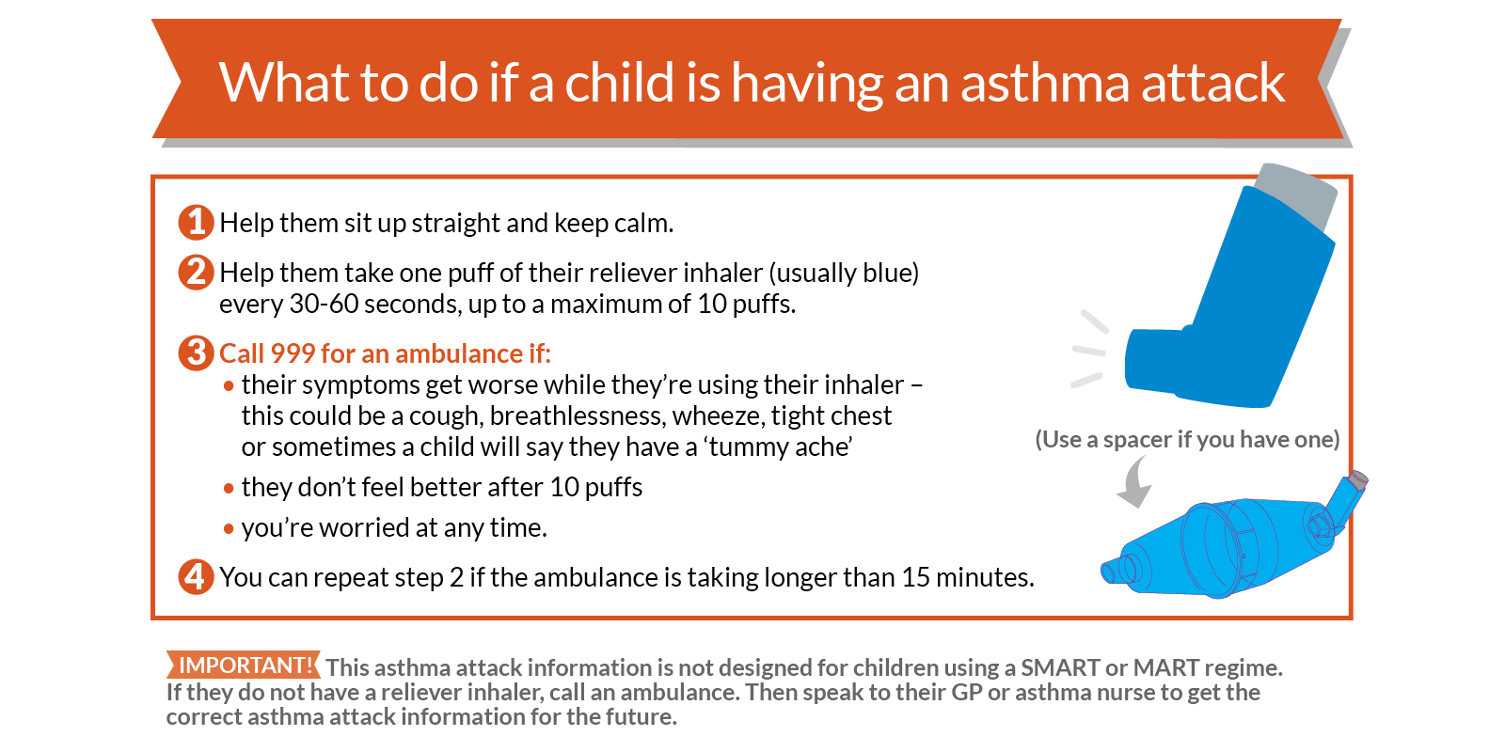
Further source of information:
Asthma UK
Tel: 0300 222 5800
Email: info@asthma.org.uk
https://www.asthma.org.uk/

2. Good Practice Points for the Administration of Auto Adrenaline Injectors
Anaphylaxis is an acute, severe allergic reaction requiring immediate medical attention. It usually occurs within seconds or minutes of exposure to the allergen, which may be a certain food or other substance, but may occur after a few hours. Auto adrenaline injectors should only be administered by staff who have volunteered and been trained by the appropriate health professional. Schools should have obtained parental consent and prepared a Care Plan for the child on becoming aware that the child has been prescribed this medication.
An auto adrenaline injector (AAI) is a preloaded pen device, which contains a single measured dose of adrenaline for administration in cases of anaphylaxis. It is not possible to give too large a dose from one device used correctly in accordance with the child’s Care Plan, so even if it is given inadvertently it is unlikely to do any harm. However medical advice should be obtained as soon as possible after the medication is administered. Auto adrenaline injectors should only be used for the person for whom it is prescribed.
National guidance on AAI’s within school was released by the DfE in September 2017 and this should be considered as a supplement to this guidance. The DfE Guidance can be found at: https://www.gov.uk/government/publications/using-emergency-adrenaline-auto-injectors-in-schools
Schools should consider:
- Where to safely store the AAI, in the original box, at room temperature and protected from heat and light, so that it is readily available. If the Care Plan records that the pupil is competent then the AAI can be carried on their person
- What systems can be put in place to check, termly, the AAI expiry dates and discolouration of contents so that parents can be asked to dispose of and replace medication.
- Ensuring that all staff know that immediately after the AAI is administered, a 999 ambulance call must be made and parents notified. If two adults are present, the 999 call should be made at the same time as the administration of the AAI. The used AAI must be given to the ambulance personnel.
- The use of the AAI must be recorded on the School Record of Medication Administered, with time, date, and full signature of the person who administered it.
- Reminding parents that, if the AAI has been administered, they must renew it before the child returns to school.
- Ensuring that the pupil is accompanied by an adult, who has been trained to administer the AAI on off-site visits, and that the AAI is available and safely stored at all times during the visit.

Administering Epipen
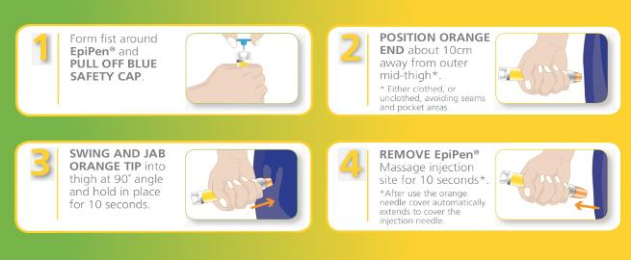
Administering Jext
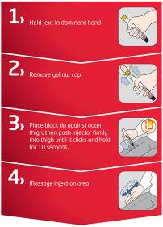
Administering emerade
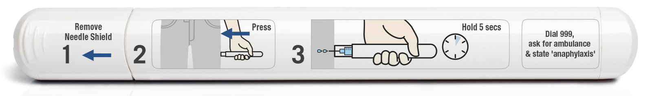
Further source of information
The Anaphylaxis Campaign
Helpline: 01252 542029
Website: https://www.anaphylaxis.org.uk
Email: info@anaphylaxis.org.uk

            - Good Practice Points for the Management of Diabetes
Diabetes is a condition where the person’s normal hormonal mechanisms do not control their blood sugar levels because the pancreas does not make any or enough insulin, because the insulin does not work properly, or both. There are two main types of diabetes:
Type 1 Diabetes develops when the pancreas is unable to make insulin. The majority of children and young people will have Type 1 diabetes and need to replace their missing insulin either through multiple injections or an insulin pump therapy.
Type 2 Diabetes is most common in adults, but the number of children with Type 2 diabetes is increasing, largely due to lifestyle issues and an increase in childhood obesity. It develops when the pancreas can still produce insulin but there is not enough, or it does not work properly.
Treating Diabetes
Children with Type 1 diabetes manage their condition by the following:-
- Regular monitoring of their blood glucose levels
- Insulin injections or use of insulin pump
- Eating a healthy diet
- Exercise

The aim of treatment is to keep the blood glucose levels within normal limits. Blood glucose levels need to be monitored several times a day and a pupil may need to do this at least once while at school.
Insulin therapy
Children who have Type 1 diabetes may be prescribed a fixed dose of insulin; other children may need to adjust their insulin dose according to their blood glucose readings, food intake, and activity levels. Children may use a pen-like device to inject insulin several times a day; others may receive continuous insulin through a pump.
Insulin pens
The insulin pen should be kept at room temperature but any spare insulin should be kept in the fridge. Once opened it should be dated and discarded after 1 month. Parents should ensure enough insulin is available at school and on school trips at all times.
Older pupils will probably be able to independently administer their insulin; however, younger pupils may need supervision or adult assistance. The pupil’s individual Care Plan will provide details regarding their insulin requirements.
Insulin pumps
Insulin pumps are usually worn all the time but can be disconnected for periods during PE or swimming etc. The pumps can be discretely worn attached to a belt or in a pouch. They continually deliver insulin and many pumps can calculate how much insulin needs to be delivered when programmed with the pupil’s blood glucose and food intake. Some pupils may be able to manage their pump independently, while others may require supervision or assistance. The child’s individual Health Care Plan should provide details regarding their insulin therapy requirements.
Medication for Type 2 Diabetes
Although Type 2 Diabetes is mainly treated with lifestyle changes e.g. healthy diet, losing weight, increased exercise, tablets or insulin may be required to achieve normal blood glucose levels.
Administration of Insulin injections
If a child requires insulin injections during the day, individual guidance/training will be provided to appropriate school staff by specialist hospital paediatric diabetic nurses, as treatment is individually tailored. A Care Plan should be prepared.

Best Practice Points for Managing Hypoglycaemia (hypo or low blood sugar) in Children Who Have Diabetes
Schools should offer all staff diabetes awareness training which will be provided by the paediatric diabetic nurses, if a child in the school has diabetes. Training should include how to prevent the occurrence of hypoglycaemia which occurs when the blood-sugar level falls. Staff who volunteer can also be trained in administering treatment for hypoglycaemic episodes.
Symptoms of diabetes can vary from person to person, therefore it will always be necessary for schools to prepare a Care Plan for children who have the condition and obtain parental consent to administer treatment. Often, this will be done when the nurse attends the staff training session if the parent is also able to attend to give their views
To prevent a hypo
- Children must be allowed to eat regularly during the day. This may include eating snacks during class time or prior to exercise. Meals should not be unduly delayed due to extracurricular activities at lunchtimes, or detention sessions;
- Offsite activities e.g. visits, overnight stays, will require additional planning and liaison with parent; and
- Schools should ask parents to ensure that they provide the school with sufficient, in-date, quantities of the treatment that their child may require.

To treat a hypo
- Staff should be familiar with pupil’s individual symptoms of a “hypo” so that steps to treat the pupil can be taken at the earliest possible stage. Symptoms may include confrontational behaviour, inability to follow instructions, sweating, pale skin, confusion, and slurred speech;
- If a meal or snack is missed, or after strenuous activity, or sometimes even for no apparent reason, the child may experience a “hypo”. Treatment might be different for each child, and will be set out in their Care Plan, but will usually be either dextrose tablets, or sugary drink, or Glucogel/Hypostop (dextrose gel) which should be readily available, not locked away and may be carried by the pupil. Expiry dates must be checked each term by the parent/carer.
- Glucogel/Hypostop is used by squeezing it into the side of the mouth and rubbing it into the gums, where it will be absorbed by the bloodstream.
- Once the child has started to recover a slower acting starchy food such as biscuits and milk should be given.
- If the child is or becomes very drowsy, unconscious, or fitting, a 999 call must be made and the child put in the recovery position. Due to the risk of choking the caregiver should not attempt to give the child an oral treatment, i.e. a drink, tablets or food.
- Parents should be notified that their child has experienced a hypo, informed of the treatment provided and asked to provide new stocks of medication.

Once the child has recovered the School Record of Medication Administered should be completed

Best Practice Guidance for Blood Glucose Monitoring for Children
The Care Plan will explain how frequently the pupil needs to check their blood glucose levels and will set out the method that should be used.
It is recommended that all staff use a fully disposable Unistik 3 Comfort Lancets device if they are undertaking patient blood glucose testing on a pupil. This is a single use device and the lancet remains covered once it has been used.
If a child has an insulin pump, individual arrangements will be made with a specialist nurse and parents to ensure school staff are fully trained in the management and use of the pump.
For children who self-test the use of Unistiks is not necessary and he/she will be taught to use a finger pricker device in which a disposable lancet will be inserted. This device can be purchased at a local chemist or in some cases may be provided by the Paediatric Diabetes Specialist nurse. The disposable lancet can be ordered on prescription via the pupil’s GP.
Whenever possible, staff will encourage pupils to undertake their own finger prick blood glucose testing and management of their diabetes, encouraging good hand hygiene. However, in exceptional circumstances such as a pupil having a hypoglycaemic attack, it may be necessary for a member of staff to undertake the test.
How to use the Unistik lancet:
- Prior to the test wash hands
- Encourage pupil to wash their hands wherever possible
- Ensure all equipment is together on a tray including a small sharps box
- Where possible explain the procedure to the pupil
- Apply gloves before testing
- Use a meter which has a low risk for contamination then blood is applied to the strip such as an optium exceed or one touch ultra
- Ensure meter is coded correctly for the strips in use and that the strips are in date.
- Place the strip into the meter
- Prick the side of the finger using a Unistik comfort 3
- Apply blood to the test strip according to the manufacturer’s instructions
- Once the test is completed put the used test strip and lancet directly into the sharps box
- Return the tray to a safe area/room
- Wash hands following the removal of gloves avoiding any possible contact with blood; use alcohol rub
- Record the blood glucose reading in the pupil’s care plan/diary
- Parents are responsible for supplying all necessary equipment and medication
- Provision and disposal of a sharps box should be discussed individually with the Paediatric Diabetes Specialist Nurse
Further notes:
The Care Plan will document what action to take if the blood glucose result is higher or lower than expected.

Further sources of information:
Diabetes UK
Tel: 020 7424 1000
Email: info@diabetes.org.uk
Website: https://www.diabetes.org.uk/

- Good Practice Points for Managing Eczema
Eczema (also known as dermatitis) is a non-contagious dry skin condition which affects people of all ages, including one in five children in the UK. It is a highly individual condition which varies from person to person and comes in many different forms.
In mild cases of eczema, the skin is dry, scaly, red, and itchy but in more severe cases the child’s skin may experience be weeping, crusting, and bleeding which can be exacerbated by constant scratching causing the skin to split and bleed and leaving it open to infection. In severe cases, it may be helpful and reassuring for all concerned if a Care Plan is completed. . If whole body or significant creaming is required, factors that will need to be taken into account might include:
- Who will do the creaming? (Including taking into account how much the child can do for him/herself depending on age, maturity etc., Permission needed from parents)
- How often does this need to happen? (How can this be planned around curriculum time etc.?)
- Where will the creaming take place? (Considering the need to ensure both privacy and safeguarding of the pupil and the safety of staff.)
- What medication and/or equipment will the parents provide and what may school need to provide (e.g. gloves etc.)?
These details would all need to be provided on the pupil’s care plan.
Atopic eczema is the most common form. We still do not know exactly why atopic eczema develops in some people. Research shows a combination of factors play a part including genetics (hereditary) and the environment. Atopic eczema can flare up and then calm down for a time, but the skin tends to remain dry and itchy between flare ups. The skin is dry and reddened and may be very itchy, scaly and cracked. The itchiness of eczema can be unbearable, leading to sleep loss, frustration, poor concentration, stress, and depression.
There is currently no cure for eczema but maintaining a good skin care routine and learning what triggers a pupil’s eczema can help maintain the condition successfully, although there will be times when the trigger is not clear. Keeping skin moisturised using emollients (medical moisturisers) is key to managing all types of eczema, with topical steroids commonly used to bring flare ups under control.
- Good practice point for epilepsy
Epilepsy is a neurological condition that causes recurrent seizures. This is caused by abnormal electrical activity in the brain. Seizures can happen anytime anywhere. 60% of people with epilepsy there is no known reason for them to have developed epilepsy. The other 40% there is an underlying cause or brain trauma. About 1 in 133 people suffer from epilepsy.
Epilepsy is diagnosed through a good medical history and an eye witness account of the seizure. When it is suspected that a child has epilepsy the child is sent for tests such as EEG’s and MRI to help support the diagnosis and to look for any structural abnormalities in the brain. There is a big problem with misdiagnosis, as some things that look like epilepsy are not epilepsy such as migraine and fainting.
There are two main types of seizures: focal and generalized.
- Generalized seizure is where the whole of the brain is affected and the electrical activity is coming from all over. These seizures are when the muscles relax and the person falls to the floor, they can become stiff and have generalized jerking of all four limbs. These are also the absence types of epilepsy.
- Focal seizures are when the electrical activity is localized to one part of the brain, these seizures can present with twitching in their face, hands, arms and legs. They can feel strong emotions, make unusual noises and have unusual behavior such as lip smacking, head turning to one side.
When you suspect a child to have a seizure, make sure you try and time the seizure, record what happened before, during and afterwards. If you have permission from parents a video is very helpful to make a diagnosis.
General first aid advice
- Managing a Tonic Clonic Seizure
If a child has a generalized tonic clonic seizure (jerking or all four limbs) it is important to stay as calm as possible. Reassure the other children in the classroom. Ensure that the child having the seizure cannot harm themselves
- Check safety of the area
- Move any potential dangerous object which the child could hurt themselves on
- Cushion head with something soft – such as a small jumper (especially if on concrete to avoid injury)
- Stay with the child throughout the seizure
- After the seizure is over put into recovery position until completely recovered
- Check the child for injury and maintain privacy and dignity throughout

DO NOT
- Restrain the child
- Do not move the child unless they are in direct danger
- Put anything in their mouth
- Do not give any food or drink
When to call for an AMBULANCE
- If the seizure is going on for longer than 5 minutes
- If it is the child’s first seizure
- If the child is injured
- If you are concerned at any point

REMEMBER
- Keep a record of the seizure
- Time the seizure
- Description of the event if possible - how it started, what happened, how it finished
- Did anything happen before the seizure? i.e. bump to the head, argument, sleepy, do they have a fever.
- What happened during? i.e. were they stiff, floppy, jerking, eyes rolled, head turned etc.- were they incontinent
- What happened after? i.e. how long it took to recover, were they sleepy after, did they go back to normal and do they remember it.

Epilepsy can be controlled with regular medications, emergency medications, Ketogenic diet, surgery and VNS. The medications that we use to control epilepsy are strong and important to take regularly. When a child is prescribed an anti-epileptic medication, they are usually given a plan with how and when to take the medication. Usually they only take the medication twice a day however, there are some children who need a third dose in the day time. If the child was to vomit after the administration of the medication, unless it was a tablet and you can see it, we would advise not to repeat the dose as you are not sure how much has been absorbed.
If a dose is missed, a catch up dose may be given within 4 hours of the designated time. After the 4 hours, do not give the dose and carry on with the next dose. If a child was to miss a dose of medication, be aware that they may have more seizures as a result.
Epilepsy can have a significant impact on a child’s achievement; they can experience problems with the visual/verbal learning process, reading, writing, speech language, numeracy, memory, psychosocial problems, concentration and behavior. We can help improve this through group work, providing written information as a prompt, making sure that the student has not missed anything, encourage note taking, cue cards, highlighting important information, rhymes, repetition and revision.
Every child with a diagnosis of epilepsy should have a health care plan in school with details on how to manage that child’s seizure. Children with emergency medication also need an up-to-date care plan with details of when to give the medication. Most of the time the child will be prescribed Buccolam (midazolam), however if the child cannot take this, they will be prescribed a rectal emergency medication.

Guidelines for the administration of Bucolic (midazolam)
Bucolic (midazolam) is an emergency treatment for epilepsy, for prolonged convulsions and clusters of seizure activity. It is administered via the mouth in the Bucolic cavity (between the gum and the cheek)
Bucolic (midazolam) can only be administered by a member of the school staff, ideally someone who spends the most time with the student, who has been assessed and has been signed to say they have received the training and know what to do. Training of the designated staff will be provided by the school nurse and a record of the training undertaken will be kept by the head teacher for the schools records. Training must be updated annually. The training must be child specific, general Bucolic (midazolam) training can be done but each child who requires it must have their care plan reviewed and understood by the staff members who would be administering the Bucolic (midazolam).
Bucolic (midazolam) care plans should reflect the specific requirements of each case and further advice should be sought from the specialist nurse/consultant/GP
- Buccolam (midazolam) can only be administered in accordance with an up-to-date written care plan with medical and parental input. If the dose changes it is the responsibility of the parent to have the care plan updates. Old care plans should be filed in the pupils records.
- The Buccolam (midazolam) care plan should be renewed yearly. The school nurse will check with the parent/ carer that the dose remains the same
- The care plan must be available each time the Buccolam (midazolam) is administered: if practical to be kept with the Buccolam (midazolam)
- Buccolam (midazolam) can only be administered by designated staff, who has received training from the school nurse. A list of appropriately training staff will be kept.
- The consent form and care plan must always be checked before the Buccolam (midazolam) is administered
- It is recommended that the administration is witnessed by a second adult
- The child should not be left alone until fully recovered
- The amount of Buccolam (midazolam) that is administered must be recorded on the pupil’s Buccolam (midazolam) record card. The record card must be signed with a full signature of the person who has administered the Buccolam (midazolam), timed and dated. Parents should be informed if the dose has been given in an emergency situation
- Each dose of Buccolam (midazolam) must be labelled with the individual pupil’s name and stored in a locked cupboard, yet readily available. The keys should be readily available to all designated staff
- School staff must check expiry date of Buccolam (midazolam) each term. In special schools, where nurses are based on site, the school nurse may carry out this responsibility. It should be replaced by the parent/ carer at the request of the school or health staff. Please inform parents within a month of expiry to give them time to replace it.
- All school staff designated to administer Buccolam (midazolam) should have access to a list of pupils who may require emergency Buccolam (midazolam). The list should be updated annually, and amended at other times as necessary.
- All Buccolam (midazolam) training needs to be child specific. General training can be done but each individual care plan needs to be reviewed.
- A Buccolam authorisation form should be completed by a consultant paediatrician outlining the dosage, and administration guidance from the doctor and signed parental consent confirming the dose. Within special schools best practice would be that parents are contacted before buccolam administration to establish if an earlier dose has been administered.
C Consent Form to Administer Medicines on School site and off-site activities
School staff will not give your child medication unless this form is completed and signed.
Dear Head teacher
I request and authorise that my child* be given/gives himself/herself the following medication: (*delete as appropriate)
Name of child |  | Date of birth
Address
Daytime Tel no(s)
Group/Class/Form

Medical Condition or Illness, and reason for medication
Name of medicine: | N.B Medicines must be in their original container, and clearly labelled
Special precautions e.g. take after eating
Are there any side effects that the school needs to know about |  |  | Dose
Time of Dose |  |  | Maximum Dose  (if applicable)
Start Date |  |  | Finish Date
I confirm that:
- I have received medical advice stating that it is, or may be in an emergency, necessary to give this medication to my child during the school day and during off-site school activities;
- I agree to collect it at the end of the day/week/half term (delete as appropriate) and replace any expired medication as soon as possible, disposing of any unused medication at the pharmacy;
- This medicine has been given without adverse effect in the past/ I have made the school aware any side effects that my child is likely to experience, and how the school should act if these occur (delete as appropriate);
- The medication is in the original container labelled with the contents, dosage, child’s full name and is within its expiry date; and
- The above information is, to the best of my knowledge, accurate at the time of writing and I give consent to school staff administering medicine in accordance with the school policy and my child’s Care Plan. I will inform the school immediately, in writing, if there is any change in dosage or frequency of the medication or if the medicine is stopped.

Signed (parent/Carer)
Date
Based on the above information the Head Teacher acknowledges that it is, or may be, necessary for your child to be given medication during school hours
Signed (Head teacher)

- 1 School Record of Medication Administered
Name of child…………………………………………………………………..
Date
Quantity received
Quantity returned
Staff name and signature
Date of birth…………………………………..Class…………………………
Name and strength of medication………………………………………….
Dose and Frequency of medication………………………………………..
Time last dose given…………………………………………………………..
Maximum dosage………………………………………………………………. Other medication being taken……………………………….
Date

Time Given

Dose Given

Staff Signature

Print Name

Additional notes, e.g. parent notified
Parents signature and date

B.2 – Special School Nurse Medicine Administration Form
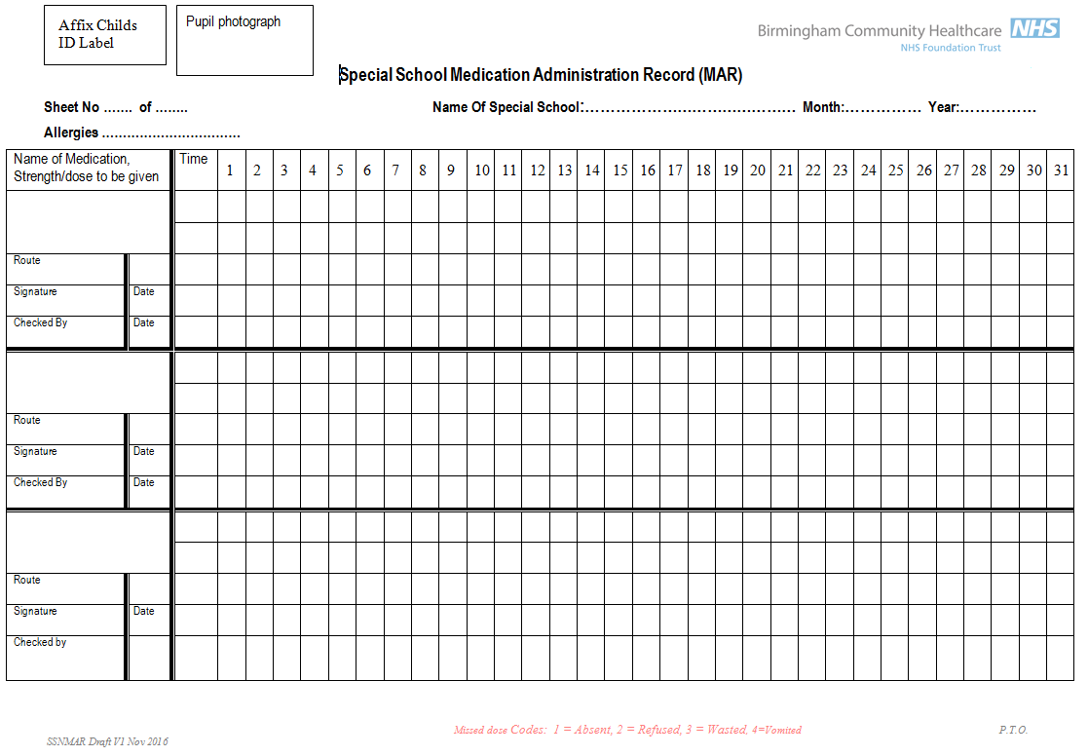
D1 – Asthma Plan

Primary version
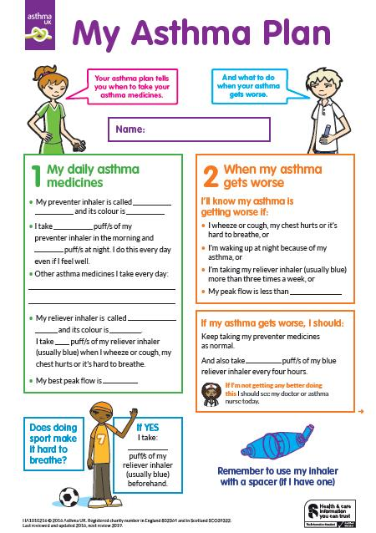 | 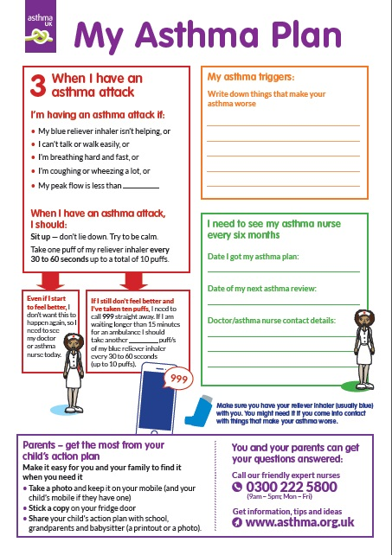
Secondary Version
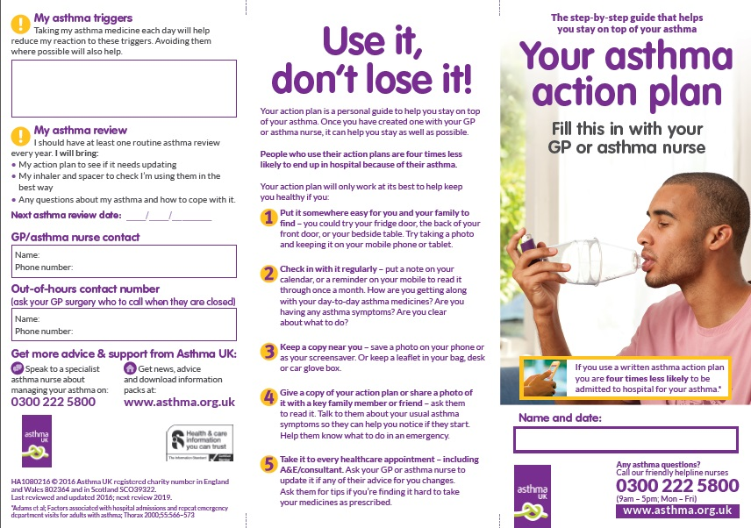 | 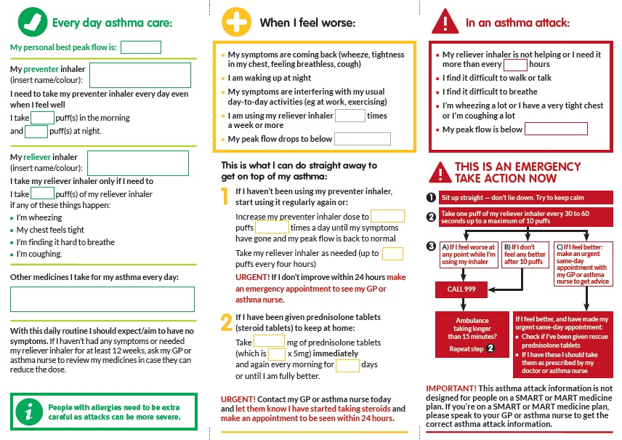

D2 – Anaphylaxis Healthcare plan

Jext Pen  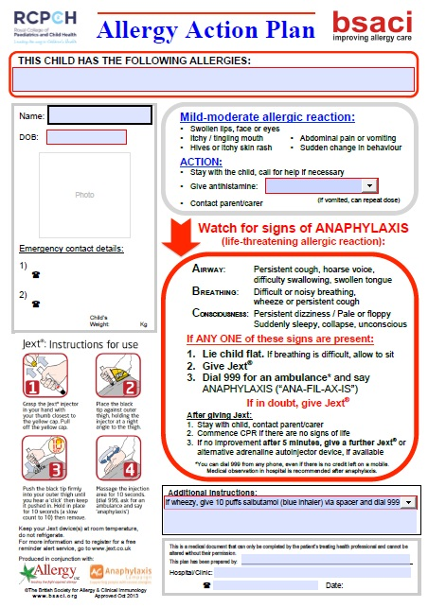 | Epipen  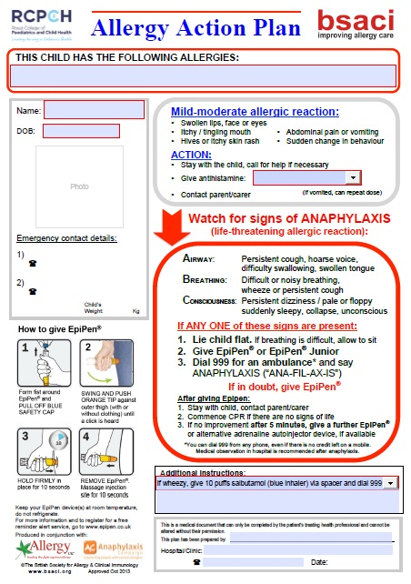
Emerade  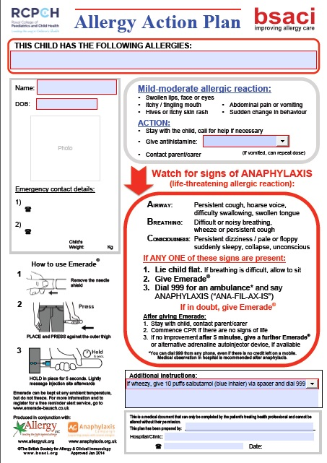 | Blank  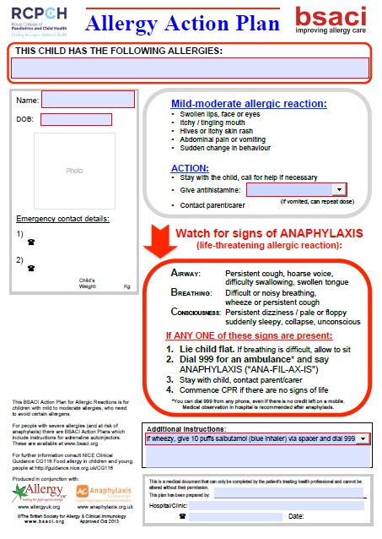

D3 – Example of personal alert card

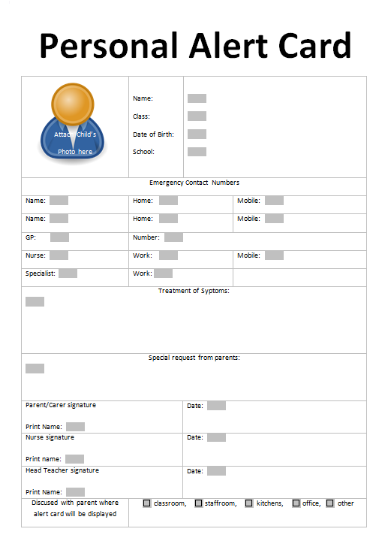

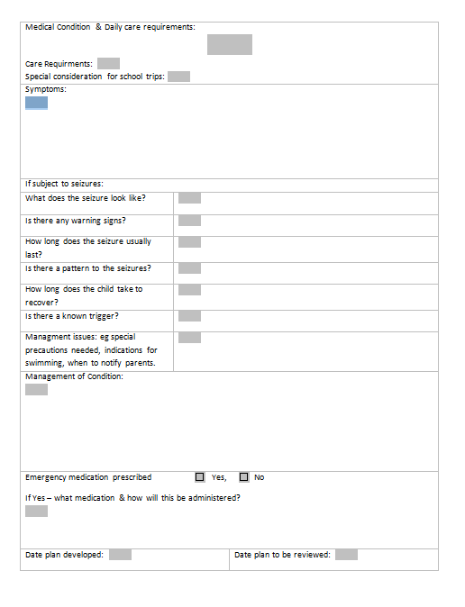
E. Example Sample letter

The letter below is attached for guidance. It can be adapted and used for issue by school staff as well as Birmingham Community Healthcare Foundation Trust school nurses.

Address

Telephone contact details

Date

Dear parent/carer

Name of child – Medication in school

As you know, following consultation with you, your child, the school nurse or other healthcare professional and school staff, it has been agreed that your child requires, or may require, medicine to be administered to them during school hours. Your parental consent form and, if your child has one, their Care Plan, explains what medication needs to be administered and when.

It is parents’ responsibility to contact me, or another member of staff at the school, in order to check your child’s medication regularly, and at least on a termly basis, to ensure it is in date, there are no changes to the dose and it is still needed by your child. The medication should be replaced or removed as necessary, especially at the beginning of each new academic year.

If there are changes to your child’s condition and/or medication, please ensure the school and school nurse are notified as soon as possible.

I am available at the school/clinic, contact details as above, if you wish to discuss your child’s condition

Yours sincerely

School/School Nurse

F Example Training Record: staff training record – administration of medicines

Name of school/setting
Staff Name
Type of training received
Date of training completed
Training provided by
Profession and title

I confirm that the above named member of staff has received the training detailed above and is competent provide the treatment which was the subject of the training session outlined above.

Trainer’s signature

Date

I confirm that I have volunteered for and received the training detailed above.

Staff signature

Date

Review date

G Reviewing School’s Provision
Key questions | School’s Evidence
Key questions | Achieved | In progress | Not achieved
- Do you ensure that parents and pupils are consulted about, and made aware of, your arrangements for supporting pupils with medical conditions in school?
- Do you promote pupils’ confidence and self-care in managing their own medical needs?
- Do you ensure that staff receive satisfactory training on supporting pupil’s medical needs in school?
- Do governors ensure that policies, plans, procedures and systems are properly prepared and implemented?
- Does the school have a policy for supporting children with medical conditions in school?
- Does the school have a contingency plan to cope if staff refuse to administer medication?
- Is the policy reviewed regularly?
- Is the policy easily accessible by parents & staff, in particular the section which explains the schools procedures for dealing with medication in school?
- Does a named individual have overall responsibility for implementation of the policy?
- Are arrangements in place to ensure that the policy is implemented effectively?
- Are Individual Healthcare Plans (IHPs) reviewed at least annually?
- Is there a named individual who is responsible for the development of IHPs?
- Is the school able to identify which staff in school need to be made aware of pupil’s medical needs and are those staff aware of which children have health needs and what support is required?
- Is written permission from parents and the head teacher obtained to allow administration of medication by a member of staff, or self-administration by the pupil, during school hours?
- Are arrangements identified in the policy to allow children to manage their own health needs?
- Do IHPs contain appropriate prescription and dispensing information?
- Are emergency contact details and contingency arrangements included within the IHP?
- Does the IHP explain what arrangements or procedures should be in place during school trips or other school activities outside of the normal school timetable so that the child can participate and are these reviewed prior to each event?
- Does practice reflect the policy?
- Does the policy identify roles and responsibilities?
- Are training needs regularly assessed?
- Have sufficient staff received suitable training?
- Is a record kept of training undertaken?
- Are written records kept of all medicines administered to children?
- Do all staff know what should happen in an emergency?
- Is the appropriate level of insurance in place and does it reflect the level of risk?
- Does the policy set out how complaints can be made?

