Guidance on Due Diligence Checks:
Consider:
- What does the individual, group or organisation want to say within the school?
- Does the activity appear to promote extremist ideological, political or religious belief?
- Does the activity or organisation appear to breach the Equality Act 2010 duty, either by discriminating against individuals with protected characteristics or by not complying with the public duty.
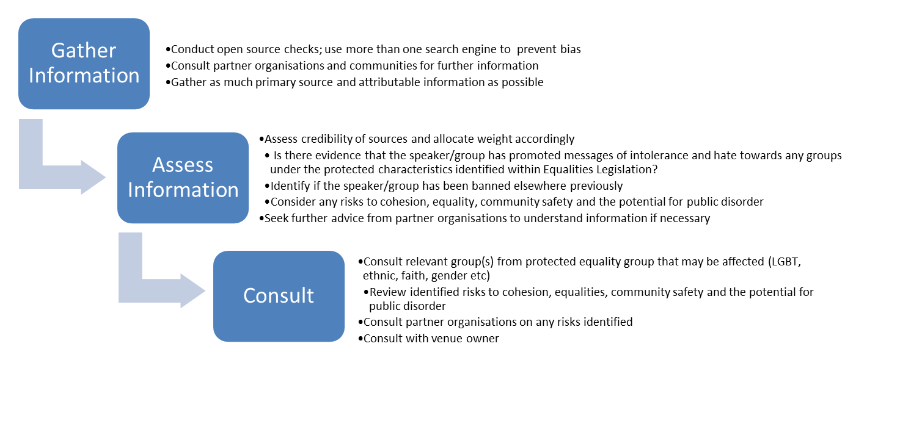
Checks would include looking at more than one internet search engine, discussion with local community groups and when necessary discussion with partner agencies

The Terrorism Act 2000 makes it a criminal offence to:
- belong, or profess to belong, to a proscribed organisation
(Section 11 of the Act);
- invite support for a proscribed organisation (and the
- support is not, or is not restricted to the provision of
money or other property) (section 12(1));

To check to see if an agency is listed on the government proscribed list please check:

https://www.gov.uk/government/publications/proscribed-terror-groups-or-organisations--2

If an individual, group or organisation is or has a history of speaking in favour of racism, religious hatred, sexism, homophobia, anti-democracy (this list is not exhaustive), then allowing them to use the school’s facilities to promote any of these views would almost certainly be in breach of policy.
Once you have enough information the Leadership Team will have to balance the evidence (use a pros and cons list) and make a decision on the evidence as to whether the activity promotes extremist ideological, political or religious belief and/or breaches the Equality Act 2010.

External Speaker Register 2016/17
Name of organisation | Name of speaker (where possible) | Date of visit | Due Diligence (pass/fail) | Notes/issues

