Paying for care – choice of home and Top-up Payments
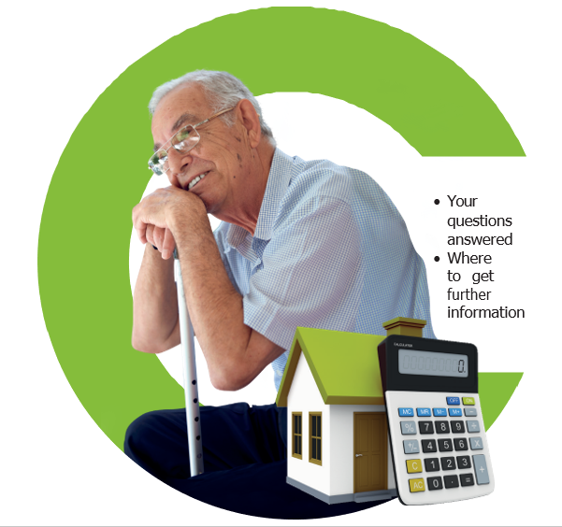

Introduction
This leaflet tells you about your rights to choose the care home where you will receive care and support, once the care planning process has identified that this type of accommodation is the most appropriate way of meeting your needs. It also explains what you will have to do if you wish to choose accommodation that costs more than the amount that has been specified in your personal budget for the provision of that type of accommodation.

What is my personal budget?
A personal budget is the total amount we have agreed can be spent on your social care and support needs. To work out your personal budget we will assess your care and/or support needs and, if you meet the criteria for social care, we will work out how much money it would cost to meet your needs.

Will I have to contribute towards my personal budget?
There are some exceptions, but most people will have a financial assessment to work out how much they can afford to pay towards their personal budget. For more details contact your social worker for a copy of the leaflet ‘Your care and support – how much you will have to pay’ or you can find this on birmingham.gov.uk/ helppayingforcare or if you
would like an estimate of how much your contribution is likely to be please visit birmingham.gov.uk/ care-estimator .
This is anonymous.

Can I choose the care home where I will live?
The care planning process will have identified how your needs are to be met and where this involves a particular
type of accommodation, you have the right to choose between different providers and/or locations of that type of accommodation in England provided that:
- the accommodation is suitable to meet your assessed needs as identified in your care and support plan
- to do so would not cost the council more than the amount specified in your Personal Budget. However, you might wish to choose a setting that costs more than the amount in your personal budget. If you do, the difference between the accommodation’s weekly charge and your personal budget will have to be met. These are called Top-up Payments and are explained later in this leaflet
- the care provider is willing to enter into a contract with the council at the rate identified in the Personal Budget and on our normal terms and conditions

What is a top-up?
When making your choice, you may choose a setting that costs more than the amount identified in your personal budget and the difference is called a top-up.
However, the amount identified in your personal budget must be sufficient to meet your needs and we will try to ensure that at least one option is available that is affordable within your personal budget and will try to ensure that there is more than one.

If I choose more expensive accommodation, who

will pay the top-up?
Your family, a friend or other such as a charity, must be willing and able to make a top-up payment to cover the difference
between the care home’s fees and the amount in your personal budget for the duration of your stay. If there is no suitable accommodation to meet your care and support needs available within your personal budget, the personal budget will be adjusted to meet the costs of the accommodation needed to meet your assessed eligible needs.

Can I pay my own top-up? There are circumstances when you can pay your own top-up, for example, if you own a property the value of which has been disregarded for the first 12 weeks of your stay you can pay your own top-up for the 12 weeks only from your savings. Or if the council has agreed to a deferred payment to include the top-up because you meet the criteria.
For more information contact
your social worker for a copy of the Deferred Payment Leaflet or you can find this on birmingham. gov.uk/helppayingforcare

Is the top-up a formal
agreement?
Yes, whoever is paying the
top-up will need to sign a written agreement that they are willing and able to meet the difference in cost and will continue to do
so throughout your stay. This agreement is also signed by the council and the care home so all parties are clear on the terms of the agreement.
If there is any doubt that the person paying the top-up can afford this for the likely duration of your stay, we will not agree to arrange care and support in the preferred accommodation. In this case, you will need to move to accommodation that is affordable within your personal budget.

What happens in the future if my family/friend can no longer afford to pay the top-up?
You/they will need to notify Adult Social Care via Customer services adult social care on 0121 303
1234 Text phone 0121 6230 or email CSAdultSocialCare@ birmingham.gov.uk as
soon as possible and a social worker will be allocated to
work with you to find accommodation
that is affordable within your personal budget.
Where can I get more information?
The fastest way you can get information and advice about adult social care, how to care for yourself and meet your care needs is by visiting www.birmingham. gov.uk
/helppayingforcare
Or, you can contact your social worker or if you do not have one, contact the team below: Customer services adult social care on 0121 303 1234
Text phone 0121 6230 or email CSAdultSocialCare@ birmingham.gov.uk
For lots of financial information visit: birmingham.gov.uk/ helppayingforcare

Further information:
You can also get information from the following organisations:
Citizens Advice citizensadvice.org.uk Telephone: 0344 477 1010
Money Advice Service moneyadviceservice.org.uk Freephone: 0800 138 7777

Age UK
ageuk.org.uk
All locations have contact telephone numbers which can be found on line or via directory.

Other leaflets in this series:
- Deferred Payments
- Direct Payments
- Rates and charges
- Top-up Payments
- How much will you have to pay?
- Self-funders
If you would like an estimate of how much your contribution is likely to be please visit birmingham.gov.uk/care- estimator . This is anonymous

Care Act details can be found at gov.uk (search Care Act).
If you use an organisation or individual that carries out regulated financial service activities in the UK, you are advised to check that they are authorised by the Financial Conduct Authority.
You can check this by visiting fca.org.uk/firms/systems- reporting/register

105.6_FEB 2021

