Planning and Development

Your Views, and Ombudsman Monitoring Report

ANNUAL REPORT 2018/19

Purpose of the Report:

To summarise and make comparisons of Your Views and Ombudsman cases received and responded to during April 2018 to March 2019 inclusive.

Background:

The Your Views and LGO case handling is an end to end process within the Business Improvement and Support Function.

At the end of this report is a list of service improvements that have been implemented during the course of this year as a direct result of Your Views and Ombudsman cases. Reminders are issued to staff and relevant Team Managers either verbally or via email during the course of complaint investigations, however it is proposed to issue a list of reminders and implemented service improvements to staff to engage all staff on customer service matters. Should the requirement for large scale business improvement be identified as a result of a complaint or LGO investigation the information is passed over to the Business Support Manager for implementation.

Stage 1 Complaints:

Stage 1 complaints are dealt with at the first point of contact with officers and are not generally recorded as they may be resolved immediately.

Stage 2 Complaints:

Numbers of Stage 2 complaints received over the past 5 years.

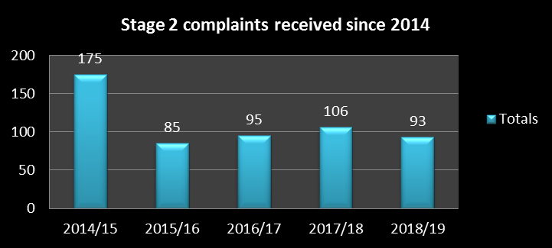

2017/18 has seen a slight decrease of 12% in the number of Stage 2 complaints received compared to 2018/19.

Stage 2 Complaint Outcomes

The following chart demonstrates the outcomes of the Stage 2 complaints over the past five years. Years 2015/16 through to 2017/18 complaints not upheld have remained relatively constant with a reduction of 20% in not upheld complaints in 2018/19. However there was a small increase in complaints that were upheld or partially upheld and this is largely attributable to service provision and decreasing numbers of staff.

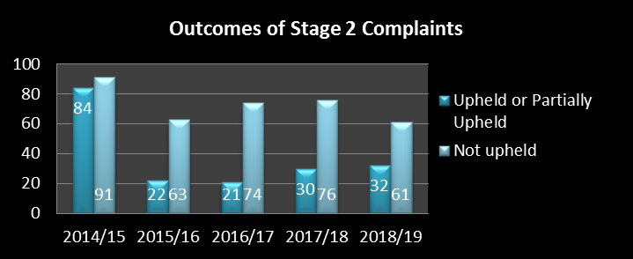

Stage 2 Corporate Natures of Complaint

Top 3 causes for complaint over the past five years averages out to the following root causes:

- Disagreement with policy or decision
- Appropriateness of service
- Efficiency of Service/Appropriateness of Service /Staff Attitude

It is evident that on average the main reason for complaint is a customer’s expression of disappointment with either a planning or enforcement decision. This has been the case historically; however, more recently, appropriateness of service and efficiency of service have become more evident as root causes for complaints, with complaints about staff attitude also increasing within the last 24 months.

We must remember though that the number of complaints received each year are exceptionally low in comparison to the thousands of interactions, decisions, responses, and services we provide are.

Performance - Stage 2 Complaint Responses

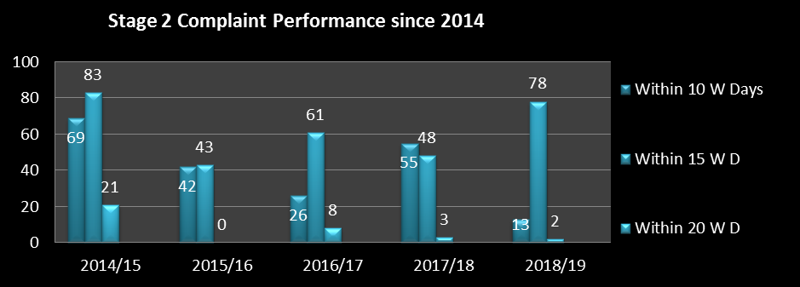

The above chart demonstrates that performance has improved dramatically within the last 12 months, and the corporate Your Views target has been achieved and exceeded.

Stage 3 Complaints

The numbers of stage 3 complaints received in 2018/19 increased slightly by 7% in comparison to previous years where the number remained relatively constant. Which reflects customer expectations and the desire to escalate complaints in the hopes of achieving compensation. This is nationally recognised in the private sector. Steps are being taken to reduce escalated Stage 3 complaints.

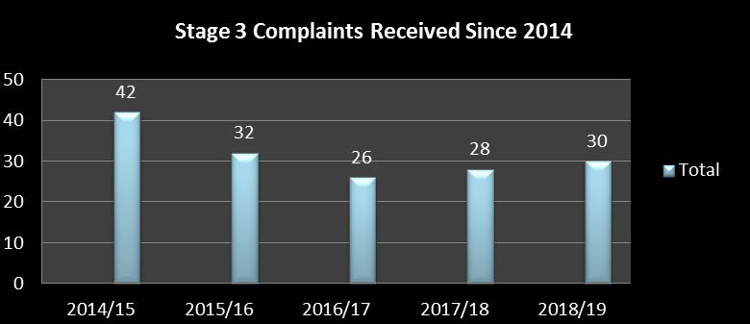

Stage 3 Complaint Outcomes

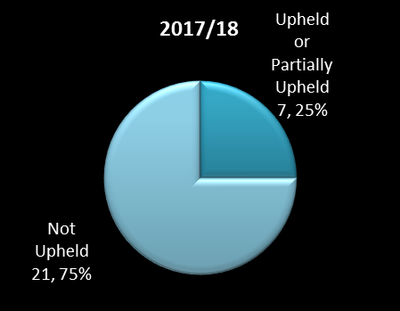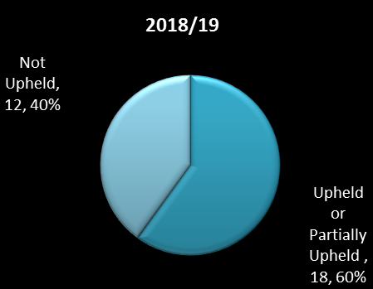

Stage 3 upheld or partially upheld complaints have increased over the course of 2018/19 in comparison to 2017/18. Again attributable to service provision and decline in staff numbers.

Performance - Stage 3 Complaint Responses

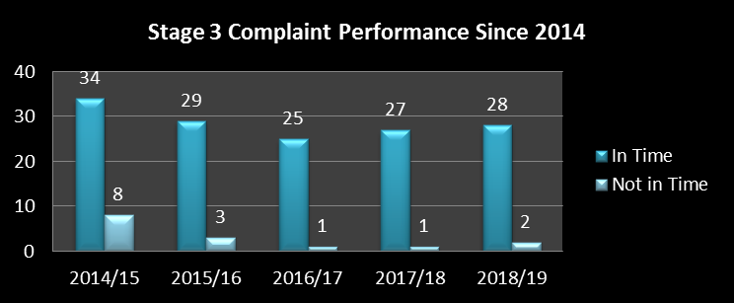

93% of all stage 3 complaints received in 2018/19 were responded to in time. Although the aim is always to achieve 100%; only 2 complex case exceeded the 20 day complaint response deadline

Ombudsman Cases:

The number of Ombudsman complaints received during 2018/19 decreased by 37% in comparison to 2017/18 as identified in the chart below. This year’s figures are the lowest to date which reflects the quality of the Stage 2 & 3 complaint responses which accurately explain the situation to the customer deterring them from wishing to progress to the LG&SCO.

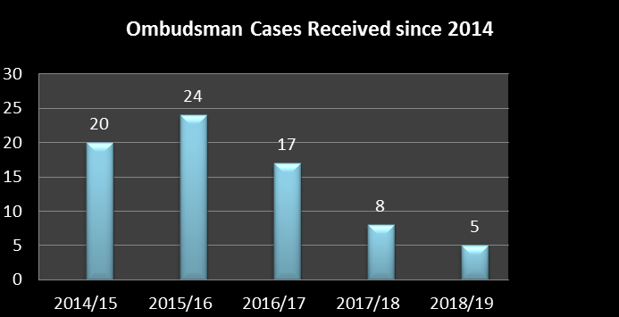

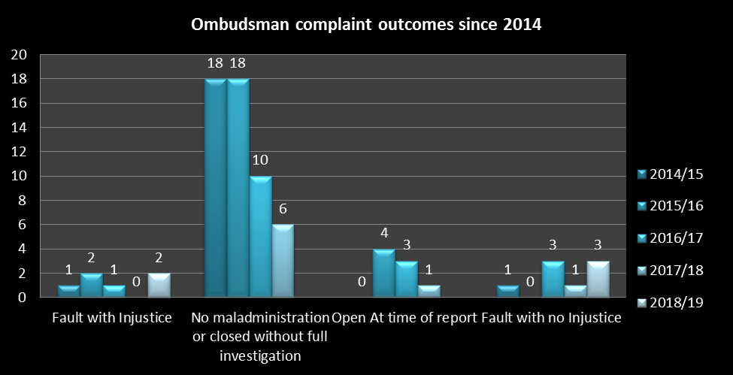

This above chart demonstrates that the vast majority of cases are defended well as we are unable to agree with the complainants view. The LGO places reliance and trust in the Stage 2 and 3 responses prepared by Customer Services and this is reflected in the number of cases that do not progress to full investigation and those where no fault is found.

The Planning and Regeneration service has not been subject of an LGO Report for some years now and this also is testament that the Planning and Regeneration service are getting it right. The last 12 months has again seen the receipt of some complex LGO complaints with just one being found at fault but with no injustice.

Comments

The following chart shows the comparison of comments received. There was a decrease in comments in 2018/19 (12%).

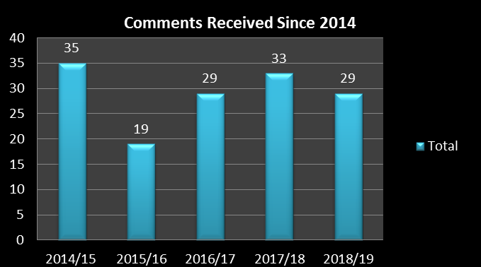

Compliments

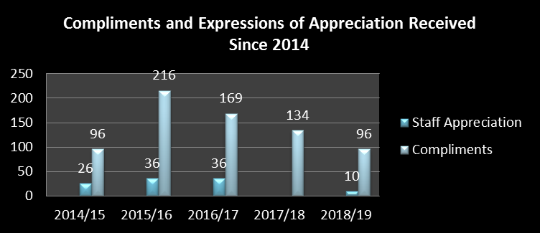

It is very pleasing that that compliments are still being received despite falling staff numbers which reflects again the constant improvements to customer service delivery.

Service Improvements:

A significant number of ‘small tweaks’ have been made to service delivery as a result of the complaints handled during 2018/19. Whilst works are still ongoing on some improvements others have been implemented and have worked well. Below is a list of some of the recurring reminders that are issued to officers and the most significant Service Improvements implemented throughout the last year:

- Officers across the service have been reminded to return customer calls, respond to customer correspondence within the timescales set within the P & R customer charter, and to respond to enquiries about planning proposals whilst a planning application is considered. Failure to engage with members of the public who may require further assistance to register comments about applications could be identified as maladministration if complaints escalate to the LGO.

- Officers have been reminded that they must ensure all material planning comments of objection or support are fully summarised in their reports. In addition to providing reasoning behind decisions in regard to pre-application responses to customers so the customer can take on board the comments and amend the proposal accordingly if required

- Officers reminded that if we do get it wrong then an apology to the customer to acknowledge that on this occasion the service provided was not what our customers should expect.

- Officer reminded of the need to act more proactively if a there are reports of tree felling

- Officers reminded of the need to ensure all address points are picked when determining addresses to be identified for planning application public participation letters.

- Service improvement implemented following identification that the comment due date showing on the planning online register was inaccurate. This affected a substantially large number of records and an amendment was made to the M3 planning system which has now resolved the problem ensuring accurate information for people that check comment closure dates on the web.

Conclusion:

This year’s report demonstrates there has been a slight decrease in complaints and a decrease in LGO cases which demonstrates the quality of the Stage 2 & 3 responses deterring customers to take their concerns further. The continued support of management to the customer service ethos is crucial along with the awareness of Customer Service Excellence assessment and all the work done to achieve accreditation.

Whilst there has been little need for large scale service improvements to be introduced, there has been constant reminder and recommendations for small tweaks to service delivery and staff behaviour. These are clearly being implemented with pleasing results. In an attempt to reduce complaints further over the next 12 months we will look to better manage customer expectations by improving information available.

In addition, it may also help if we can strive to eradicate the small number of complaints upheld each year about simplistic staff behaviours such as lack of response to correspondence within the correct timescales, or failure to return calls, etc. It is evident that a small number of complaints each year are upheld or partially upheld for these reasons and efforts to improve these behaviours will also help prevent complaints. This will be achieved by requesting Team Managers in their group meetings to remind staff of their required behaviours.

Notwithstanding this, we are very aware that the complainant culture is changing, with many customers are determined to pursue complaints to the highest levels in order to achieve their desired outcome.

