QUARTER 3 FINANCIAL MONITORING RETURN

GUIDANCE AND TEMPLATE INSTRUCTIONS

Contents

Quarter 2 Return Update 4
Quarter 3 Guidance 4
Training Dates 4
Submission Date 5
Period 9 – Soft Closedown 5
Quarter 3 Template Instructions 5
‘1. Checklist’ Tab 5
‘2. CFR Return’ Tab 5
REVENUE AND CAPITAL ACCOUNTS 6
2024/25 Outturn 6
2025/26 Approved School Budget Plan - Original 6
2025/26 Approved School Budget Plan Virements 6
Revised 2025/26 Approved School Budget Plan after Virements 6
Cash Sheet – YTD 7
Non-Cash Sheet - YTD 7
2025/26 Actual Year to Date Position 8
% Actual Against Budget 8
% Actual compared to Total Inc/Exp 9
2025/26 Forecast Year End Position at Q3 9
Budget - Forecast Variance 9
Mandatory comment for variance & any additional information 9
BALANCE SHEET 9
Bank Balance as per attached statement 9
Reconciling Items (Unpresented Cheques and Uncredited Receipts) 10
Closing Petty Cash Balance 10
VAT Reimbursements 10
Other Adjustments 10
System Debtors and Creditors 11
Non-BCC Payroll Creditor - costs 11
DIFFERENCE 11
‘3 Establishment’ Tab 12
‘4. Schools System Report’ Tab 12
Supporting Documents 12
Common Issues 14

Quarter 2 Return Update

Thank you to all schools who submitted their Quarter 2 Financial Monitoring return. If your return was fine, you will not have heard from us.

We have now reviewed the returns and contacted schools individually where we had any queries.

For schools that did not submit prior to the absolute deadline of 7 November 2025, your school position was closed on the cash in bank as of 30 September 2025. For schools banking with Barclays under the BCC corporate umbrella, we managed to obtain the cash position through our corporate access. However, for schools banking externally, the bank statement submitted with the VAT return for the final period of Quarter 2 was used.

We would like to remind all schools that the Quarterly Financial Monitoring is a statutory return and must be submitted on time with the correct supporting documentation. Delays in submission impact the local authority’s ability to carry out the necessary tasks to review the submissions and contacts schools for further information in a timely manner.

Quarter 3 Guidance

This document provides guidance for completing the Quarterly Financial Monitoring Return. It outlines the steps and key requirements to ensure an accurate and timely submission. The aim of the return is to ensure schools are delivering reliable data for budget monitoring and reporting purposes.

Training Dates

6 January 2026 10:00 – 11:00 Join the meeting now
Meeting ID: 361 617 405 835 23
Passcode: hF62Wc28

7 January 2026 14:00 – 15:00 Join the meeting now
Meeting ID: 350 650 064 002 45
Passcode: j3ep2to9

There will be no drop-in sessions. However, schools can ask any questions or request a 20-minute slot by contacting the Schools Finance mailbox. Please note that the priority for 20-minute slots are schools who did not submit or submitted an imbalanced Quarter 2 return.

Submission Date

The Quarter 3 Financial Monitoring return must be signed by the school’s headteacher at the bottom of the ‘2. CFR Return’ tab and submitted in excel format no later than 15 January 2026 to SchoolsFinance@Birmingham.gov.uk

When submitting the return, please ensure the subject line of the email is:

Quarter 3 Return – DfE Number – School Name

Once you have submitted your Quarter 3 return, Schools Finance will undertake necessary checks to ensure the worksheets are accurate and will contact schools if any further information is required.

All maintained schools must submit a return. In instances where the return does not balance, we advise you contract school finance as early as possible and before the submission deadline to resolve the imbalance. Where schools are unable to resolve differences prior to the submission deadline, we advise that returns are still submitted and differences are resolve prior to year end. Non submission in not an option and where schools do not comply, the Local Authority will be writing to the Headteacher and Chair of Governors of the respective school.

Period 9 – Soft Closedown

Period 9 (December 2025) represents a soft closedown of financial accounts. Schools are expected to ensure that all transactions up to this point are accurately recorded. While adjustments can still be made after Period 9, the aim is to identify discrepancies and address any outstanding issues prior to year-end and ensure a smoother transition into closedown for 2025/26.

Quarter 3 Template Instructions

Open the spreadsheet, go to tab ‘2. CFR Return’, select your school in the drop-down menu in cell E3. The data will auto-populate in the required format. Do not select your DfE number, this will update automatically in cell E4.

‘1. Checklist’ Tab

This tab provides an overview of the steps that should be taken when completing the return. Further guidance on completing each of the tabs within the workbook is provided within this document. We request that the individual completing the return populates cells C7-C9 and mark each item as completed once actioned. If any are not applicable to the school, ensure these are clearly identified.

‘2. CFR Return’ Tab

All maintained schools in Birmingham are required to record and report income and expenditure under the Consistent Financial Reporting (CFR) framework. The CFR framework provides a standard template for schools to collect information about their income and expenditure.

For further guidance on the CFR framework see Consistent financial reporting (CFR) framework - GOV.UK.

For 2025/26, the Department for Education (DfE) removed CFR code I18, any grants previously reported in I18C and I18D should be shown under I06. E20 has also now been split into additional spend lines.

REVENUE AND CAPITAL ACCOUNTS

Schools typically manage two types of accounts: revenue and capital. Revenue accounts cover day-to-day operational costs such as staffing, utilities and learning resources. Capital accounts record funding and expenditure for long-term investments such as building projects, refurbishment and the purchase of assets such as land and IT equipment.

2024/25 Outturn
'
Column F is pre-populated with the school’s reported CFR position for the 2024/25 financial year. This position was reported to the DfE and subsequently uploaded to the Financial Benchmarking and Insights Tool.

Home - Financial Benchmarking and Insights Tool - GOV.UK

2025/26 Approved School Budget Plan - Original

Column G should be populated with the original budget plan that was agreed by the school headteacher and governing body for the current financial year.

In 2026/27, this column will be pre-populated with the budget plans that are submitted to Schools Finance for the 2026/27 financial year.

2025/26 Approved School Budget Plan Virements

Column H should be populated with any virements (adjustments) to the 2025/26 Approved School Budget Plan reported in column G.

Schools should ensure that any virements to the school budget plan are reported to the headteacher and governing body.

Revised 2025/26 Approved School Budget Plan after Virements

Column I is pre-populated to calculate the totals of columns G and H.

Cash Sheet – YTD

Column J is pre-populated with the total income that Schools Finance has paid to the school since the beginning of the financial year. The total of J124 is the total of the Revenue and Capital funding to date. J124 will match the total CFR to date reflected on the December 2025 Cash Sheet.

Example:
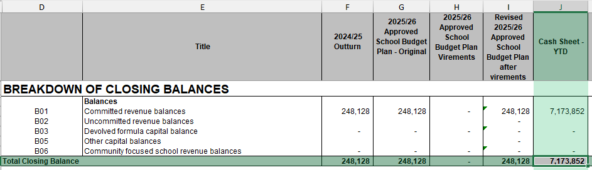

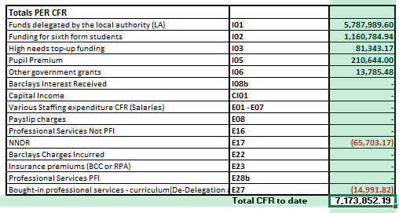

Schools must ensure that the total in column J is reflected on their systems.

Non-Cash Sheet - YTD

Column K should be populated by the school with actual income received in the bank and actual expenditure paid from the bank since the beginning of the financial year. This includes any other income paid by other BCC services outside of Schools Finance.

This column should also be populated to account for any unpresented bank items at month-end as well as commitments such as any payroll oncosts that have not yet been paid.

Note: Income and expenditure which should not be recorded in this column includes VAT, and prior year accruals which were accounted for in the previous financial year.

Schools should not include any Cash Sheet income in this column as it is already included in column J.

Schools should also refrain from using column K to reduce the total values for the income or charges reported in column J. However, there are some instances where this may be required i.e., to reapportion Post 16 High Needs Place funding from CFR I01 to I02. Any adjustment to the values in column J should equal nil. In most instances, the value against CFR codes in column J is correct and should not be adjusted.

Schools should ensure that they correctly account for revenue and capital income and expenditure. If a school has used its revenue budget to fund capital projects, they must ensure the costs are reflected in the capital account, and a revenue to capital contribution is shown against CFR code E30. Any revenue to capital contribution inputted against CFR code E30 will automatically pre-populate the same amount against CFR code CI04 in the capital account. Any revenue to capital contribution cannot be reversed – any remaining revenue contribution not utilised should form part of the school’s capital carry forward.

2025/26 Actual Year to Date Position

Column S is pre-populated to calculate the totals of columns J and K.

The amounts in S71 and S94 reflects the school’s in-year revenue and capital positions.

The amounts in S73 and S96 reflects the school’s cumulative revenue and capital positions. The total of these two combined is reflected in S124.

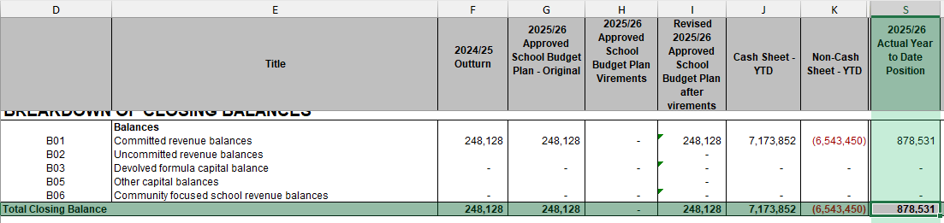

Note: whilst the cumulative closing revenue balance in cell S73 can be a deficit, the cumulative closing capital balance in cell S96 cannot. If a deficit closing capital balance is being reported, the school must make a revenue to capital contribution for any deficit against CFR code E30. This will ensure the capital closing balance is nil.

% Actual Against Budget

Column T is pre-populated to calculate the percentage of the total in column S against the Approved School Budget Plan in column G for each income and expenditure line.

% Actual compared to Total Inc/Exp

Column U is pre-populated to calculate the percentage of the total in column S for each income line against the total income. Each expenditure line is compared against the total expenditure.

2025/26 Forecast Year End Position at Q3

Column V must be populated by the school with an accurate forecast. This is essential for effective budget management, compliance and supporting informed decisions. Schools should review their current expenditure and projected commitments as part of this forecast.

There is no longer a requirement to submit an update 3-year budget forecast however a Quarter 3 return must be completed and submitted.

Budget - Forecast Variance

Column W is pre-populated to calculate the variance between the forecasted year-end position in column V against the revised budget plan after virements in column I.

Mandatory comment for variance & any additional information

If the school adjusts in column K the values in column J, the school must provide reasoning for this in column X.

Schools should also use column X to provide any additional information where necessary i.e., if the forecast for a CFR line is expected to be significantly higher or lower than the YTD.

BALANCE SHEET

Having completed the Revenue and Capital Accounts, the next stage is to populate the balance sheet position as of 31 December 2025.

Bank Balance as per attached statement

Columns K and S, cells 130 should be populated with the bank balance as per the 31 December 2025. Schools must provide a bank statement to support these figures.

Schools must ensure that they use Columns K to reflect their main school bank account, and Column S to collate any additional bank accounts. Where multiple bank accounts are reflected in column S, schools should ensure this is formulated e.g., =1000+2000, so that the figures can be easily be matched to the bank statements provided.

Reconciling Items (Unpresented Cheques and Uncredited Receipts)

Columns K and S, cells 133-134 should be populated with any unpresented bank items.

This must not include any transactions that have taken place in January 2026 that would not have been captured within the income and expenditure up to 31 December 2025. To do this, you will have to deduct any items dated January 2026 from the unpresented items reports.

Schools must ensure that they use column K to reflect the unpresented bank items for the main account, and column S to collate any unpresented bank items for any additional bank accounts. Where multiple bank accounts are reflected in column S, schools should ensure this is formulated so that figures can easily be matched to the unreconciled items reports provided for each bank account.

Closing Petty Cash Balance

In cell K138, schools should input any figures for petty cash balances i.e., cash in office (an example is if the school has received income from parents that the school has recognised as income in the revenue accounts but not yet deposited in the bank account). Please ensure that you make a note of what this relates to in cell V138.

VAT Reimbursements

Input any VAT reimbursements that are outstanding. An entry for December 2025 VAT should be inputted in cell K139, and any prior month VAT returns that have not yet been reimbursed should be inputted in cell K140. Please ensure that you make a note of which prior months the outstanding reimbursements relate to in cell V140.

Other Adjustments

Cell S142 will be pre-populated with any cash advances that have been transferred to schools with external bank accounts. Schools must ensure that any cash advance is not recorded as actual income – they are simply a bank adjustment / float to prevent the school going into an overdraft.

If any other adjustment is inputted in cell K142, please ensure that you make a note of what the adjustment relates to in cell V142 and provide sufficient backup.

System Debtors and Creditors

If a school has any system debtors and creditors (also known as aged accruals), these need to be reflected in column S, cells 161-166. Where figures are inputted here, the school must ensure that they provide sufficient backup for these with their return.

Non-BCC Payroll Creditor - costs

Please ensure that you have fully imported the payroll for April to December onto the school’s financial system.

It is likely that the school have not yet paid the December payroll oncosts (i.e., superannuation and employer national insurance contributions) by 31 December 2025. Any oncosts that have not yet been paid but have been recognised in the revenue account should be reflected as a minus figure in cell S168.

There may be an instance where the school is due a reimbursement for overpayment of oncosts which has been recognised in the revenue accounts. Where this is the case, the figure in cell S168 should be positive.

Where figures are inputted here, the school must ensure that they provide sufficient backup for these with their return.

DIFFERENCE

There should be no variance between the figure in cells S124 and S170. Any difference will be reflected within cell S172.

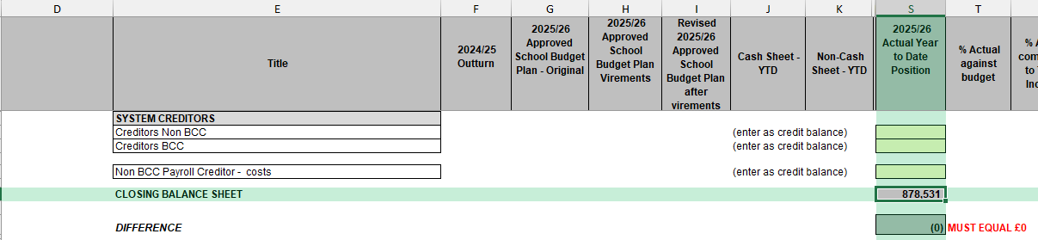

There is an expectation that there is no difference. Where there is a difference, this will need to be resolved. This would mean checking that nothing has been posted to the accounts outside the expected date range (April to December), and checking that all CFR codes are mapped as well as reviewing VAT.

If following this there is still a difference, please do not delay in sending the return to Schools Finance. Any difference will need to be resolved in consultation with Schools Finance.

‘3 Establishment’ Tab

BCC must report certain information on the schools staffing and establishment numbers and costs. Schools must:

- Provide full time equivalent (FTE) and cost under the relevant cost bandings for both teaching and non-teaching staff as of 31 December 2025.
- Cost information should be taken from your payroll reports for the period April to December 2025.

‘4. Schools System Report’ Tab

Schools are required embed a copy of their system report within the quarterly return. Where the Cash Sheet – YTD (column K on CFR Return tab) differs to what is reported on the school system, the school must provide a reasoning for any difference.
In some cases, the system reports opening balance will not match the actual closing balance however in year income and expenditure should be correct. In this case, must still submit a system report.

Supporting Documents

The following documents must be submitted with the Quarter 3 Financial Monitoring Return.
- Completed and signed Excel Quarter 3 template
- School CFR system report if not embedded within the return
- Trial Balance
- Balance and Reserves report
- Bank Statements as of 31 December 2025 for all accounts reported in column K and S.
- Bank Reconciliation for all bank accounts
- Unpresented bank items report for all bank accounts
- VAT Submission including December 2025 and any outstanding for prior months
- Aged creditor/debtor reports to support any inputted figures
- Payroll report to support any inputted figures in the non-BCC payroll creditor costs

FAQ’s

There are several common questions that were asked in the Quarter 2 submissions.

- Can I make adjustment to the Cash Sheet – YTD figures?
Schools should refrain from adjusting in column K the values against the CFR codes in column J.
There were instances of schools removing the NNDR E17 and De-delegation E27 charges. Schools are required to report these charges. By removing them, the school would be declaring no NNDR and De-delegation charge for the year, which we know is not true. Whilst we understand the school system may not currently reflect these charges, these have a net nil impact on the bottom line and should therefore not be deducted from the return.
There were instances of schools reapportioning the income against I02, I03, I05, I06, and I07 in column J to I01 in column K. Schools should not do this unless they are making a reasonable adjustment (e.g., reallocating Post 16 High Needs Place Funding to I02). In most cases, the income in column J is reported against the correct CFR code. If a school reallocates I05 Pupil Premium funding to I01, it effectively reports no Pupil Premium income, which we know is not true.
Where grants are recorded under a different CFR code on the school system, the school should add a note on the system report to explain this but should not reallocate the funding within this return.

- Why is there a difference in cell S172?
If there is a positive difference in cell S172, this means that either income is overstated, or expenditure is understated.
If there is a negative difference in cell S172, this means that either income is understated, or expenditure is overstated.
If the school has historical issues with their internal finance systems and have used their system report to populate the return, there is likely to be a difference. The school should ensure that the income and expenditure reported in column K reflects the income and expenditure that has gone through the bank account since April 2025, excluding VAT and prior year accruals. Where the bank is used to reconcile the return, there is more likely to be no difference in cell S172.

- Do I need to provide a year-end forecast?
Some schools did not provide a year-end forecast at Quarter 2. It is essential that all schools submit a forecasted financial position to ensure accurate reporting and planning.

- Why does the bank balance not match the bank statements?
Schools must ensure that the bank balance inputted in K130 and S130 reflect the bank statements as of 31 December 2025.
There were instances of schools using the bank figure reported on the school system that did not match the balance as per the bank statement as of 31 December 2025.
Schools must ensure that their systems are reconciled to bank up until 31 December 2025.
There were instances of schools with multiple bank accounts not using column K and S to differentiate between their main account and additional accounts. We request that schools utilise these columns to distinguish between their various accounts.

- Do I need to provide backup for system accruals?
Schools must ensure that sufficient backup is submitted with the return for any inputted system accruals and non-BCC payroll creditor figures. It is essential that these are provided with the return as the balances for the system accruals on the school system may change post-submission.

