

Part-time/Reduced timetable – individual risk assessment & management plan
Completing a risk assessment which addresses any actual or potential safeguarding, welfare or harmful behaviour concerns that may result from a change in the pattern of school attendance is essential. Schools may want to develop their own risk assessment to meet the needs and risk of their school community. The assessment should include the risks when the child is not in receipt of education during the school day, including the impact on the wider family.

Name of child
Date of birth
UPN
Date of completion
First assessment or review? | New/Review
Dates of previous reviews
Date parent/carer consent received for the risk assessment to be shared

Complete the risk analysis, using the 0-5 rating as below:
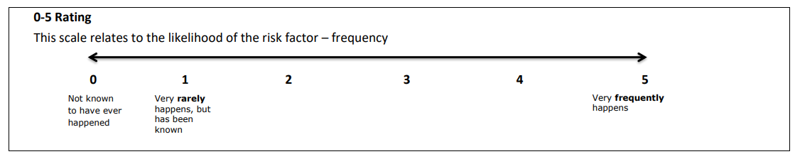

Risk factors – identify all relevant risks | Likelihood scale 0→5 | What steps have been put in place to manage the risks? | Likelihood scale 0→5 after risk management has been put in place
The risk/s presented to the child from others:
The risk/s the child poses to themselves:
The risk/s the child poses to others:
Risk/s within the community:

What support and supervision will be available at home (when not in school)?

Views of child (in own words, if possible):

Views of parent/carer:

Partnership Working:
Partnership working | Name | Role in supporting the child to access their entitlement
Key Person (in school)
Parent/Carer
Other agencies (name agency)

This plan should be regularly reviewed, at least every 6 weeks
Please consider the requirements of the General Data Protection Regulation when gathering and submitting information via this form and ensure that as a school you have gained the required consents in line with GDPR to be able to share this information.

