QUARTER 1- APRIL 2025 TO JUNE 2026 RETURN

TEMPLATE INSTRUCTIONS

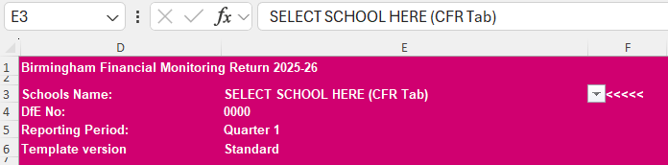
Open the s/sheet, go to tab ‘CFR Return’, select your school from the drop-down menu in cell E3. The data will be auto-populated in the required format. Do not select your DfE No, this will change automatically in cell E4.

Please note that any income received from the LA cash sheet will have been pre-populated in column J for you. However, this does not include payments from outside Schools Finance. Other payments must be added along with any other income in column K.

Update the sheet with your CFR report balances taking into account the entries within Column J.

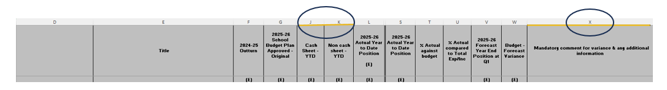
Please add notes in column X then review the template to ensure you are reporting the correct position to the LA and click on save.

Once you have completed the Revenue, Capital, and Community-Focused School Revenue accounts check that the bottom line is consistent with your ledger, checking your in-year position, and opening and closing reserve balances.
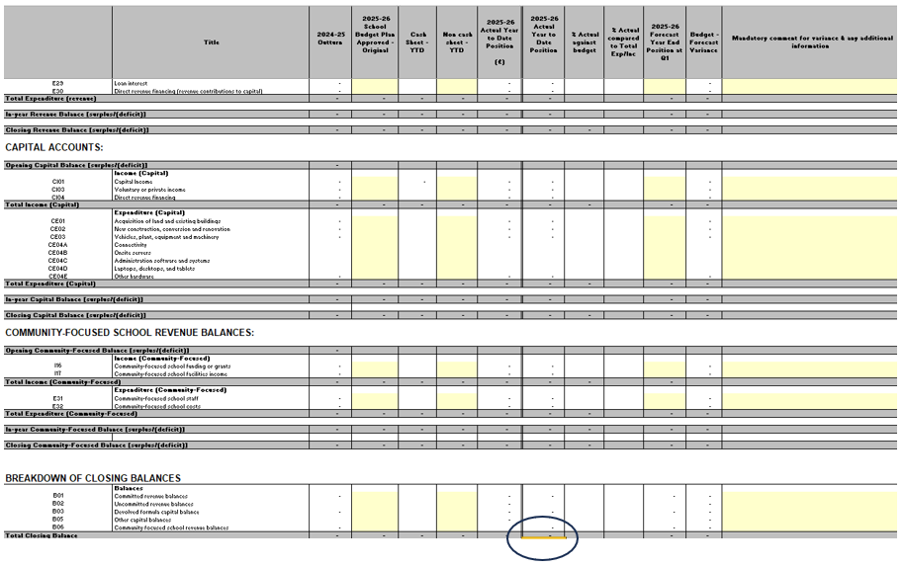

CFR CODES
DfE has CHANGED certain CFR codes to capture income and expenditure incurred in connection with IT Learning resources.

Consistent financial reporting framework guidance

BALANCE SHEET
Bank Position
Having completed the revenue and capital accounts the next stage is to populate your bank reconciliation to the end of June 2025, rows 130 to 168. Use your completed bank reconciliation for June 2025 to populate the return which has been completed as at 30/06/25. Check that the reconciliation does not include items that have been posted for July 2025. Unpresented cheques and uncredited receipts must not include any transactions in July 2025 that would not have been captured within the CFR return (to do this you will have to print off an unpresented cheques and unpresented receipts list and manually deducted any items dated July 2025 before adding the totals to the spreadsheet).
Schools that have an external payroll will need to populate figures for each bank account (main bank accounts and payroll account) by completing cells S130-S168 for the payroll bank account as well as K130-K168 for the main bank account. Please ensure that you have fully loaded the June payroll onto the schools financial system (dated 30th June 2025) as these will need to appear as unpresented cheques.
Also add details of petty cash and any pending VAT reimbursements, an entry for VAT June 2025 would need to be added at least.
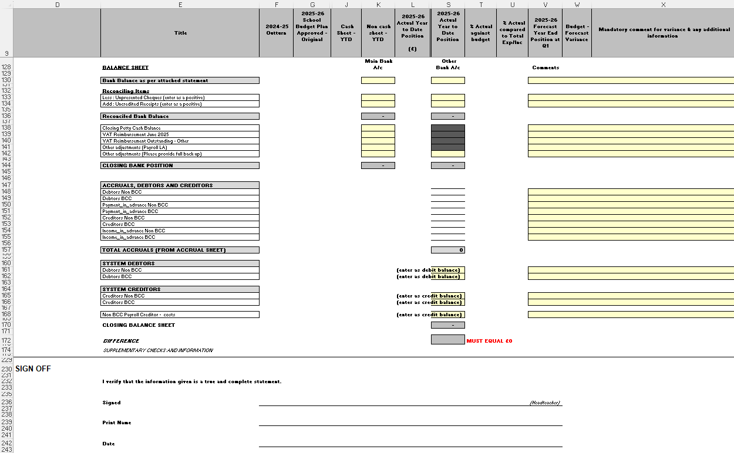

Income Adjustment
If there is a difference between income as per cash sheet and actual income transferred into bank and you have recorded income as per the payment schedule within your revenue account/within the return, the difference between actual bank and the payment schedule will be income or payment in advance. This difference can be reflected in row 141.

Balancing – no difference
There is an expectation that there is no difference within cell P172. Where there is a difference, this will need to be resolved. This would mean checking that nothing has been posted to the accounts outside the expected date range, checking that all CFR codes are mapped and reviewing VAT.
If following this there is still a difference, please do not delay sending the return to Schools Finance. Differences will be resolved in consultation with Schools Finance.
Please note that the template includes tabs for Establishment and School System Report. The total cost YTD is from April to June inclusive can be calculated by adding these amounts from your monthly payroll summary sheet (payroll schools). Please ensure all tabs are completed. Please submit a copy of your payroll report with the return.
The electronic signed excel version must then be emailed to the Schools Finance mailbox. Please include Qtr1 return 2025 followed by school DFE Number and school name on the email subject line.

Documents to Submit
- Bank Reconciliation
- Bank Statement(s)
- Signed Excel Copy
- Payroll Report (External)
- VAT Submission (Inc Nil)

