# **Birmingham Smoke Control Area 2025**

© Crown Copyright and database right 2025. Ordnance Survey AC0000819638

Red line indicates extent of Smoke Control Area

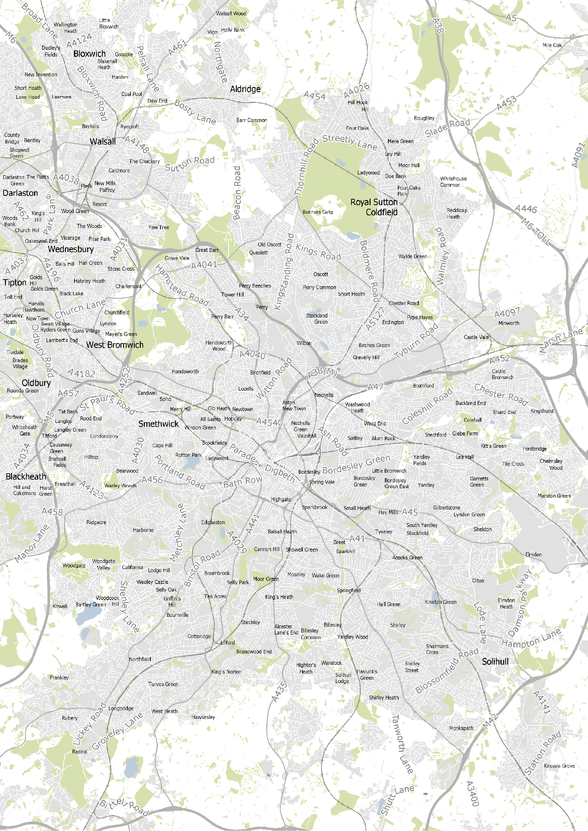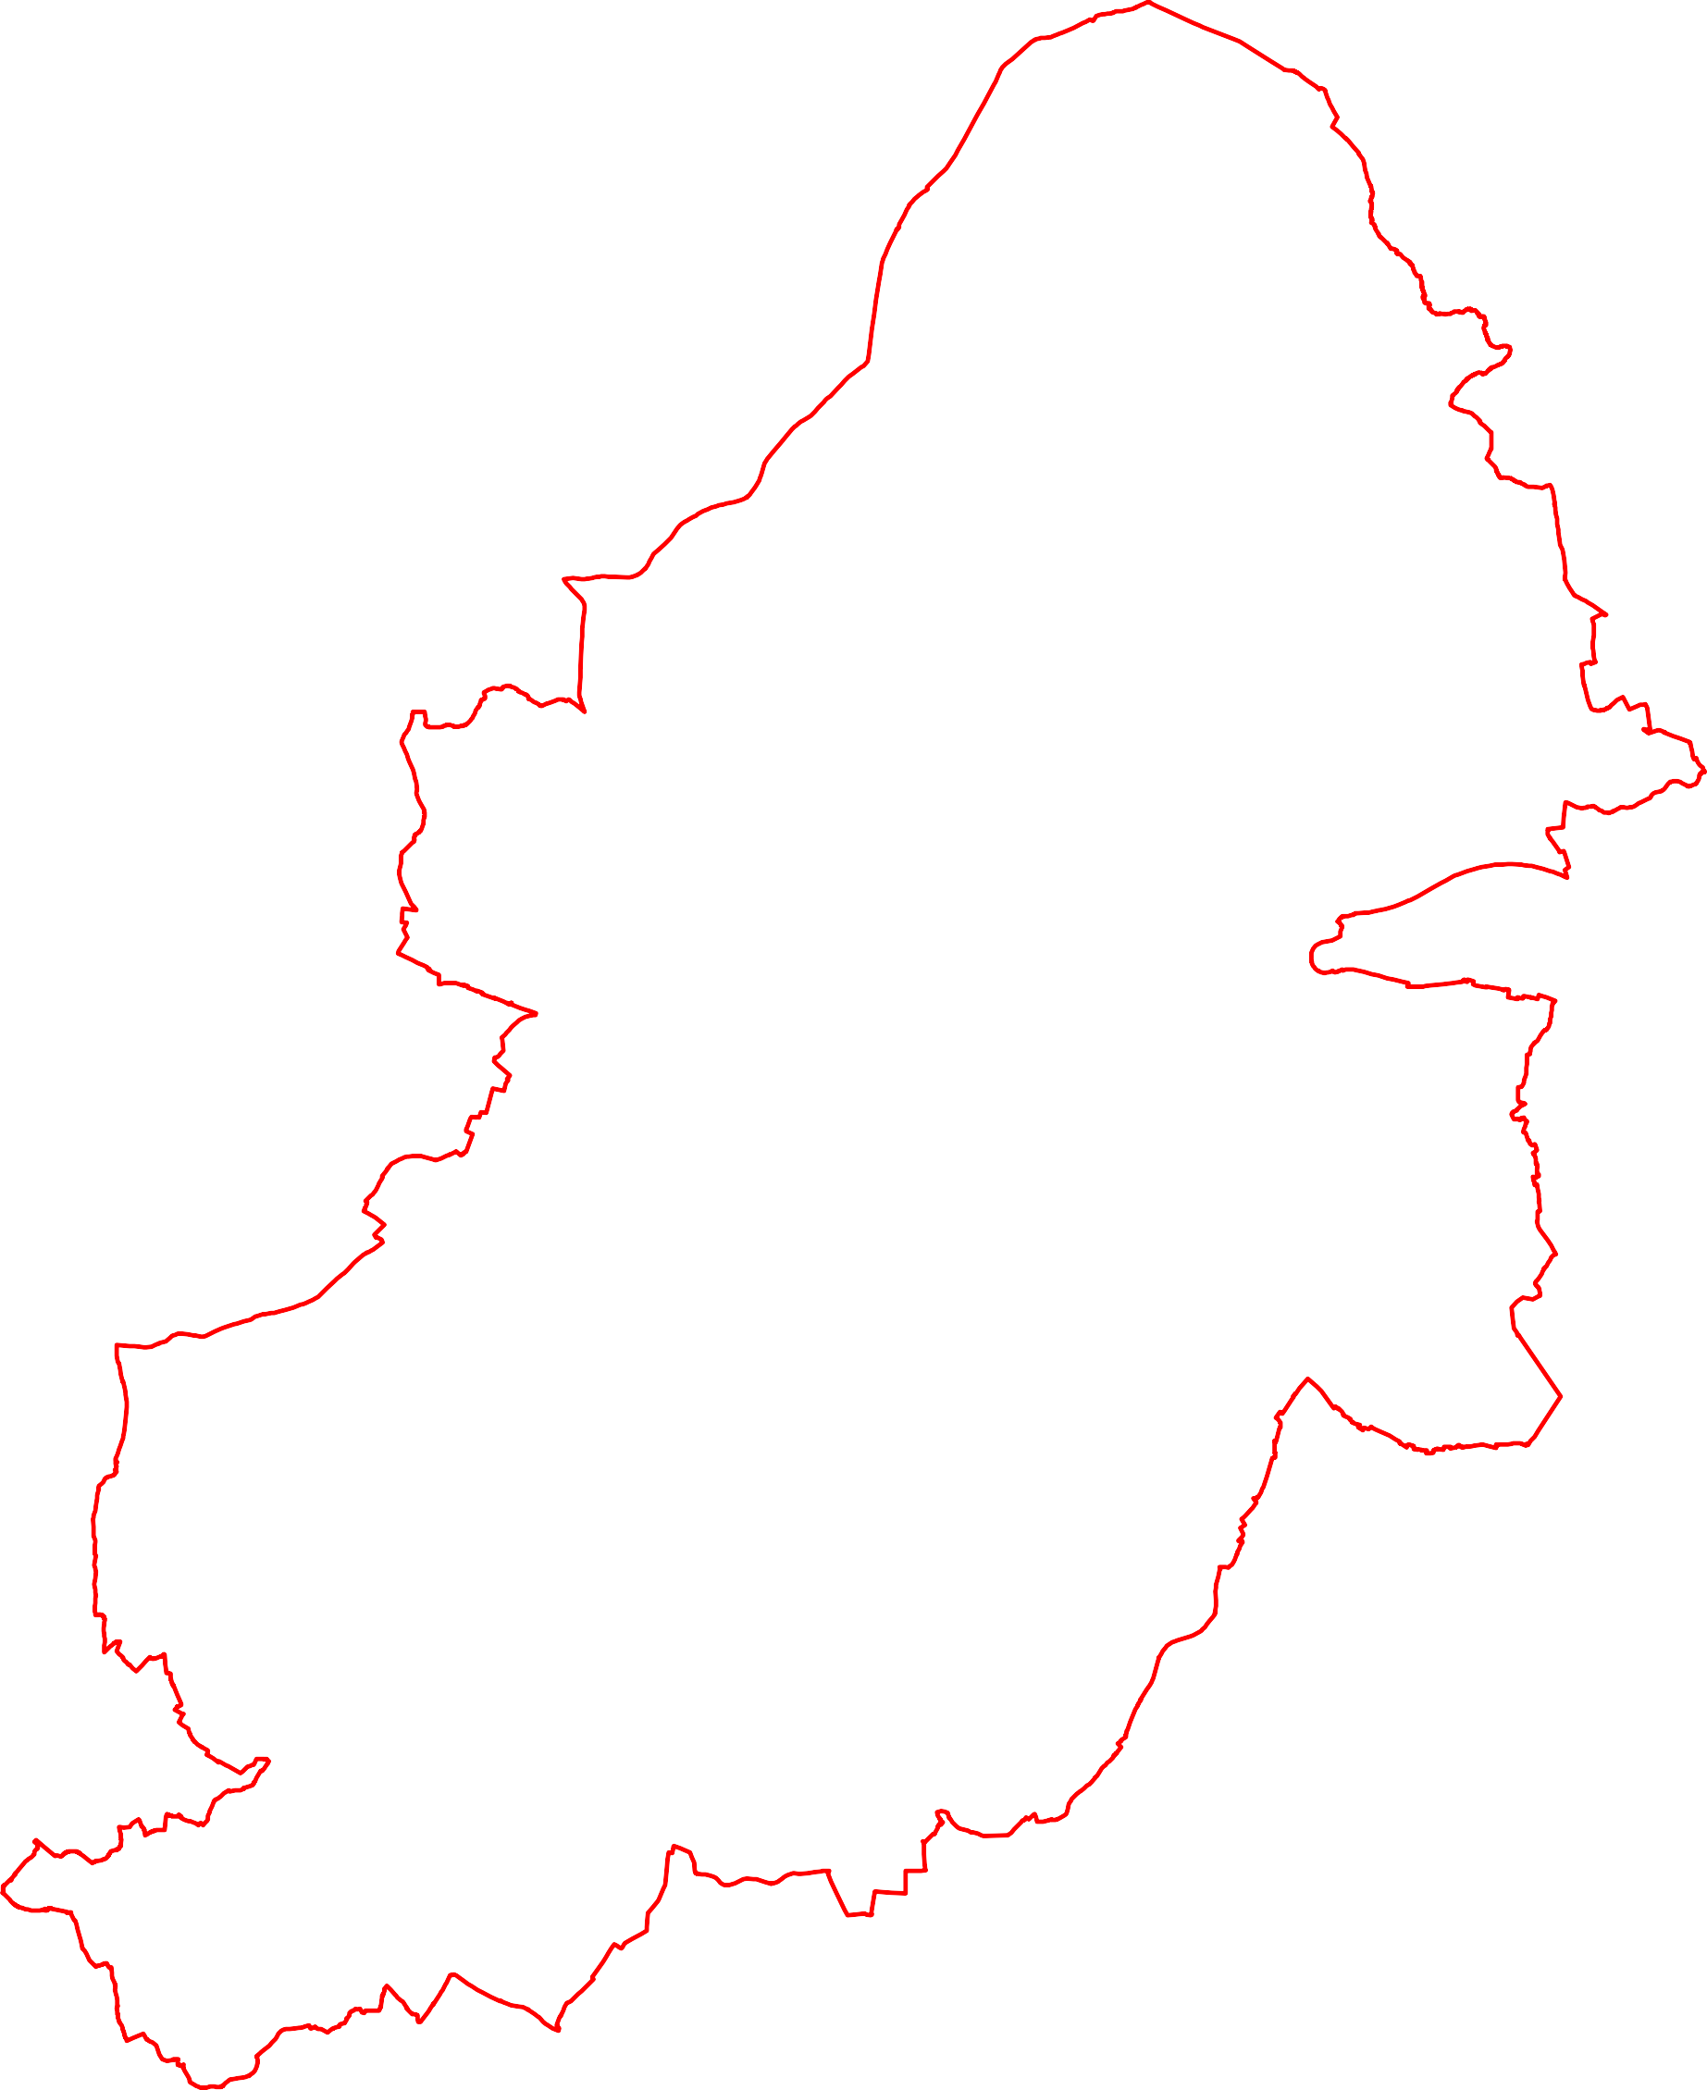

0 0.5 1 2 3 4

Kilometers

¯