# Tyseley and Hay Mills Liveable Neighbourhood Action Plan

**Name:**

**Email:**

**The liveable Neighbourhoods project is trying to deliver the following vision;**

*“That residents living in Tyseley and Hay Mills have access to a pleasant, green, safe, inclusive environment and are within a short safe walk or cycle journey of quality services, and facilities that meet their daily needs, and enable them to lead full, happy, healthy & purposeful lives.”*

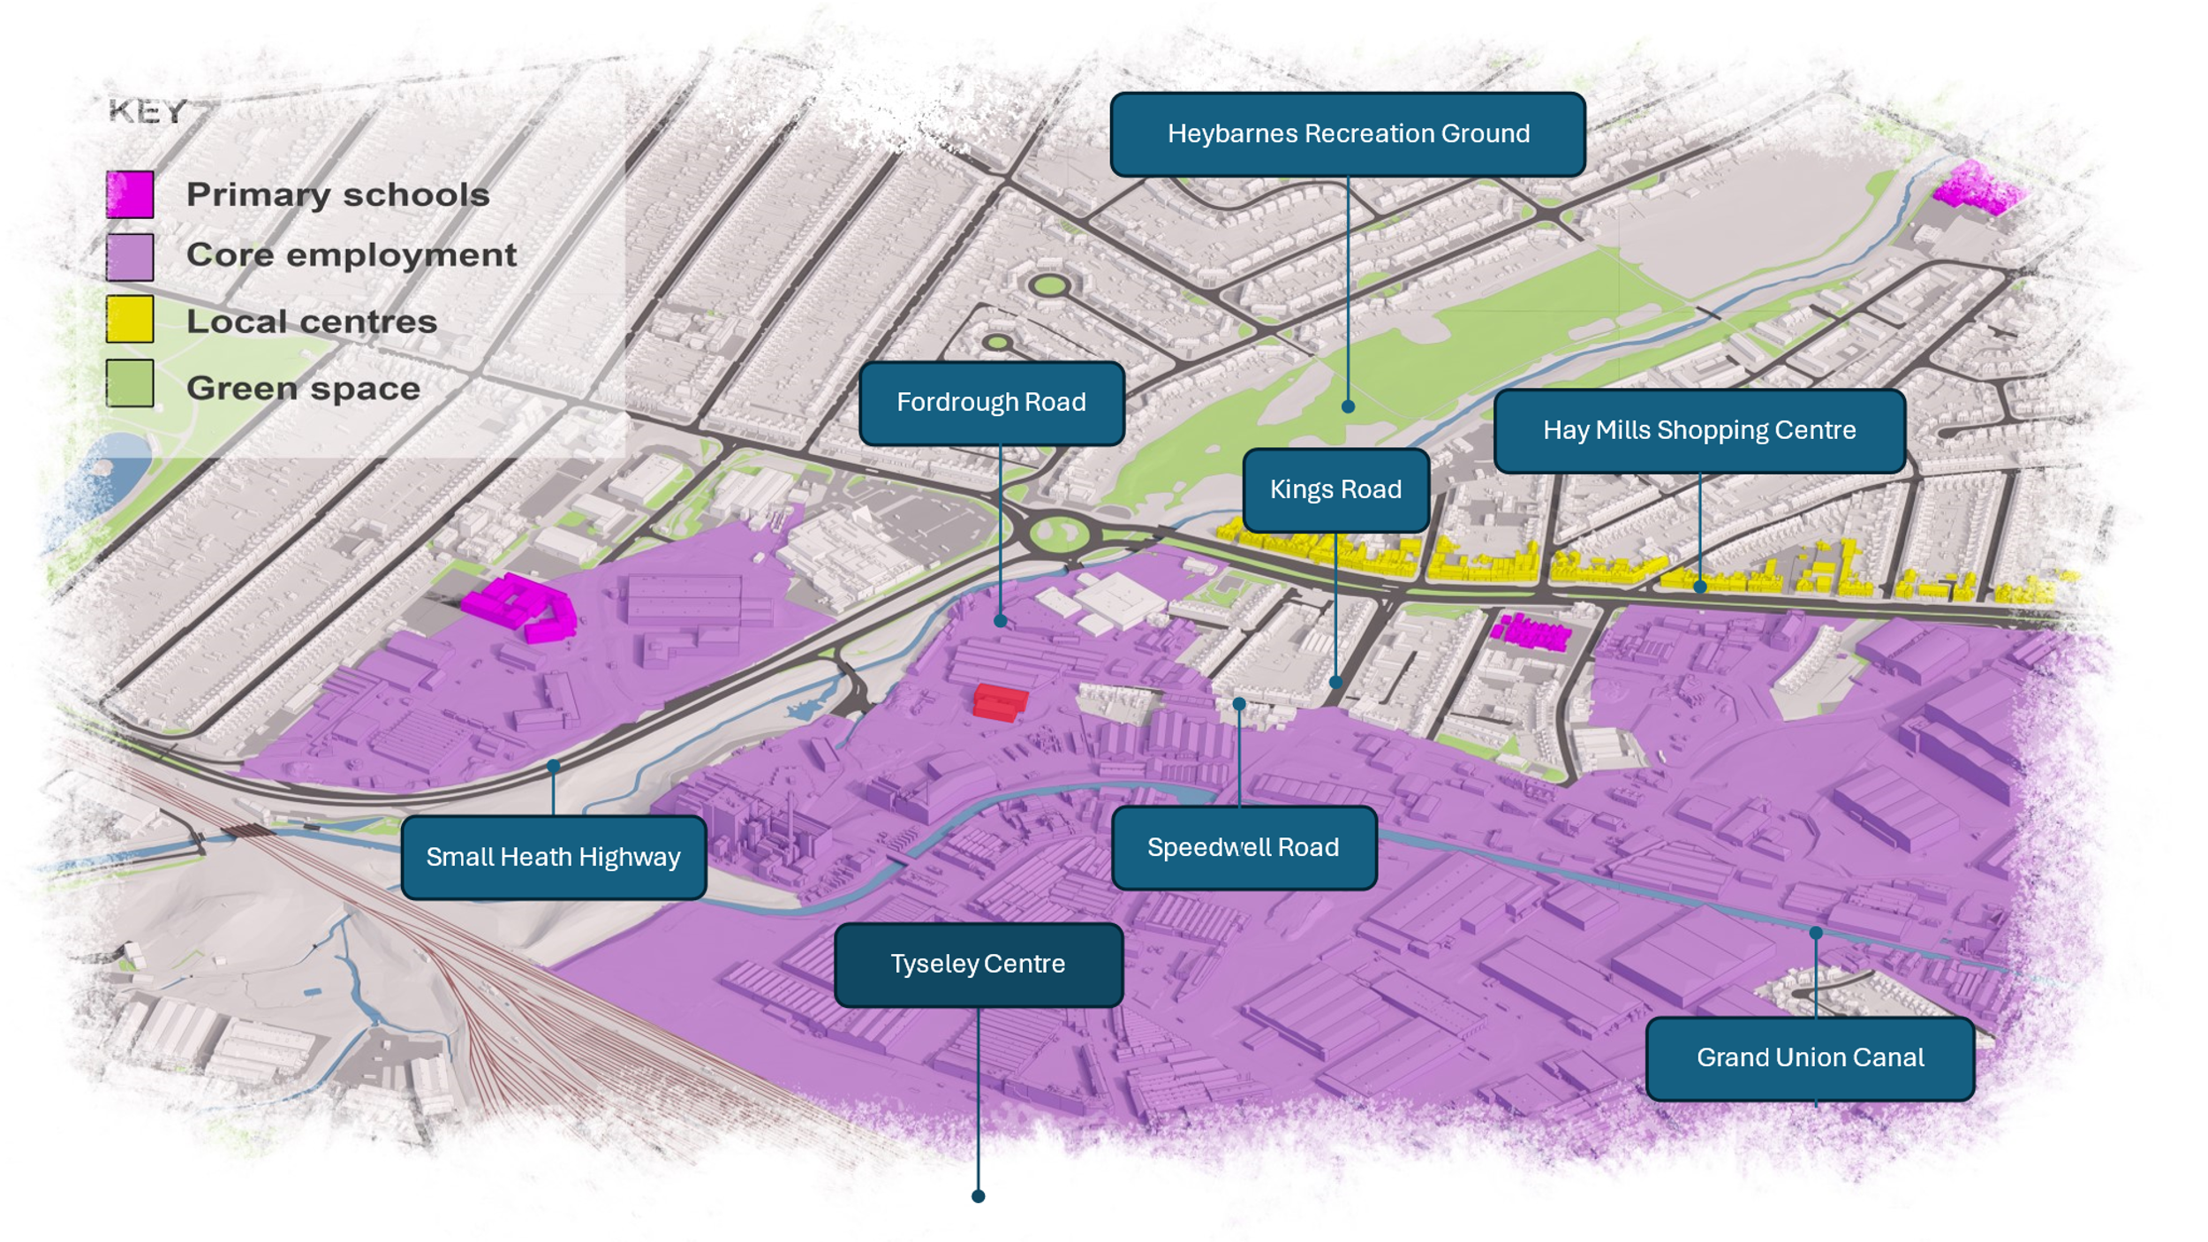

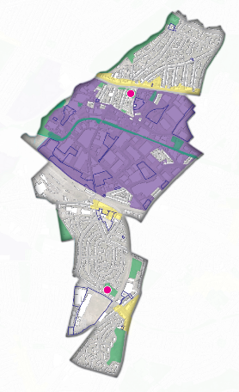

**It is considered that the following principles can be used to shape the strategy and action plan in   
order to deliver this vision;**

**1. Good access to quality high density diverse and affordable & market housing that meets local needs**

**2. Good Access to quality public transport and opportunities for active travel**

**3. Good Access to quality local healthcare services and exercise facilities**

**4. Good Access to nature and a quality welcoming green environment that supports physical activity & natural play, helps the area adapt to and mitigate the effects of climate change, and enhances and celebrates the areas unique history, culture, and character**

**5. Good Access to quality education services and the unique needs of individual children/students**

**6. Good Access to quality employment and training Opportunities that meet the needs of local employers**

**7. Good Access to quality services and facilities that meet identified needs**

**8. Good Access to quality social and cultural infrastructure**

**9. Good Access to quality local Healthy affordable food**

**10. Good Access to quality Digital Services**

**11. Good Access to a quality safe and inclusive environment**

**Using the principles above to frame a response please in the space provided let us know what you  
think are the issues in the area, where the issues are, what is preventing this vision from being delivered, and how we could potentially address them.**

**You plan should be no more than 10 pages, and as well as text can include drawings, masterplans of particular areas of Tyseley and Hay Mills, as well as design codes to give more detail.** *(Masterplans,  
and drawings can be included in an appendix if necessary)*

**Links to useful resources can be found at the end of the document, as well as the criteria of what  
will make a good submission.**

**Project Summary:**

|  |
| --- |
| *Please provide a brief overview here of your findings and suggestions.* |

**Project Plan:**

*Please provide your responses here:*

**Resources:**

**In preparing your submission you may find the below links useful;**

* [National Design Guide](https://assets.publishing.service.gov.uk/media/602cef1d8fa8f5038595091b/National_design_guide.pdf)
* [National Model Design Guide](https://www.gov.uk/government/publications/national-model-design-code)
* [Birmingham City Design Guide](https://www.birmingham.gov.uk/info/20054/local_plan_documents/1367/birmingham_design_guide)
* [Planning Evidence Base](https://www.birmingham.gov.uk/info/20008/planning_and_development/2477/new_local_plan_for_birmingham/4)
* [Public Heath fingertips Data](https://fingertips.phe.org.uk/)
* [Population and labour market statistics](https://www.nomisweb.co.uk/)
* [City of Nature and Climate Risk Assessment](https://www.birmingham.gov.uk/info/50282/climate_change/2642/what_is_the_council_doing_about_climate_change/5)
* [Birmingham City Data Observatory](https://www.cityobservatory.birmingham.gov.uk/)
* [Ward Profile](https://www.cityobservatory.birmingham.gov.uk/birmingham-city-observatory/ward-profiles-november-2023)
* [Tyseley Energy Park Masterplan](https://www.tyseleyenergy.co.uk/masterplan/)

**What would a good submission look like?**

* Research! - it will be clear that you have read a lot of background material to reach your conclusions and a list of all the books, articles, and studies you have read should be appended with your submission. Some useful links for this will be available at the end of these slides
* Your recommendations on how the area should change should be clearly justified by evidence from your research, and be realistic
* Your response will be structured under the 11 domains referred to previously
* You will have also used the key principles of the National Model Design Guide, and the City Design Guide to structure your responses and solutions to the local issues you identify.
* Where you think there needs to be major change in certain areas you have produced a masterplan for these areas using the National Model Design Guide, and the Birmingham City Design Guide as a structure for your proposals. You will have focused on things such as street layouts, quality of streets, sites for housing, sites businesses, sites for green spaces, leisure, improved building frontages etc and how these all relate to each other in a particular area/space to help inform the plan.
* You have gone further than a masterplan which deals with how the built and natural environment relates to each other spatially,( ie where one feature is relative to another) and developed a set of design codes that lists how a particular area will develop.

*(Where as the masterplan plan is all about relationships and placement of things in geographical space, design codes focus on the detailing of particular areas “within” a masterplan and puts flesh on the bones. This can cover design, materials used, style, types of planting etc)*

**The submission deadline is the 30th December 2024**

**Address Details**

Please send your completed action plan to our inbox at;

**lnpilot@birmingham.gov.uk**

Or alternatively post your action plan to us at;

Birmingham City Council, Council House Reception, Victoria Square,

**B1 1BB**