PLANNING RESPONSE
HIGH STREET / HARBORNE PARK ROAD, BIRMINGHAM

844-D5A-00-XX-RP-A-0004-Planning_Reponse-S3-P01
04.11.2022
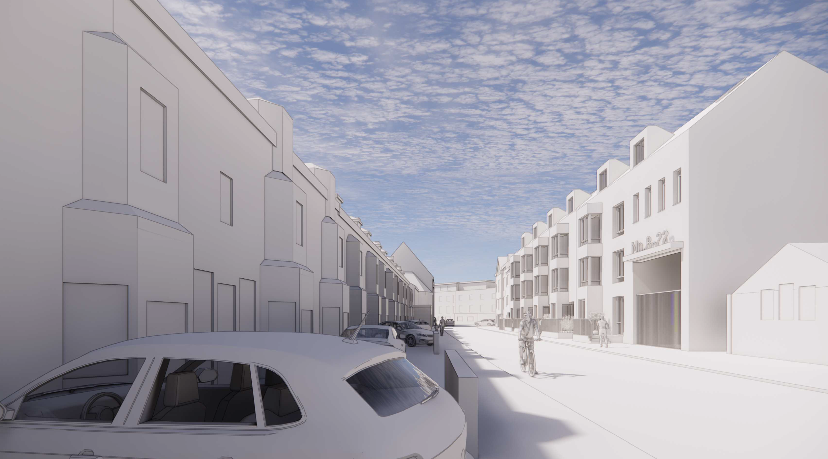



CONTENTS

1.00 INTRODUCTION

2.00 BLOCK A: HIGH STREET

3.00 BLOCK B: HARBORNE PARK ROAD

4.00 MIX

  - INTRODUCTION
  - This document sets out the planning response is in relaion to the High Street / Harborne Park Road planning applicaion, ref 2022/06737/PA. Upon submitti ng the applicaion for full planning, comments have been received from BCC and applicaion consultees.

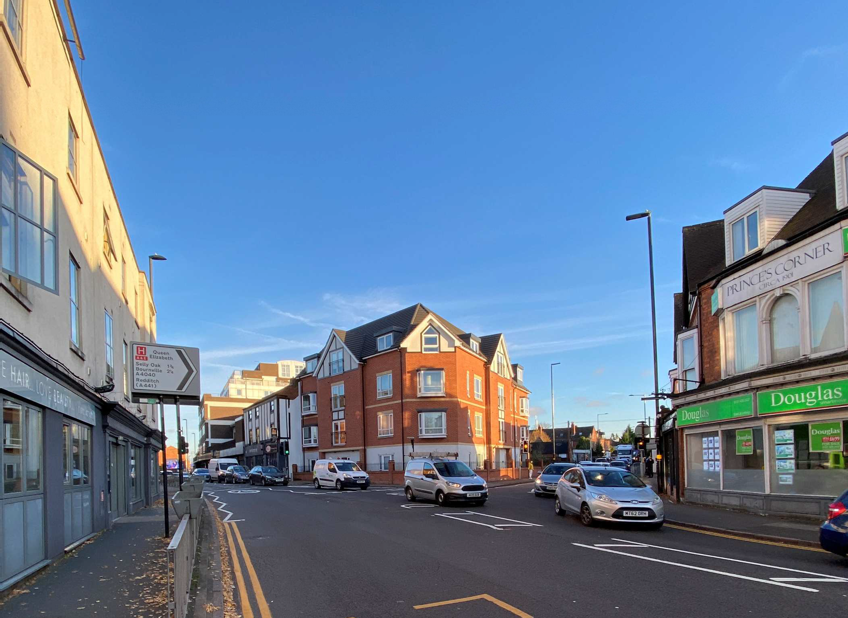

Site Photo: Harborne High Street and Harborne Park Road Junction

BLOCK A: HIGH STREET
  - The massing of Block A has been amended to step down towards the High Street / Harborne Park Road Juncion. The scale of the block adjacent the Cardamom restaurant building, steps down to a height in between the proposed and exising creaing a softer gable.

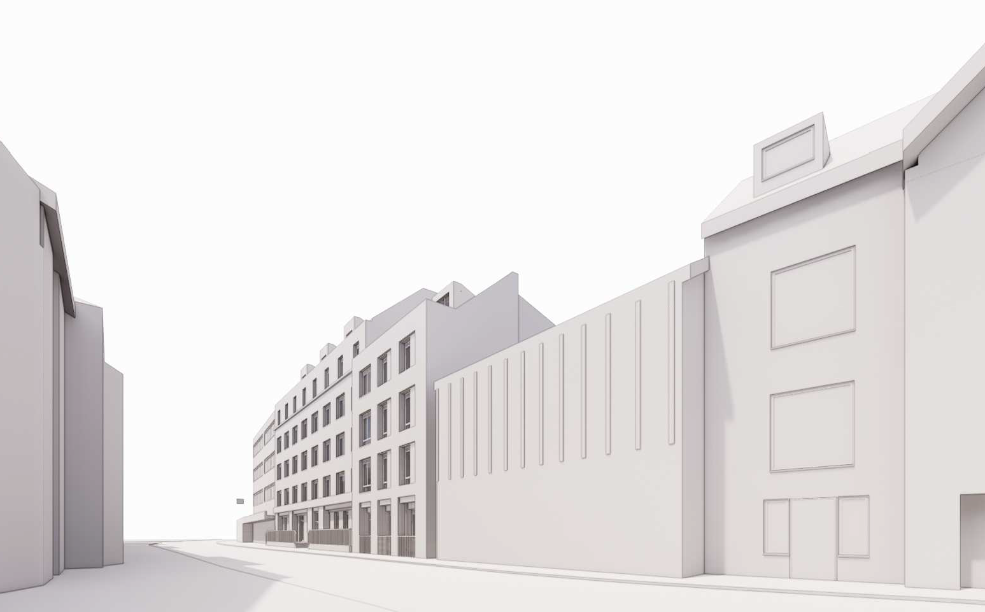

Amended Scheme: High Street Junction View

2.00 BLOCK A: HIGH STREET
2.02 The pre-applicaion massing was accepted with the advice to remove all setbacks to the proposed buildings. The planning applicaion scheme revised the massing to remove the set backs and created pitched roof forms. For further details of accepted massing, please refer to the pre-app document,
844-D5A-00-XX-RP-A-0001-Outline Feasibility_P03.

SUMMARY
The accepted pre-app massing (below left) included 5 storeys to the street frontage and a 6 storey set back. At pre-app the 6 storey set back was not accepted and has been replaced by a pitched roof. The submitted planning scheme proposes 5 storeys to the street frontage.

Why is the massing now a concern as this was massing agreed at pre-app?

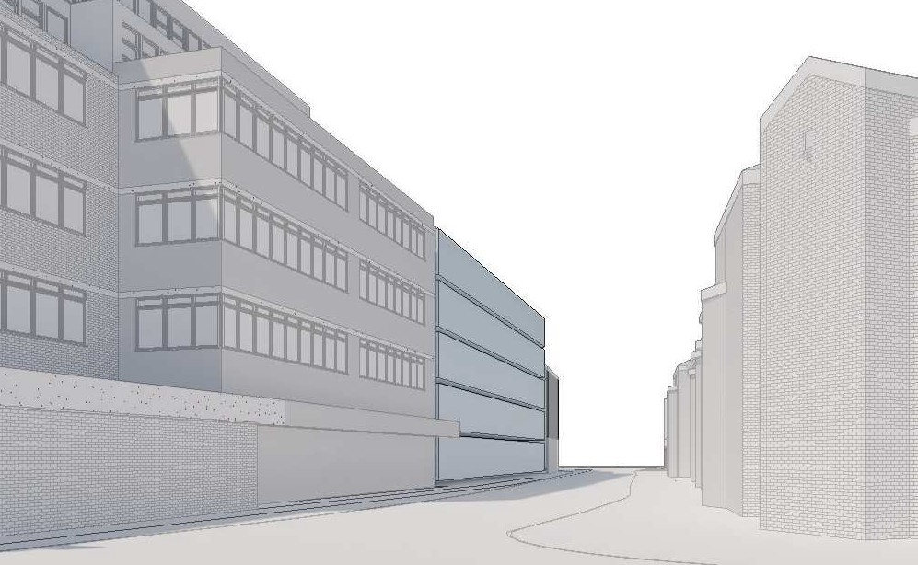
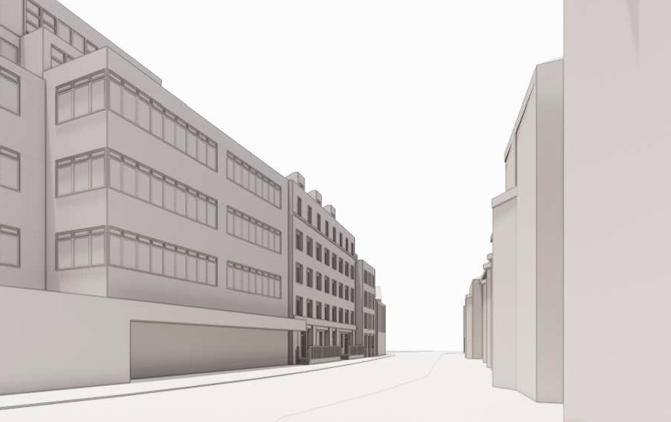

Accepted Pre-Application Scheme: High Street View Planning Scheme: High Street View

BLOCK B: HARBORNE PARK ROAD
  - The pre-applicaion massing was accepted with the advice to remove all setbacks to the proposed buildings. The planning applicaion scheme revised the massing to remove the set backs and created pitched roof forms. For further details of accepted massing, please refer to the pre-app document,
844-D5A-00-XX-RP-A-0001-Outline Feasibility_P03.

SUMMARY
The accepted pre-app massing (below left) included 3 storeys to the street frontage and a 4 storey set back. At pre-app the 4 storey set back was not accepted and has been replaced by a pitched roof form. The submitted planning scheme proposes 3 storeys to the street frontage.

Why is the massing now a concern as this was massing agreed at pre-app?

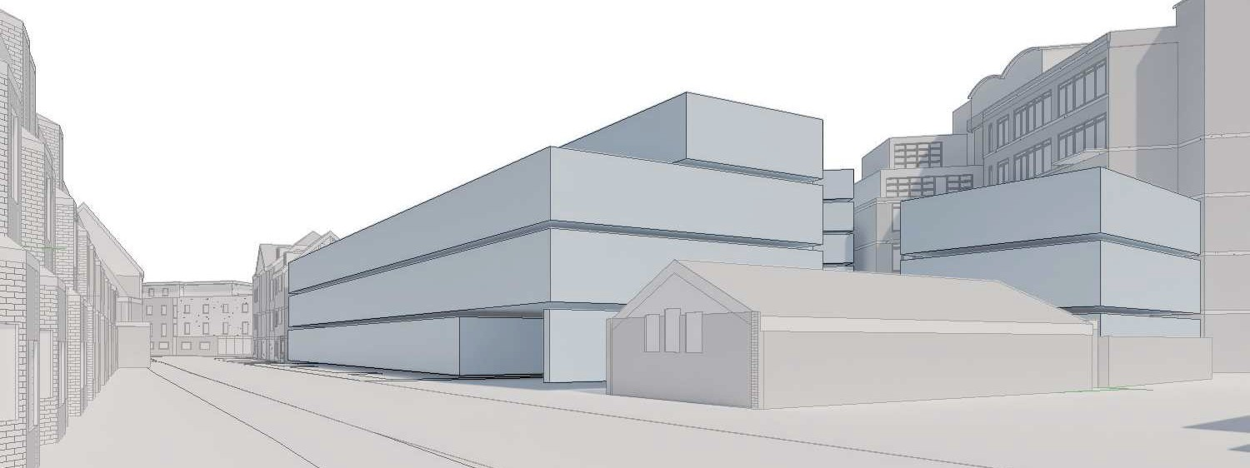
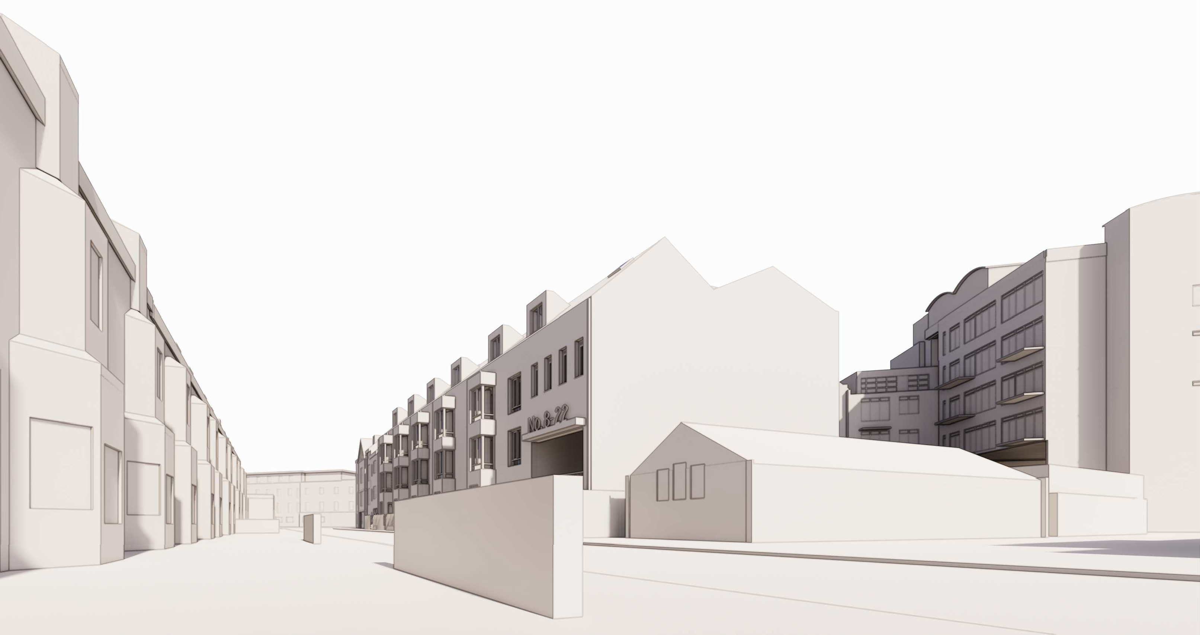

Accepted Pre-Application Scheme: Harborne Park Road View Planning Scheme: Harborne Park Road View

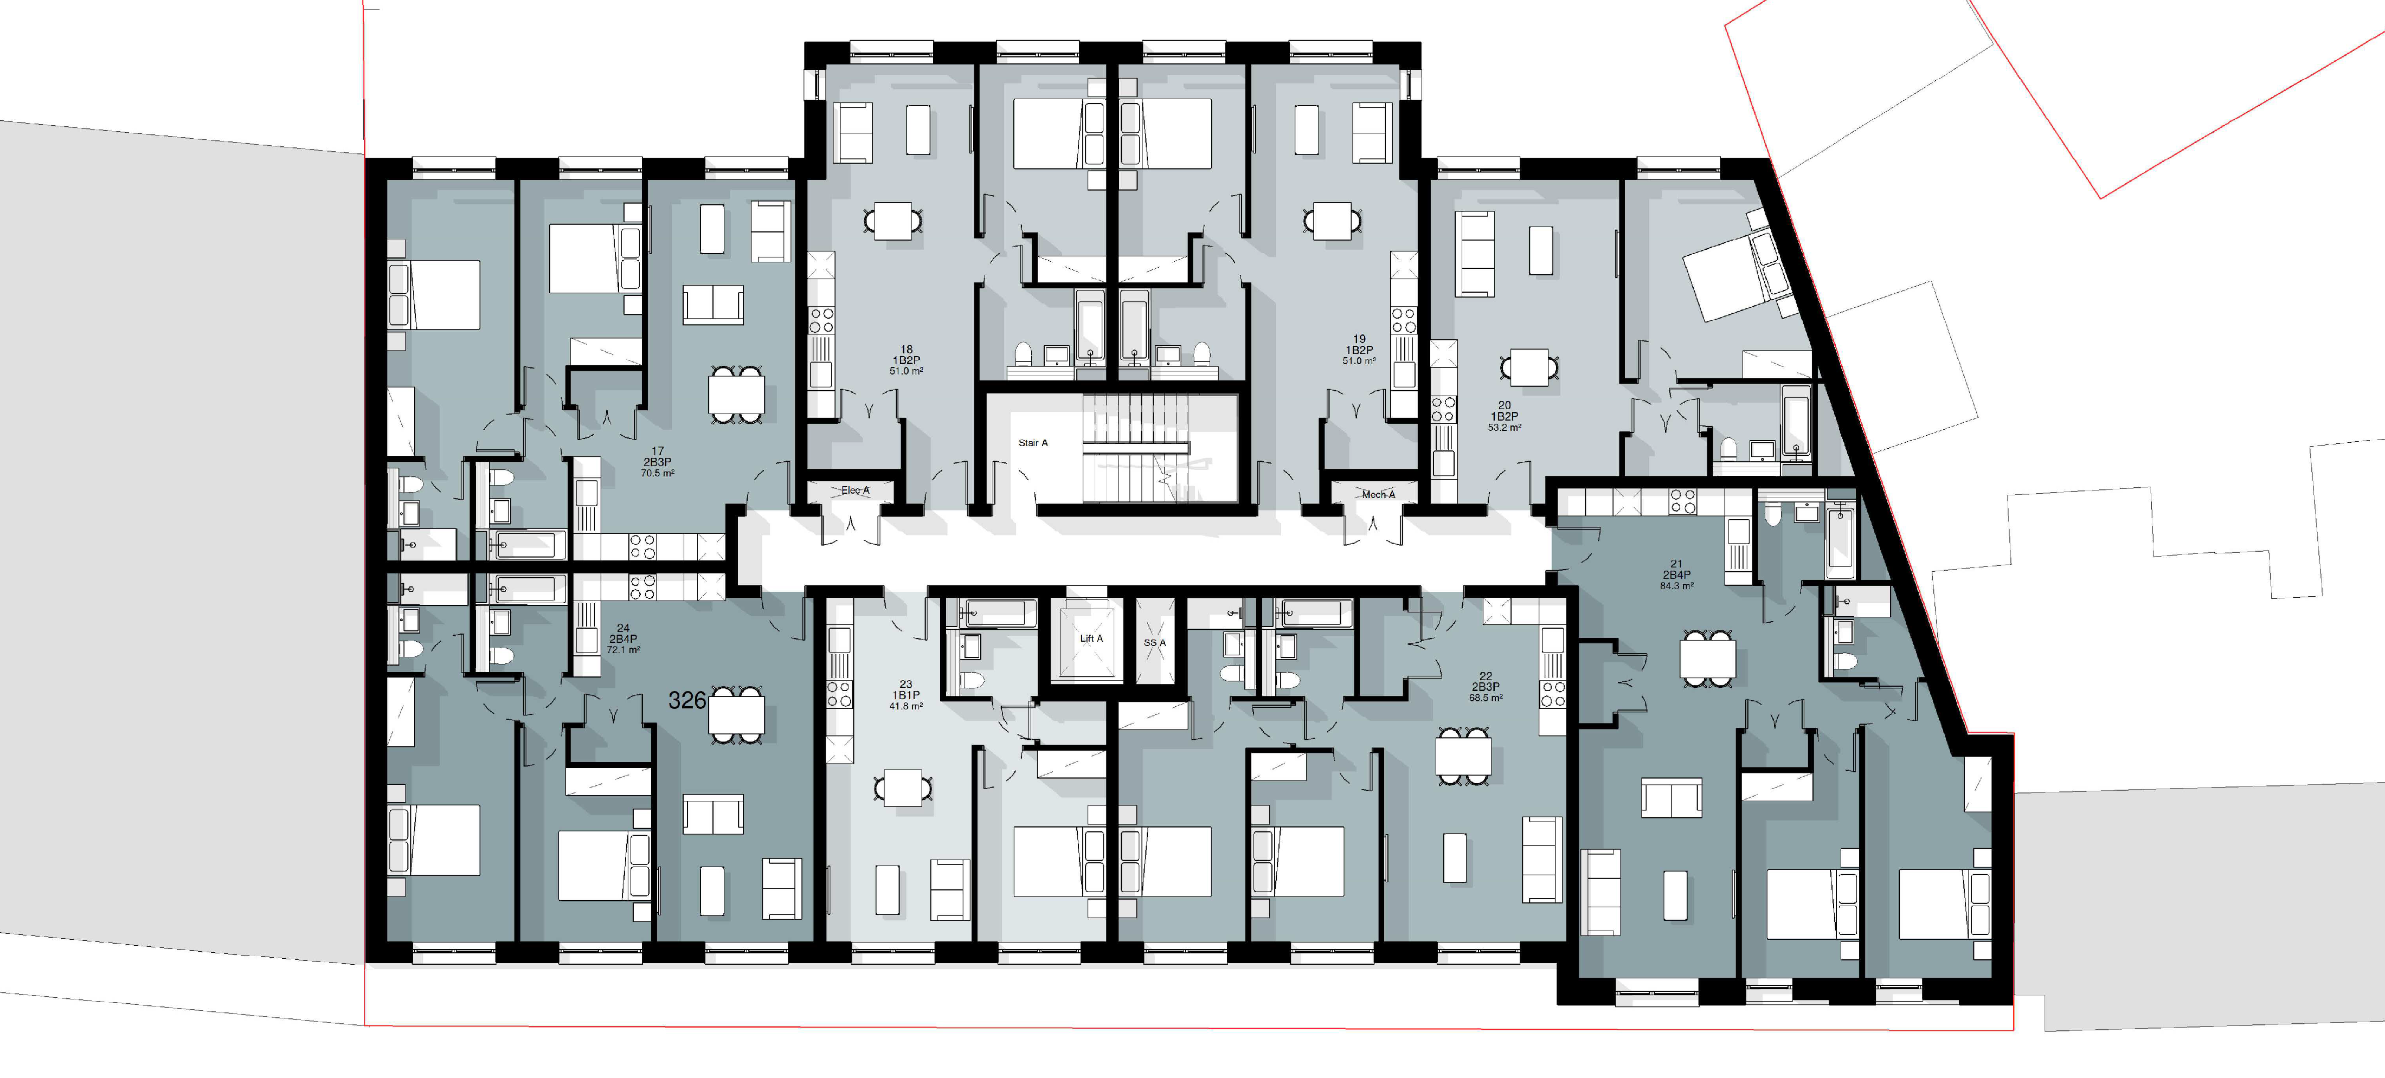

Proposed Block A (High Street) Typical Floor Plan

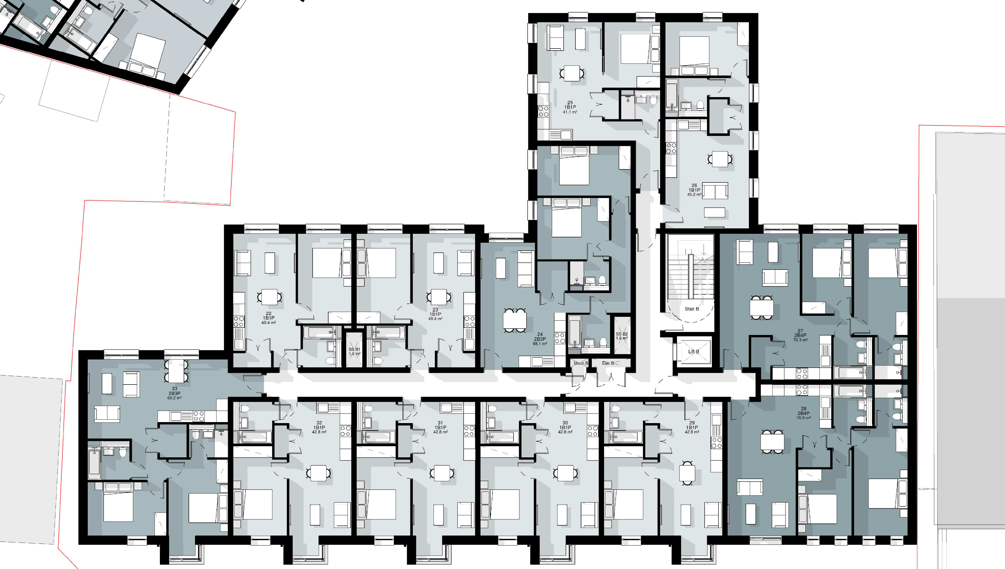

Proposed Block B (Harborne Park Road) Typical Floor Plan

MIX

  - The Pre-App scheme proposed a mix of :
76% one bed and 24% 2 bed apartments which was accepted.

  - The proposed planning applicaion improved on the pre-app scheme and proposes a mix of: 61% one bed and 39% 2 bed apartments which was an improvement.

  - The scheme also provides a wide range of diﬀerent apartments types, where 38% of units exceed the required unit areas as set out in the Naionally Described Space Standards under Policy DM10 of Development Management in Birmingham.

Apartment Type | Total Apartments | Apartments exceeding | Percentage exceeding
 |  | NDSS | NDSS
1 Bed | 53 | 21 | 40%
2 Bed | 34 | 12 | 35%

Apartments that exceed NDSS calculated as follows:
1 Beds over 50sqm 2 Beds over 70sqm

SUMMARY
The accepted 2 bed pre-app proporion was 24% The current 2 bed proporion is 39 %
40% of the apartments within the scheme are over the NDSS spaial requirement

Why is the mix now a concern when the submitted scheme increased the proportion of 2 bed apartments?

