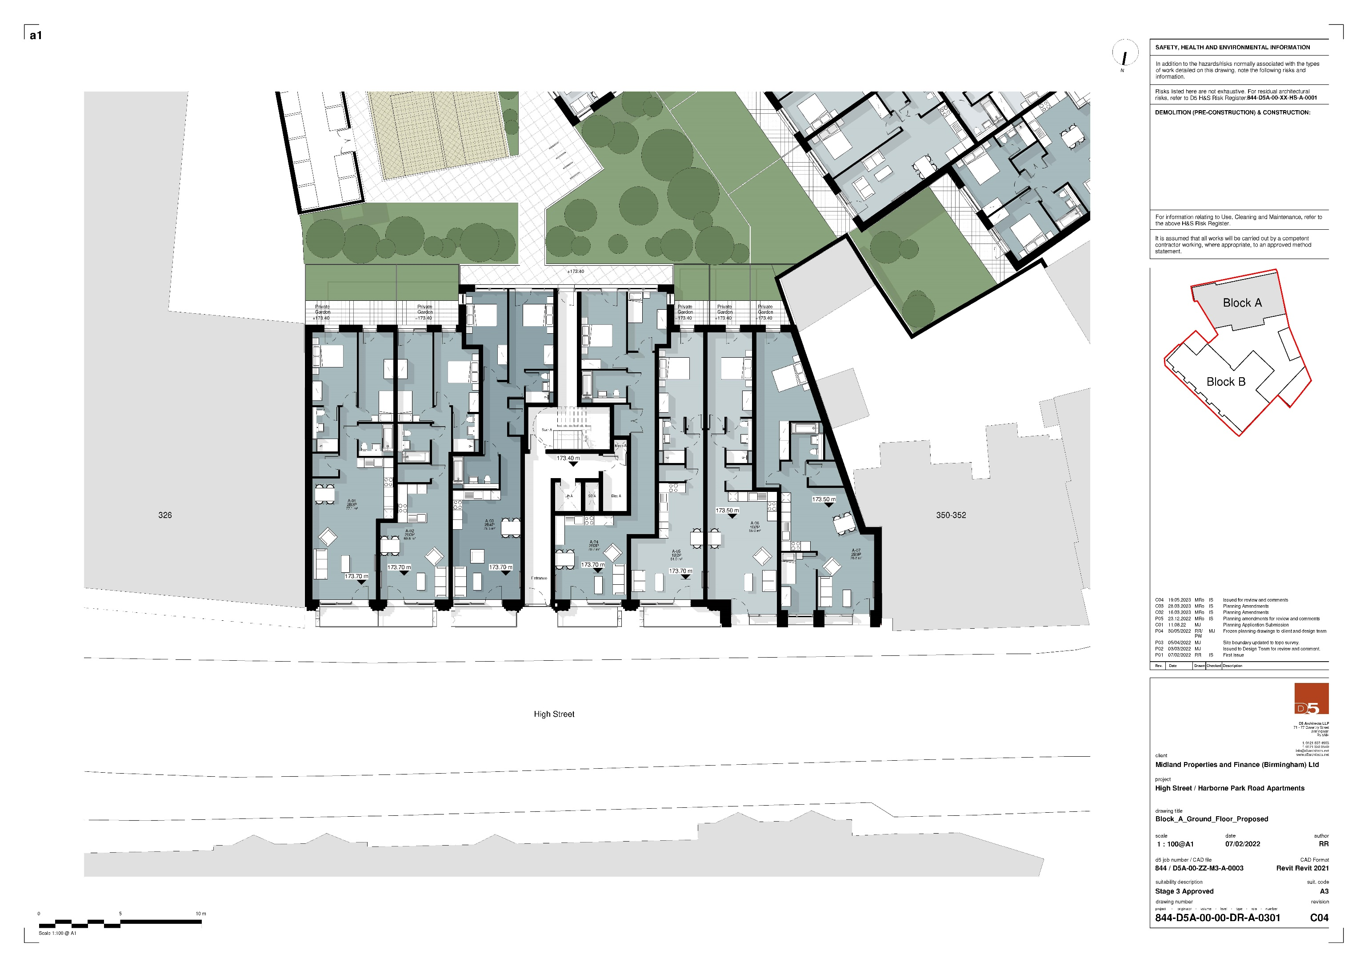

# Block A Ground Floor Proposed