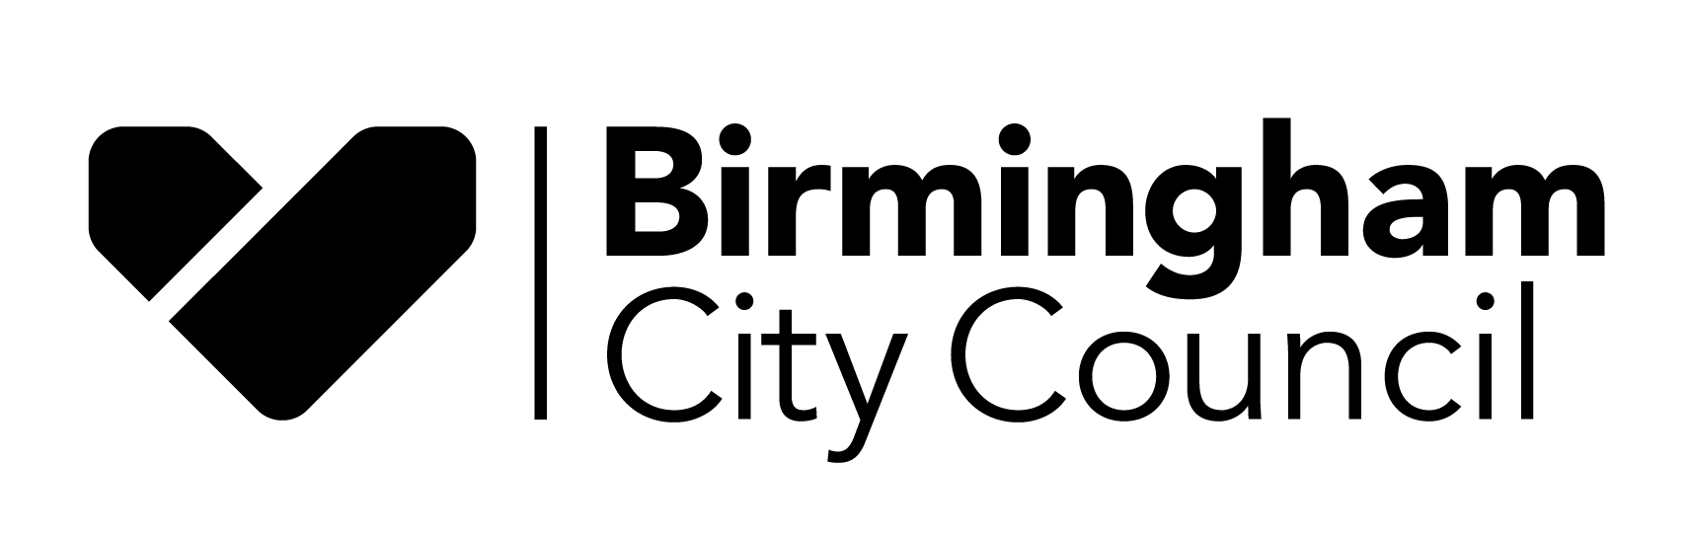

FOOD HYGIENE RATING

Food Hygiene Rating Scheme Appeal Form
Notes for businesses
- As the food business operator of the establishment you have a right to appeal the food hygiene rating given following your inspection if you do not agree that the rating reflects the hygiene standards and management controls found at the time of the inspection.
- You have 21 days (including weekends and bank holidays) from the date of receipt of the notification letter to lodge an appeal.
- Please use the form below and return it to the Lead Officer for Food from your local authority – contact details are provided below and with the written notification of your food hygiene rating.

The Lead Officer for Food will review your rating and communicate the outcome of your appeal to you within seven days.

Food Business Operator/Proprietor:

Business Name:

Business Address:

Business Tel. No:

Business email:

Date of Inspection:

Food hygiene rating given:

Date notified of rating:

I do not agree with the food hygiene rating given by the food safety officer because (please explain overleaf under each of the three headings; continue on a separate sheet if necessary):

Compliance with food hygiene and safety procedures

Compliance with structural requirements

Confidence in management/control procedures

Signed:

Name in Capitals:

Position:

Tel, No:

Date:

Please return this form to:
Operations Manager Food; Regulation and Enforcement
1-3 Ashted Lock Way, Birmingham B7 4AZ
Email: admin.eh@birmingham.gov.uk

