Birmingham Joint Local Health and Wellbeing Strategy

Creating a Bolder, Healthier City 2022-2030

Annual Review 2022-2023

Contents
Introduction 3
Chair’s Statement 3
What is the Birmingham Health and Wellbeing Board? 4
About this review 4
Creating a Bolder, Healthier City 2022-2030: Strategy on a page 5
Our Vision 5
Our Principles 5
Our Themes 5
Headline Indicators 6
Review of the HWB Year 8
July 2022 8
September 2022 8
November 2022 8
January 2023 9
March 2023 9
May 2023 10
Review of the Forums’ Year 11
Creating a Healthy Food City Forum 11
Creating a Mentally Healthy City Forum 14
Creating a Physically Active City Forum 17
Creating a City without Inequality Forum 19
Health Protection Forum 21
Conclusion and looking ahead to next year 24
Indicator Updates 25
Theme 1: Healthy and Affordable Food 25
Theme 2: Mental Wellness and Balance 30
Theme 3: Active at Every Age and Ability 37
Theme 4: Contributing to a Green and Sustainable Future 43
Theme 5: Protect and Detect 46
Life Course: Getting the Best Start in Life 52
Life Course: Living, Working and Learning Well 56
Life Course: Ageing and Dying Well 60

Introduction

Chair’s Statement
There is much to reflect on from the Health and Wellbeing Strategy’s first year, which aligns with my first full year as Chair of the Health and Wellbeing Board. I became Chair at a time of great excitement for the city and transition for the Board.
The breadth of projects covered in this review is a great example of how partnership working can engage, inspire, and deliver for communities in Birmingham. However, there is still clear evidence across the city of health inequalities that will take time and effort to tackle.
Learning from COVID-19 meant that Birmingham restructured its ways of community engagement, developing and supporting health and wellbeing champions and networks, which are now helping with The Cost of Living Response. Maintaining ongoing relationships and trust with communities is essential. A reflection of positive partnership working looking at, Birmingham 2022 hosted the 22nd Commonwealth Games, which was the biggest sporting and cultural event ever held in the city featuring thousands of world-class athletes and over a million spectators.
We can look forward to further building and sustaining relationships and measuring integrated working across the council and with partners in the ICS and the voluntary and community sectors so that we can continue to deliver in the most efficient way possible.
We must address the inequalities that disadvantage so many communities across the city by supporting people to live longer in good health and enhancing people’s quality of life and experience of care. To put our residents at the heart of what we do and offer and mobilise the skills and knowledge of local people and the connections and resources within communities and organisations to improve health and well-being.

Cllr Mariam Khan
Cabinet Member for Health and Social Care
Chair of the Birmingham Health and Wellbeing Board

What is the Birmingham Health and Wellbeing Board?
The Health and Wellbeing Board (HWB) is a group of senior representatives from organisations across Birmingham, including Birmingham City Council, the NHS, the community sector and Healthwatch, which represents views of the public. There is cross-party political representation, with meetings chaired by the Cabinet Member for Health and Social Care.
The Health and Wellbeing Board’s vision for Birmingham is to “create a city where every citizen, whoever they are, wherever they live and at every state of life, can make choices that empower them to be happy and healthy”. The Health and Wellbeing Board works collectively, with the strengths and assets of Birmingham people, to oversee, influence and shape action to ensure Birmingham is a healthy city with high quality services.

About this review
This review covers the first year of delivery for the Joint Health and Wellbeing Strategy since its publication in May 2022. It is not a comprehensive examination of all the activity that has happened in the last year but a summary of developments at the Health and Wellbeing Board alongside a showcase of project and initiatives that contribute towards the strategy’s ambitions.
These have been presented as case studies that emphasise a bold approach with effective partnership working at their core. These case studies have been compiled from contributions from across the health and social care system in Birmingham as well as voluntary and community partners.
Each case study is linked to a theme from the Joint Health and Wellbeing Strategy and provides context on what the project is and who is delivering it. It also states which ambition/s are contributed to and, where available, who is the point of contact to approach for more information or collaboration opportunities.
Included at the end of this review is an update on the progress around the indicators of the Birmingham Health and Wellbeing Strategy using the most contemporary data. Each indicator is accompanied by commentary that explains the recent movement of the data and any longer-term trends. All the data is available on the Joint Health and Wellbeing Strategy Dashboard.

Creating a Bolder, Healthier City 2022-2030: Strategy on a page

Our Vision
To create a city where every citizen, whoever they are, wherever they live and at every state of life, can make choices that empower them to be happy and healthy.

Our Principles
- Citizen-driven and informed by citizens’ lived experience
- Consciously focused on reducing inequalities through promoting equality, diversity and inclusion
- Data and evidence-informed and research-enabled action
- Impact of COVID-19 pandemic mitigated as part of our legacy work

Our Themes
The strategy has five core themes for action covering the wider determinants of health, health protection and environmental public health. These are:
- Healthy and Affordable Food
- Mental Wellness and Balance
- Active at Every Age and Ability
- Contributing to a Green and Sustainable Future
- Protect and Detect

The five core themes run throughout the life course, which is split into three stages:
- Getting the Best Start in Life
- Living, Working, and Learning Well
- Ageing and Dying Well
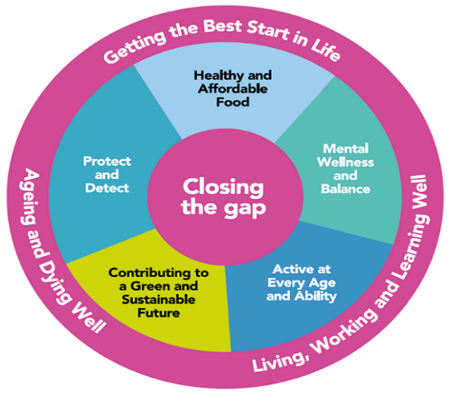
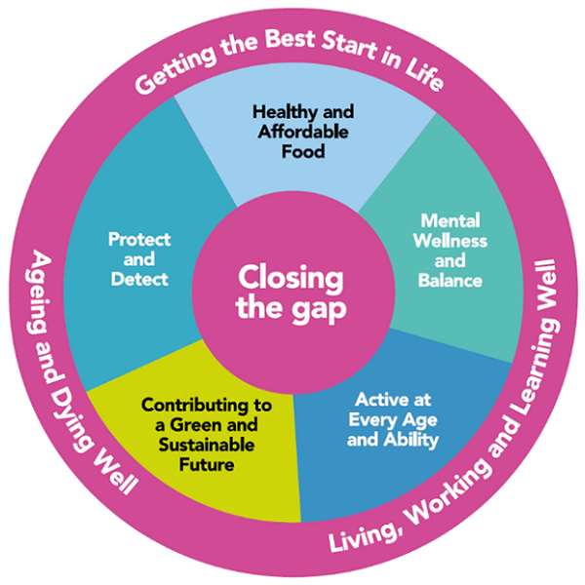

Headline Indicators
Life expectancy at birth (Male) Updated 17 Feb 2023 | Life expectancy at birth (Female) Updated 17 Feb 2023
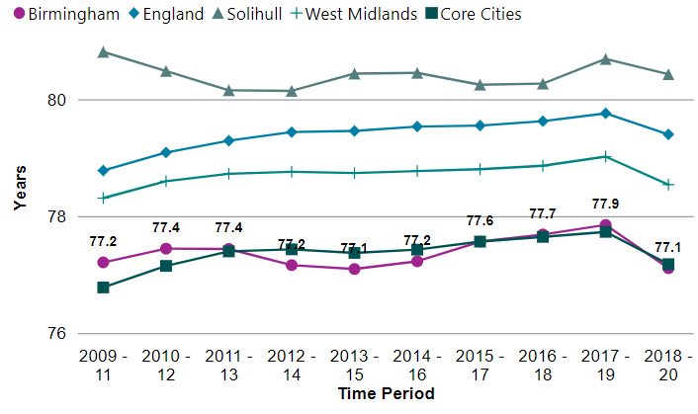 | 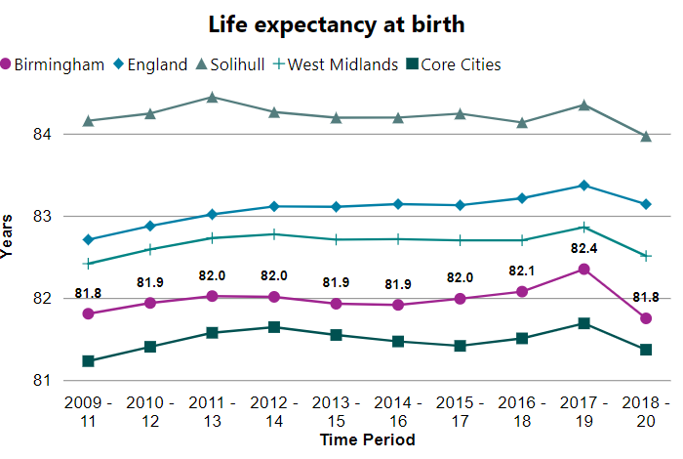
Life expectancy at 65 (Male) Updated 17 Feb 2023 | Life expectancy at 65 (Female) Updated 17 Feb 2023
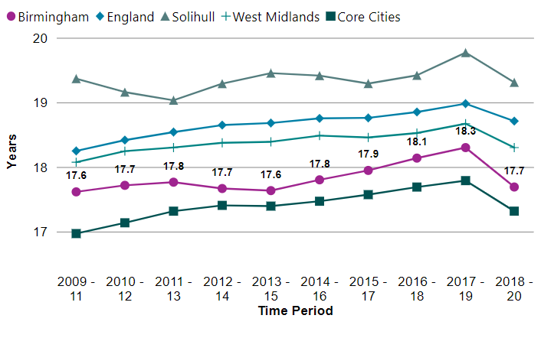 | 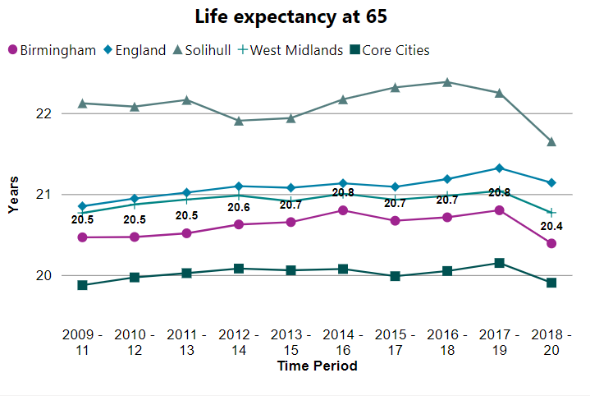
Healthy life expectancy at birth (Male) Updated 5 July 2022 | Healthy life expectancy at birth (Female) Updated 5 July 2022
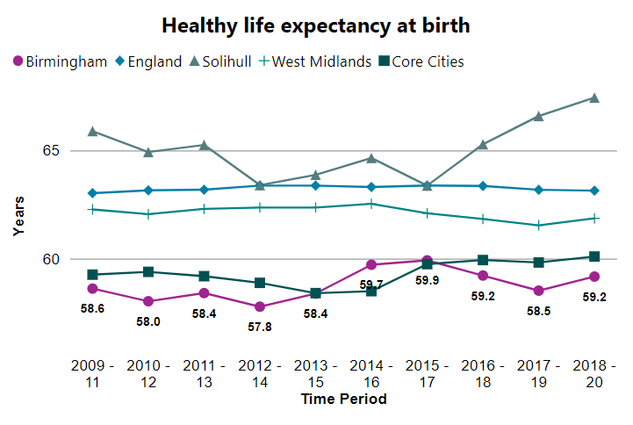 | 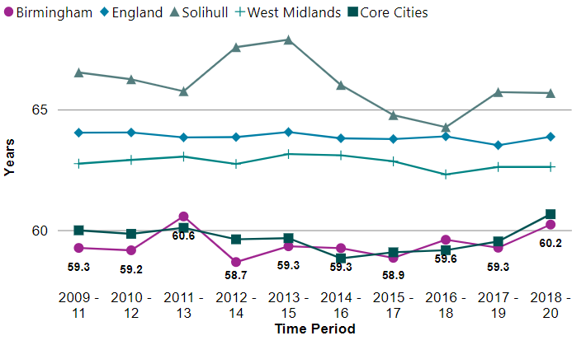
Healthy life expectancy at 65 (Male) Updated 7 July 2022 | Healthy life expectancy at 65 (Female) Updated 7 July 2022
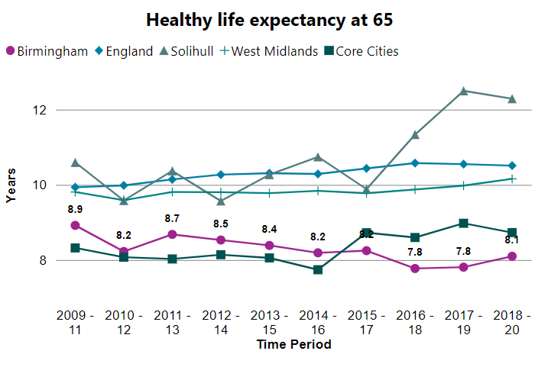 | 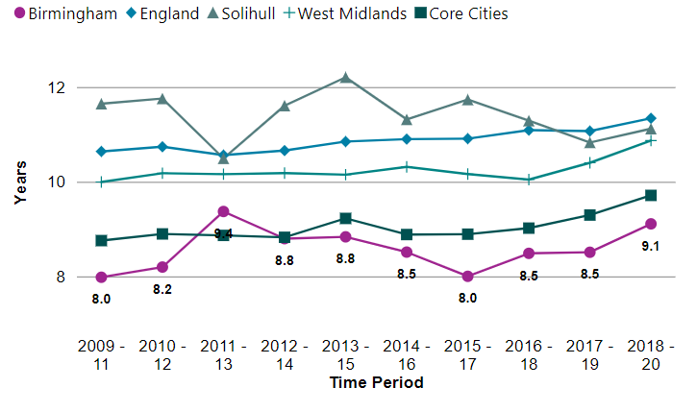

Review of the HWB Year

July 2022
In July, the Health and Wellbeing Board was cancelled in preparation for the 2022 Commonwealth Games, which took place across the city and the wider West Midlands region. The Board had been receiving regular updates on progress around the planning and delivery of the Commonwealth Games. There was a particular interest towards the maximisation of legacy benefits that stem from hosting an international multi-sport event and how this might positively impact levels of physical activity in the city. These updates also allowed the Board to understand the preparations made from a health and safety perspective, including issues around heat exposure or disease outbreaks.

September 2022
In September, the Health and Wellbeing Board refreshed its formal membership and ratified a new Chair (Cllr Mariam Khan) and Vice Chair (Dr Clara Day). September was also the first full meeting in the Health and Wellbeing Board’s calendar and contained a healthy number of items for discussion and approval. Representatives from Adult Social Care presented the End-of-year report and 2022/223 Plan for the Better Care Fund, which funds the delivery of crucial social care services in Birmingham.
The Board also discussed the findings from the public consultation for the Birmingham & Solihull Draft Sexual Health Strategy 2023-2030. These findings alongside further consultation will inform the design of the service and how it engages with residents. Finally, there was an update from the ‘Creating a Mentally Healthy City’ Forum around the recent work of forum partners and progress on key projects. These included projects funded by the Better Mental Health Fund and actions contributing to the Birmingham Suicide Prevention Strategy.

November 2022
In November, the Board received its first update on the measure taken by Birmingham City Council to address the Cost of Living crisis. These updates are now a standing item at every Health and Wellbeing Board meeting and are supplemented by an update from a member organisation of the Board as well. The first was delivered by the Birmingham Social Housing Partnership. These updates provide members with an overview of response and available resources to alleviate the acute pressure on residents across the city. The Board also considered a refreshed Terms of Reference for the ‘Creating a City Without Inequalities’ forum which sets out the areas of work that it will now explore and report on, including the Gender Health Inequalities project.

Alongside this, the Board also agreed to the publication of the Indicator Dashboard for the Joint Health and Wellbeing Strategy on Birmingham City Council’s City Observatory website. An update of the indicators on this dashboard is available as an appendix to this review. Finally, the Board received an annual update from the ‘Creating a Healthy Food City’ forum which focused on the ‘Birmingham Food Revolution’ and how it might align with projects on the Cost of Living crisis.
In November, the Board also received a written update from the ‘Creating a Physically Active’ Forum on its latest projects, including the following case study: ‘Safe and Active Mobility’ Campaign.

January 2023
In January, the Board discussed an update from the Perinatal and Infant Mortality Taskforce, which was followed by a report to the Health and Overview Scrutiny Committee. The Board also discussed and approved the publication of the Triple Zero Drug and Alcohol Strategy 2022-2032. This strategy will address drug and alcohol addiction through prevention, intervention, treatment, and recovery. Additionally, the ‘Health Protection’ Forum provided an update on its recent activity.
The Board also received its regular Cost of Living updates from Birmingham City Council and Birmingham Healthwatch. It was also presented with an insights report from the Birmingham Voluntary Services Council, which illustrated the voluntary and community sector’s perspective of the crisis.

March 2023
The Board also received an update from the Birmingham and Solihull Integrated Care Board on its progress since its constitution in 2022 and from Adult Social Care on an assessment of its services by the Care Quality Commission. Finally, the Board received an update from the Local Maternity and Neonatal System on its recent response to the Ockenden Review and on relevant projects, such as the one in the following case study: Culturally Specific Infant Feeding Groups.
The Board also received its regular Cost of Living update from Birmingham City Council and Birmingham Healthwatch, with the particular focus of this update being on food provision. The Board was presented with several key strategies and reports at this meeting. Firstly, the Birmingham Food System Strategy 2022-2030, will help to enable the ‘Birmingham Food Revolution’ and transition the city to a more equal and sustainable food system. The Board was then presented with the Birmingham and Solihull Integrated Care System’s 10-year Strategy, which, in tandem with the Joint Health and Wellbeing Strategy, will define the system’s overall approach to health and care issues. The Board then received a progress report from the Birmingham and Lewisham African Caribbean Health Inequalities Review. This was particularly focused on the work of the BLACHIR Implementation Board, detailed in a case study.
The Board also approved the publication of the Birmingham and Solihull Pharmaceutical Needs Assessment and the Director of Public Health Annual Report 2022-2023, thereby fulfilling its statutory requirements as an accountable public committee.

May 2023
In May, the Board held its annual development day at The Exchange in central Birmingham. This was a useful and productive experience for all the Board members as they had the opportunity to discuss recent successes as well as ongoing and future challenges that the Board faces.

Review of the Forums’ Year

Creating a Healthy Food City Forum
The Creating a Healthy Food City (CHFC) Forum continues to deliver key activities that contribute towards the goal of a fair and sustainable food system. The membership, aims, and vision can be found on the Council’s website: Creating a Healthy Food City Forum. The Forum has met six times in the past year and has delivered a range of key projects including the Birmingham Food System Strategy, Food Poverty and Justice Projects, Creative Dinners and Cook the Commonwealth.

The Birmingham Food System Strategy
The draft Food System Strategy was published in June 2022 and sets out an ambitious eight-year approach to create a bold, fair, sustainable and prosperous food system. From June to September 2022, the strategy was open to organisations and the public for consultation, which gathered useful feedback to inform the final version. The final strategy was published formally in April 2023: Birmingham Food System Strategy 2022-2030.

Food Poverty and Justice Projects
The CHFC Forum has asked cities to sign the Food Justice Pledge which aims to create a united global movement. The pledge was signed by the Leader of Birmingham City Council, the Cabinet Member for Health and Social Care, and the Director of Public Health in July 2022. The Forum has also supported Public Health’s Food System team with the food provision work strand of Birmingham City Council’s Cost of Living crisis response. The response shows how Birmingham can create effective and sustainable solutions to food system challenges. The food provision work strand has been highly praised across the system. Since January 2023, the following has been delivered:
- Through the Emergency Food Aid Fund, £480,000 of food and consumables have been provided for food projects, going directly to Birmingham citizens. This includes £800 for 6 months to 100 organisations. A further 16 food projects have had applications accepted for the Supplementary Food Aid Fund which consists of £400 for 3 months. The supplementary fund was introduced due to high demand for the Emergency Food Aid Fund.
- Additional funding has supported Birmingham Youth Service to purchase kitchen equipment, delivering the provision of nutritious food for more than 500 young people at 49 sessions per week. This represents a total of 10,700 meals being provided in 6 weeks.
- Automatic registration approaches have been explored for Free School Meals and Healthy Start, and ways to increase uptake.
- A Surplus Food Hub pilot has been initiated in Balsall Heath.
- Through the Affordable Food Infrastructure Fund, grants of up to £3,000 have been provided for infrastructure/equipment to increase the capacity of Birmingham’s food projects for food provision. Ideally, this is for providing more food that is nutritious, culturally appropriate, and safe (and hot where appropriate) to more people, in ways that enable dignity, choice, and socialisation.
Contact
Sarah Pullen sarah.pullen@birmingham.gov.uk

Case Study: Birmingham Food Legends Fund

Theme: Healthy and Affordable Food

What is it about?
To support the Health and Wellbeing Strategy’s vision of healthy and affordable food, we are initiating the Birmingham Food Revolution. This has included the Birmingham Food Legends Fund, which has provided grants of up to £5,000 to organisations to undertake projects aligning with our vision of creating a fair, sustainable, and prosperous food system and economy, where food options are nutritious, affordable and desirable so everyone can thrive. Projects are focussed on the areas of food production, food skills and knowledge, and food economy and employment. Through a competitive application process, we funded proposals that followed the key principles: collaborate (strengthen partnerships and build on existing good practice), empower (remove barriers and facilitate solutions), and equalise (focus actions where they are needed most to reduce inequalities).

Who has delivered/ is delivering it?
We have funded 44 different charities, CICs, CIOs and community organisations to deliver projects across the city. This is also being overseen by the Creating a Healthy Food City Forum and linked to partners who are helping to tackle the cost-of-living crisis across the city.

Which HWB Strategy ambition/s does it relate to?
- Reduce the prevalence of obesity (including severe obesity) in children in Reception and Year 6 by 10% by 2030

Creative Dinners
In collaboration with University College Birmingham, a series of Creative Dinners events started in November 2022 with a focus on knowledge exchange and understanding the impacts of the Cost of Living crisis on the local food system. To date, three have taken place so far as part of this collaborative effort.
The Creative Dinners consist of debate-style dining experiences and aim to bring together diverse, inspiring, and innovative trailblazers from across Birmingham, the UK, and around the world to have conversations on key subjects affecting our food system and spark the collective power of change. The first Creative Dinner was held in November 2022, with the Cost of Living being the focus of conversation and speeches.
The dinner in March 2023 had the theme of food behaviour change, food innovation and food transformation. The May 2023 dinner focused on food production and food sourcing (“From Farm to Fork”). The Creative Dinners have been a great success so far, with feedback being overwhelmingly positive. The events have provided a platform to bring together stakeholders and key players within the food system, to discuss how to work together moving forward. The 4th dinner in the series will take place in October 2023.

‘Cook the Commonwealth’
To celebrate the hosting of the 2022 Commonwealth Games, the Forum supported the ‘Cook the Commonwealth’ campaign from June to August 2022. This provided nearly 800 recipes for anyone to use on the Whisk cooking app. These recipes would be from all the Commonwealth countries and encourage healthy and culturally diverse cooking. In total, the recipes were viewed 39,000 times with people in Birmingham making up 22% of all UK views.

Contact
Amy MacLean amy.maclean@nhs.net
Case Study: Culturally specific infant feeding groups

Theme: Getting the Best Start in Life

What is it about?
In Ladywood and Perry Barr, the Community Health Collaborative, called Flourish aims to build trust amongst local communities, encouraging greater engagement with available services; and to educate, inform and support mothers to help reduce infant mortality, especially among highly affected communities.

Who has delivered/ is delivering it?
Seven organisations within West Birmingham have been offered micro grants of £5k, funded by the Birmingham & Solihull Integrated Care System, to run culturally specific infant feeding support groups. A local infant feeding peer support team is offering training and support for the group leaders. These groups are in their infancy, but some are already thriving and bustling. There are three groups which started in late 2022 and early 2023 who are now running regular sessions, with a further four planned to start in the near future. There has been an average of 8-10 mothers attending each session with engagement increasing as well. Group leaders are also receiving training on a 10-week long peer support training programme.

Which HWB Strategy ambition/s does it relate to?
- Increase the percentage of babies who are breastfed 6-8 weeks after birth to over 50% by 2027 and to over 60% by 2030.

Creating a Mentally Healthy City Forum
The CMHC Forum focuses on developing a public health approach to mental health and wellbeing in the City. The forum is a partnership between core organisations like Birmingham City Council, Birmingham & Solihull Integrated Care System, Birmingham MIND, Newman University, University of Birmingham, and Washwood Health Multi-Academy Trust. The full membership, aims, and vision can be found on the Council’s website: Creating a Mentally Healthy City Forum.

Framework for Action Workshop
In April 2023, the Forum held a half-day workshop to develop and agree priorities for the Forum’s Framework for Action. Crucially, this framework defines which areas the Forum should focus on, and it might add value to working as a partnership on this. The areas chosen to focus on are; building our intelligence, life course, ethnicity, gender and sexuality, inclusion health groups, and understanding our impact.
The workshop was very successful with partners encouraged by the ability to talk about issues and next steps within an in-person setting. Two main learning points from the workshop were to increase the level of representation at the Forum of those with lived experience of poor mental health and/or wellbeing, and to develop a plan for how the Framework can be co-produced and evaluated.

Real-time Listening for Cost of Living Crisis Response
A project was commissioned in March 2023 to better understand the mental health impact of the Cost of Living (CoL) Crisis, led by Thinks Insight and Strategy. The project will involve real-time research with participants across Birmingham to understand the impact of the CoL crisis. There will also be engagement with relevant organisations, including Forum partners. The research will be paused until September 2023 to allow it to run into the winter when it is anticipated that the impacts of the CoL crisis will be greatest.

Better Mental Health Fund
The Better Mental Health Fund (BMHF) programme has been funding local projects throughout 2022 and the start of 2023 to address mental health inequalities in Birmingham, particularly those exacerbated by the Covid-19 pandemic. This fund allowed 13 organisations across the city to deliver 16 specific projects, with the council receiving £813,673 in total. These projects have directly engaged over 3000 residents with 72% of these residents living in the 10% most deprived neighbourhoods. The funding has also offered local organisations an opportunity to pilot projects that they had in their pipeline. An independent evaluation of the Birmingham projects has been commissioned and the final report will be shared in July 2023. The success of these projects has ensured that six of them will continue to be funded by Birmingham City Council.
Case Study: Better Mental Health Fund

Theme: Mitigating the legacy of Covid-19

What is it about?
The Better Mental Health Fund was set up by the UK national government to address the mental health impacts of the Covid-19 pandemic. Funding was offered to 40 local authorities in England to commission public health interventions to improve mental health. In total, the council received over £800,000 to use in 2021 and 2022 on 16 specific projects.

Who has delivered/ is delivering it?
A diverse range of 13 organisations from across the city have been funded to deliver key projects that address mental health inequalities. These projects were targeted at communities who were disproportionately affected by the Covid-19 pandemic. 3,143 people were directly engaged through these projects with 14,062 people being supported and indirectly engaged overall. 72% of those engaged lived in the 10% most deprived neighbourhoods and 70% of those engaged were aged between 5 and 17. To ensure that these projects continue to have a positive impact, Birmingham City Council has agreed to continue funding for six of the projects across the city for the next year.

Suicide Prevention Advisory Group
This group has been developing a new action plan for the Birmingham Suicide Prevention Strategy 2019-2024. This plan will be finalised in the coming months with feedback received from partners at the Forum in May 2023. This will also contribute to a refresh of the strategy that will begin in December 2023, culminating in December 2024 with the publication of the new Suicide Prevention Strategy. The group has also been supporting the ‘Baton of Hope’ campaign which will be held in Birmingham in July 2023. This raises awareness of suicide by connecting communities and enabling prevention and signposting to appropriate support.
Case Study: Community Engagement Officer for the Central and Eastern European Community

Theme: Mental Wellness and Balance

What is it about?
The Suicide Prevention Strategy has identified an increased risk of suicide in Central and Eastern European Communities (Birmingham Suicide Prevention Partnership, 2019). In collaboration with this community, a Mental Health and Wellbeing Community Engagement Officer will be recruited to work in, and with the community, to create stronger relationships, to understand and build intelligence on mental health and wellbeing inequalities and activities and services that the community value.

Who has delivered/ is delivering it?
This project will be delivered by the Polish Expats Association and Birmingham City Council Public Health Division. The officer will be managed by the Polish Expats Association who are an organisation who support the Central and Eastern European Community.

Which HWB Strategy ambition/s does it relate to?
- Reduce our suicide rate (persons) in the city to be the lowest Upper Tier Local Authority (UTLA) in England by 2030

Creating a Physically Active City Forum
The Creating a Physically Active City (CPAC) Forum aims to bring partners together to increase physical activity at a population level across Birmingham by developing and delivering a joint action plan. The Forum meets every eight weeks and is chaired by Councillor Liz Clements (Cabinet Member for Transport). More information and the full membership can be found here: Creating an Active City Forum. In the past year (2022-2023), the Forum has focused on the following strands of activity:

Physical Activity Needs Assessment and Strategy
The Forum has been supporting the Public Health Physical Activity team to develop a needs assessment and Physical Activity Strategy for Birmingham. The purpose of the needs assessment is to develop a systematic approach to understanding the physical activity needs of the Birmingham population. The process includes reviewing existing evidence and data, mapping current service provision, and identifying any gaps and recommendations. The strategy aims to identify opportunities, barriers and challenges and bring all partners together to develop a coordinated set of delivery plans to support the implementation of the strategy, focussing on key geographies and communities where targeted action is needed. These plans will drive the change needed and show how we will go further and faster to reach our ambitious targets for the city.
In April 2023, an engagement event for the strategy was attended by over 30 organisations and several key themes were proposed, including workforce development, improving the evidence base, and measuring the impact of physical activity interventions. Further workshops are planned to develop these themes and a draft strategy will be presented at Cabinet in October 2023 for permission to undertake public consultation. There is collaboration between the development of the physical activity and sports strategies to ensure alignment.​

‘Travel Smart’ – Safe and Active Mobility Campaign
Birmingham City Council commissioned a short social marketing project to focus on increasing physical activity through walking and cycling in South Asian and African and Caribbean Communities in ten wards of the city. The ten focused wards for the intervention were Alum Rock, Aston, Birchfield, Bordesley Green, Handsworth, Holyhead, Lozells, Small Heath, Sparkbrook & Balsall Heath East and Sparkhill.
The project built on the existing communication channels and communities engaged in the 2021 campaign ‘Tola Time’. The overall ambition was to encourage a shift in knowledge, attitude, and behaviour around active travel, walking and cycling. The project had an impact through community engagement and participation (600+ people from target communities), community influencers and outreach (6,000+ people) and social media (a total of 27,000 ‘impressions’ across pages). The reach also included television and radio and had coverage in English, Urdu, Punjabi, Potwari, Romanian and Somali. There was a potential audience of 100,000+ people reached through media coverage. As a result of the messaging and public engagement from the campaign, a Bikeability programme delivered by TAWS is being established at a youth hub in Small Heath and Birmingham Central Mosque.
Contact
Humera Sultan
humera.sultan@birmingham.gov.uk
Case Study: ‘Safe and Active Mobility’ Campaign

Theme: Active at Every Age and Ability

What is it about?
The campaign aims to promote behavioural change by encouraging active travel by walking and cycling over a 4–5-week period. As part of the promotion the campaign brings attention to physical safety when walking or cycling next to and on roads, an identified barrier when moving around the city. This has led to a further understanding of barriers seen in some ethnic groups who are at high risk of adverse health outcomes and who may not be active (Patel, N et al., 2017). This campaign, therefore, focused on the 10 wards with the greatest proportion of the population identifying as Asian or Asian British and Black or African or Caribbean or Black British (75-88% of the population in these wards). The wards are Lozells, Small Heath, Alum Rock, Aston, Handsworth, Sparkhill, Sparkbrook and Balsall Heath East, Birchfield, Bordesley Green and Holyhead.

Who has delivered/ is delivering it?
Focusing on the Cost-of-Living Crisis as a motivator for behaviour change, the campaign providers Hawkmoth designed the ‘Travel Smart’ campaign. Using communication channels established during the previous initiatives, the campaign has reached over 4,000 residents from Pakistani, Indian, African Caribbean, Bangladeshi and Somali communities between January and June. Through social media platforms an estimated reach of 12,500 has been achieved and through radio and TV interviews this campaign is estimated to have reached over 100,000 people.

Which HWB Strategy ambition/s does it relate to?
Close the activity gap between different ethnic groups by 2030

Commonwealth Active Communities
The Commonwealth Active Communities (CAC) project is an investment from Sport England from the Commonwealth Games. Birmingham was one of the six places to receive funding. The focus is on areas of physical inactivity and five wards were chosen: Sparkbrook, Balsall Heath East, Castle Vale, Alum Rock, Heartlands and Lozells. The purpose is to address complex and challenging issues to get people more active and tackle health inequalities in each of these wards and co-create solutions with those communities. TAWS has been providing regular updates to the Forum and inviting relevant feedback from partners with the last update in May 2023.

Creating a City without Inequality Forum
The Creating a City Without Inequality Forum is focused on reducing health inequalities and raising awareness of partnership work to address the needs of excluded groups within the population. The Forum is chaired by the Cabinet Member for Social Justice, Community Safety and Equality. Over the last year, the Forum has taken the opportunity to refine its terms of reference and agree on a new direction based on the Joint Health and Wellbeing Strategy’s key areas of inequalities: Creating a City without Inequality Forum. Key programmes include BLACHIR, Community Health Profiles, Birmingham Poverty Truth Commission and the Gender Health Inequalities Project.

Birmingham and Lewisham African Caribbean Health Inequalities Review (BLACHIR)
Birmingham and Lewisham African Caribbean Health Inequalities Review was published in March 2022. In the past year, the Forum has supported the implementation of the opportunities for action that are included in the report. The implementation phase of BLACHIR was inaugurated at a wider stakeholder and community event on 19th October 2022. The event introduced the BLACHIR Implementation Board (BLACHIRIB) and also provided the space to co-produce key elements of the overarching implementation plan.
BLACHIRIB has recruited two independent co-chairs and has initiated two workstreams, based on the seven cross-cutting themes identified within the Review. BLACHIRB is supported by a community engagement partners and a youth panel consisting of members from Black African and Black Caribbean communities in Birmingham who assist the implementation programme, implementation board and the two main delivery groups: ICS BLACHIR Taskforce and the newly established BCC BLACHIR Taskforce.
The implementation programme is ongoing and progress updates on delivery for the 39 opportunities for action are provided regularly.

Birmingham Poverty Truth Commission
The Birmingham Poverty Truth Commission (BPTC) was launched in May 2022 to improve citizen engagement and highlight the local experiences of poverty. There are ten community commissioners (with current lived experiences of poverty) and eight civic commissioners (people in positions of power and influence in the city). In spring 2023, the Commission culminated its activity and held three listening events around the experience of children in poverty and the specific impacts on their health and wellbeing, food poverty and housing poverty. The ongoing contribution of the commission to the city’s response to the Cost of Living crisis as well as the development of key city strategies (housing and homelessness, food system, financial inclusion) has been recognised and has influenced the commission’s contract being extended until March 2024, allowing the final 6-9 months to complete the project evaluation and develop a legacy plan. The commission itself concludes its activity in summer 2023.

Gender Health Inequalities Project
Contact
Monika Rozanski
monika.rozanski@birmingham.gov.uk
Case Study: Birmingham and Lewisham African & Caribbean Health Inequalities Review

Theme: Promoting equality, diversity and inclusion

What is it about?
The Birmingham and Lewisham African & Caribbean Health Inequalities Review (BLACHIR) was launched in 2020 as a partnership between Birmingham and Lewisham to explore and better understand the inequalities affecting African and Caribbean communities in our areas and co-produce opportunities for action with communities to break structural inequalities. The review used a new approach of mixed methodology working with an external community advisory board and an academic advisory board to examine findings and shape recommendations. It followed a thematic approach to considering health inequalities drawing on the life-course model and the wider determinants of health.

Who has delivered/ is delivering it?
A partnership between the Lewisham Council and Birmingham City Council partnered to review and gather insights on health inequalities within Black African and Caribbean communities in Birmingham and Lewisham. The Birmingham Health and Wellbeing Board endorsed the findings from the review and are actively promoting their implementation across local healthcare system. An overarching BLACHIR implementation board has been established to lead on the opportunities for action identified by the review. The Birmingham and Solihull Integrated Care Board (ICB) established a specific taskforce to progress implementation of the opportunities for action relating specifically to NHS.
The Forum has supported the Public Health Inequalities Team to begin delivery on a 5-phase project around gender related health inequalities. This project aims to reduce specific health inequalities experienced by all genders. The Forum has supported the first phase of the project focused on women’s health, including the promotion of the National Women’s Health Strategy (2022) through relevant channels and organisations. The women’s health inequalities strategic action plan is currently being developed and work to explore the men’s health inequalities has already started.

Community Health Profiles
The Forum has also supported the Public Health Communities Team to develop their Community Health Profiles over the last year. These profiles are short evidence summaries that offer greater insight into the health and wellbeing needs of a range of diverse communities across Birmingham: Overview | Community health profiles | Birmingham City Council.

Health Protection Forum
The Health Protection Forum (HPF) meets monthly to discuss and seek assurance on health protection arrangements from local health protection system stakeholders. The Forum is a partnership between core organisations such as Birmingham City Council, Birmingham and Solihull Integrated Care Board, UK Heath Security Agency (UKHSA) and NHS England. More information can be found on the Council’s website: Health Protection Forum. Activities and discussions in the last year are outlined below.

Prevention – Strengthening the System
Several groups have been established to strengthen the local system, including the ICS (Integrated Care System) Immunisation and Vaccination Programme Board to enable joint working across the ICS to improve vaccination uptake across Birmingham.
The Birmingham and Solihull Tobacco Control Alliance was established in June 2022, and a CLeaR self-assessment was completed with partners. An ICS Cancer Screening & Early Diagnosis group has also been set up to deliver cancer plan objectives and to facilitate joint working with ICS partners to identify and reduce inequalities.
The HPF has received assurance that antenatal and new born screening providers have recovered from the impacts of the Covid-19 pandemic and returned to pre-pandemic ways of working. In addition, BSol ICB and BCC reported to the Health Overview and Scrutiny Committee on immunisations in Birmingham, securing support for future work to promote and increase immunisations.
Non-recurrent funding from NHS England was secured to commission toothbrush packs for vulnerable adults and children in Birmingham and food banks across the West Midlands. Recurrent funding was secured from NHS England to establish an Oral Health Improvement (OHI) service.
MOUs (Memorandum Of Understanding) have been developed for complex TB and an MOU for general health protection is ongoing. MOUs will strengthen the incident management processes, confirming expectations, roles, and responsibilities of key stakeholders in planning for, and responding to incidents.
The HPF is working in partnership with Solihull Public Health and BSol ICB to identify priorities for a new Birmingham and Solihull Infection Prevention and Control (IPC) service.

Protection
The HPF has led on resilience and planning for cold weather communications and engagement (linking with the Cost of Living crisis), and reports on the new heat health alert system.
The HPF has responded to challenges regarding patients with complex TB, and social risk factors were identified through a review of TB cases. This included a literature review, case management review, and key stakeholder interviews. Recommendations have influenced changes in working practices when managing incidents of complex TB.
Over the past year there have been fewer cases and outbreaks of Rotavirus, Norovirus and Respiratory Syncytial Virus (RSV) in children (in 2021/22) compared to previous years, with hospital trusts effectively isolating suspected and confirmed cases.
The HPF supported the launch of the Air Quality Monitoring in Schools project in 2022 that involves the deployment of indicative air quality sensors to monitor gaseous and particulate pollutants at school sites.

Response
The HPF has supported cross-partnership planning and operational delivery to ensure a safe Commonwealth Games without any significant health protection incidents.
The HPF has supported UKHSA (UK Health Security Agency) in leading incidents involving lead poisoning and coordinated investigations and the response, with contributions from Environmental Health. The recent reduction in the blood lead concentration threshold for children and pregnant women has resulted in more investigations.
The HPF continues to convene regular and ongoing reviews and discussions of infectious disease outbreaks presenting a health protection risk to the Birmingham population, as well as the undertaking of reviews of communicable disease incidence data.
Contact
Juliet Grainger juliet.grainger@birmingham.gov.uk
Case Study: Fast Track Cities + Initiative

Theme: Protect and Detect

What is it about?
FTC+ aims to strengthen existing programmes and focus resources to accelerate locally coordinated, city-wide responses to end blood-borne viruses (BBVs) as major public health threats by 2030 and 2035 respectively. To date, the initiative has successfully brought together key stakeholders, facilitating invaluable networking opportunities and identification of ways the different teams involved can work better together to enhance prevention, testing and patient care.

Who has delivered/ is delivering it?
Individuals and organisations work together to achieve the goals of this initiative through a Steering Group which meets regularly. It is made up of representatives from the following organisations: Birmingham City Council, UK Health Security Agency, NHS England, Birmingham, and Solihull ICS, ‘Change, Grow, Live’ and the Hep C Trust. The Steering Group reports to a strategic level Project Board which provides overall direction and resources to support this work. The project will run until at least 2030 in line with the World Health Organisation (WHO) elimination targets for HIV, viral hepatitis, and TB. The project outcomes are a series of targets which have been developed by the Steering Group with input from national and local epidemiologists. A draft action plan has been produced which will be presented to the Health and Wellbeing Board for sign off later in 2023. The initiative has already made progress towards raising public awareness of the risks to health of BBVs and how and where to get tested. While the initiative is still in its early stages it is providing a key forum where key stakeholders can collaborate, problem-solve, and identify opportunities for more joined-up working.

Which HWB Strategy ambition/s does it relate to?
- Reduce the transmission of HIV, Hepatitis C (HCV) and TB to reduce new cases by 50% by 2030.

Conclusion and looking ahead to next year
The Birmingham Health and Wellbeing Board recently met for its first development day in two years. During the day, the Board conducted a pre-mortem exercise for the Health and Wellbeing Strategy. This imagined a scenario where we arrived in 2030 to find that the Board had failed to make an impact on any of the strategy’s ambitions. Members were then challenged to identify what might have happened, how this could happen, and what solutions were available to ensure it didn’t happen. These discussions were vital and, alongside this Annual Review, confirm that while there is a significant volume of activity to address health inequalities, there is always more than can be done.
The Health and Wellbeing Board can use this Annual Review to identify where its priorities should be for the next immediate year as well as for the long-term delivery of the Joint Health and Wellbeing Strategy. Equally, the Health and Wellbeing Board can explore opportunities for greater partnership working, using the examples of current projects as springboards for future initiatives.
The Health and Wellbeing Board may also choose to refine the delivery mechanisms for the Joint Health and Wellbeing Strategy. The Annual Review can be used as a guide to examine where strong delivery has led to clear success.

Indicator Updates

Theme 1: Healthy and Affordable Food
Indicator Breastfeeding prevalence at 6-8 weeks after birth - current method
2030 Ambition Increase the % of babies who are breastfed 6-8wks after birth to over 50 & by 2027 and over 60% by 2030
Date updated 24/03/2023 Time Period 2021/2022

Birmingham (2020/2021) | Birmingham (current) | Solihull | West Midlands | Core Cities | England
45.8 | 46.8 | 46.7 | N/A | 52.9 | 49.2

The Birmingham % has increased slightly by 1 pp (percentage point) in the most recent annual period. However, this is still below the England average and the Core Cities average. The overall trend is also a slight increase but again the Birmingham % is fairly far behind the % for the Core Cities.

Indicator Obesity: QOF prevalence (18+)
2030 Ambition Reduce the prevalence of adult obesity (18+) to the national average by 2030
Date updated 27/10/2022 Time Period 2021/2022

Birmingham (2020/2021) | Birmingham (current) | Solihull | West Midlands | Core Cities | England
7.1 | 9.8 | 8.4 | 10.6 | 9.4 | 9.7

In the most recent annual period, the prevalence in Birmingham has risen by almost 3 pp. It is currently almost the same as the prevalence for England and the Core Cities. However, this does not accurately reflect the long-term trend as reporting in the 2020/2021 period was skewed by the Covid-19 pandemic. The current Birmingham prevalence is actually lower than the pre-pandemic prevalence of 10.9 from 2019/2020.
Indicator Percentage of 5-year olds with experience dental decay (Persons, 5 yrs)
2030 Ambition Reduce the % of 5yr olds with experience of dental decay to below 20% by 2030
Date updated 25/01/2023 Time Period 2021/2022

Birmingham (2018/2019) | Birmingham (current) | Solihull | West Midlands | Core Cities | England
28.6 | 23.8 | 16.4 | 23.8 | 30.5 | 23.7

The Birmingham % is at almost the same level as that in England and lower than the average for the Core Cities. There has also been a reduction of almost 5 pp since this data was last recorded, although there are reporting gaps during the Covid-19 pandemic. The overall trend for Birmingham is that the % has been decreasing since 2007/2008 with minor fluctuations.

Indicator Proportion of the population meeting the recommended ‘5-a’day’ on a ‘usual day’ (adults)(Persons, 16+ yrs)
2030 Ambition Increase the % of adults regularly eating ‘5-a-day’ to more than 55% by 2030
Date updated 14/04/2022 Time Period 2019/2020

Birmingham (2018/2019) | Birmingham (current) | Solihull | West Midlands | Core Cities | England
48.2 | 47.5 | 54.3 | 52.6 | 52.9 | 55.4

The Birmingham % for the most recently recorded annual period is noticeably lower than the England average and Core Cities average. The trend for the last 5 years also shows a reduction in the Birmingham % which does not necessarily track national or regional trends. However, there has not been any data recorded since 2019/2020 so we do not know the direction of the most recent trend.

Indicator Reception: Prevalence of obesity (including severe obesity) (Persons, 4-5 yrs)
2030 Ambition Reduce the prevalence of obesity (including severe obesity) in children in Reception and Year 6 by 10% by 2030
Date updated 29/11/2022 Time Period 2021/2022

Birmingham (2019/2020) | Birmingham (current) | Solihull | West Midlands | Core Cities | England
10.9 | 12.2 | 9.6 | 11.3 | 11.5 | 10.1

The prevalence in Birmingham is higher than regional and national prevalence, although this is still following a trend from the last decade. The increase in prevalence between the previous and current recordings may be partially attributable to the gap in data from the 2020/2021 period due to Covid-19 disruption.

Indicator Reception: Prevalence of underweight (Persons, 4-5 yrs)
2030 Ambition Reduce the prevalence of underweight children in Reception to less than 1% by 2030
Date updated 23/11/2022 Time Period 2021/2022

Birmingham (2019/2020) | Birmingham (current) | Solihull | West Midlands | Core Cities | England
1.4 | 1.8 | 1.2 | 1.3 | 1.2 | 1.2

The current prevalence in Birmingham is higher than the England average and, when detailed, the highest among all of the Core Cities. The Birmingham trend for the last decade has fluctuated, although the prevalence has not been as high since 2010/2011. There is a gap in the reporting of data from 2020/2021 and this may have an effect on trend comparisons.
Indicator Uptake of healthy start vouchers in eligible families (%)
2030 Ambition Increase the uptake of healthy start vouchers in eligible families to at least 80% by 2027
Date updated 01/03/2022 Time Period 2022

Birmingham (2021) | Birmingham (current) | Solihull | West Midlands | Core Cities | England
65 | 70 | 66.3 | 68.3 | 73.2 | 67.3

The Birmingham % for the most recent annual period is higher than both the England and regional average. It has also increased by 5pp since the last recording. There is not enough available data to discuss the trend as there is no data earlier than 2021 for this indicator.

Indicator Year 6: Prevalence of obesity (including severe obesity) (Persons, 10-11 yrs)
2030 Ambition Reduce the prevalence of obesity (including severe obesity) in children in Reception and Year 6 by 10% by 2030
Date updated 29/11/2022 Time Period 2021/2022

Birmingham (2019/2020) | Birmingham (current) | Solihull | West Midlands | Core Cities | England
25.5 | 27.9 | 19.2 | 26.2 | 27.1 | 23.4

The prevalence in Birmingham for the most recent annual period is higher than both the England average and the Core Cities average, although there is less than a 1% difference between the latter. The trend shows that the prevalence has flattened in the last 7 years but risen since last recording. There is no data recorded for 2020/2021 so the current data may have been affected by the Covid-19 pandemic.
Indicator Year 6: Prevalence of underweight (Persons, 10-11 yrs)
2030 Ambition Reduce the prevalence of underweight in children in Year 6 to less than 1% by 2030
Date updated 23/11/2022 Time Period 2021/2022

Birmingham (2019/2020) | Birmingham (current) | Solihull | West Midlands | Core Cities | England
2.3 | 2.1 | 1.5 | 1.5 | 1.4 | 1.5

The prevalence in Birmingham is higher than the averages for England and the Core Cities. There has been a small reduction in prevalence compared to the previous data recording. The trend has fluctuated over the last 10 years, although this may be a result of small numbers involvement. Birmingham also has the highest prevalence compared to any of the other Core Cities.

Theme 2: Mental Wellness and Balance
Indicator Admission episodes for alcohol-related conditions (Broad definitions) per 100,000
2030 Ambition Reduce episodes for alcohol-related conditions (Broad definitions) to below the national average by 2030
Date updated 21/02/2023 Time Period 2021/2022

Birmingham (2020/2021) | Birmingham (current) | Solihull | West Midlands | Core Cities | England
769.3 | 781.4 | 516.7 | 618.5 | 871.1 | 626.1

The number of admission episodes in Birmingham is higher than the average in England but lower than that for the Core Cities. There was a rise between the previous recorded period and the current period, although this rise is only slight. It is difficult to establish a trend as the historic data is currently being adjusted to reflect population data from Census 2021 and, therefore, is not visible on the dashboard.

Indicator Average anxiety rating (0-10: 0 ‘not at all anxious’, 10 ‘completely anxious’)
2030 Ambition Ensure our personal well-being scores are equal to or better than the national average by 2030
Date updated 02/11/2022 Time Period 2021/2022

Birmingham (2020/2021) | Birmingham (current) | Solihull | West Midlands | Core Cities | England
3.5 | 3.2 | 3.1 | 3.1 | 3.3 | 3.1

The rating in Birmingham is almost equal to both the averages of England and the Core Cities for the most recent annual period. There has been a reduction in the rating since the previous data recording. However, the trend shows that the rating is still higher than any other recording of the past 10 years.
Indicator Average happiness rating (0-10: 0 ‘not happy at all’, 10 ‘completely happy’)
2030 Ambition Ensure our personal well-being scores are equal to or better than the national average by 2030
Date updated 02/11/2022 Time Period 2021/2022

Birmingham (2020/2021) | Birmingham (current) | Solihull | West Midlands | Core Cities | England
7.2 | 7.3 | 7.4 | 7.4 | 7.3 | 7.5

The Birmingham rating is equal to the Core Cities average and almost equal to the England average. While the rating has very slightly increased since last recording, the trend shows a sharp drop in the rating which corresponds to the Covid-19 pandemic. The pre-pandemic trend had a higher rating than the current one.

Indicator Average life satisfaction rating (0-10: 0 ‘not at all satisfied’, 10 ‘completely satisfied’)
2030 Ambition Ensure our personal well-being scores are equal to or better than the national average by 2030
Date updated 02/11/2022 Time Period 2021/2022

Birmingham (2020/2021) | Birmingham (current) | Solihull | West Midlands | Core Cities | England
7.2 | 7.5 | 7.4 | 7.5 | 7.5 | 7.6

The Birmingham rating is equal to the Core Cities average and almost equal to the England average. While the rating has very slightly increased since last recording, the trend shows a sharp drop in the rating which corresponds to the Covid-19 pandemic. The pre-pandemic trend shows that the rating had increased in the last 10 years and the current rating shows a partial recovery.
Indicator Average worthwhile rating (0-10: 0 ‘not at all worthwhile’, 10 ‘completely worthwhile’)
2030 Ambition Ensure our personal well-being scores are equal to or better than the national average by 2030
Date updated 02/11/2022 Time Period 2021/2022

Birmingham (2020/2021) | Birmingham (current) | Solihull | West Midlands | Core Cities | England
7.7 | 7.7 | 7.7 | 7.7 | 7.8 | 7.8

The rating in Birmingham is almost equal to the averages of England and the Core Cities. The rating has not changed since the last data recording and the trend has been flat for the last 5 years. Interestingly, there appears to have been no perceptible impact from the Covid-19 pandemic on Birmingham’s rating.

Indicator Depression and anxiety among social care users: % of social care users
2030 Ambition Reduce depression and anxiety among social care users to less than 50% by 2030
Date updated 03/01/2020 Time Period 2018/2019

Birmingham (2017/2018) | Birmingham (current) | Solihull | West Midlands | Core Cities | England
59.1 | 51.7 | 58.8 | 55.5 | 51.8 | 50.5

The Birmingham % is slightly higher than the England average and almost equal to the Core Cities average. There has been a roughly 8pp reduction in the Birmingham % since the last data recording. However, this data has not been updated for several years.

Indicator Emergency hospital admissions for intentional self-harm per 100,000
2030 Ambition Reduce the emergency intentional self-harm admission rate to be within the lowest 10 UTLA in England by 2030
Date updated 08/02/2023 Time Period 2021/2022

Birmingham (2020/2021) | Birmingham (current) | Solihull | West Midlands | Core Cities | England
185.5 | 162.8 | 140.3 | 151.0 | 174.4 | 163.9

The number of admissions in Birmingham is lower than the averages of England and the Core Cities. The number has also reduced since the last data recording. It is difficult to establish a trend as the historic data is currently being adjusted to reflect population data from Census 2021 and, therefore, is not visible on the dashboard.

Indicator Prevalence of depression and anxiety in adults
2030 Ambition Reduce the prevalence of depression and anxiety in adults to less than 12% by 2030
Date updated 10/03/2020 Time Period 2016/2017

Birmingham (2015/2016) | Birmingham (current) | Solihull | West Midlands | Core Cities | England
14.6 | 14.5 | 11.9 | N/A | 16.8 | 13.7

The prevalence in Birmingham is higher than the England average but lower than the average for the Core Cities. There has been a very slight reduction since the last data recording. However, a contemporary trend cannot be established as the data has not been updated for several years.
Indicator Proportion of adults who have a high self-reported life satisfaction score
2030 Ambition Ensure our personal well-being scores are equal to or better than the national average by 2030
Date updated 02/11/2022 Time Period 2021/2022

Birmingham (2020/2021) | Birmingham (current) | Solihull | West Midlands | Core Cities | England
45.9 | 54.0 | 60.9 | 53.5 | 55.4 | 54.0

The Birmingham % is equal to the England average and slightly lower than the Core Cities average. There has been a sizeable increase of 9pp since the last data recording. The trend has fluctuated for the last 10 years although the current data represents the highest % for the last 5 years.

Indicator Smoking prevalence in adults with a long-term mental health condition (18+)
2030 Ambition Reduce the smoking prevalence in adults with a long-term mental health condition to at least the national average by 2027
Date updated 28/03/2023 Time Period 2021/2022

Birmingham (2020/2021) | Birmingham (current) | Solihull | West Midlands | Core Cities | England
28.7 | 28.7 | 28.1 | 27.3 | 28.9 | 25.2

The prevalence in Birmingham is higher than the England average but almost equal to the Core Cities average. The prevalence has not changed since the last data recording. The trend is that the prevalence is decreasing overall with some annual fluctuations.
Indicator Successful completion of drug treatment – non-opiate users
2030 Ambition Increase successful completion of drug treatment – non-opiate users to over 48%
Date updated 10/01/2023 Time Period 2021

Birmingham (2020) | Birmingham (current) | Solihull | West Midlands | Core Cities | England
24.3 | 34.6 | 42.8 | 33.5 | 33.8 | 34.3

The % in Birmingham is almost equal to the England average and slightly higher than the Core Cities average. The % has increased by 10pp since the last data recording. This is counter to the trend of the last 5 years which has seen the % decreasing.

Indicator Successful treatment of drug treatment – opiate users to over 8%
2030 Ambition Increase successful completion of drug treatment – opiate users to over 8%
Date updated 10/01/2023 Time Period 2021

Birmingham (2020) | Birmingham (current) | Solihull | West Midlands | Core Cities | England
3.2 | 3.5 | 6.9 | 4.5 | 4.5 | 5.0

The Birmingham % is lower than the averages for England and the Core Cities. There has been a slight increase in the % since the last data recording. However, the trend over the last 10 years has shown a drop in the % with large fluctuations.
Indicator Suicide rate (persons) per 100,000
2030 Ambition Reduce our suicide rate (persons) in the city to be in the lowest 10 UTLA in England by 2030
Date updated 31/08/2022 Time Period 2019/2021

Birmingham (2018/2020) | Birmingham (current) | Solihull | West Midlands | Core Cities | England
8.4 | 8.7 | 10.3 | 10.7 | 11.2 | 10.4

The rate in Birmingham is lower than the averages for England and the Core Cities. The rate is the lowest among all of the Core Cities. The trend is that the rate has fluctuated in the last 5 years with a slight increase over this period.

Theme 3: Active at Every Age and Ability
Indicator Activity gap between ethnic groups: White British and Asian (excluding Chinese)
2030 Ambition Close the activity gap between different ethnic groups by 2030
Date updated 19/05/2022 Time Period 2020/2021 (Nov)

Birmingham (2020/2021 May) | Birmingham (current) | Solihull | West Midlands | Core Cities | England
17.3 | 19.3 | -5.8 | 16.0 | 15.2 | 14.4

The % gap in Birmingham is higher than the averages for England and the Core Cities. The % gap has increased by 2pp since the last data recording. The trend over the last 10 years is that the % gap has increased, although this has fluctuated.

Indicator Activity gap between ethnic groups: White British and Black
2030 Ambition Close the activity gap between different ethnic groups by 2030
Date updated 19/05/2022 Time Period 2020/2021 (Nov)

Birmingham (2020/2021 May) | Birmingham (current) | Solihull | West Midlands | Core Cities | England
7.8 | 9.6 | N/A | 9.5 | 11.3 | 9.1

The % gap in Birmingham is slightly higher than the England average but lower than the Core Cities average. There has been a small increase since the last data recording. The trend has fluctuated sharply over the last 10 years although it has roughly tracked the England average.
Indicator Activity gap between ethnic groups: White British and Chinese
2030 Ambition Close the activity gap between different ethnic groups by 2030
Date updated 19/05/2022 Time Period 2020/2021 (Nov)

Birmingham (2020/2021 May) | Birmingham (current) | Solihull | West Midlands | Core Cities | England
N/A | N/A | N/A | 16.4 | 11.2 | 7.0

There is no available data on activity levels in the Chinese community in Birmingham.

Indicator Inactivity gap between those living with disabilities and long-term health conditions and those without
2030 Ambition Reduce the inactivity gap between those living with disabilities and long-term health conditions and those without by 50% by 2030
Date updated 19/05/2022 Time Period 2020/2021 (Nov)

Birmingham (2020/2021 May) | Birmingham (current) | Solihull | West Midlands | Core Cities | England
15.5 | 16.6 | 21.7 | 19.6 | 17.3 | 19.8

The % gap in Birmingham is smaller than the averages for England and the Core Cities. The % gap has increased by roughly 1pp since the last data recording. The trend in general is flat with some fluctuation.

Indicator Percentage of adults cycling for travel at least three days a week
2030 Ambition Increase the % of adults walking or cycling for travel at least three days a week by at least 25% by 2030
Date updated 19/10/2021 Time Period 2019/2020

Birmingham (2018/2019) | Birmingham (current) | Solihull | West Midlands | Core Cities | England
1.4 | 2.0 | 1.3 | 1.4 | 3.0 | 2.3

The % in

Birmingham is lower than the averages for England and the Core Cities. The % has slightly increased since the last data recording. However, the trend shows that the % is still lower than it had been over the past 5 years.

Indicator Percentage of adults walking for travel at least three days a week
2030 Ambition Increase the % of adults walking or cycling for travel at least three days a week by at least 25% by 2030
Date updated 19/10/2021 Time Period 2019/2020

Birmingham (2018/2019) | Birmingham (current) | Solihull | West Midlands | Core Cities | England
25.5 | 16.8 | 14.0 | 12.6 | 19.5 | 15.1

The % in Birmingham is slightly higher than the England average but lower than the Core Cities average. There is a significant drop in the % since the last data recording, although this is reflected across all geographic localities. This suggests it is an impact of the Covid-19 pandemic. The current % is lower than the pre-pandemic trend.

Indicator Percentage of physically active children and young people
2030 Ambition Increase the % of physically active children and young people to the national average by 2030
Date updated 06/06/2022 Time Period 2020/2021

Birmingham (2019/2020) | Birmingham (current) | Solihull | West Midlands | Core Cities | England
49.9 | 32.0 | 40.2 | 42.0 | 43.6 | 44.6

The % in Birmingham is significantly lower than the averages for England and the Core Cities, although the Core Cities data is incomplete. There has been a significant drop in the % since the last data recording, suggesting a large impact from the Covid-19 pandemic. The pre-pandemic trend shows the % increasing in recent years.

Indicator Percentage of physically inactive adults
2030 Ambition Reduce the % of adults who are physically inactive to less than 20% by 2030
Date updated 19/04/2023 Time Period 2021/2022

Birmingham (2020/2021) | Birmingham (current) | Solihull | West Midlands | Core Cities | England
28.8 | 29.4 | 24.3 | 25.5 | 23.0 | 22.3

The % in Birmingham in the most recent annual period was higher than the averages for England and the Core Cities. There was a slight increase in the % from the last data recording. The trend shows that the % was decreasing but has since flattened at a higher rate, as an impact of the Covid-19 pandemic.

Indicator Percentage of physically active adults
2030 Ambition Increase the % of physically active adults to over 65% by 2030
Date updated 19/04/2023 Time Period 2021/2022

Birmingham (2020/2021) | Birmingham (current) | Solihull | West Midlands | Core Cities | England
58.3 | 58.1 | 65.7 | 63.4 | 67.0 | 67.3

The % in Birmingham is lower than the averages for England and the Core Cities. The % is the lowest among all of the Core Cities for the most recent annual period. The % has changed minimally since the last data recording. The trend shows that there has been a significant reduction since the Covid-19 pandemic and the % continues to decrease, albeit less sharply.

Indicator Percentage of young people who are regularly cycling as part of their daily travel to school or other places
2030 Ambition Increase the % of young people who are regularly walking or cycling as part of their daily travel to school or other places by 50% by 2030
Date updated 09/12/2021 Time Period 2021/2022

Birmingham (2020/2021) | Birmingham (current) | Solihull | West Midlands | Core Cities | England
5.9 | 7.3 | 12.9 | 8.4 | 11.2 | 9.7

The % in Birmingham is lower than the averages for England and the Core Cities. The % has increased since the last data recording. However, the trend shows that this is still lower than the pre-pandemic recording.

Indicator Percentage of young people who are regularly walking as part of their daily travel to school and other places
2030 Ambition Increase the % of young people who are regularly walking or cycling as part of their daily travel to school or other places by 50% by 2030
Date updated 09/12/2021 Time Period 2021/2022

Birmingham (2020/2021) | Birmingham (current) | Solihull | West Midlands | Core Cities | England
39.6 | 41.3 | 40.1 | 49.9 | 49.9 | 50.5

The % in Birmingham is lower than the averages for England and the Core Cities. The % has increased slightly since the last data recording. The trend has fluctuated over the last 5 years but the % has changed minimally.

Theme 4: Contributing to a Green and Sustainable Future
Indicator Daily utilisation of green and blue spaces
2030 Ambition Increase the daily utilisation of green and blue spaces to 25% of the population by 2030
Date updated 01/11/2020 Time Period 2020

Birmingham (2019) | Birmingham (current) | Solihull | West Midlands | Core Cities | England
N/a | 14.0 | N/a | N/a | 14.0 | N/a

As there is only one data point for Birmingham, it is difficult to comment on the trend.

Indicator Emergency hospital admissions for respiratory disease in adults per 100,000
2030 Ambition Reduce emergency hospital admissions for respiratory disease in adults to at least the national average by 2030
Date updated 20/01/2022 Time Period 2021/2022

Birmingham (2020/2021) | Birmingham (current) | Solihull | West Midlands | Core Cities | England
1015.6 | 1611.9 | 1310.9 | N/a | 1405.5 | 1175.3

The number of admissions for Birmingham is higher than the averages for England and the Core Cities. There is a significant increase in the number of admissions since the previous data recording. However, the trend shows that there was a significant drop in 2020/2021 which shows the impact of the Covid-19 pandemic.
Indicator Fraction of mortality attributable to particulate air pollution (Persons, 30+ yrs)
2030 Ambition Reduce the fraction of mortality attributable to particulate air pollution to less than 4.5% by 2030
Date updated 10/01/2023 Time Period 2021

Birmingham (2019) | Birmingham (current) | Solihull | West Midlands | Core Cities | England
5.8 | 6.2 | 5.7 | 5.5 | 5.7 | 5.5

The % in Birmingham is slightly higher than the averages for England and the Core Cities. There has been a very slight increase in the % since the previous data recording. There is no data available for 2020 but the trend shows that the % has continued to increase over the last 5 years.

Indicator Percentage of people listening to birdsong
2030 Ambition Increase the proportion of our population connecting with nature to at least 35% of the population listening to birdsong by 2030
Date updated 01/11/2020 Time Period 2020

Birmingham (2019) | Birmingham (current) | Solihull | West Midlands | Core Cities | England
N/a | 25.5 | N/a | N/a | 25.5 | N/a

There is only 1 data recording for Birmingham.

Indicator Utilisation of outdoor space for exercise/health reasons (Persons, 16+ yrs)
2030 Ambition Increase the utilisation of outdoor space for exercise/health reasons to over 25% by 2028
Date updated 04/04/2017 Time Period 2015/2016

Birmingham (2014/2015) | Birmingham (current) | Solihull | West Midlands | Core Cities | England
11.5 | 18.4 | 24.7 | 17.7 | 17.1 | 17.9

The % in Birmingham is slightly higher than the averages for England and the Core Cities. The % has increased by roughly 7pp since the last data recording. The trend shows the % increasing but there is a lack of any contemporary data for the last 5 years.

Indicator Volunteering in green and blue spaces
2030 Ambition Increase volunteering in green and blue spaces to at least 10% of the population by 2027
Date updated 01/11/2020 Time Period 2020

Birmingham (2019) | Birmingham (current) | Solihull | West Midlands | Core Cities | England
N/a | 3.3 | N/a | N/a | 3.3 | N/a

There is only 1 data recording for Birmingham.

Theme 5: Protect and Detect
Indicator Abdominal Aortic Aneurysm Screening – Coverage (Male, 65)
2030 Ambition Improve the uptake of national screening programmes (close the gaps between Birmingham and the national targets)
Date updated 18/01/2023 Time Period 2021/2022

Birmingham (2020/2021) | Birmingham (current) | Solihull | West Midlands | Core Cities | England
38.9 | 65.7 | 82.1 | 75.6 | 70.4 | 70.3

The % in Birmingham for the most recent annual period is lower than the averages for England and the Core Cities. There is a significant increase in the % from the previous data recording. However, this shows an impact of the Covid-19 pandemic as the current % is still below the pre-pandemic trend.

Indicator Cancer screening coverage – Bowel cancer (Persons, 60-74 yrs)
2030 Ambition Improve the uptake of national screening programmes (close the gaps between Birmingham and the national targets)
Date updated 10/01/2023 Time Period 2022

Birmingham (2021) | Birmingham (current) | Solihull | West Midlands | Core Cities | England
56.5 | 60.3 | 73.0 | 68.7 | 66.1 | 70.3

The % in Birmingham for the most recent annual period is lower than the averages for England and the Core Cities. There has been an increase of almost 4 pp since the previous data recording. The trend shows that there has been a continual increase in the % since 2019 after a period of minimal change.
Indicator Cancer screening coverage – Breast cancer (Female, 53-70 yrs)
2030 Ambition Improve the uptake of national screening programmes to close the gaps between Birmingham and the national targets
Date updated 21/03/2023 Time Period 2022

Birmingham (2021) | Birmingham (current) | Solihull | West Midlands | Core Cities | England
57.3 | 55.6 | 54.1 | 62.4 | 61.5 | 65.2

The % for Birmingham is lower than the averages for England and the Core Cities. The % has also decreased since the previous data recording. This has continued a declining trend which has dropped more sharply since the Covid-19 pandemic.

Indicator Cancer screening coverage – Cervical cancer (Female, 25-49 yrs)
2030 Ambition Improve the uptake of national screening programmes to close the gaps between Birmingham and the national targets
Date updated 10/01/2023 Time Period 2022

Birmingham (2021) | Birmingham (current) | Solihull | West Midlands | Core Cities | England
59.6 | 58.7 | 71.7 | 67.2 | 63.0 | 67.6

The % in Birmingham is lower than the averages for England and the Core Cities. The % has also slightly decreased since the previous data recording. The trend shows that the % has been decreasing gradually for the last 10 years with a larger drop in recent years.

Indicator Hepatitis C detection rate/100,000 (Persons, 1+ yrs)
2030 Ambition Reduce transmission of HIV, Hepatitis C (HCV) and TB to reduce new cases by 50% by 2030
Date updated 02/10/2019 Time Period 2017

Birmingham (2016) | Birmingham (current) | Solihull | West Midlands | Core Cities | England
39.0 | 35.2 | 6.5 | N/a | 30.9 | 18.4

The rate in Birmingham is significantly higher than the average for England and slightly higher than the Core Cities average. It has decreased since the previous data recording. It is difficult to establish a contemporary trend as the data has not been updated for several years.

Indicator HIV late diagnosis (all CD4 less than 350)(%) (Persons, 15+ yrs)
2030 Ambition Reduce the percentage of HIV Late Diagnosis to less than 30% by 2027
Date updated 30/11/2022 Time Period 2019/2021

Birmingham (2018/2020) | Birmingham (current) | Solihull | West Midlands | Core Cities | England
41.8 | 43.0 | 0.0 | 42.8 | 41.6 | 43.4

The % in Birmingham is almost equal to the average for England and slightly higher than the Core Cities average. There has been a slight increase in the % since the previous data recording. The trend shows a slight increase on the % from 5 years ago, although the trend has fluctuated minimally from the national trend.
Indicator MMR for one dose (2 yrs old)
2030 Ambition Achieve the national ambitions or targets for all national immunisation programmes by 2030
Date updated 05/10/2022 Time Period 2021/2022

Birmingham (2020/2021) | Birmingham (current) | Solihull | West Midlands | Core Cities | England
83.7 | 82.5 | 90.3 | 89.4 | 86.3 | 89.2

The % in Birmingham for the most recent annual period is lower than the averages for England and the Core Cities. It has slightly decreased since the last data recording. The trend shows that there has been a gradual decrease for the last 7 years. The Birmingham % is also the lowest among all of the Core Cities.

Indicator MMR for two doses (5 yrs old)
2030 Ambition Achieve the national ambitions or targets for all national immunisation programmes by 2030
Date updated 06/10/2022 Time Period 2021/2022

Birmingham (2020/2021) | Birmingham (current) | Solihull | West Midlands | Core Cities | England
78.0 | 76.7 | 88.3 | 85.2 | 81.2 | 85.7

The % for Birmingham is lower than the averages for England and the Core Cities. It has slightly decreased since the previous data recording. The trend shows that there has been a gradual decline in the % over the last 5 years with a sharper drop in the last 2 years.
Indicator New HIV diagnosis rate per 100,000 (Persons, 15+ yrs)
2030 Ambition Reduce transmission of HIV, Hepatitis C (HCV) and TB to reduce new cases by 50% by 2030
Date updated 30/11/2022 Time Period 2021

Birmingham (2020) | Birmingham (current) | Solihull | West Midlands | Core Cities | England
5.3 | 6.6 | 2.3 | 4.2 | 7.3 | 4.8

The rate for Birmingham is higher than the average for England but lower than the Core Cities average. The rate has increased slightly since the previous data recording. The trend shows that the rate has decreased over the past 10 years with some fluctuations.

Indicator New STI diagnoses (excluding chlamydia aged under 25) per 100,000 (All ages)
2030 Ambition Reduce the overall prevalence of new sexually transmitted diseases to close the gap between Birmingham and the national average by 2030
Date updated 27/09/2022 Time Period 2021

Birmingham (2020) | Birmingham (current) | Solihull | West Midlands | Core Cities | England
318.1 | 386.7 | 201.4 | 290.9 | 427.3 | 394.5

The rate in Birmingham is lower than the averages for England and the Core Cities. The rate has increased since the last data recording. However, the trend shows a sharp drop that corresponds with the impact of the Covid-19 pandemic and the current rate is still a decrease compared to the pre-pandemic trend.
Indicator Repeat HIV testing in gay, bisexual and other men who have sex with men (%) (Male, All ages)
2030 Ambition Increase the percentage of men who have sex with men who access repeat HIV testing in the last year to over 50%
Date updated 28/09/2022 Time Period 2021

Birmingham (2020) | Birmingham (current) | Solihull | West Midlands | Core Cities | England
38.2 | 44.5 | 37.3 | 39.0 | 40.0 | 45.3

The % in Birmingham is slightly lower than the England average but higher than the Core Cities average. It has increased by almost 6pp since the previous data recording. This also follows a trend that shows an increasing % across the last 5 years.

Indicator TB incidence (three year average) (Persons, All ages)
2030 Ambition Reduce transmission of HIV, Hepatitis C (HCV) and TB to reduce new cases by 50% by 2030
Date updated 24/03/2023 Time Period 2019/2021

Birmingham (2018/2020) | Birmingham (current) | Solihull | West Midlands | Core Cities | England
18.4 | 18.0 | 4.0 | 9.5 | 11.2 | 7.8

The incidence in Birmingham is higher than the Core Cities average and significantly higher than the England average. The incidence has very slightly decreased since the previous data recording. The trend shows that the incidence has decreased continually for the last 10 years, although there has been a slowing in the most recent 3 years.

Life Course: Getting the Best Start in Life
Indicator Child development: percentage of children achieving a good level of development at 2 to 2 ½ years
2030 Ambition Increase the percentage of children achieving a good level of development by age 2 to 2 ½ years to over 83% by 2030
Date updated 24/03/2023 Time Period 2021/2022

Birmingham (2020/2021) | Birmingham (current) | Solihull | West Midlands | Core Cities | England
N/a | 82.5 | 84.3 | 79.0 | 79.7 | 81.1

The Birmingham % is slightly higher than the averages for England and the Core Cities. A trend cannot be established as there is no previously available Birmingham data.

Indicator Children aged 11-15 killed or seriously injured in road traffic accidents (Persons, 11-15 yrs)
2030 Ambition Halve the rate of children killed and seriously injured (KSI) on Birmingham’s roads by 2030
Date updated 17/02/2022 Time Period 2018/2020

Birmingham (2017/2019) | Birmingham (current) | Solihull | West Midlands | Core Cities | England
45.3 | 39.0 | 17.2 | 30.7 | 35.4 | 30.8

The rate in Birmingham is higher than the averages for England and the Core Cities. The rate has decreased since the previous data recording. The trend shows that the rate has fluctuated over the past 10 years but has generally reduced.
Indicator Homelessness (aged 16-24) – households owed a duty under the Homelessness Reduction Act
2030 Ambition Reduce the rate of homeless young people (16-24 years) to the English average by 2030
Date updated 26/01/2023 Time Period 2021/2022

Birmingham (2020/2021) | Birmingham (current) | Solihull | West Midlands | Core Cities | England
1.7 | 2.6 | 2.6 | 2.5 | 3.3 | 2.4

The rate in Birmingham is almost equal to the England average and lower than the average for the Core Cities. It has increased since the last data recording. However, the trend shows that this previous recording may have been lower as an impact of the Covid-19 pandemic. The trend otherwise is flat.

Indicator Hospital admissions due to asthma in young people under 19 yrs
2030 Ambition Halve the hospital admissions due to asthma in young people under 19 yrs by 2027
Date updated 20/02/2023 Time Period 2021/2022

Birmingham (2020/2021) | Birmingham (current) | Solihull | West Midlands | Core Cities | England
131.0 | 231.0 | 151.9 | 165.6 | 144.8 | 131.5

The number of admissions in Birmingham was higher than the averages for England and the Core Cities. Birmingham has the highest number of admissions among all of the Core Cities. The number has increased since the previous data recording. There is not enough available Birmingham data to establish a trend.
Indicator Infant mortality rate
2030 Ambition Reduce infant mortality in Birmingham by 25% by 2027 and by 50% by 2030
Date updated 09/02/2023 Time Period 2019/2021

Birmingham (2018/2020) | Birmingham (current) | Solihull | West Midlands | Core Cities | England
6.6 | 7.0 | 4.9 | 5.6 | 5.0 | 3.9

The rate in Birmingham is higher than averages for England and the Core Cities. There has been a very slight increase in the rate since the previous data recording. The trend shows that the rate has fluctuated but is consistently higher than the trend lines for other noted localities.

Indicator Percentage of children achieving a good level of development at the end of Reception
2030 Ambition Increase the percentage of children achieving a good level of development at the end of Reception to 75% by 2030
Date updated 25/01/2023 Time Period 2021/2022

Birmingham (2018/2019) | Birmingham (current) | Solihull | West Midlands | Core Cities | England
68.0 | 62.7 | 66.9 | 63.7 | 60.8 | 65.2

The % in Birmingham is higher than the average for the Core Cities but lower than the England average. The % is also lower than the previous data recording. However, there is a multi-year gap in recording due to disruption from the Covid-19 pandemic. The pre-pandemic trend line shows a consistent increase in the % with the current % now lower.
Indicator Rate of first-time entrants (10-17 years) to the youth justice system
2030 Ambition Reduce the rate of first-time entrants (10-17 years) to the youth justice system by 25% by 2030
Date updated 25/01/2023 Time Period 2021

Birmingham (2020) | Birmingham (current) | Solihull | West Midlands | Core Cities | England
266.9 | 158.0 | 90.6 | 134.8 | 222.3 | 146.9

The Birmingham rate is lower the average for the Core Cities but higher than the England average. The rate is lower than the last data recording. The trend shows that the rate has been consistently decreasing over the last 10 years, with a slightly sharper drop in more recent years.

Indicator Under 18 teenage conception rate
2030 Ambition Reduce the under 18 teenage conception rate to close the gap between Birmingham and the national average by 2030
Date updated 25/04/2023 Time Period 2021

Birmingham (2020) | Birmingham (current) | Solihull | West Midlands | Core Cities | England
16.1 | 13.5 | 11.4 | 15.2 | 16.8 | 13.1

The rate in Birmingham is almost equal to the average in England and lower than the average for the Core Cities. The rate has decreased since the last data recording. The trend cannot be established as there is not enough previous Birmingham data.

Life Course: Living, Working and Learning Well
Indicator Emergency hospital admissions for coronary heart disease, standardised admission ratio
2030 Ambition Reduce coronary heart disease admissions rate (all ages) by 20% by 2030
Date updated 05/07/2022 Time Period 2016/17 – 20/21

Birmingham (previous) | Birmingham (current) | Solihull | West Midlands | Core Cities | England
N/a | 126.8 | 90.9 | N/a | 115.9 | 100.0

The number of admissions for Birmingham is higher than the averages for England and the Core Cities. A trend cannot be established as there are no previous data recordings for Birmingham.

Indicator Fuel poverty (low income, low efficiency methodology)
2030 Ambition Reduce the number of households in fuel poverty to the national average by 2030
Date updated 06/07/2022 Time Period 2020

Birmingham (2019) | Birmingham (current) | Solihull | West Midlands | Core Cities | England
21.2 | 21.8 | 12.5 | 17.8 | 18.6 | 13.2

The % in Birmingham is higher than the average for England and the Core Cities. There has been a very slight increase in the % since the previous data recording. There is not enough available previous data to establish a trend.
Indicator Percentage of adults from ethnic communities with Type 2 Diabetes
2030 Ambition Reduce the percentage of adults from ethnic communities with Type 2 Diabetes to match the demographic profile of our city by 2030
Date updated 03/01/2023 Time Period 2020/2021

Birmingham (2019/2020) | Birmingham (current) | Solihull | West Midlands | Core Cities | England
47.1 | 48.3 | 16.9 | 24.5 | 28.8 | 22.2

The % in Birmingham is significantly higher than the averages for England and the Core Cities. There has been a small increase in the % since the last data recording. The trend shows that the % has been rising gradually with a notable increase starting 7 years ago.

Indicator Percentage of people with Type 2 Diabetes aged 40 to 64
2030 Ambition Reduce the percentage of adults aged 40-64 yrs with Type 2 Diabetes by 7 percentage points by 2030
Date updated 03/01/2023 Time Period 2020/2021

Birmingham (2019/2020) | Birmingham (current) | Solihull | West Midlands | Core Cities | England
48.7 | 49.0 | 39.1 | 43.3 | 47.0 | 43.3

The % in Birmingham is higher than the average for England and the Core Cities. There has been a very slight increase in the % since the previous data recording. The trend shows that the % has flattened in the last 5 years after a sharp increase in the preceding years.
Indicator Proportion of eligible adults with a learning disability having a GP health check (%)
2030 Ambition Increase the number of targeted health checks (e.g. for people with learning disabilities and/or severe mental health issues) by 25% by 2027
Date updated 26/05/2020 Time Period 2018/2019

Birmingham (previous) | Birmingham (current) | Solihull | West Midlands | Core Cities | England
N/a | 46.4 | 52.2 | 46.1 | 49.5 | 52.3

The % in Birmingham for the most current annual period is lower than the averages for England and the Core Cities. A trend cannot be established as there is no previous data available for Birmingham.

Indicator Rate of long-term musculoskeletal problems
2030 Ambition Reduce the percentage rate of long-term musculoskeletal problems to 5% below the England average by 2030
Date updated 21/02/2023 Time Period 2022

Birmingham (2021) | Birmingham (current) | Solihull | West Midlands | Core Cities | England
15.3 | 17.0 | 20.8 | 19.0 | 16.5 | 17.6

The rate in Birmingham is slightly higher than the Core Cities average and slightly lower than the England average. There has been a small increase in the rate since the previous data recording. The trend shows that the rate was decreasing, although that direction has changed with the most recent data recording.
Indicator Smokers that have successfully quit at 4 weeks
2030 Ambition Increase the rate of the estimated individuals who snoke achieving a 4-week quit by 2030
Date updated 22/03/2021 Time Period 2017/2018

Birmingham (2016/2017) | Birmingham (current) | Solihull | West Midlands | Core Cities | England
451.0 | 1350.3 | 1752.7 | 1154.5 | 2499.4 | 1808.4

The rate in Birmingham is lower than the averages for England and the Core Cities. There has been a large increase in the rate since the previous data recording. The trend shows that there have been large reductions in the rate in the last 10 years. It is difficult to establish a more recent trend as there is no available Birmingham data.

Indicator Under 75 mortality rate from heart disease (Persons, 3 year range)
2030 Ambition Reduce coronary heart disease mortality under 75 yrs by at least 10 points in the rate of deaths per 100,000 population by 2030
Date updated 03/11/2021 Time Period 2017-2019

Birmingham (2016/2018) | Birmingham (current) | Solihull | West Midlands | Core Cities | England
54.5 | 53.0 | 28.0 | 42.9 | 51.1 | 37.5

The Birmingham rate is higher than the average for England and slightly higher than the Core Cities average. There has been a small decrease in the rate since the previous data recording. There is not enough previous data to establish a trend.

Life Course: Ageing and Dying Well
Indicator Carer-reported quality of life score
2030 Ambition Improve the carer-reported quality of life score to equal to or above the national average by 2030
Date updated 24/10/2022 Time Period 2021/2022

Birmingham (2018/2019) | Birmingham (current) | Solihull | West Midlands | Core Cities | England
6.9 | 6.7 | 7.0 | 7.2 | 7.0 | 7.3

The score in Birmingham is slightly lower than the averages for England and the Core Cities. The score has very slightly decreased since the last data recording. The trend is difficult to establish as there is not enough available Birmingham data.

Indicator Carer-reported quality of life score for people caring for someone with dementia
2030 Ambition Improve the carer-reported quality of life score for people caring for someone with dementia to equal to or above the national average by 2030
Date updated 31/03/2020 Time Period 2018/2019

Birmingham (2016/2017) | Birmingham (current) | Solihull | West Midlands | Core Cities | England
7.1 | 6.7 | 7.0 | 7.2 | 7.2 | 7.3

The score in Birmingham is slightly lower than the averages for England and the Core Cities. There has also been a slight reduction to the score since the previous data recording. The trend is difficult to establish as there is a lack of contemporary data for Birmingham.

Indicator Cumulative percentage of the eligible population aged 40-7 who have received an NHS Health Check
2030 Ambition Increase the percentage of eligible citizens offered an NHS Health Check who received it to over 70% by 2030
Date updated 16/06/2022 Time Period 2017/2018 – 2021/2022

Birmingham (2016/17 – 21/22) | Birmingham (current) | Solihull | West Midlands | Core Cities | England
47.7 | 44.7 | 30.6 | 28.9 | 25.1 | 28.4

The % in Birmingham is significantly higher than the averages for England and the Core Cities. The % has decreased since the last data recording. The trend shows that the % has been decreasing gradually over the last 10 years.

Indicator Emergency hospital admissions due to falls in people aged 65 and over (Persons, 65+ yrs)
2030 Ambition Reduce the rate of emergency hospital admissions due to falls in people aged 65 yrs and over to below the national average by 2030
Date updated 08/02/2023 Time Period 2021/2022

Birmingham (2020/2021) | Birmingham (current) | Solihull | West Midlands | Core Cities | England
N/a | 2357.7 | 2491.5 | 1986.1 | 2388.6 | 2099.9

The rate in Birmingham is slightly lower than the Core Cities average but higher than the England average. A trend is difficult to establish as there is no previous available data for Birmingham.
Indicator Estimated dementia diagnosis rate (aged 65 and over)
2030 Ambition Improve the dementia diagnosis rate to over 75% by 2030
Date updated 09/08/2022 Time Period 2022

Birmingham (2021) | Birmingham (current) | Solihull | West Midlands | Core Cities | England
59.5 | 58.8 | 50.7 | 58.9 | 68.6 | 62.0

The % in Birmingham is lower than the averages for England and the Core Cities. There has been a very small decrease in the % since the last data recording. The trend shows that there has been a steady drop in the % for the last 5 years.

Indicator Excess winter deaths index (Persons, all ages)
2030 Ambition Reduce the excess winter deaths to the national average by 2030
Date updated 17/04/2023 Time Period 2020/2021

Birmingham (2019/2020) | Birmingham (current) | Solihull | West Midlands | Core Cities | England
9.0 | 40.6 | 28.7 | 35.5 | 27.3 | 36.2

The % in Birmingham is higher than the averages for England and the Core Cities. There has been a significant increase in the % since the last data recording. However, this was likely to be an impact of the Covid-19 pandemic. The trend shows that there has been pronounced fluctuations in the last 10 years, although the pre-pandemic trend saw the % decreasing.
Indicator Percentage of adult carers who have as much social contact as they would like (65+ yrs)
2030 Ambition Improve the % of adult carers who has as much social contact as they would like (>65 yrs) to more than 45% by 2027
Date updated 30/01/2023 Time Period 2021/2022

Birmingham (2018/2019) | Birmingham (current) | Solihull | West Midlands | Core Cities | England
25.1 | 23.3 | 25.7 | 29.4 | 26.7 | 28.0

The % in Birmingham in lower than the averages for England and the Core Cities. The % has slightly decreased since the previous data recording. The trend shows that the % has been continually decreasing in the last 10 years, although there is no available data for 2020/2021.

Indicator Population vaccination coverage – Flu (aged 65+)
2030 Ambition Increase the uptake of the seasonal flu vaccine in people aged 65 yrs to above 75% by 2030
Date updated 20/07/2022 Time Period 2021/2022

Birmingham (2020/2021) | Birmingham (current) | Solihull | West Midlands | Core Cities | England
74.7 | 74.9 | 85.5 | 81.8 | 80.4 | 82.3

The % in Birmingham is slightly lower than the averages for England and the Core Cities. There has been minimal change to the % since the last data recording. The trend shows that the % has increased in recent years after a period of relative flatness.

