

# **Affordable Food Models Grant Scheme**

| Application Deadline: midday on 20 October 2023 |
| --- |

**Please fill in this form and send it to** [**foodsystemPH@birmingham.gov.uk**](mailto:foodsystemPH@birmingham.gov.uk)**. If you do not receive an automatic reply from this email address, please assume we have not received it and try resending. You may need to send it from a different email address to get through.**

Affordable food models include food pantries, food clubs, social supermarkets and some community fridges, based in locations that are embedded in communities. These models offer individuals access to nutritious food and other essentials through either membership or a fixed fee for usage, at a fraction of the normal retail cost. Affordable food models support people on low incomes to stretch their budgets further each week, in ways that promote dignity and choice. Feeding Britain have put together a toolkit on Affordable Food Models, which can be found here <https://feedingbritain.org/what-works-centre/affordable-food-clubs/>

As part of the Cost of Living response, we are offering grants to organisations to set up Affordable Food Models in specified locations in Birmingham. Up to £160,000 is available. Organisations can apply for as many of these locations as you wish – please note that you may be successful in some but not all of the locations you apply for. The locations are as follows:

Locations 1-6:

A map with 6 locations in different colours. 
Location 1 is yellow; it is the area south of Bordesley Green Lane, including Birmingham Heartlands Hospital and Blakesley Hall Museum.
Location 2 is Pink, incorporating East Stetchford, Lea Hall and north Yardley
Location 3 is orange. It includes west Stetchford, Little Browich, and Pelham.
Location 4 is brown and it includes Saltley and Nechells.
Location 5 is blue and it includes Ward End, Washwood Heath and Hodge Hill.
Location 6 is Green and it includes Small Heath and Bordesley Green up to the railway line

Location 1: Yellow

Location 2: Pink

Location 3: Orange

Location 4: Brown

Location 5: Blue

Location 6: Light Green

Location 7:

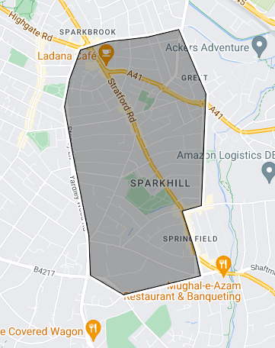

Location 8:

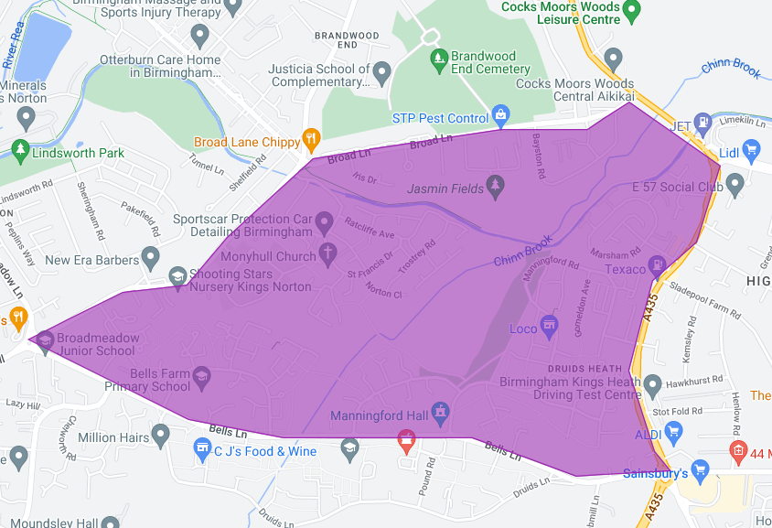

Location 9:

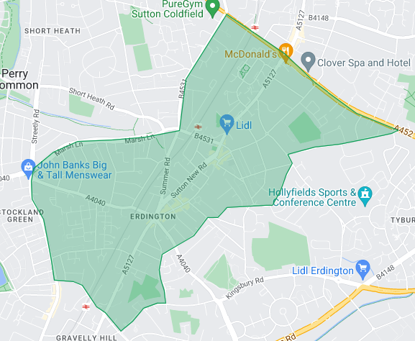

Location 1 (yellow) - the area south of Bordesley Green Lane, including Birmingham Heartlands Hospital and Blakesley Hall Museum.

Location 2 (pink) - incorporating east Stetchford, Lea Hall and north Yardley

Location 3 (orange) – incorporating west Stetchford, Little Bromwich, and Pelham.

Location 4 (brown) – Saltley and Nechells

Location 5 (blue) – Ward End, Washwood Heath and Hodge Hill

Location 6 (light green) – incorporating Small Heath and Bordesley Green up to the railway line

Location 7 (black) – Sparkhill and Sparkbrook

Location 8 (purple) – Druid’s Heath

Location 9 (dark green) – Erdington

For a Google Map version of the locations, please follow this [link](https://www.google.com/maps/d/edit?mid=1eC3Pe9IgDi_PCNgmS7EP-rOpNndCdPc&ll=52.52980464751096%2C-1.8432627099587506&z=14). The Affordable Food Models should be based with the location boundaries, which also function as idealised catchment areas for the Affordable Food Model (though we recognise that organisations cannot totally govern who uses their project). These locations were targeted as areas of Birmingham which do not already have Affordable Food Models.

Your approach should have sustainability at its heart, seeking to initiate new affordable food models that will last beyond the Cost of Living response period and so not relying on future funding from the Council. The grant should be spent in the 2023-24 financial year (before March 2024).

Applicants should have experience of EITHER or BOTH:

1. Food aid, ideally Affordable Food Models
2. The community and location(s) of the areas they are applying for

This funding is available through the Household Support Fund, funded by the Department for Work and Pensions. As part of the set-up of these affordable food models, we ask that organisations collect data on numbers using the service and who is using the service. This is a requirement of the Household Support Funding – more details around what to measure will be given if successful.

You will also need to ensure that you are registered as a supplier on the Birmingham City Council system – this can take time, so we recommend that you do this at the same time as filling in this form (as it could be useful in future even if you are unsuccessful). You can register [here](https://eur01.safelinks.protection.outlook.com/?url=https%3A%2F%2Fenre.fa.em3.oraclecloud.com%2FfscmUI%2Ffaces%2FPrcPosRegisterSupplier%3FprcBuId%3D300000006062115&data=05%7C01%7CRosemary.Jenkins%40birmingham.gov.uk%7Cbc165ebf74ed4afd106e08db9e673d6b%7C699ace67d2e44bcdb303d2bbe2b9bbf1%7C0%7C0%7C638277938954006594%7CUnknown%7CTWFpbGZsb3d8eyJWIjoiMC4wLjAwMDAiLCJQIjoiV2luMzIiLCJBTiI6Ik1haWwiLCJXVCI6Mn0%3D%7C3000%7C%7C%7C&sdata=Zhj20YWJGMiglZTcgmyWMhkhMotd2J%2BnhS1XF6Dj%2Ffs%3D&reserved=0) and find guidance on how to do this [here](https://www.birmingham.gov.uk/downloads/file/23108/oracle_cloud_supplier_guide). Please note that you will need to provide a copy of a business/headed letter, and within this letter please state your organisation information and banking details to be able to register as a supplier.

This grant application will be assessed by a panel. If your application is successful, we will let you know via email and ask you to sign a Condition of Grant Aid (COGA).

Please note that this is a time-limited fund as part of the cost of living response for winter 2023-24 and further support from the council may not be available after this. Again, we thank you for your hard work and hope that this fund will support your ongoing work in this area.

Please complete all the questions in the application form.

We have put together this video to talk you through the application form if that is something that would be helpful to you: <https://www.youtube.com/watch?v=rhiaIXc44Xw>

**Access Support**

We are committed to being accessible. If you experience or anticipate any barriers within the application process or require help to make an application or accessing services and information, please contact us.

If you have any questions, please contact [foodsystemPH@birmingham.gov.uk](mailto:foodsystemPH@birmingham.gov.uk)

# **Your Organisation**

|  |  |
| --- | --- |
| Organisation/group name (Applicant) |  |
| Registered/official address, including postcode |  |
| Correspondence address, including postcode (if different to above) |  |
| Organisation telephone number |  |
| Website, blog or Facebook page etc, if you have one |  |

Please confirm that you are one of the following:

| Unincorporated Association with a constitution, committee, bank account and regular meetings |  |
| --- | --- |
| Not-for-profit Limited company | Registration number: |
| Registered Charity | Registration number: |
| Community interest company (CIC) | Registration number: |
| Charitable Incorporated Organisation (CIO) | Registration number: |
| Other – please state: |  |

| Have you been awarded another grant by Birmingham City Council in the last 12 months? *Please note that your answer has no bearing on the possibility of receiving funding.* | Yes / No (delete as appropriate) |
| --- | --- |
| Are your primarily based out of Birmingham? | Yes / No (delete as appropriate) |

# **Locations you are applying for**

|  |  |
| --- | --- |
| Location | Please put an “X” in the box below if you are applying for the corresponding location |
| Location 1 (yellow) - the area south of Bordesley Green Lane, including Birmingham Heartlands Hospital and Blakesley Hall Museum. |  |
| Location 2 (pink) - incorporating east Stetchford, Lea Hall and north Yardley |  |
| Location 3 (orange) – incorporating west Stetchford, Little Bromwich, and Pelham. |  |
| Location 4 (brown) – Saltley and Nechells |  |
| Location 5 (blue) – Ward End, Washwood Heath and Hodge Hill |  |
| Location 6 (light green) – incorporating Small Heath and Bordesley Green up to the railway line |  |
| Location 7 (black) – Sparkhill and Sparkbrook |  |
| Location 8 (purple) – Druids Heath |  |
| Location 9 (dark green) – Erdington |  |

# **Contacts for this application**

Main contact for this application

|  |  |
| --- | --- |
| Name |  |
| Position in organisation |  |
| Phone number |  |
| Email address |  |

Additional contact for the application

|  |  |
| --- | --- |
| Name |  |
| Position in organisation |  |
| Phone number |  |
| Email address |  |

# **Your Project**

|  |
| --- |
| **Please provide a brief summary of your organisation, including your work in the area of food insecurity / affordable food models / other food aid and/or the location(s) you are applying for (~200 words)** |
| Answer here |

**Do you already run affordable food models in Birmingham?**

Please include numbers of people using this service and whether this is at capacity (if so, please state the number of people on the waiting list).

*If you do not run an affordable food model already, this will not affect your application if you are involved in the local community in other ways. If so, please leave the box below blank.*

|  |  |
| --- | --- |
| Venues/ locations including postcodes. | Location: Number of users:  At capacity: Y / N (delete as appropriate)  Number of people on waiting list if appropriate: Location: Number of users:  At capacity: Y / N (delete as appropriate)  Number of people on waiting list if appropriate  (continue as appropriate) |

**Do you already run other community activities in the area(s) you’re applying for?**

Please include numbers of people using this service.

*If you do not run other community activities, this will not affect your application if you have experience of running affordable food models or other food aid. If so, please leave the box below blank.*

|  |  |
| --- | --- |
| Venues/ locations including postcodes. | Location: Number of users:  Type of activities run:  Location:  Number of users:  Type of activities run:    (continue as appropriate) |

**Do you already have a location in mind where you could set up an affordable food model in this area?** *This isn’t a requirement of this funding, but it is helpful for us to know if you have any potential locations or plans as you apply.*

If the locations / venues are not accessible, please consider any reasonable adjustments you may need to make for people with disabilities.

|  |  |
| --- | --- |
| Venues/ locations including postcodes. |  |
| Have they been approached about this yet? | Y / N (delete as appropriate) |

|  |
| --- |
| **What approach do you or would you follow when setting up the affordable food model(s)? (max 500 words)** |
| Answer here |

|  |
| --- |
| **Please detail your proposal for how you would use this funding here, including a breakdown of costings (max 500 words). If you are applying for more than one location, please put down the proposed cost per location and the total cost of your proposal.** |
| Answer here |

|  |
| --- |
| **This is a one-time grant as part of the cost of living response / Household Support Fund. How will you ensure sustainability in your approach, so that you are not relying on the council for future funding for this affordable food model? (max 300 words)** |
| Answer here |

|  |
| --- |
| **How will you ensure value for money in this project? (max 300 words)** |
| Answer here |

|  |
| --- |
| **How would you ensure a dignified experience for affordable food model users? This might include consideration of choice, the queueing system, making the shopping experience as “normal” as possible and ensuring the affordable food model is a welcoming, safe place (max 200 words)** |
| Answer here |

|  |
| --- |
| **Who is the target population of the proposed affordable food model(s)? Do you have experience of working with these communities? (max 200 words)** |
| Answer here |

|  |
| --- |
| **How would you ensure you work with communities as you set up the affordable food model(s)? Please consider the communities of the area(s) you are applying for in your answer – including culture, religion & ethnicity (max 300 words).** |
| Answer here |

|  |
| --- |
| **How will you advertise the new affordable food model(s) and ensure local people who need the service are using it? (max 200 words)** |
| Answer here |

|  |
| --- |
| **How would you ensure a consistent, appropriate, varied and diverse food supply in your affordable food model(s)? (max 300 words).** |
| Answer here |

**Living Wage**

| I confirm that all paid individuals working on the project will be paid the Birmingham Living Wage in accordance with the Council’s policy |  |
| --- | --- |
| If any, please tell us how many existing employees will be uplifted to the Birmingham Living Wage through this activity. |  |

# **Projects and Activities engaging or working with Children, Young People or Adults at Risk**

Who in your organisation at senior level is responsible for the Safeguarding policy’s implementation and monitoring?

|  |  |
| --- | --- |
| Name |  |
| Position in organisation |  |

| Do all relevant members of staff or organisers have an up to date Criminal Records Bureau check (DBS)? | Yes/No |
| --- | --- |
| Do you have in place a record of DBS checks carried out, confirming that DBS checks are satisfactory? | Yes/No |

| If you have selected ‘No’ to either of the above questions, please state the reasons for your answer. |
| --- |
|  |

# **Declaration**

Birmingham City Council is committed to being open and transparent about decisions which affect Birmingham Citizens. Details of grant payments to voluntary and community sector organisations are published on the Council’s website every three months. To view published information, please go to [www.data.birmingham.gov.uk](http://www.data.birmingham.gov.uk/).By submitting this application, you are agreeing that your details will be published.

In addition, if you are successful in your application, you will be required to confirm that you have the following in place by sending us the documents:

* Insurance
* Food Hygiene Certificates where appropriate
* Safeguarding policy
* Copy of constitution
* Health and Safety Policy

Please note: Where applicable grant officers may add additional conditions into the Conditions of Grant Aid (COGA).

**DATA PROTECTION ACT 2018, CONFIDENTIALITY STATEMENT**

Birmingham City Council collects information for the purposes of procurement and payment functions.  The information we collect about you will depend on the nature of your business with us but may be used for any of the Council's purposes.

We may check information provided by you, or information about you provided by a third party, with other information held by us.  We may also get information about you from certain third parties, or give information to them, to check the accuracy of information; to prevent or detect crime; or to protect public funds in other ways, as permitted by law. These third parties include other local authorities, government departments, credit reference agencies and the police.

We will not disclose information about you to anyone outside the City Council unless the law permits us to. Confidential information will not be disclosed to third parties.  We recognise that information is valuable, and we take all reasonable measures to protect it whilst in our care.

The City Council is the Data Controller for the purposes of the Data Protection Act.  If you want to know more about what information we have about you, or the way we use your information, you can ask at our main offices or telephone the Corporate Information Governance Team on Tel: (0121) 303 4876.

Please note that we do not require or request that you collect or provide personal information about food project users for this grant.

# **Applicant Declaration**

| **On behalf of** (organisation/group name) |  |
| --- | --- |
| for **Project Title** |  |

I confirm that:

* The information in this application is correct and complete. If the requested grant is approved, any additional supporting documents required will be provided.
* If the requested grant is approved, the funds will be utilised as described in this application.
* I am authorised to sign and submit this application for grant funding on behalf of the organisation.

This section must be signed by the person who completed this form, on behalf of the organisation applying. The witness must not be a relative of the person who completed the form.

**Form completed by:**

| Name |  |
| --- | --- |
| Role |  |
| Signature |  |
| Date |  |

**Witnessed by:** (if possible and practical)

| Name |  |
| --- | --- |
| Role |  |
| Signature |  |
| Date |  |