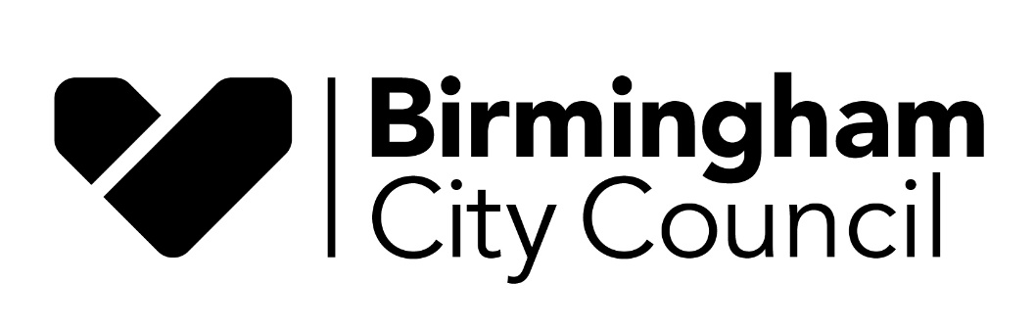

Report to: Schools’ Forum

Date: 19th January 2023

Report of: Terry Shaw, Schools Funding Manager

Title: Dedicated Schools Grant Settlement 2023/24

Status: For Approval

Purpose

The purpose of this report is to inform Schools’ Forum of the Dedicated Schools Grant settlement for 2023/24.

Background

Schools receive funding via a variety of different funding streams, the main ones being the four blocks of the Dedicated School Grant (DSG), Pupil Premium, Education & Skills Funding Agency (ESFA) Post 16 Funding and Universal Infant Free School Meals.

DSG is the main funding stream for schools and education services and is split into the following four blocks of funding:

DSG Block | Purpose of funding
Schools Block | To fund primary and secondary mainstream schools
Central Schools Services Block (CSSB) | To fund LA functions supporting schools & education
High Needs Block | To fund special schools and resource bases
Early Years Block | To fund nurseries and early years providers

The allocation of DSG funding is governed and managed in conjunction with the Schools’ Forum.

Dedicated Schools Grant Allocation 2023/24

The allocation of DSG announced by DfE 16 December 2022, is set at £1,457.6m for 2023/24.

The ESFA currently recoups an amount from the DSG allocation to directly passport to academies and free schools and the Council is then responsible for the remaining budget. At the time of writing the recouped amount for schools had not been announced by DfE/ESFA, but for scale purposes £659.0m was recouped in 2022/23.

A breakdown of the DSG allocation for 2023/24 and a comparison with the DSG allocation for 2022/23 is shown in the table below.

Dedicated Schools Grant Funding (for all schools)
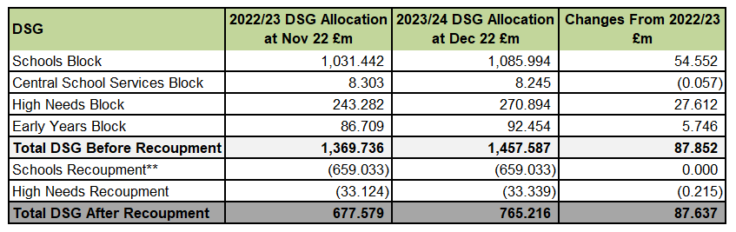

** Schools recoupment for 2023/24 will not be known until March 2023 so the latest 2022/23 recoupment figure has been shown for illustrative purposes

Additional DSG Grant Allocations 2023/24

Schools are expected to meet all the pay and inflationary pressures from within their budget allocations.

However on 16th December 2023, the ESFA also published the Mainstream Schools Additional Grant indicative allocations. Birmingham City Council has provisionally been awarded £37.6m funding for schools for the 2023/24 financial year in addition to the main Schools Block DSG settlement for 2023/24 to further support schools with the costs of inflation and wider costs. School level allocations will be confirmed in Spring 2023.

Schools Block

The basis of allocation to schools and other providers is underpinned by national funding regulations and is different for each of the blocks of the DSG, as is the timeline by which allocations must be made.

For the Schools Block Birmingham is required to submit a prescribed return (Authority Proforma Tool - APT) to the Education, Skills and Funding Agency (ESFA) setting out its proposed fair funding formula for delegating funding to primary and secondary schools covering Reception to Year 11. A report on the 2023/24 APT is to be presented to Schools’ Forum on 19th January 2023. Schools’ Forum ratification for is required at this meeting prior to being submitted the ESFA. The ESFA then checks the proforma to ensure it is compliant with national regulations.

Following ESFA approval the Council will need to issue budgets to its maintained primary and secondary schools by the national deadline of 28th February 2023. The ESFA will also use the proforma to calculate the Academy budgets.

The proposed funding factors meet all statutory requirements. In addition, the DfE requires Local Authorities to set a Minimum Funding Guarantee between 0.0% and 0.5%, as this forms part of the funding formula. The minimum funding guarantee (MFG) is intended to provide schools with stability of funding: the MFG does this by guaranteeing all schools a minimum percentage increase in their funding per pupil from one year to the next. MFG excludes business rates and lump sums. Schools’ Forum will be asked to agree to set a minimum funding guarantee of 0.5% (that also becomes a maximum funding guarantee), and increase:

- De Delegation: increase by 1.9% in line with the general NFF factor increase rate
- Split sites: increase by 1.9% in line with general NFF factor increase rate
- PFI top ups for PPP1 schools: increase by 13.5% in line with Office for National Statistics (ONS) published RPI(x) rate as at November 2022.

Central Schools Services Block

The Central School Services block (CSSB) was established by the DFE in 2018/19 and created with the aim of funding Local Authorities for the statutory duties they hold for both maintained schools and academies. It brings together:

- Funding for ongoing responsibilities, such as admissions
- Funding previously allocated through the retained duties element of the Education Services Grant (ESG)
- Residual agreed funding for historic commitments

The indicative 2023/24 allocation for the CSSB is estimated to be £8.245m – a reduction of £0.057m from the figure for 2022/23. The DfE has begun reducing the element of funding within the CSSB that some LA’s receive for historic commitments made prior to 2013/14. This will reduce by 20% each year. DfE does not believe it is fair to maintain significant differences in funding indefinitely between local authorities which reflect historic decisions.

This overall change disguises two important factors, regarding DfE’s overall calculation:

- for 2023/24 Birmingham Council has lost 20% of its funding for historical commitments
- for 2023/24 Birmingham Council has gained 4.5% for its other responsibilities.

High Needs Block

The increasing level of spend on High Needs and SEND is a national issue, which is also reflected in Birmingham.

At the end of 2021/22 the cumulative High Needs deficit was £4.1m with the final repayment to clear planned to be made during 2022/23.

The Government has announced substantial increases in High Needs for which Birmingham will receive £237.6m after direct academy recoupment and import/export adjustments in 2023/24, a total increase of £27.4m on the amount received in 2022/23.

This includes an additional allocation of £10.8m funding for the schools’ budget announced at the Autumn Statement 2022.

Details of the proposed HNB budget will be shared with the Schools’ Forum sub-groups prior to the main March 2023 Forum meeting.

Early Years Block

The indicative DSG settlement for the Early Years Block for 2023/24 is £92.5m, an increase of 5.7m (6.6%) when comparing to the Early Years Block settlement for 2022/23.

The Council is required to passthrough a minimum of 95% of the annual allocation to its early years providers and is allowed to retain a maximum of 5% of the annual allocation to support central functions.

The Early Years budgets will be determined and communicated to providers in full by the mandatory deadline of 28th February 2023.

