WHERE NOT TO PARK
WHERE NOT TO PARK

You must NOT park during the time a ban on loading or unloading is in force (normally indicated by one or two yellow marks on the kerb at the times shown on post mounted plates). For example:
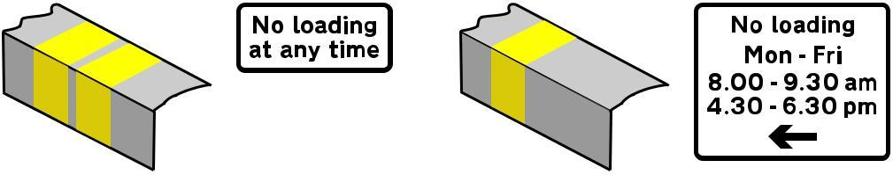

Loading prohibited  24 hours a day,  7 days a week, for at least  4 consecutive months. | Loading prohibited for any lesser period. The arrow indicates the direction in which the prohibition starts.
However, in pedestrian areas, waiting and loading restrictions may be in force even where there are no yellow lines shown on the road or kerb. Details of any restrictions in force will be shown on plates displayed at the kerb side of the road. You must NOT park in the following places:

- where there are double white lines in the centre of the road even if one of the lines is broken
- in a bus or tram lane during its hours of operation
- in a cycle lane
- on any clearway, double or single red lines during their hours of operation
- on all pedestrian crossings - including Zebra, Pelican, Toucan and Puffin crossings
- on zig-zag markings before and after Zebra, Pelican, Toucan and Puffin crossings
- in parking places reserved for specific users, eg loading bays, taxis, cycles
- where temporary restrictions on parking are in force along a length of road eg as indicated by no-waiting cones
- on a residents’ parking bay, unless there are signs showing that you may do so, or you have checked with the local authority's Highways Department that you may do so
- in suspended Pay and Display meter bays or when use of the meter or bay is prohibited
- on school "keep clear" markings during the hours shown on a yellow no-stopping plate

You must NOT park where it would be obstructive or cause a danger to others. The following are likely examples:

- at school entrances, bus stops, on a bend, or near the brow of a hill or hump bridge
- where it would make it difficult for others to see clearly, eg close to a junction
- where it would make the road narrow, eg by a traffic island or where road work is in progress
- where it would hold up traffic, eg in narrow stretches of road or blocking vehicle entrances
- where emergency vehicles stop or go in and out, eg hospital entrances
- where the kerb has been lowered or the road raised to form a pedestrian crossing
- on a pavement unless signs permit it

