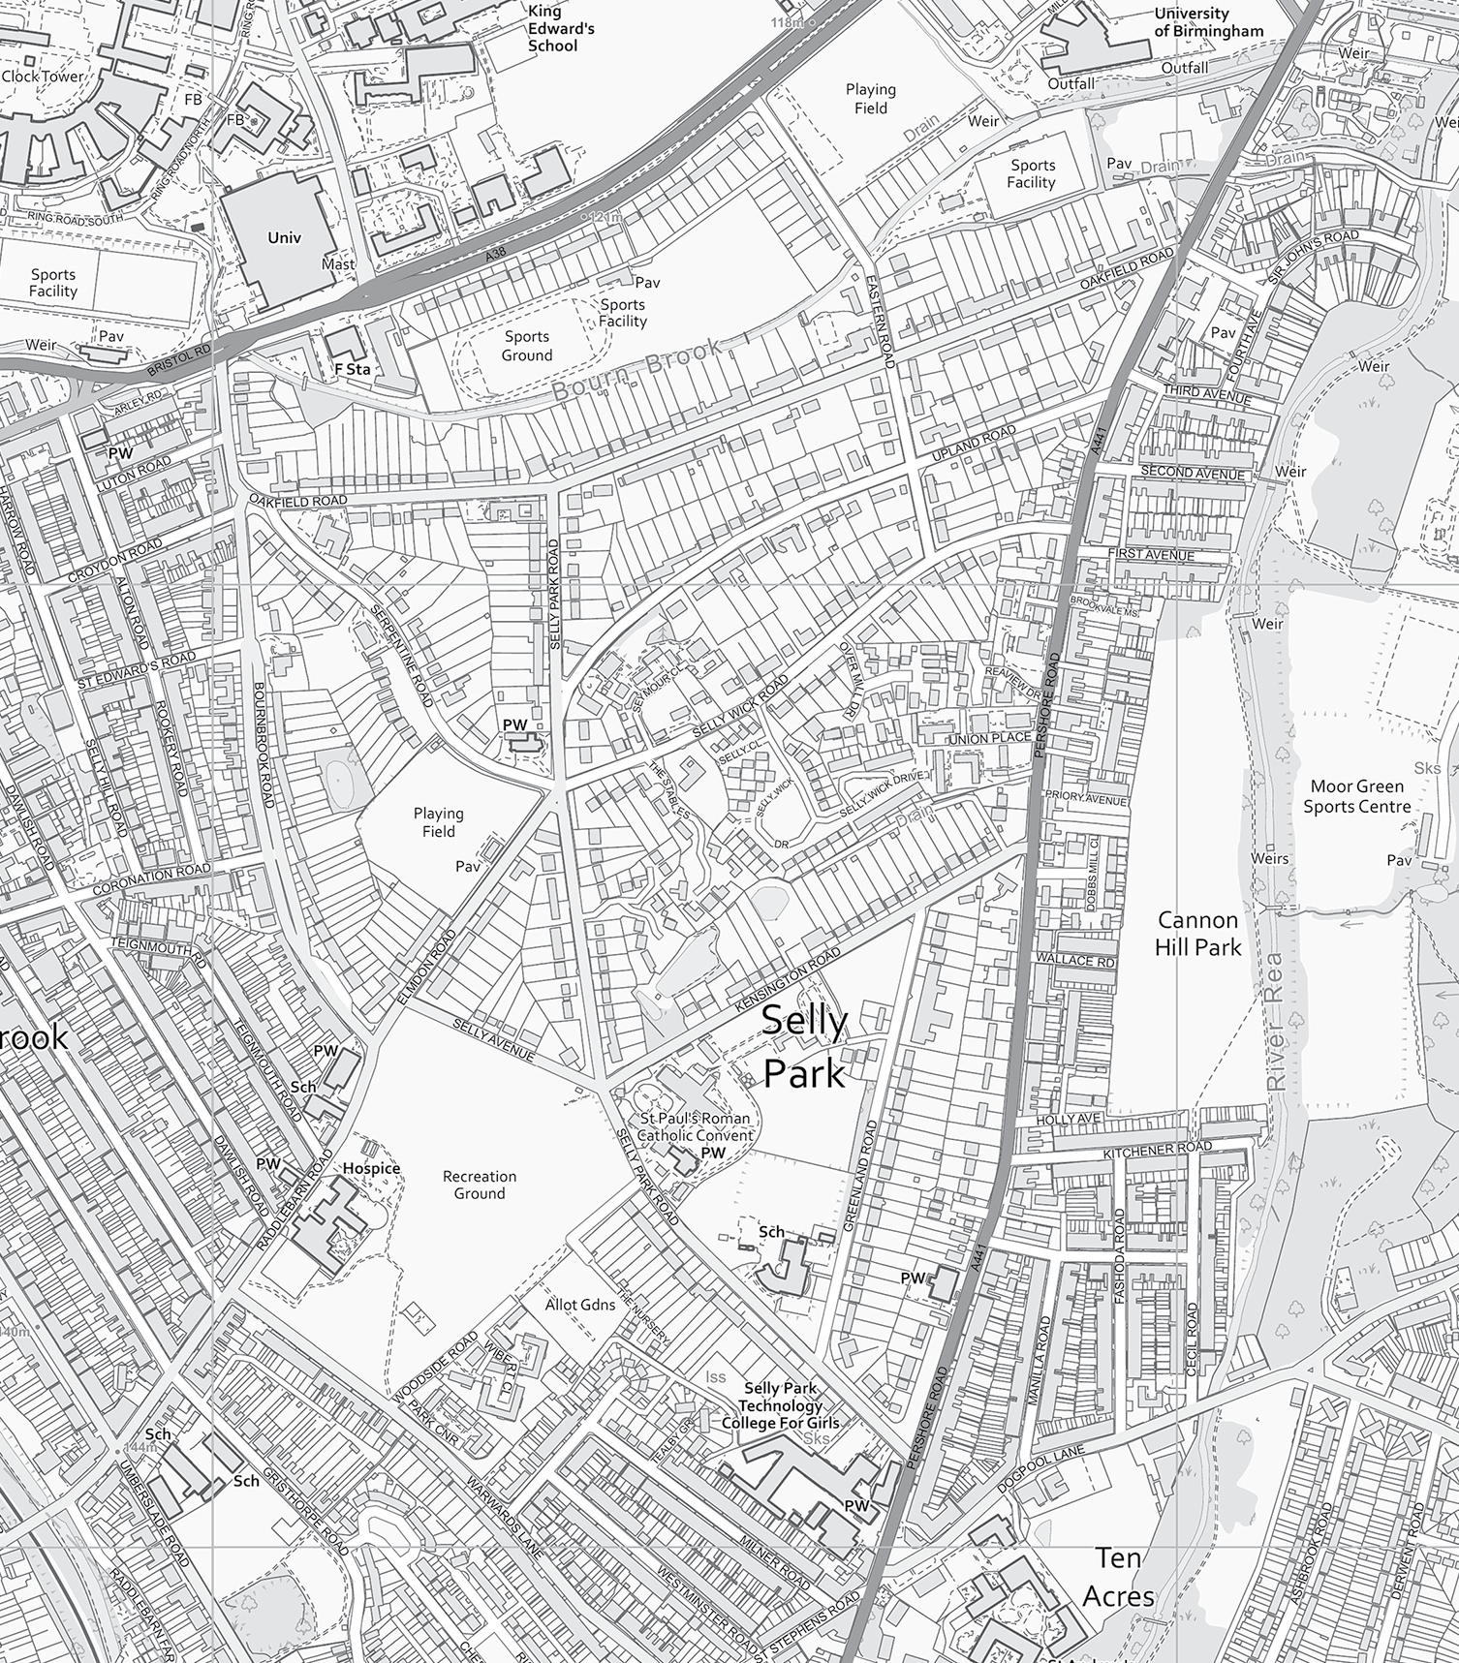

n
NORTH
NOT TO SCALE

Selly Park Conservation Area Map.

Key
Selly Park Conservation Area boundary as designated 1st August 2022.

New additions to the Selly Park Conservation Area following designation of new boundary 1st August 2022.

