De Delegated Budgets 2022/23

Report to: Schools Forum

Date: 20th January 2022

Report of: Clare Sandland, Finance Business Partner

Title: De Delegated Budgets 2022/23

Status: For Approval

- Purpose of the Report

This report covers prescribed activities/commitments that are required to be delegated through the mainstream Reception to Year 11 formula, but for which the LA can propose de delegation for LA maintained primary and secondary schools only. For 2022/23 the LA is to propose de delegation for three areas of commitments which are unchanged from 2021/22.

These three areas are:
- Contingencies: to fund residual costs arising from the opening/closing of schools, deficits of discontinued schools, schools in financial difficulties, and other expenditure where the circumstances were unforeseen.
- Facilities Time: this enables the costs of releasing city-wide union representatives to be shared between schools, so that they do not fall disproportionately on the staffing of a small number of schools with these representatives.
- Behavioural Support Services: this is part of helping to sustain inclusion. The budget will allow resourcing of short-term programmes and preventative type work via the City of Birmingham School to continue while alternative models are developed for future years.
The unit rate has been increased by 3% in 2022/23, however academisation and pupil number changes will lead to a reduction in overall de delegation.
The LA seeks approval from Forum members representing maintained primary and secondary schools only, to agree to continue the above three areas for de delegation for 2022/23 and the increase of 3%.
On 11th January 2022, the ESFA confirmed it will proceed with reducing the Local Authority School Improvement Monitoring and Brokering Grant by 50% for financial year 2022/2023, prior to full removal in financial year 2023/2024. Provision will be included in the School and Early Years Finance Regulations 2022 (England) to instead allow local authorities to deduct funding for their core school improvement activities from maintained schools. The LA is not proposing to de delegate from maintained schools for this in 2022/23.
Therefore, the proposed 2022/23 total de delegation budget is £1,635,359 as per APT for the three existing functions.
The proposed amount of de delegation in 2022/23 is set out in Appendix 2. De delegation is not an option for Nursery Schools, Special Schools, PRUs or Academies. Their proportion of the budget is already delegated.
It is to be noted that for each proposed area for de delegation, it is for the Schools Forum members in the relevant phase (primary or secondary) to decide whether that service should be provided centrally. The decision would apply to all maintained mainstream schools in that phase and result in the funding for these services being removed from the formula before school budgets are issued. There could be different decisions made for each phase.
Other possible items which can be de delegated include:

- Free School Meals eligibility
- Insurance
- Licences / Subscriptions
- Staff costs – supply cover excluding facility time
- Support to underperforming ethnic minority groups and bilingual learners
- Museum and library services

Schools Forum representatives for the relevant phases have previously decided not to de delegate these aspects, therefore figures have not been provided.

- Benchmarking

Please see Appendix 1 for benchmarking data issued by the DfE using 2021/22 Section 251 statements. The columns set out the totality of what LAs could be budgeting for, but it is the green shaded columns and rows that highlight commitments applicable to Birmingham.
3. Recommendations

School Forum to agree the allocations for 2022/23 as outlined in Appendix 2. Please note that the actual total figures are subject to change due to academisation.
Appendix 1: Benchmarking

Source: https://www.gov.uk/government/publications/section-251-2021-to-2022

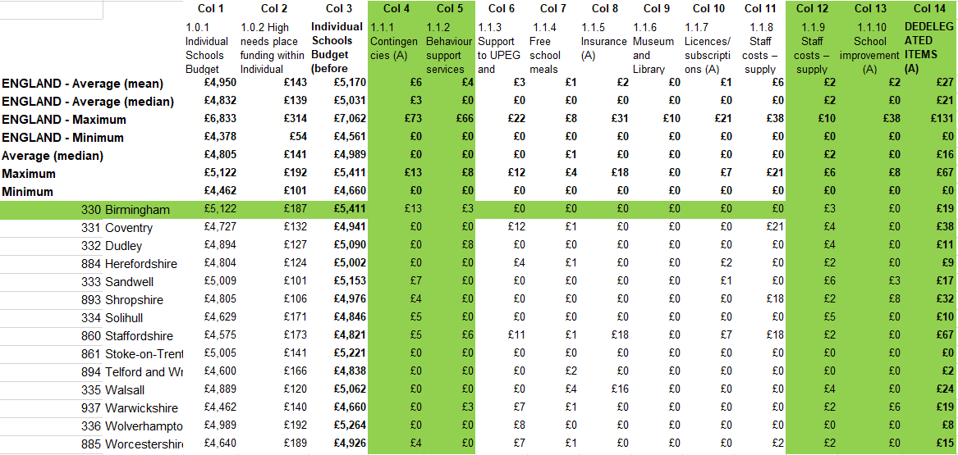

Appendix 2: De Delegation 2022/23 and Comparison with 2021/22

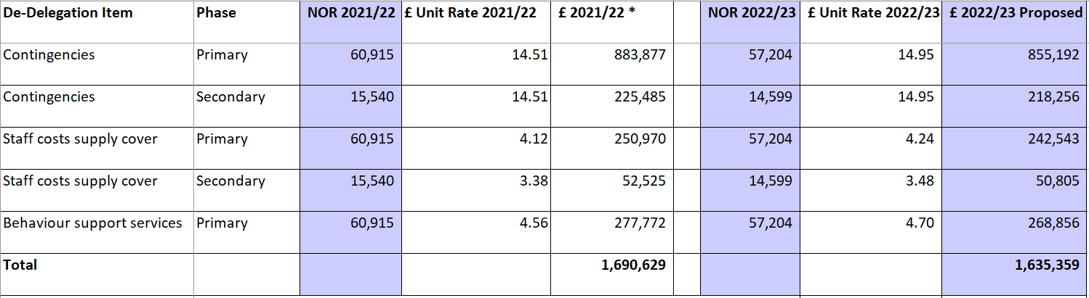

* Source for 2021/22 data: School Forum 19th November 2020 "De Delegated Budgets - Nov 20 SF Appendix 2"

Note: The total amount is based on APT (Authority Proforma Tool). There is a minor difference between 2022/23 APT total de delegation and calculation by rate x NOR. It is a rounding difference.

