Mainstream Schools Funding Formula and Minimum Funding Guarantee 2022/23

Report to: Schools Forum

Date: 20th January 2022

Report of: Clare Sandland, Finance Business Partner

Title: Mainstream Schools Funding Formula and Minimum Funding Guarantee 2022/23

Status: For Decision

Purpose

The purpose of this report is to seek Schools Forum approval for the allocation of the national funding formula factor values and the Minimum Funding Guarantee (MFG) at 2% as part of the mainstream school funding formula for Birmingham for 2022/23 and to agree the preferred option for allocating the additional £311,020 available after applying the National Funding Formula.

Background

Each year local authorities are required to detail their schools block funding formulae in accordance with the arrangements set out by the Secretary of State for Education. The Education and Skills Funding Agency (ESFA) has developed the authority proforma tool (APT) to assist local authorities to model and then confirm how they plan to do this for the funding year.

The overall structure of the formula is the same as in 2021/22. Most factors have increased by 3%, but with some exceptions, for example the per pupil funding floor has a 2% uplift from 2021/22, and the FSM factor has a 2% uplift to per-pupil value.

The total allocation as at 16th December 2021 for Birmingham is £1,031,442,395 including £7,909,491 NNDR within the premises factor, or £1,023,532,904 excluding NNDR.

The council has applied NFF rate in the APT and modelled four different options to allocate the £311,020 funding available after applying the NFF. The impacts of applying a different rate of MFG (minimum funding guarantee) and AWPU (age-weighted pupil units) are set out in the options table below.

Schools supplementary grant
The autumn 2021 spending review confirmed an additional £1.6 billion funding for schools and high needs, for the 2022/23 financial year, above the previously announced DSG settlement. In the 2022/23 financial year, schools will be allocated £1.2 billion of this additional funding, to provide support for the costs of the Health and Social Care Levy and wider costs. This funding will be allocated through the School’s Supplementary Grant 2022/2023. In addition to the School’s Supplementary Grant, local authorities have been allocated £325 million additional high needs funding for 2022/23, on top of the dedicated schools grant high needs block allocations, calculated under the national funding formula.
The base funding rates for 5-16 schools will be:
- basic per-pupil rate of £97 for primary pupils
- basic per-pupil rate of £137 for key stage 3 pupils
- basic per-pupil rate of £155 for key stage 4 pupils
- lump sum of £3,680
- FSM6 per-pupil rate of £85 per eligible primary pupil
- FSM6 per-pupil rate of £124 per eligible secondary pupil
Additionally, 16 to 19 schools and academies will receive £35 per post-16 student.
Government National Funding Formula Expectations

Every school must receive a minimum of £5,525 per-pupil funding for secondary schools and £4,265 for primary schools (KS3: £5,321, KS4: £5,831). This has been reflected in the APT.

Birmingham Methodologies

Apart from applying the rate specified in NFF Guidance, we have also increased the following factors in the APT:
- De Delegation: increase by 3% in line with general NFF factor increase rate
- Split sites: increase by 3% in line with general NFF factor increase rate
- PFI top ups for PPP1 schools: increase by 7.2% in line with ONS (Office for National Statistics) published RPI(X) rate at November 2021.

Base funding model at National Funding Formula

Apply the NFF including the primary AWPU rate at £3,217, MFG @2% with no capping or scaling. This NFF base model results in total cost of £1,031,131,375 with £311,020 to allocate.

Options:

The table below summaries the four options that we would ask School Forum to consider:

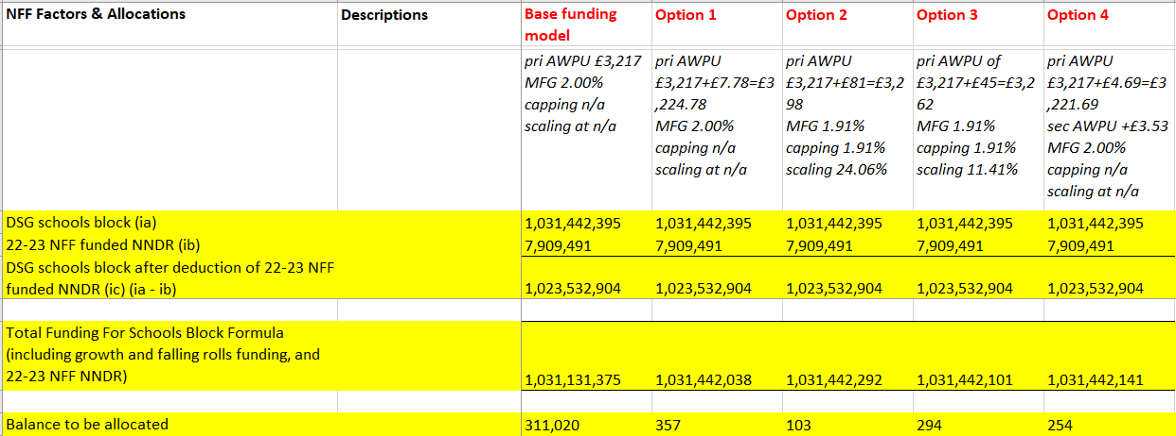

Option 1: An additional £7.78 per pupil added to the primary AWPU to reflect the higher value paid in 2021/22, MFG @2% with no capping or scaling. This option results in total costs of £1,031,442,038 with £357 as a balancing figure.

Option 2: An additional £81 per primary AWPU to follow DfE guidance in reducing over-NFF payment by 10% each year. This is only affordable with MFG @1.91% with capping at 1.91% and scaling at 24.06%.

Option 3: An additional £45 per primary AWPU as a mid-point between the NFF and last year’s primary AWPU. This is only affordable with MFG @1.91% with capping at 1.91% and scaling at 11.41%.

Option 4: Share the £311k surplus equally between primary and secondary phase with an additional £4.69 per pupil for primary schools, and £3.53 per pupil for secondary schools, MFG @2% with no capping or scaling.
This option results in total cost of £1,031,442,141, with £254 as a balancing figure.

For Decision
In comparison, Option 1 still gives higher value to primary schools, whilst Option 2 and Option 3 requires capping and scaling to be affordable. Therefore Option 4 is our preference. It maintains the MFG at 2%, does not apply capping or scaling to schools, so no school loses out.
We recommend School Forum choose Option 4.

Appendix: Modelling four options by different MFG rate and AWPU rate:
