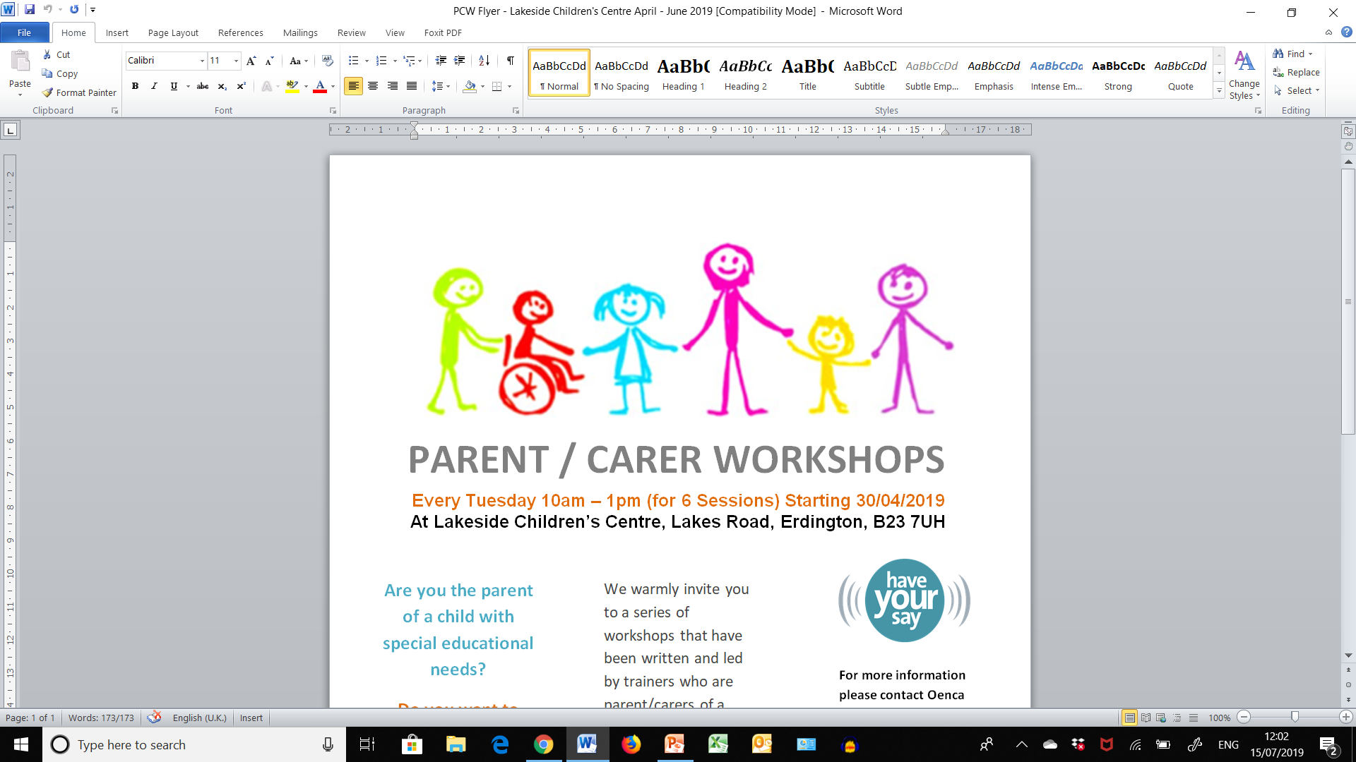

**Be Empowered** **Workshop** – Early Support Programme for SEND Parent Carers

**We warmly invite you to join in a series of daytime in-person workshops that have been written and led by trainers who are parent/carers of a child with additional needs themselves.**

**These workshops are for parent/carers of children and young people of any age, with any additional need, with or without a diagnosis. They are an attempt to support parent/carers through times of change and at whatever stage of the journey participants may find themselves.**

**JAN – FEB 2022 – On a MONDAY, 10am – 1pm**

**Starting Mon 10th Jan 2022, then continuing Mon 107h Jan, Mon 24th, Mon 31st, Mon 7th Feb and finishing Mon 14th Feb**

**At Dyson Gardens Children’s Centre, 145 Highfield Road, Birmingham B8 3QF**

**THE NEXT IN-PERSON BE EMPOWERED WORKSHOP OF THIS ACADEMIC YEAR.**

**MONDAY’S 10th JANUARY to 14TH FEBRUARY, FROM 10AM – 1PM**

**Deadline for receiving bookings is**

**TO BOOK YOUR PLACE:**

**Please apply by completing and signing the attached booking form and consent and email to:** [**BeEmpowered@birmingham.gov.uk**](mailto:BeEmpowered@birmingham.gov.uk)

For any enquiries about the next Be Empowered Workshop please call

Oenca Fontaine (Parent Engagement Consultant)

Tel: 07956 929 151 **– these contact details may change once admin comes on board…**

**DEADLINE FOR RECEIVING BOOKINGS IS THURSDAY 16TH DECEMBER 2021!**