Report to Planning Committee for Shannon Road and Hillmeads Road

Committee Date: | 04/03/2021 | Application Number: | 2020/08270/PA
Accepted: | 19/10/2020 | Application Type: | Full Planning
Target Date: | 05/03/2021
Ward: King's Norton South

Land at Shannon Road and Hillmeads Road, Pool Farm, Kings Norton, Birmingham
Outline application for residential development of up to 150 dwellings (C3), open space, creation of three new accesses off Shannon Road, new access arrangements via Hillmeads Road, and associated
landscaping attenuation, infrastructure and ancillary development.

Recommendation

Approve subject to Conditions

- Proposal

  - Outline planning permission is sought for the erection of up to 150 dwellings across three sites. All matters are reserved except for access.

Shannon Road site
  - Existing four 10-storey tower blocks currently being demolished (separate prior approval granted already). The illustrative layout shows their replacement with 79 dwellings (39 houses and 40 apartments). Two apartment blocks would be located at the northern and southern ends of the site with two and three-storey houses in between.

  - Indicative layout would be facilitated by the stopping up of small sections of existing roadway and the creation of three new accesses and roads into the site to serve the new dwellings; and by a minor diversion to a public right of way which runs north to south along the west boundary of the site. Existing substation retained.

  - Site area: 2.33ha. Density: 33dph.

  - 50% of dwellings (40 units) would be affordable housing (social rent).

Hillmeads Road sites
  - 41 existing properties to be demolished (prior approval already granted) and replaced with 71 new dwellings in a more regular, perimeter block-style layout. Indicative layout shows two new accesses, one off Heathside Drive and one off Hillmeads Road to serve short cul-de-sacs.

  - Site area: 2.28ha Density: 31dph.

  - 9% of dwellings (6 units) would be affordable housing (social rent).

  - Link to Documents

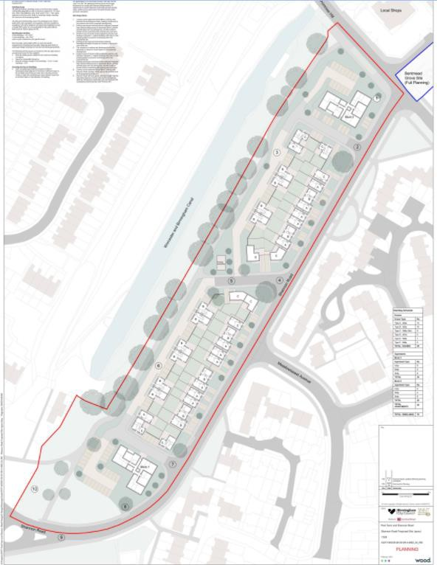
Figure 1: Shannon Road indicative layout
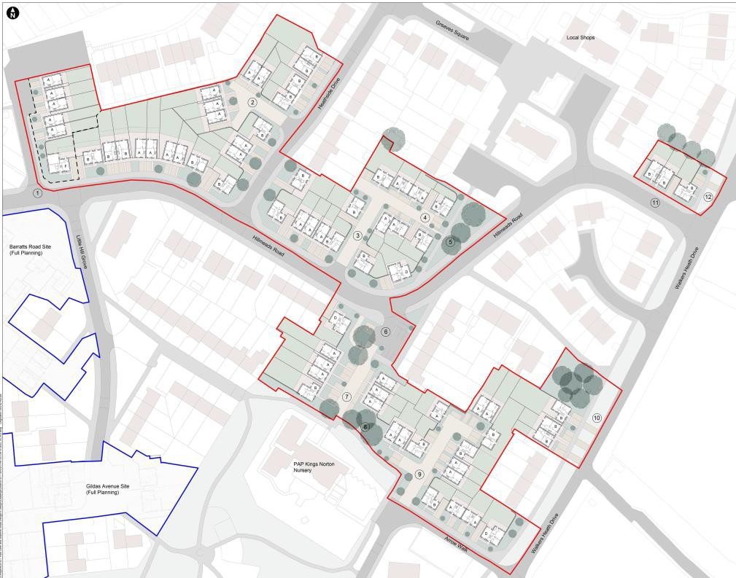
Figure 2: Hillmeads Road indicative layout

- Site & Surroundings

  - These sites form part of the Kings Norton ‘Three Estates’, comprising Primrose, Hawkesley and Pool Farm, where an ongoing regeneration scheme by BMHT and other partners over 20 years is renewing the housing stock and facilitating a shift away from flatted accommodation to traditional family housing.

  - Shannon Road site: broadly rectangular and bordered by Primrose Hill and Shannon Road to the north and east, and the Worcester and Birmingham canal to the west. Grade II Listed Canal Cottages and tunnel portal of Wasthill Tunnel are located immediately to the southwest of the site. The land falls away to the south. It currently comprises 4 tower blocks in a linear arrangement with associated parking and incidental open space. A public right of way runs along the west boundary of the site parallel to the canal.

  - Hillmeads Road site: This is an irregular shaped site as the proposed dwellings would be interspersed with houses to be retained. As well as two-storey dwellings, the site includes some three-storey maisonettes. The existing layout is rather irregular and to the north of Hillmeads Road the site is steep. A short section of public right of way is found in the southern part of the site.

  - Site location

- Planning History

  - 15/04/2020 - 2020/02269/PA – Barberry House, Shannon Road - Prior Notification for the proposed demolition of existing residential tower block – Prior Approval Required and granted with conditions.

  - 19/10/2020 - 2020/08312/PA - Land at Gildas Avenue, Barratts Road and Bentmead Grove - Full planning application for residential development of 117 dwellings (C3), open space, new access arrangements and improvements at Barratts Road and Gildas Avenue and associated landscaping attenuation, infrastructure and ancillary development – Awaiting decision.

- Consultation/PP Responses

  - Transportation Development: No objection. Recommend a condition requiring pedestrian visibility splay to be applied to all driveways.

  - Regulatory Services: No objection subject to conditions as follows:

    - Noise and Vibration Assessment to be carried out to safeguard habitable rooms and outdoor living spaces from excessive traffic noise.
    - Submission of Construction Method Statement/Management Plan
    - Submission of Contamination Remediation Scheme and Contaminated Land Verification Report.

Conclusions of Air Quality Technical Note are broadly agreed with; no significant net effect on air quality expected and any temporary effect during construction could be dealt with by condition. Development is not within an area known to Regulatory Services to have high concentrations of nitrogen dioxide. Phase 1 Geoenvironmental Desk Study identifies the likely presence of ground contamination/ground gas and proposes further intrusive survey work secured by condition. Some of the proposed

properties e.g. on Hillmeads Road, would be located in areas currently affected by high levels of road traffic noise and will require mitigation such as acoustic glazing.

  - Leisure Services: In accordance with BDP policy TP9, a financial contribution towards off-site Public Open Space and play area provision should be made. Noting the net loss of dwellings, a calculation in the normal way would not be appropriate. Given the number of family units proposed, a contribution of £110,000 should be made.

  - Education (School Places): Financial contribution of £737,778.89 requested towards the provision of school places (nursery, primary and secondary) based on the number and size of the proposed dwellings.

  - Birmingham Public Health: No response received.

  - Employment Access Team: No objection subject to a condition requiring a Construction Employment Plan.

  - Lead Local Flood Authority: No objection subject to conditions requiring a surface water drainage scheme and a Sustainable Drainage Operation and Maintenance Plan.

  - Severn Trent Water: No objection subject to a condition requiring drainage plans for the disposal of foul and surface water.

  - Environment Agency: No objection.

  - Canal and River Trust: No objections raised however conditions are requested to ensure the structural integrity of the canal and associated structures, and to promote the use of the canal by local residents:

    - No soakaways or services to be installed above or below the canal tunnel.
    - Provision of details of sustainable drainage schemes, boundary treatment or pathways to be installed atop the cutting slope along the northern boundary of the site, and construction methodology and foundation design for buildings close to the crest of the cutting slope.
    - Phase 2 ground investigation study to be carried out.
    - Demolition Method Statement and Construction Ecological Mitigation Plan to be provided.
    - Wayfinding and signage to be provided within the public realm created by the development.
    - Promotion of the canal as a sustainable means of access to other areas through travel plans.
    - Financial contribution towards the improvements to the Masshouse Lane/Primrose Hill and Foyle Road/Shannon Road access points.

  - The Ramblers: No response received.

  - West Midlands Police: No objection.

  - West Midlands Fire Service: No objection.

  - Site and press notices posted and local MP, Councillors, Residents’ Associations and the occupiers of nearby dwellings notified of the application; the following responses received:

Gary Sambrook MP:
    - More large family housing should be proposed to meet local need.
    - A more comprehensive development should be proposed in the area to tackle more of the housing which is in a very poor state of repair.
    - Existing residents of the estate and the local area must be given a right to return as part of the redevelopment and therefore prioritised when placing people in the new housing.
    - Objects to apartment blocks on Shannon Rd site; more housing would be better for the local community.
    - The Council should invest in improvements to open up the canal which could be a real feature for the area.
    - At the Hillmeads Road site, some houses are not included in the scheme but should be.
    - The design of the housing should reflect the key design features of the wider Kings Norton area to tie the new housing together and into the wider community.
    - The tower blocks on Shannon Road should be demolished promptly as they have become a magnet for anti-social behaviour.

1 letter from a local resident wanting to know where he will be re-housed and when.

- Policy Context

  - Birmingham Development Plan 2017
Birmingham Unitary Development Plan 2005 (saved policies) Development Management in Birmingham DPD Publication Version 2019 Places for Living SPD 2001
Car Parking Guidelines SPD 2012 Kings Norton Planning Framework 2009

NPPF; NPPG; National Design Guide.

- Planning Considerations

Principle
  - In conjunction with the concurrent application for full planning permission (2020/08312/PA), a total of 418 dwellings across the Pool Farm estate, mostly Council-owned, would be demolished and replaced with 267 new dwellings, with a net loss of 151 dwellings.

  - The Kings Norton Three Estates are identified in BDP policy TP32 as being one of the initial priority areas for regeneration and renewal of existing housing. The proposal accords with this policy and would make a positive contribution to meeting the housing needs of the city and to the regeneration of a priority area.

Housing Mix
  - Proposed indicative dwelling mix:

16 x 1-bed flats (11% of units proposed) 24 x 2-bed flats (16%)
51 x 2-bed houses (34%)
54 x 3-bed houses (36%)
4 x 4-bed houses (2%)
1 x 5-bed houses (1%)

  - The Strategic Housing Market Assessment (SHMA) (2013) indicates that the greatest demand across the city is for 2 bedroom dwellings (30.8%) followed by 4 beds (28.1%) then 3 beds (26.3%). The proposed mix, which concentrates on 2 and 3 bed dwellings, seeks to balance national and local planning policy requirements, particularly the efficient use of land, the need for smaller family dwellings and the capacity and requirements for the regeneration of the site. The final mix would be confirmed at reserved matters stage.

Density and Indicative Layout
  - TP30 sets a target density of 40dph in this location. The illustrative layout suggests densities ranging from 31-33dph, which is acceptable given the physical constraints of the sites.

Shannon Road layout
  - Several constraints make this a difficult site to lay out: an area of flood plain, existing trees, the narrow shape of the site and an electricity substation. However, the indicative layout would achieve:

    - a loose perimeter block linking three distinct ‘character areas’;
    - a strong building line along Shannon Road, addressing this main frontage and important connecting route;
    - to the rear, facing the canal, appropriate back to back separation, a strong rhythm, and a distinctive identity;
    - ‘book ends’ created by the apartment blocks at each end of the site which could be distinctive landmarks adding to the sense of place; and
    - retention of the most important mature trees and space for sustainable planting and new trees.

  - There are some shortfalls on the Places for Living separation distances, particularly where three-storey dwellings and four-storey apartment blocks are located, and in respect of amenity space in some plots. Communal amenity space for apartment block 2 (north of the site) could also be laid out differently to offer a more attractive and useable space for residents. However, layout and scale are reserved matters and, broadly, indicative drawings show that the site could accommodate the 79 dwellings proposed.

Hillmeads Road layout
  - Retention of existing dwellings around the perimeter of this site and the steep level changes within it present significant constraints however, the indicative layout would achieve :

    - a perimeter block approach with frontages onto public streets and back gardens enclosed within blocks;
    - coherent building lines tied into established setbacks and frontages;
    - corner-turning houses to reduce exposed garden boundaries and add interest and variety;
    - short cul-de-sacs making efficient use of space;
    - retention of important mature trees have been retained and space for sustainable landscaping and tree planting where possible; and
    - adequate garden sizes and back-to-back separation distances as set out in Places for Living, particularly in relation to existing properties.

  - There are some instances where the Places for Living separation distances are not met in front-to-front or windowed elevations-to flank situations, and one particular instance where a new two-storey dwelling would back onto the rear boundaries of Nos. 127 and 129 Walkers Heath Drive at a distance of only 5m. These shortfalls should be reviewed on a reserved matters application, when full detail is known regarding the design of individual dwellings within these plots and the positioning of windows.

Trees, landscaping and ecology
  - Across the three sites, there are 63 A-category trees, 34 B-category trees and 37 C- category trees. Trees in all categories are likely to be removed to facilitate the indicative layouts, including approx. 20 A-category and 22 B-category trees. The layouts have been designed around retention of some of the most important and prominent trees. Space for replacement tree planting is more limited than with the current layout but there are areas which could support the provision of good sized trees, and other soft landscaping, to enhance the character of the development. Conditions are attached to secure more detailed planting information.

  - Aside from bats and breeding birds, the site is of low biodiversity value due to areas of short mown grass and a variety of garden spaces. The main area of ecological interest is the canal adjacent to the Shannon Road site, although this is outside of the application site. A condition is attached requiring a Construction Ecological Mitigation Plan which would ensure appropriate mitigation for light, dust and noise disturbance during the demolition and construction phases. Recommendations are made in the Preliminary Ecological Appraisal for ecological mitigation and enhancement and a condition is attached to secure this.

Access, parking and highway safety
  - Transportation Development has no objection to the proposed access arrangements or to more general considerations of traffic movement or highway safety. The development involves a net loss of dwellings and off-street/designated parking spaces could be provided for all units at a ratio or 1 space for 2-bed units and 2 spaces for all other housetypes (210 spaces in total). A stopping up order is required to facilitate the new accesses and the appropriate recommendation is set out below. The existing Public Right of Way (PROW) which runs up the west side of the Shannon Road site would undergo a minor diversion within the site to facilitate the proposed layout.

Sustainability
  - In broad terms, and notwithstanding the net loss in the number of dwellings, the proposal would meet sustainability objectives; the site is located within the existing urban area, is suitably dense whilst maintaining and reinforcing the positive characteristics of the surroundings, and would regenerate an area of poor quality housing.

  - Passive design and enhanced insulation could be achieved on the site and the proposal therefore complies with TP3 (Sustainable Construction).

  - The Energy Statement predicts energy demand and CO2 emissions, following the proposed passive design measures and enhanced thermal efficiency reductions, of between 3-6% from the baseline. Solar photovoltaics are considered to be a viable option with estimated reductions in total energy requirements of around 25%. This is acceptable subject to a condition requiring an update of the statement at reserved matters stage with the results of further feasibility studies into the potential technologies which could be implemented.

Flood risk and drainage
  - The site falls within Flood Zone 1 and there is very low risk of fluvial flooding from rivers. Surface water flood risk is low across most of the site however there is an area of high and medium risk across the south of the Shannon Road site and consequently this area would remain grassed with no built development proposed here. The development would increase the impermeable area within the site however an Outline Drainage Strategy demonstrates how run-off would be managed and attenuated, through underground sustainable drainage storage features, to avoid increasing flood risk downstream. Recommended conditions are attached.

Impact on residential amenity
  - Noise: No new noise sources would result from this proposal however some of the proposed dwellings, such as those on Hillmeads Road, would be located in areas affected by high levels of road traffic noise at present due to nearby classified roads (Walkers Heath Rd and Icknield St). A condition is attached requiring a noise assessment to demonstrate that habitable rooms and outdoor living spaces would not suffer from excessive noise or vibration.

  - Air Quality: The Air Quality Technical Note indicates that the main source of air pollution within the city is traffic. The amount of traffic generated in the vicinity of the application site is expected to decrease due to the net reduction in the number of dwellings. Coupled with the ongoing improvements to vehicles, the replacement of older vehicles and continued encouragement of the use of alternative modes of travel, air quality in the Pool Farm area is expected to improve. A condition requiring a Construction Management Plan is attached and would ensure that construction dust is minimised.

  - Contaminated Land: The Geoenvironmental Desk Study indicates the likely presence of ground contamination and ground gas from made ground principally associated with construction and demolition activities. Further survey work and a remediation strategy are needed and the conditions recommended by Regulatory Services to secure these are attached.

Impact on heritage assets
  - Assets affected:

Shannon Road:
Setting of Grade 2 Listed canal cottages on Masshouse Lane
Grade 2 Listed tunnel portal of Wasthill Tunnel
Find spot of Roman coin haul.

Hillmead Road:
Setting of Grade 2 listed Walkers Heath Farm
Archaeology of Pool Farm Moat.

  - The Principal Conservation Officer has no objection to the proposal on the basis of the following:

    - Buildings to be demolished are not architecturally significant.
    - Canal is in a deep cutting to the north of the application site and the tunnel portal can only be accessed by boat. Development is unlikely to harm the significance by altering the setting of the tunnel.
    - Canal cottages are located above the tunnel portal and the setting is rather divorced from the canal by being above the cutting, despite clear historical association. Cottages’ significance stems from their association with the canal, simple 18th century vernacular architecture and relative isolation. New development will be

slightly closer and Block 1 will slightly block existing views of the rear of the cottages from Shannon Road. However, removal of Lavender House tower and replacement with a lower-level development and generous landscape buffer may enhance the setting. Significance of the Canal Cottages should be preserved.
    - Walkers Heath Farm significance is derived from its surviving medieval and historic fabric, associated farm buildings and rural location. Views of the farm and the experience of the heritage assets will be unchanged and it is not considered the significance of the listed buildings would be affected by changes to their setting.

  - No further investigative work is necessary in relation to either the Roman coin hoard or Pool Farm Moat sites. Existing development in the vicinity of the canal and on Shannon Rd is likely to have removed any further archaeological evidence in respect of the coin hoard, and Hillmeads Road is likely to be too far from the Pool Farm Moat site to contain archaeological remains.

Community Infrastructure Levy/Planning Obligations
  - CIL: The site does not fall within a charging zone so no CIL is payable.

  - Education: The development is not large enough to generate demand for a new school or form entry so no contributions are required.

  - Affordable housing: Of the 150 dwellings proposed, 31% would be allocated for social rent, as follows:

Hillmeads Rd: 6 houses (5 x 2-beds and 1 x 5-bed)

Shannon Rd: 40 flats (16 x 1-bed 2 person flats, 8 x 2-bed 3 person flats and 16 x 2- bed 4-person flats)

  - This is slightly short of the 35% sought in TP31, however, the Full Business Case, which jointly covers this development and the concurrent full planning application for 117 dwellings, sets out some the budgetary constraints which are particularly high for this part of the overall regeneration scheme:

- the provision of larger family homes (£2.995m);
- site abnormals to deal with level changes across the site and the provision of extensive retaining structures (£5.1m); and
- infrastructure costs for drainage and highways (£3.9m).

  - Notwithstanding the shortfall in affordable housing within this particular proposal, dealing with the level changes and infrastructure issues would result in a much better layout of dwellings within the sites which would bring other social benefits, such as improved security and safety. It is also noted that across this and the concurrent full application, in total 61% of units (163) would be affordable.

  - Open Space: At Shannon Road, approx. 9,500m2 of green space around the existing tower blocks would be lost. In accordance with TP9, compensation should be paid for the open space to be lost and a contribution should be made towards new or improved public open space. Leisure Services suggests, given the net loss of dwellings, a sum equivalent to the cost of a junior play area (£110,000) should be paid to improve the nearby Arrow Walk Park and Walkers Heath Park. No contribution is offered and instead the application is supported by a report detailing the full costs of the proposal, with the following written justification:

    - there would be a net loss of dwellings;

    - the costs of the development are inflated by the difficult topography across the sites and the provision of larger family houses; and
    - BMHT is already funding the new Primrose Park as part of an earlier phase of the overall regeneration scheme.

  - It is regrettable that the development cannot better support the provision of open space however, on balance, the proposal is considered acceptable taking account of the justification offered and the following factors:

    - the open space to be lost is not formally laid out as a park or play area;
    - loss of the open space would facilitate a much improved layout; and
    - the good quality housing proposed is greatly needed in this area.

Other issues
  - Security: West Midlands Police has no objection to the proposal but recommends that lighting and landscape maintenance plans are required to ensure safety within the development. Suitable conditions are attached.

  - Canal and River Trust: A number of conditions and requests are made regarding the stability of the canal and promoting its use by residents. Some of these conditions are already recommended by other consultees and are attached (e.g. further ground investigation work and Construction Ecological Mitigation Plan). Considering the remaining requests against paras. 54-56 of the NPPF, the remaining conditions are not necessary to make the development acceptable in planning terms. The canal is outside of the application site and the application proposes a net loss of dwellings; it seems unlikely, therefore, that there would be a significant increase in the number of people using the canal as a result of this development.

  - Public participation comments: Concerns raised by the local MP, Gary Sambrook, are noted, in particular that a more comprehensive development should be proposed and there are too many apartments and not enough large family houses proposed. The comprehensive nature of the scheme has been influenced firstly by the type of accommodation, with the aim being to remove all low rise flats and leave houses which are in good repair; and secondly by the number of properties where owners have exercised the right to buy; including these dwellings would substantially increase the cost of the scheme. In respect of the size of units proposed, when taken with the concurrent application (2020/08312/PA) a good number of larger family dwellings, including 4 and 5-bedroom properties would be provided. In terms of securing the best layout and working with the changing levels across the sites, the apartments would sit most comfortably on the Shannon Rd site and would provide smaller units to enable young people to move out of existing family houses or older people to downsize. The provision of some apartments supports the strategy to make more family homes available.

- Conclusion

  - The development would make a positive contribution to the Three Estates regeneration programme, providing good quality family-sized dwellings in a much improved layout

- Recommendation

  - (i) That no objection is raised to the stopping-up of Shannon Road, Hillmeads Road and Heathside Drive, and that the Department for Transport (DFT) is requested to

make an Order in accordance with the provisions of Section 247 of the Town and Country Planning Act 1990.

  - (ii) That planning permission is APPROVED subject to the conditions listed below.

1 | Requires the scheme to be in accordance with the listed approved plans
2 | Restricts implementation of the permission to BMHT
3 | Requires the submission of reserved matter details following an outline approval
4 | Implement within 3 years (outline)
5 | Limits the maximum number of dwellings to 150
6 | Requires the submission of details of the residential mix and internal layouts
7 | Requires 46 dwellings to be for Social Rent
8 | Requires the prior submission of a phasing plan
9 | Requires the prior submission of contamination remediation scheme on a phased basis
10 | Requires the submission of a contaminated land verification report
11 | Requires the prior submission of a drainage scheme
12 | Requires the submission prior to occupation of the properties of a Sustainable Drainage Assessment and Sustainable Drainage Operation and Maintenance Plan
13 | Requires the prior submission of a Construction Employment Plan
14 | Requires the prior submission of a construction method statement/management plan
15 | Requires the prior submission of a construction ecological mitigation plan on a phased basis
16 | Requires the submission of a scheme for ecological/biodiversity/enhancement measures on a phased basis
17 | Requires the prior submission of details of bird/bat boxes
18 | Secures noise and vibration levels for habitable rooms
19 | Requires the prior submission of earthworks details in a phased manner
20 | No commencement until pre-commencement meeting held
21 | Requires the submission of hard and/or soft landscape details
22 | Requires the submission of hard surfacing materials
23 | Requires the submission of boundary treatment details in a phased manner

24 | Requires the submission of a landscape management plan
25 | Arboricultural Method Statement and Tree Protection Plan - Implementation
26 | Requires tree pruning protection
27 | Requires the submission of a lighting scheme in a phased manner
28 | Requires the submission of sample materials in a phased manner
29 | Non-standard - secure Low/Zero Carbon Energy Generation
30 | Limits the layout plans to being indicative only
31 | Removes PD rights for extensions
32 | Requires pedestrian visibility splays to be provided

Case Officer: Amy Stevenson

Photographs
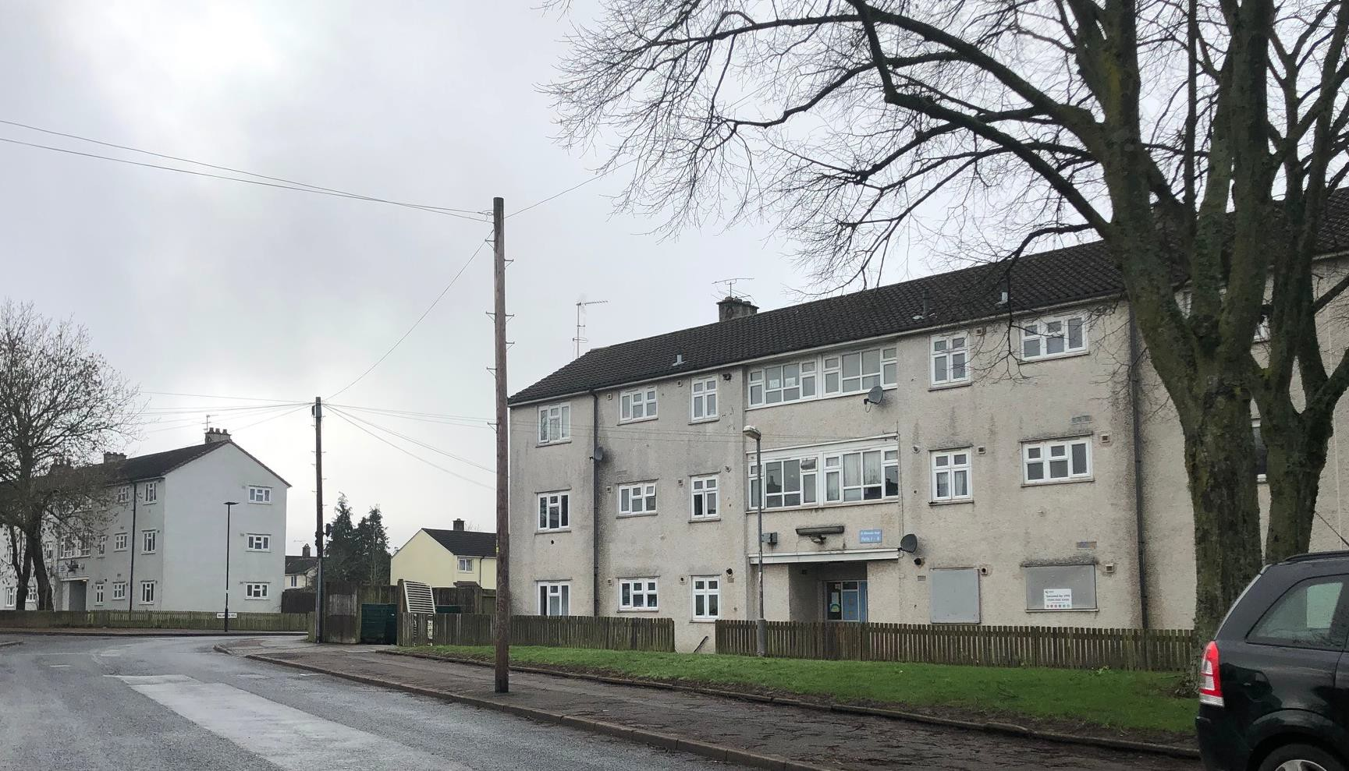
Photo 1: Hillmeads Road
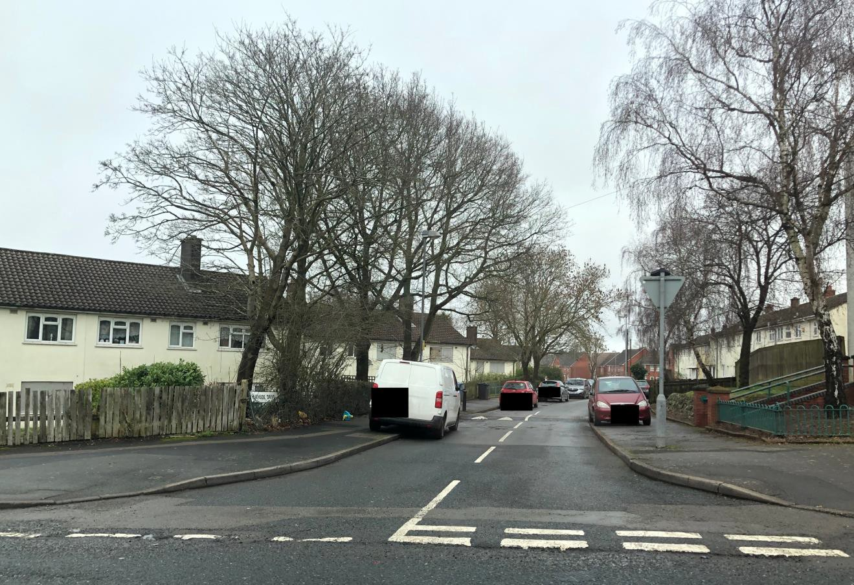
Photo 2: Heathside Drive

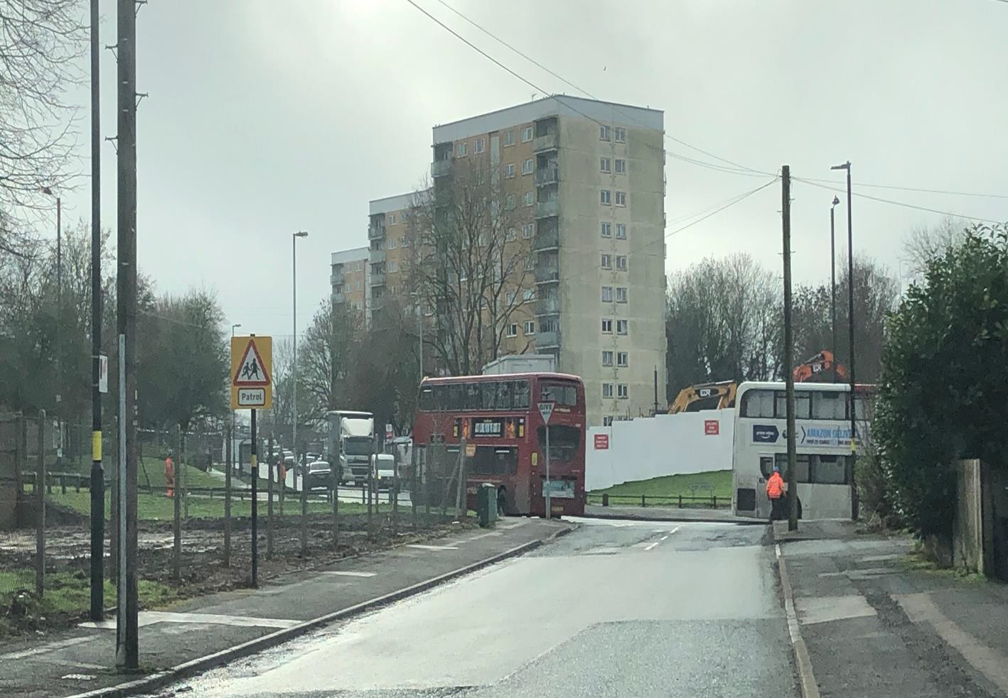
Photo 3: Shannon Road viewed from north

HILLMEADS ROAD SITE
50
79a
79b
227
229
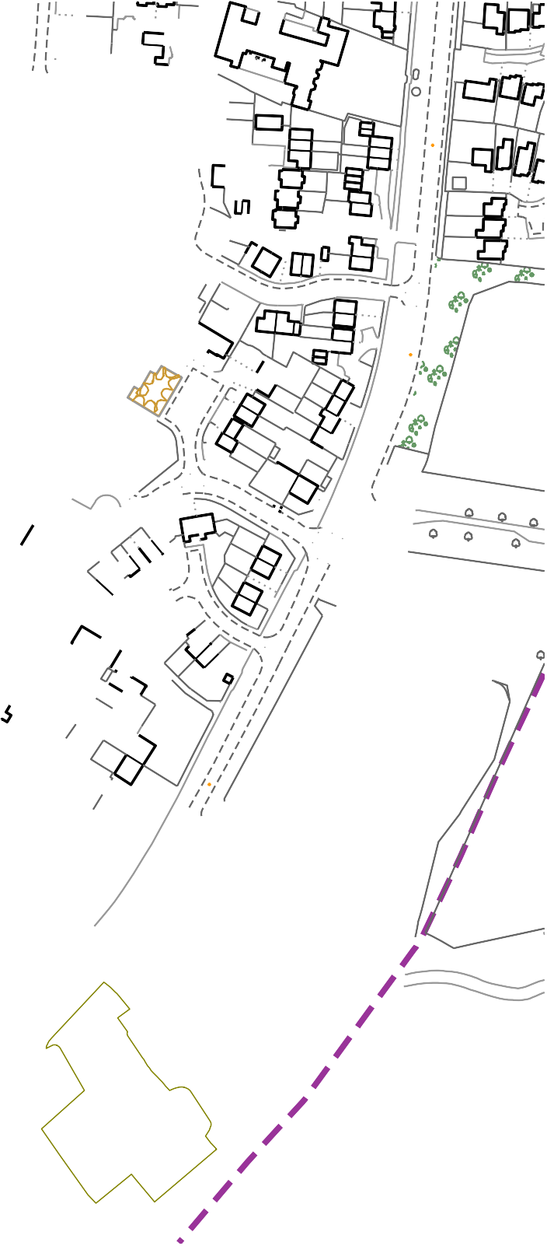
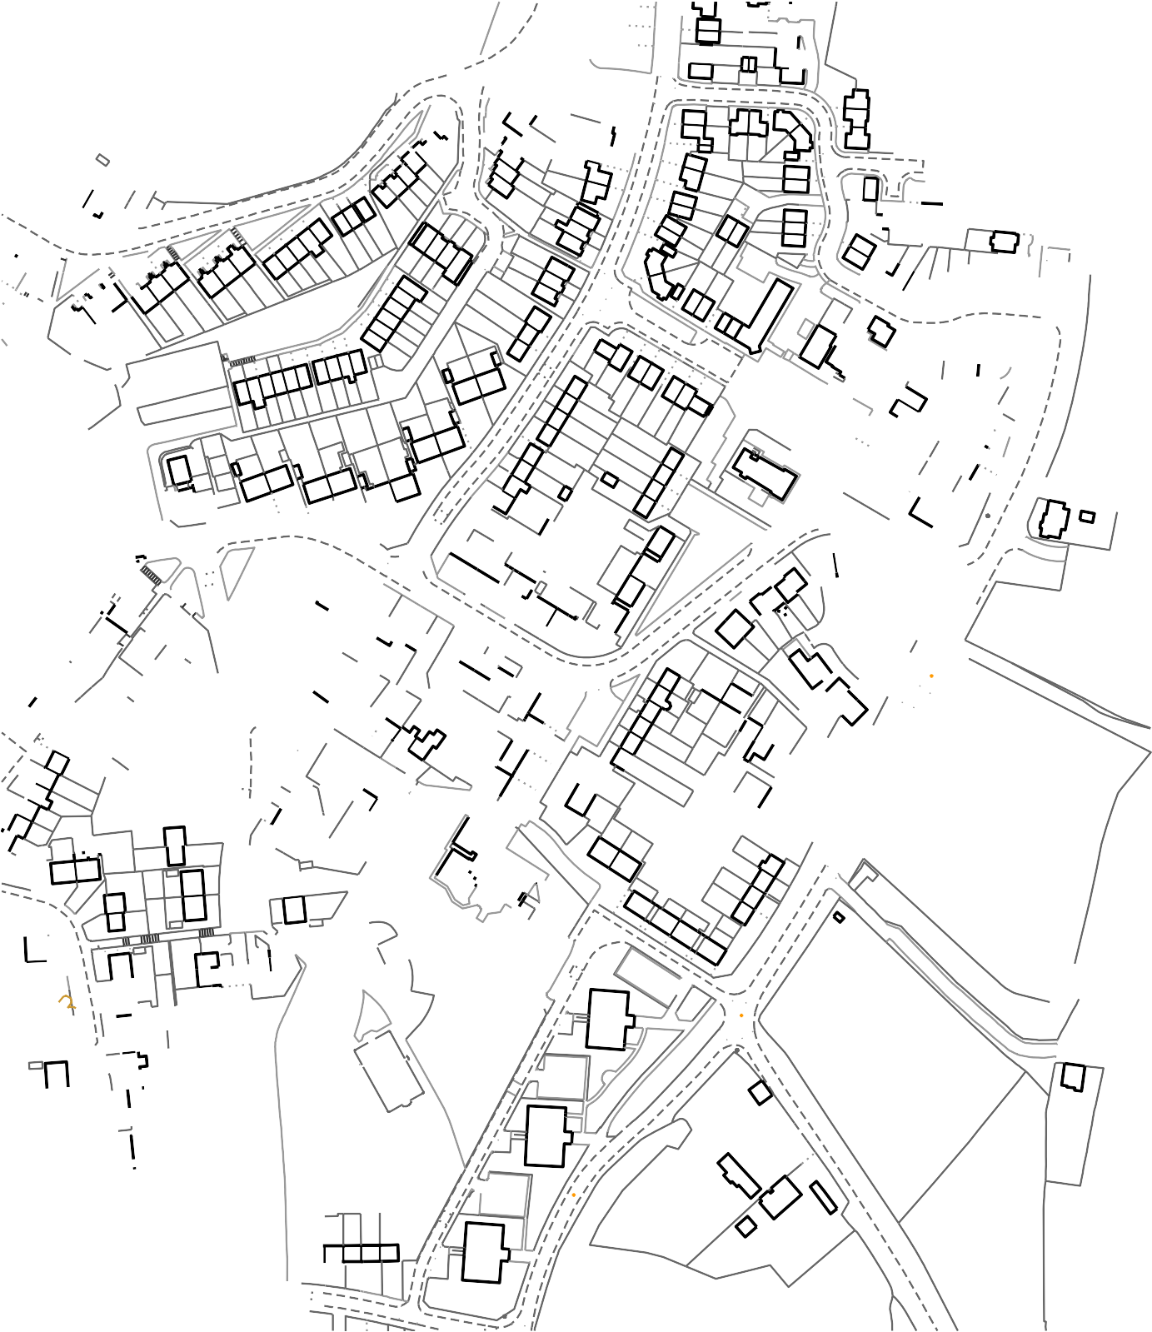
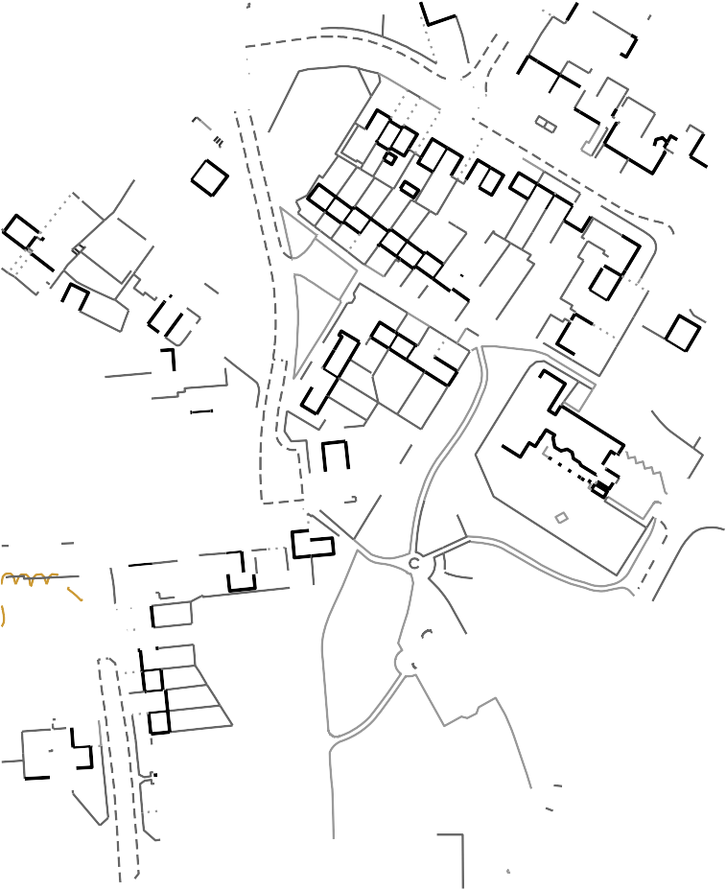
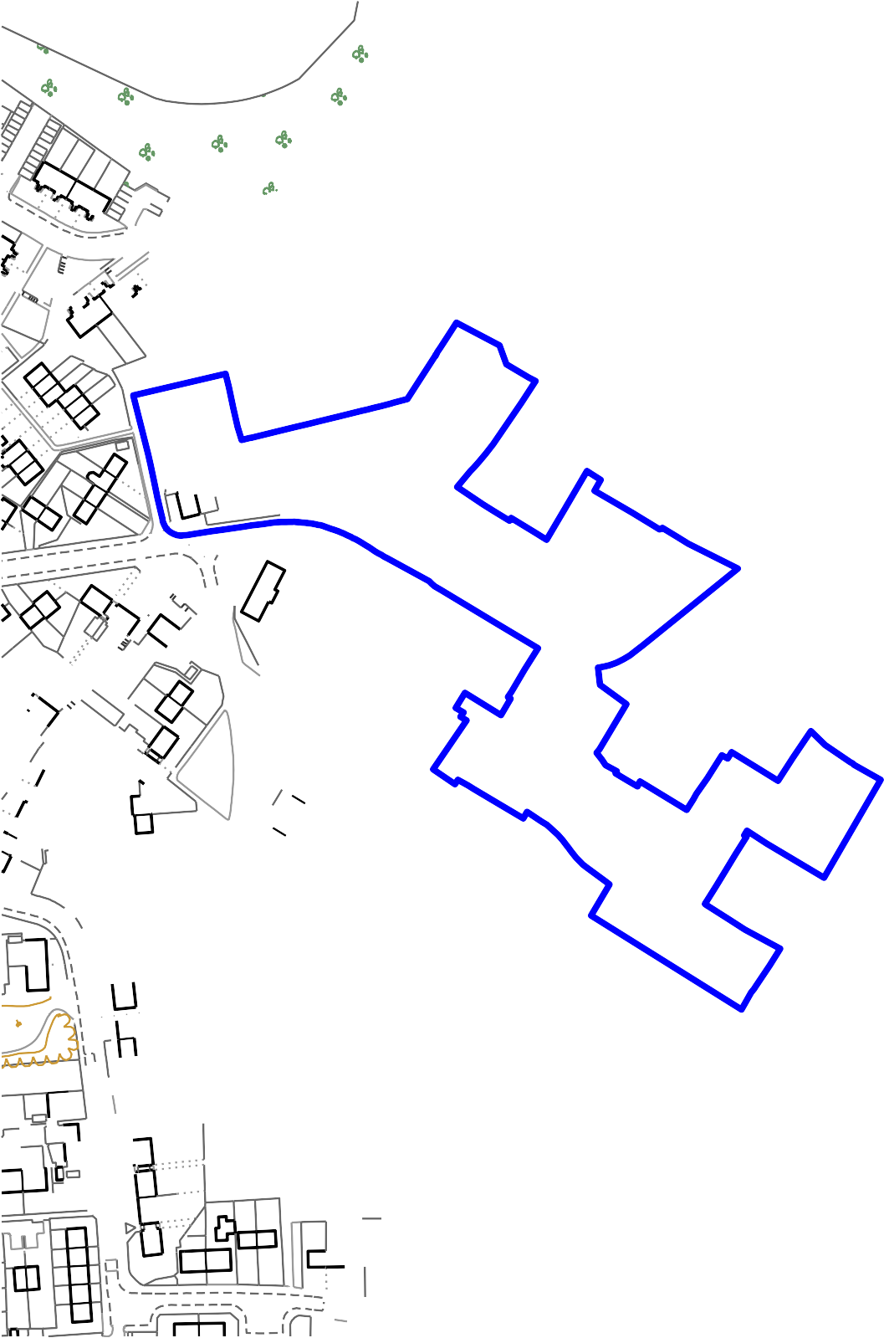
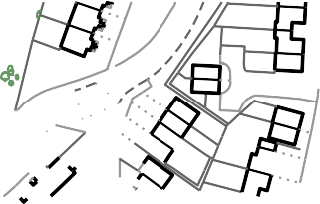

168.0 m
MONKSWAY
53
51
7
1
113
115
125
127
2
6
25
39
52
17
35
56a 56b
54a 54b
16
10
156
160
150
44
10
VISTA
83a
83c 83b
GREEN
77
81
El Sub Sta

El Sub Sta
1
2
MONKSWAY
6
148a
15 11
58b
58a
138
118
120
134
136
104
148
20
8
88
30
25
23
15
21
26
85b
22
85a
87
19
89
91a 91 89
95a 95 93
ARDATH ROAD

169.5 m
1 to 8
32
GREAVES SQUARE
30
8
67
77
Vista Green
36
62
33
102
53
43
6
2
1
11
15
91
93a
93b
95
GREAVES
SQUARE
97
HEATHSIDE DRIVE
101
103
105
Vista Green

Lodge
1
3
Greaves Hall
124
46
76
70
66
TCB
101
21
103
105
27
63 59
65 61
55
57
51
53
119
121
67
69
71

LB
Shelter
Shelter
2
41
37
39
78
70
2
62 62a
64
68
WALKER'S HEATH ROAD
31
29
HILLMEADS ROAD
5 1
7
3

172.1 m
33
35
Little Hill Grove
16
4
22
20
52
CAVENDISH CLOSE
LITTLE HILL GROVE
85
16
26
14
36
18
20
22
24
12
50
48
58a
60a
60
58
56
2
8
7
5
1
3
Met Dist Bd
Co Const
117 111
15
11

173.0 m
9
11
38
44
42
38
40
46
26
23
Und
Boro Const Bdy
123
125
119
121

Nursery (c hildren)
5
7
127
65 61
67 63

El Sub Sta
3
59
40 44
42 46
25
29
31 27
133

Gas Gov ernor
1
53
55
57
50
48
33
96
100
98 102

Play Area
1 to 12
49
51
37
ARROW WALK

174.0 m
14 to 33
47

Sports Court
GP

Waltham Hous e

M ounds ley Park
86
88

Farm Cottage
37
82
84

k ' s H a h Fa m
1 to 12
14 to 33
80
The Arrow Walk Park
35
78

Sandhurs t Hous e
GILDAS AVENUE
70
72
74
76

174.5 m
GAY HILL LANE
33

Th O d
1 to 12
66
23 21
29 25

19
14 to 33
39
37
ICKNIELD STREET
31 27
15 11

Lowes water Hous e

TCB
24
26
30

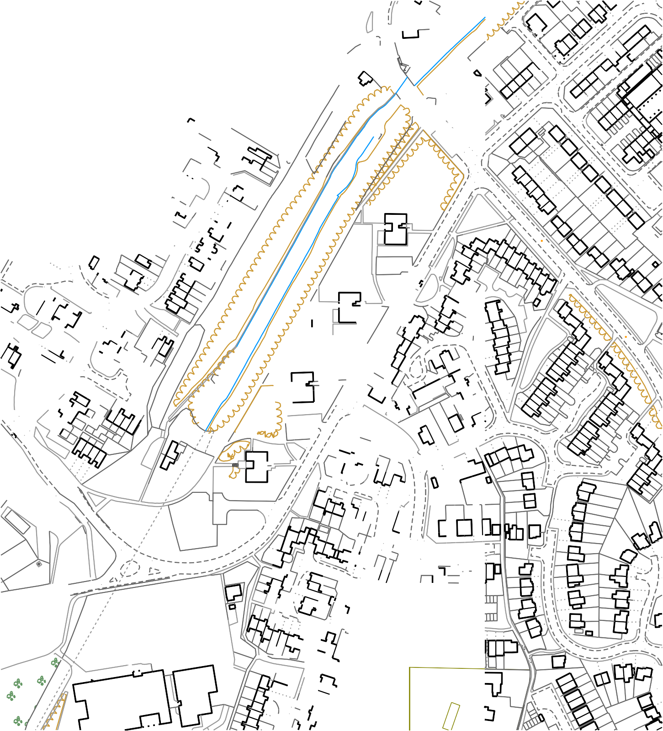
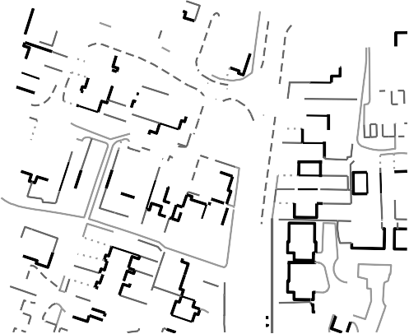
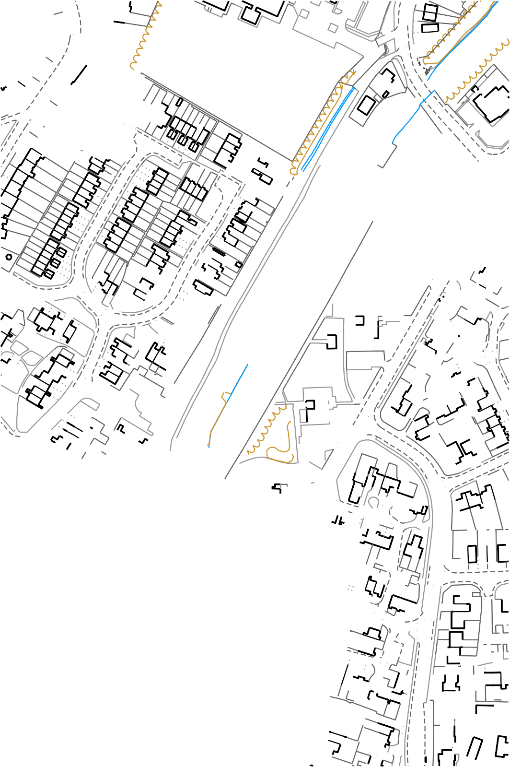
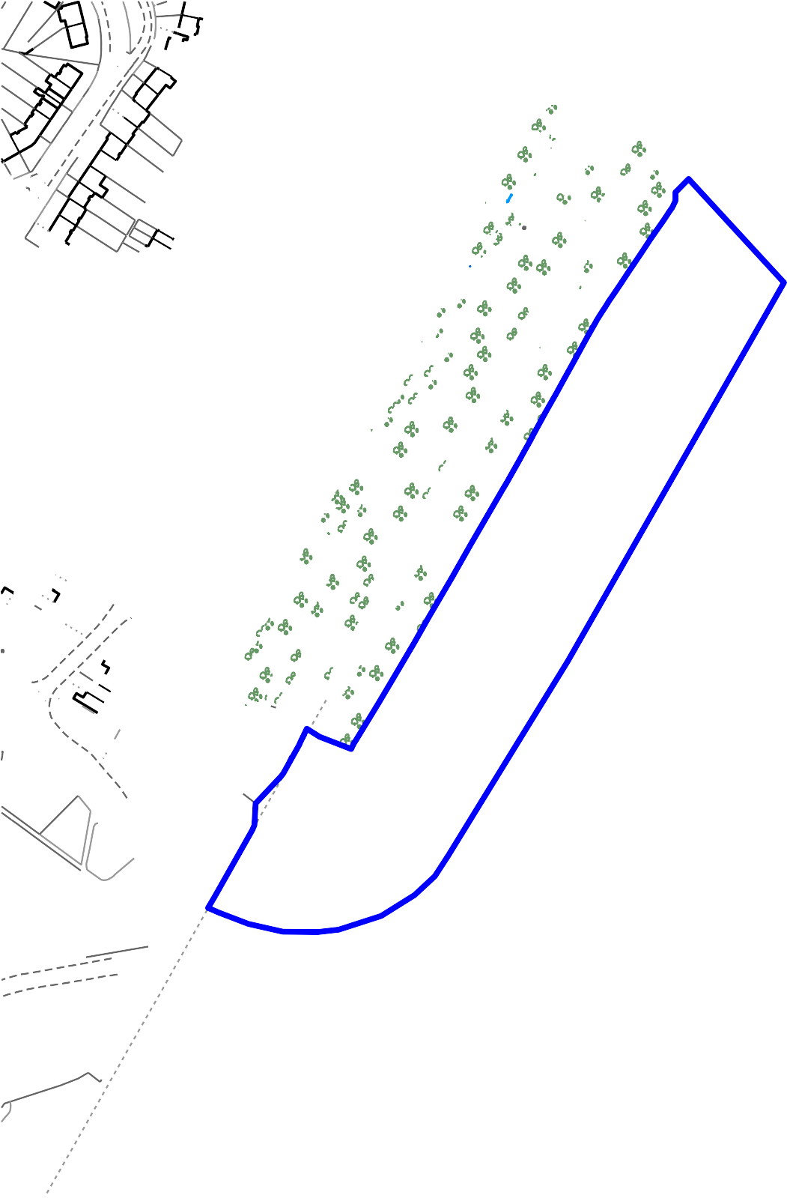
SHANNON ROAD SITE
155
3
35
CANAL SIDE DRIVE
24
24b
26
22b
146.6m

M ass house
45
58
70
PRIMROSE HILL
2
5
40
28
21 19
2
3
1
15
11
GRANSHAW CLOSE
High Bridge
SM
SM
22
SISEFIELD ROAD
21 to 27
29
The Fold
20
10
FB
7
19
9
31

M ast
35
38
36
3
18
34
5
7
1
56
37
62

LB
BENTMEAD GROVE
34
36
125
131
33
123
52
44
1
3
54
48
46
Issues
56

1 to 12
58
54
56
11
15
9
23
113
7
5
26
HALLADALE
Worcester and Birmingham Canal
MASSHOUSE LANE
36
46

14 to 43
Path
34
150.2 m
2
35
70
101
7
43
14
Barberry House

Shelter
PRIMROSE HILL
1
M ELROSE CLOSE
51
20

14 to 43
33
37
27
89
24
14
12
54
58
52 56
SHANNON ROAD
1 to 12
Hall
35
18
2

Burdock House
73
75
20
67
69

150.2 m
22
WARRENS END
15
85
87
22
24
51
53
25
27 29
22 24
26
50
40
4
46
Wigland Way
DORNIE DRIVE
14

LB
24
26
28
2
38
40
21
23
25
34
11
30 32
15
26 30
28 32
38
14
20
2
HAWKMOOR GARDENS
1 to 12
14 to 43

Heather Hous e
19
5
7
38
1
35
37

Shelter
23
HAWKMOOR
82
84
94
96
68
70
66
GARDENS
72
1
2
1
3
74
76
52
44
78
9
11
7
1
1
43
45
5
27
29
Tunnel Cottages
8
2
WARRENS END
25

1 to 12
14 to 43
Lavender Hous e

12
15
COWSLIP CLOSE
19
FOYLE ROAD
61
17
9
7
84
15
18
8
11
23 to 27
72
68
21
21
10
2
MANITOBA CROFT

Wind Turbine
9
15 11
MONKSHOOD RETREAT
49
32
37
66
31 29

Sc hool Hous e
5
1
42
39
30
22
44
29
5
33
1
37
SHANNON ROAD
7

Tom l ins Hous e
29

Walk er Hous e
MARSH
25
54
8
29
21
17
25
10
16
32
40
50
54
37
MEADOWSWEET AVENUE
27
25
CAMPION CLOSE
23
END

Field House
40 42
48
29
38
(Worcester and Birmingham Canal)

ARK Kings Academy

Galletley Hous e
1

El Sub Sta

Edm unds Hous e
15

Shelter
5

Prim ros e Barn

This map is reproduced from the Ordnance Survey Material with the permission of Ordnance Survey on behalf of the Controller of Her Majesty's Stationery Office © Crown Copyright. Unauthorised reproduction infringes Crown Copyright and may lead to prosecution or civil proceedings. Birmingham City Council. Licence No.100021326, 2010

