Report to Planning Committee for Gildas Avenue and Barratts Road
Committee Date: | 04/03/2021 | Application Number: | 2020/08312/PA
Accepted: | 19/10/2020 | Application Type: | Full Planning
Target Date: | 05/03/2021
Ward: King's Norton South

Land at Gildas Avenue, Barratts Road and Bentmead Grove,, Pool Farm, Kings Norton, Birmingham
Full Planning application for residential development of 117 dwellings (C3), open space, new access arrangements and improvements at Barratts Road and Gildas Avenue and associated landscaping
attenuation, infrastructure and ancillary development.

Recommendation

Approve subject to Conditions

- Proposal

  - Full planning permission is sought for 117 dwellings across three development areas within the Pool Farm estate. Existing residential properties in the three areas would be demolished (prior approval already in place) and new houses would be laid out in blocks among the retained properties. Together with a concurrent outline planning application for the erection of up to 150 dwellings (2020/08270/PA) these applications would provide 267 new homes within the estate.

  - Gildas Avenue

    - Two parcels of land totalling 2.87ha.
    - Erection of 74 dwellings as follows:
37 x 2 bed-4 person 18 x 4 bed-7 person
12 3 bed-5 person 7 x 5 bed 8-person
    - Road layout would remain largely the same with some minor alterations to create a more formal cul-de-sac at the southern end of Gildas Avenue and on- street parking bays.
    - Existing substation would be retained.
    - Grassed open space with pedestrian footpath running between Gildas Avenue and Barratts Road would be lost.
    - Trees: 25 trees to be removed: 1 x A category, 2 x B category and 22 x C category.

  - Barratts Road

    - Site area: 1ha.
    - Erection of 28 dwellings as follows:
16 2 bed-4 person 8 x 3 bed-5 person 4 x 4 bed-7 person
    - Existing cul-de-sac to be extended north and west.
    - Trees: 19 tree to be removed: 2 x A category and 17 x C category.

  - Bentmead Grove

    - Site area: 0.54ha
    - Erection of 15 dwellings as follows:
8 x 2 bed-4 person 5 x 3 bed-5 person 2 x 4 bed-7 person
    - Road layout unchanged.
    - Trees: 5 x C category trees to be removed.

  - All of the housing within the development would be affordable housing for social rent.

  - Parking provision: 206 spaces = 176%

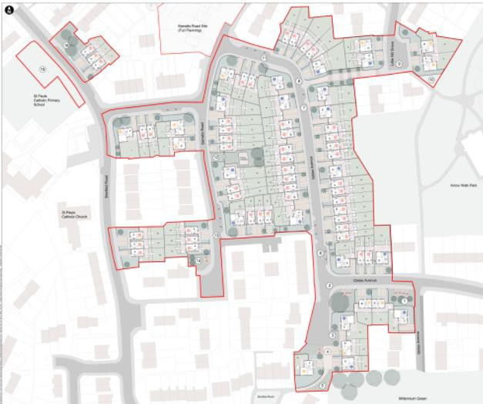
Figure 1: Gildas Avenue site plan

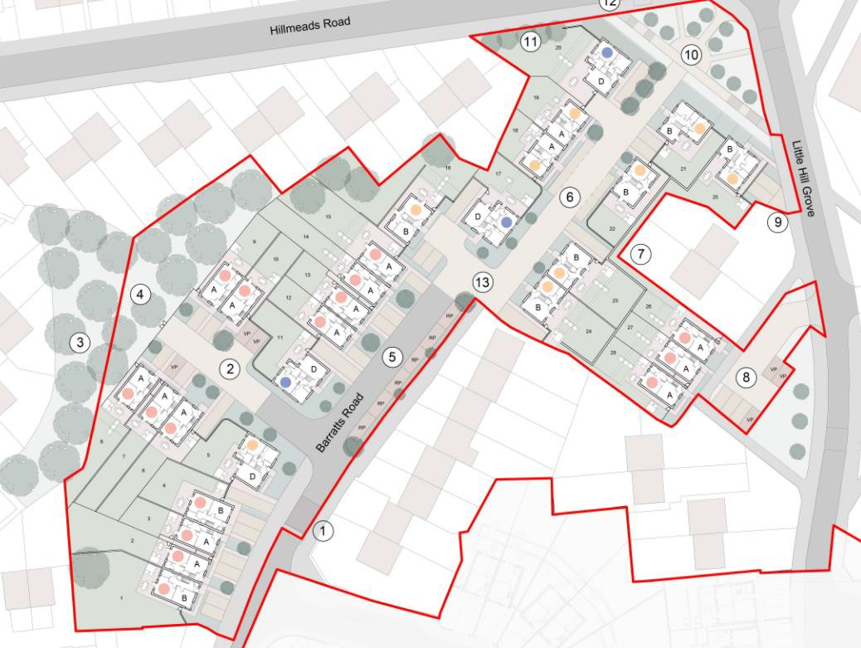
Figure 2: Barratts Road site plan

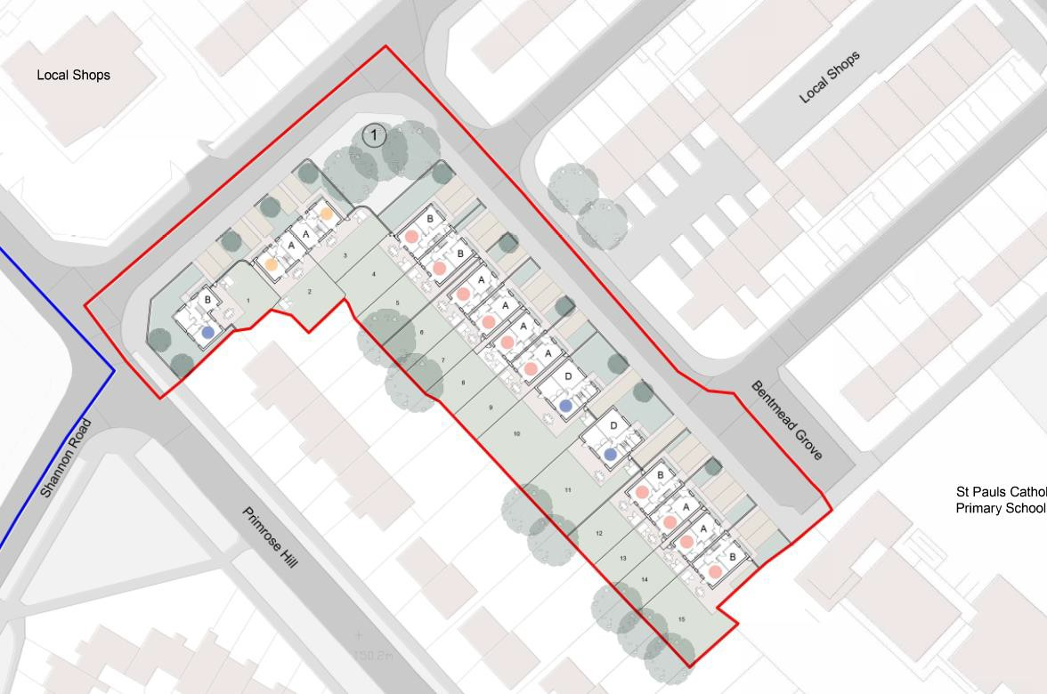
Figure 3: Bentmead Grove site plan

  - Standard BMHT housetypes would be used across the three development areas – see sample elevation below. Internal floorspace would meet the National Technical Standards. Externally, a mix of buff, red and blue bricks would be used according to the context.
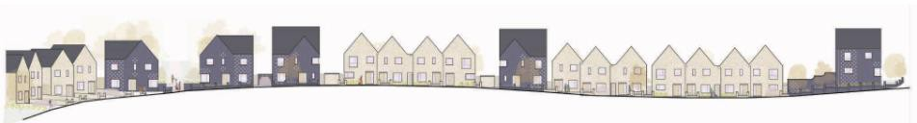
Figure 4: Example streetscene (Gildas Avenue)

  - Supporting documents:
Planning Statement
Statement of Community Involvement
Design and Access Statement
Energy Statement
Sustainable Construction Statement
Utilities Statement
Phase 1 Geoenvironmental Desk Study
Tree Constraints report
Arbirocultural Statement
Preliminary Ecological Statement
Transport Statement
Flood Risk Statement
Air Quality Technical Note
Street Lighting Detailed Design

  - Link to Documents

- Site & Surroundings

  - The application sites form part of the Kings Norton ‘Three Estates’, comprising Primrose, Hawkesley and Pool Farm, where an ongoing regeneration scheme by BMHT and other partners over 20 years is renewing the housing stock and facilitating a shift away from post-war flatted accommodation to traditional family housing. Existing dwellings are mainly two-storey but there are some three-storey maisonettes.

  - Gildas Avenue is the largest of the sites and is bordered by St Paul’s Catholic Church and Primary School, and Arrow Walk Park. A local shopping parade is located to the east of the Bentmead Grove site; beyond this the sites are surrounded by and interspersed with existing housing which would be retained. The ground slopes steeply down from east to west within the Gildas Avenue site. Land to the north on Hillmeads Road and to the west on Shannon Road is the subject of the concurrent application for outline planning permission (2020/08270/PA) for further redevelopment by BMHT.

  - Site location

- Planning History

  - 22/03/2013 – 2013/05430/PA - 32-36 Gildas Avenue - Prior notification for demolition of 32-36 Gildas Avenue – Prior Approval Required and Granted subject to provision of a demolition method statement.

3.2. 11/10/2018 - 2018/03392/PA - Nos. 25-31, 42-48, 49-55, 61-67, 70-76, 82-88 and
Blocks 33 & 35 Gildas Avenue - Application for prior notification of proposed demolition of existing flats, houses and maisonette blocks – Prior Approval Required

and Granted subject to provision of a method statement and implementation in accordance with recommendations regarding bats.

3.3. 26/09/2019 – 2019/06477/PA - Nos. 20 & 22, 24-30 (evens), 38 & 40, 57 & 59, 37-
47 (odds), 78 & 80, 96-102 (evens) Gildas Avenue; 59-65 (odds) Barratts Road;
Blocks 1 (1-6), 3 (1-6), 5 (1-6) & 7 (1-6) Bentmead Grove; 25-31 (odds) & 40-46 (evens) Little Hill Grove; and 1-7 (odds) Sisefield Road - Application for Prior Notification of proposed demolition of existing flats, houses and maisonette blocks – Prior Approval Required and Granted subject to implementation of a precautionary approach regarding bats.

3.4. 19/10/2020 - 2020/08270/PA - Land at Shannon Road and Hillmeads Road - Outline application for residential development of up to 150 dwellings (C3), open space, creation of three new accesses off Shannon Road, new access arrangements via Hillmeads Road, and associated landscaping attenuation, infrastructure and ancillary development – Awaiting decision.

- Consultation/PP Responses

  - Transportation Development: No objection subject to minor amendments and condition regarding pedestrian visibility splays.

  - Regulatory Services: No objection subject to conditions as follows:

    - Noise and Vibration Assessment to be carried out to safeguard habitable rooms and outdoor living spaces from excessive traffic noise.
    - Submission of Construction Method Statement/Management Plan
    - Submission of Contamination Remediation Scheme and Contaminated Land Verification Report.

Conclusions of Air Quality Technical Note are broadly agreed with; no significant net effect on air quality expected and any temporary effect during construction could be dealt with by condition. Development is not within an area known to Regulatory Services to have high concentrations of nitrogen dioxide. Phase 1 Geoenvironmental Desk Study identifies the likely presence of ground contamination/ground gas and proposes further intrusive survey work secured by condition. Some of the proposed properties e.g. on Bentmead Grove and Gildas Avenue, would be located in areas currently affected by high levels of road traffic noise and will require mitigation such as acoustic glazing.

  - Leisure Services: In accordance with BDP policy TP9, a financial contribution towards off-site Public Open Space and play area provision should be made. Noting the net loss of dwellings, a calculation in the normal way would not be appropriate, however, given the number of family units proposed, a contribution of £90,000 should be made for the provision, improvement and/or biodiversity enhancement of green infrastructure and play. Also, the exact line and nature of the new boundary treatment proposed between the new housing and Arrow Walk Park should be agreed with Leisure Services prior to installation to ensure the its long term robustness and to protect existing trees along the boundary of the park. No access or use of park land will be permitted during the construction period.

  - Education (School Places): Financial contribution of £643,561.67 requested towards the provision of school places (nursery, primary and secondary) based on the number and size of the proposed dwellings.

  - Birmingham Public Health: No response received.

  - Employment Access Team: No objection subject to a condition requiring a Construction Employment Plan.

  - Lead Local Flood Authority: No objection subject to conditions requiring a surface water drainage scheme and a Sustainable Drainage Operation and Maintenance Plan.

  - Severn Trent Water: No objection subject to a condition requiring drainage plans for the disposal of foul and surface water.

  - Environment Agency: No response received.

  - Canal and River Trust: No objections raised however conditions are requested to promote the use of the canal by local residents:

    - Wayfinding and signage to be provided within the public realm created by the development.
    - Secure, easily accessed and used cycle parking for residents and visitors.
    - Promotion of the canal as a sustainable means of access to other areas through travel plans.
    - Financial contribution towards the improvements to the Masshouse Lane/Primrose Hill access point.

  - The Ramblers: No response received.

  - West Midlands Police: No objection.

  - West Midlands Fire Service: No objection.

  - Site and press notices posted and local MP, Councillors, Residents’ Associations and the occupiers of nearby dwellings notified of the application; the following responses received:

Gary Sambrook MP:
    - More large family housing should be proposed to meet local need.
    - A more comprehensive development should be proposed in the area to tackle more of the housing which is in a very poor state of repair.
    - Existing residents of the estate and the local area must be given a right to return as part of the redevelopment and therefore prioritised when placing people in the new housing.
    - The Council should invest in improvements to open up the canal which could be a real feature for the area.
    - The design of the housing should reflect the key design features of the wider Kings Norton area to tie the new housing together and into the wider community.
    - At Barratts Rd site, the design should prevent vehicles from being able to cross the open space to access the road.
    - Proposals for Bentmeads Grove are supported but should include further houses that are in need of redevelopment.
    - At Gildas Avenue, retention of bungalows is supported to meet local demand. Other properties should be included in this proposal.

1 letter from a local resident wanting to know further details about the proposed road layout and whether remaining housing stock will also be improved.

- Policy Context

  - Birmingham Development Plan 2017
Birmingham Unitary Development Plan 2005 (saved policies) Development Management in Birmingham DPD Publication Version 2019 Places for Living SPD 2001
Car Parking Guidelines SPD 2012 Kings Norton Planning Framework 2009

NPPF; NPPG; National Design Guide.

- Planning Considerations

  - In conjunction with the concurrent application for outline planning permission (2020/08270/PA), a total of 418 dwellings across the Pool Farm estate, mostly Council-owned, would be demolished and replaced with 267 new dwellings, with a net loss of 151 dwellings.

  - The Kings Norton Three Estates are identified in BDP policy TP32 as being one of the initial priority areas for regeneration and renewal of existing housing. The proposal accords with this policy and would make a positive contribution to meeting the housing needs of the city and to the regeneration of a priority area.

Housing mix
  - Proposed dwelling mix:

61 x 2-bed houses (52%)
25 x 3-bed houses (21%)
24 x 4-bed houses (21%)
7 x 5-bed houses (6%)

  - The Strategic Housing Market Assessment (SHMA) (2012, revised 2013) indicates that the greatest demand across the city is for 2 bedroom dwellings (30.8%) followed by 4 beds (28.1%) then 3 beds (26.3%). The proposed mix, which concentrates on 2, 3 and 4 bed dwellings, seeks to balance national and local planning policy requirements, particularly the efficient use of land, the need for family dwellings, and the capacity and requirements for the regeneration of the site. This development would include some larger family dwellings, which would provide a good balance with the concurrent application for outline permission, which includes some 1 and 2 bedroom apartments.

Density and layout
  - BDP Policy TP30 sets the requirements for the type, size and density of new housing, based on the SHMA. TP30 sets a target density of 40dph in this location. The site layouts show densities ranging from 29-31dph, which is considered to be an acceptable range given the topographical challenges posed by the site and the emphasis on the provision of family housing.

Gildas Avenue layout
  - Ground levels are a key constraint here, with a steep slope down from east to west, however, the layout comprises the following significant and positive features:

    - Perimeter block approach with frontages facing public streets and back gardens enclosed within blocks.

    - Stronger, more coherent building line creating improved street enclosure, natural surveillance and definition of public and private space.
    - Wider, more open and better overlooked pedestrian routes.
    - Positive sense of place through the grouping of house types, treatment of corners and retention of some important landmark trees.
    - Areas for soft landscaping within frontages are of a size to be sustainable and support tree planting.

  - There are some minor shortfalls in Places for Living separation distances, in the order of 2-3m, mostly on corners and affecting proposed dwellings only. The most significant issue is the distance between windowed side elevations across the pedestrian route from Gildas Avenue to Little Hill Grove (8m instead of 21m) however this would bring increased surveillance of the footpath which is particularly important in this location. There are also significant level changes and terracing within rear gardens which may result in a sense of enclosure due to high retaining walls and boundary fencing. This is not ideal but it is more appropriate to deal with the site’s topographical changes within rear gardens so that the public realm can be more hospitable.

Barratts Road layout
  - The proposed layout would benefit from the following features:

    - Perimeter block approach.
    - Stronger and more coherent building line on Barratts Road.
    - Good use of deeper areas of the site by creating a short cul-de-sac of Barratts Road.
    - Opening up of the pedestrian route between Barratts Road and the Hillmeads Road junction, improving accessibility and surveillance.
    - A better sense of arrival at the end of the existing cul-de-sac through the grouping of houses.
    - Areas for soft landscaping within frontages of a size to be sustainable and support tree planting.
    - Retention of a tree belt to the west boundary of the site with the area secured and maintained by the Council.

  - It is noted that front-to-front separation distances are short of the guidance in Places for Living, in the order of 13m instead of 21m. However, Places for Living allows greater flexibility in front-to-front situations and the placement of dwellings would create a positive change of street character and give greater overlooking of the pedestrian route. The proximity of Plots 16, 18 and 19 to existing rear garden boundaries on Hillmeads Road (6-9m from new rear elevations) would be a tighter arrangement than is desirable. However, this part of Barratts Road currently comprises three-storey maisonettes so the proposed two-storey development would see a reduction in height when viewed from existing properties. Significant level changes and terracing within rear gardens are not ideal but it is more appropriate to deal with the site’s topographical changes within rear gardens so the public realm can be more hospitable.

Bentmead Grove layout
  - The proposed layout would benefit from the following features:

    - Perimeter block approach.
    - Strong and coherent building line created through a mix of semi-detached and detached houses.

    - An L-shaped house to turn the corner of Primrose Hill and Sisefield Road with active elevations onto both streets.
    - Retention of prominent mature trees on the corner of Bentmead Grove and Sisefield Road.

  - Garden sizes throughout the development would meet Places for Living numerical guidelines.

  - This is a challenging development to lay out given the constraints in terms of changing ground levels and the need to fit in around retained dwellings, however, overall the result would be a development which would be legible, feel safe and have a distinctive character and positive sense of place.

Scale, massing and design
  - All of the dwellings proposed would be two-storey and the combination of detached, semi-detached and terraced properties would give a typical suburban character and accord with the scale of the existing dwellings amongst which the new development would be interspersed.

  - Standard BMHT housetypes are proposed and represent a good quality of accommodation. All comply with the Government’s Technical Housing Standards internally. The housetypes would be customised to provide a coherent and distinctive identity for the streets. Projections in the brick would provide texture, and the contrasting brick colours would provide interest and decoration.

  - There are some instances where overlooking has been avoided by providing blank elevations at first floor, e.g. Plot 3 on the Bentmead Grove site, or very small windows serving stairs or bathrooms. While this is not ideal, this situation is limited throughout the sites and is justified by improvements to the overall layout of the development.

  - Buff and yellow brick colours are proposed in some locations, with red brick in others. The surrounding area is predominantly red brick, however some new BMHT developments have introduced buff into the colour palette of the area. Following discussion, choice of brick colour would now reflect the immediate context to ensure that where the development fits in around retained dwellings, a harmonious streetscene would result. Judicious use of blue brick would highlight key plots and gateways into the site.

Trees/Landscaping/Ecology
  - Trees: In total, 49 trees would be removed including 3 A-category and 2 B-category. While this is unfortunate, there is no objection since many are currently within rear gardens and their loss would facilitate the much improved layout of dwellings. A total of 105 replacement trees are proposed.

  - Landscaping: A Landscape Design Strategy detailing likely species is supported. Space for new and replacement tree and shrub planting would be limited within some frontages so where there is space, this should be maximised with suitable species, planting beds and root volumes and conditions are attached to secure these.

  - Ecology: The Preliminary Ecological Appraisal indicates that overall site conditions are of a moderate to low biodiversity value, being amenity grass and gardens of varying quality. Impacts on bats are likely through demolition, and site clearance and construction may affect nesting birds and terrestrial mammals. Conditions are

attached to secure a Construction Ecological Mitigation Plan and ecological enhancement measures.

Access, parking and highway safety
  - There are no objections to proposed alterations to the road layout, to general traffic movement or parking provision. Parking would be provided at a ratio of 1 space per 2-bed units and 2 spaces for all other housetypes, plus some additional visitor parking. Total number of parking spaces would be Detailed concerns regarding some specific parking spaces have been addressed through amended plans. Stopping up orders under S247 of the Town and Country Planning Act 1990 are necessary due to the alteration of Barratts Road and Gildas Avenue; the appropriate resolution is set out below.

Sustainability
  - In broad terms, and notwithstanding the net loss in the number of dwellings, the proposal would meet sustainability objectives; the site is located within the existing urban area, is suitably dense whilst maintaining and reinforcing the positive characteristics of the surroundings, and would regenerate an area of poor quality housing. Passive design and enhanced insulation could be achieved on the site and the proposal therefore complies with BDP policy TP3 (Sustainable Construction).

  - The Energy Statement predicts energy demand and CO2 emissions, following the proposed passive design measures and enhanced thermal efficiency reductions, of between 3-6% from the baseline across the various development plots. Solar photovoltaics are considered to be a viable option with estimated reductions in total energy requirements of around 25%. The Energy Statement is acceptable subject to a condition requiring the location of low/zero carbon energy source equipment to be shown on site plans prior to commencement of the development.

Flood Risk and Drainage
  - The site falls within Flood Zone 1 and there is very low risk of fluvial flooding from rivers. Surface water flood risk is very low across most of the site, based on Environment Agency mapping however there are small areas of low, medium and high risk in the Bentmead Grove site and within and to the west of the Gildas Avenue site. In these areas built development would be avoided, internal floor levels raised more than 150mm where necessary, and new sustainable drainage features and drainage connections would be introduced. The scheme would increase the impermeable area present within the site however a Drainage Strategy demonstrates how run-off would be managed and attenuated, through underground sustainable drainage storage features, to avoid increasing flood risk downstream. There are no objections from either the Environment Agency or the LLFA and the recommended conditions are attached.

Impact on residential amenity
  - Noise: No new noise sources would result from this proposal however some of the proposed dwellings, such as those on Bentmead Grove and Gildas Avenue, would be located in areas known to Regulatory Services to be affected by high levels of road traffic noise at present. A condition is attached requiring a noise assessment to demonstrate that habitable rooms and outdoor living spaces would not suffer from excessive noise or vibration.

  - Air Quality: The Air Quality Technical Note indicates that the main source of air pollution within the city is traffic. The amount of traffic generated in the vicinity of the application site is expected to decrease due to the net reduction in the number of dwellings. Coupled with the ongoing improvements to vehicles, the replacement of

older vehicles and continued encouragement of the use of alternative modes of travel, air quality in the Pool Farm area is expected to improve. A condition requiring a Construction Management Plan is attached and would ensure, among other things, that construction dust is minimised.

  - Contaminated Land: The Geoenvironmental Desk Study indicates the likely presence of ground contamination and ground gas from made ground principally associated with construction and demolition activities. Further survey work and a remediation strategy are needed and the conditions recommended by Regulatory Services to secure these are attached.

Impact on heritage assets
  - The development is not expected to impact on heritage assets and no further archaeological work is required.

Community Infrastructure Levy/Planning Obligations
  - CIL: The site does not fall within a charging zone so no CIL is payable.

  - Education: The development is not large enough to generate demand for a new school or form entry and therefore no contribution is required.

  - Affordable housing: BDP Policy TP31 seeks 35% affordable homes on residential developments of 15 dwellings or more, unless it can be demonstrated that this would not be viable. All of the 117 dwellings proposed in this development would be allocated for social rent. The Affordable Housing Statement reports that the Council’s waiting list data shows significant unmet need for social housing in the Kings Norton wards, with less than 50% of the need met for 2, 3 and 4 bedroom properties. The proposal would help to address that need.

  - Open Space: BDP policy TP9 seeks to protect open space from development other than in specific circumstances and requires new residential development to provide additional open space. In this case, there would be an increase of 200sqm of open space between the Barratts Road and Bentmead Grove sites, but a loss of 3,200sqm at the Gildas Avenue site. Leisure Services suggests, given the net loss of dwellings, a sum equivalent to the cost of a toddler play area (£90,000) be paid to improve Arrow Walk Park and Walkers Heath Park. No contribution is offered and instead the application is supported by a report detailing the full costs of the proposal, with the following written justification:

    - there would be a net loss of dwellings;
    - the costs of the development are inflated by the difficult topography across the sites and the provision of larger family houses; and
    - BMHT is already funding the new Primrose Park as part of an earlier phase of the overall regeneration scheme.

  - It is regrettable that the development cannot better support the provision of open space however, on balance, the proposal is considered acceptable taking account of the justification offered and the following factors:

    - the open space to be lost is not formally laid out as a park or play area;
    - loss of the open space would facilitate a much improved layout; and
    - good quality affordable housing is greatly needed in this area.

Other issues

  - Security: West Midlands Police has no objection but recommends that lighting and landscape maintenance plans are required to ensure safety within the development. Suitable conditions are attached.

  - Canal and River Trust: A number of conditions and requests are made promoting use of the canal by residents. I have considered these requests against paras. 54- 56 of the NPPF, which set out tests for planning conditions and obligations, and I do not consider them necessary to make the development acceptable in planning terms. The canal is outside of the application site and the application proposes a net loss of dwellings; it seems unlikely, therefore, that there would be a significant increase in the number of people using the canal as a result of this development.

  - Public participation comments: Concerns raised by the local MP, Gary Sambrook, are noted, in particular that a more comprehensive development should be proposed and there are too many apartments and not enough large family houses proposed. The comprehensive nature of the scheme has been influenced firstly by the type of accommodation, with the aim being to remove all low rise flats and leave houses which are in good repair; and secondly by the number of properties where owners have exercised the right to buy; including these dwellings would substantially increase the cost of the scheme. In respect of the size of units proposed, a good number of larger family dwellings, including 4 and 5-bedroom properties would be provided within this development.

- Conclusion

  - The proposed development would make a positive contribution to the Three Estates regeneration programme, providing affordable, good quality family-sized dwellings in a much improved layout

- Recommendation

  - (i) That no objection is raised to the stopping-up of Barratts Road and Gildas Avenue and that the Department for Transport (DFT) is requested to make an Order in accordance with the provisions of Section 247 of the Town and Country Planning Act 1990.

  - (ii) That planning permission is APPROVED subject to the conditions listed below.

1 | Requires the scheme to be in accordance with the listed approved plans
2 | Requires the scheme to be in accordance with the listed approved plans
3 | Requires the scheme to be in accordance with the listed approved plans
4 | Non-standard - restricts implementation to BMHT
5 | Implement within 3 years (Full)
6 | Requires all dwellings to be for Social Rent
7 | Requires the prior submission of a phasing plan
8 | Requires the prior submission of a construction method statement/management plan

9 | Requires the prior submission of a Construction Employment Plan
10 | Requires the prior submission of contamination remediation scheme on a phased basis
11 | Requires the submission of a contaminated land verification report
12 | Secures noise and vibration levels for habitable rooms
13 | No development shall take place on a particular phase of development until a surface water drainage scheme for the phase, based on sustainable drainage principles and an assessment of the hydrological and hydro geological context of the development, has been submitted to and approved in writing by the Local Planning Authority. The scheme shall be implemented in accordance with the approved details before the development is completed and thereafter maintained .
14 | Requires the submission prior to occupation of the properties of a Sustainable Drainage Assessment and Sustainable Drainage Operation and Maintenance Plan
15 | Requires the prior submission of earthworks details in a phased manner
16 | Requires the prior submission of a construction ecological mitigation plan on a phased basis
17 | Requires the submission of a scheme for ecological/biodiversity/enhancement measures
18 | Requires the prior submission of details of bird/bat boxes
19 | No commencement until pre-commencement tree meeting held
20 | Requires the submission of hard and/or soft landscape details
21 | Requires the submission of hard surfacing materials
22 | Requires the submission of boundary treatment details in a phased manner
23 | Requires the submission of a landscape management plan
24 | Arboricultural Method Statement and Tree Protection Plan - Implementation
25 | Requires tree pruning protection
26 | Requires the submission of a lighting scheme in a phased manner
27 | Requires the submission of sample materials in a phased manner
28 | Requires specific architectural details to be provided
29 | Requires pedestrian visibility splays to be provided

Case Officer: Amy Stevenson

Photo(s)

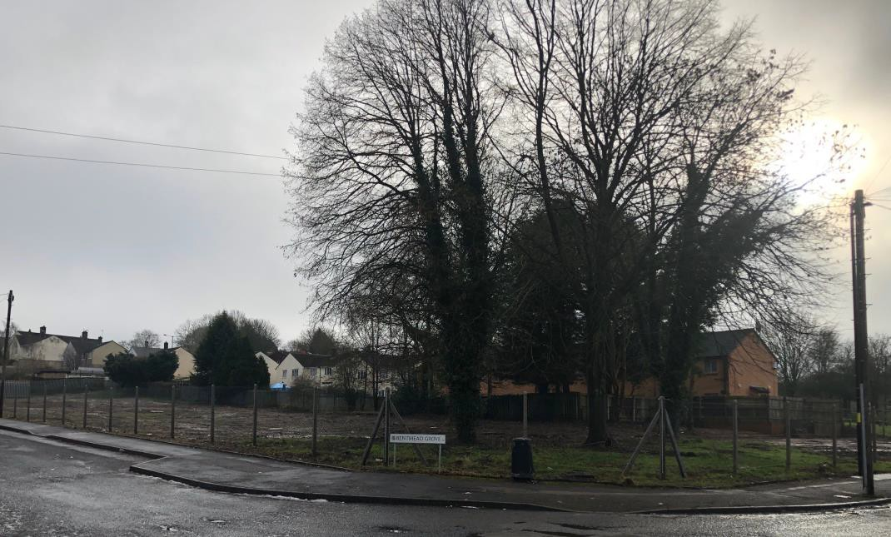
Photo 1: Bentmead Grove – cleared site

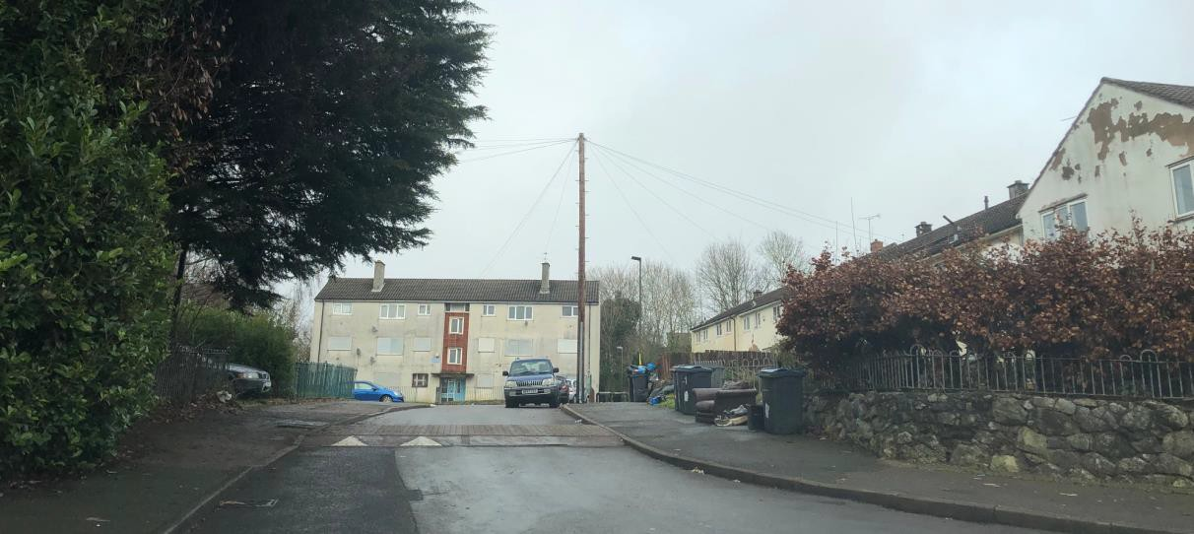
Photo 2: Barratts Road – looking north
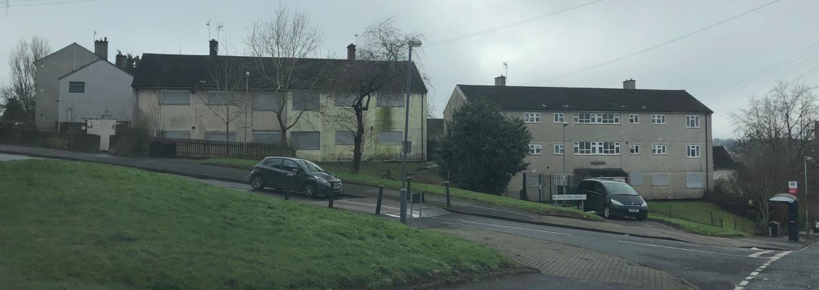
Photo 3: Hillmeads Road/Little Hill Grove

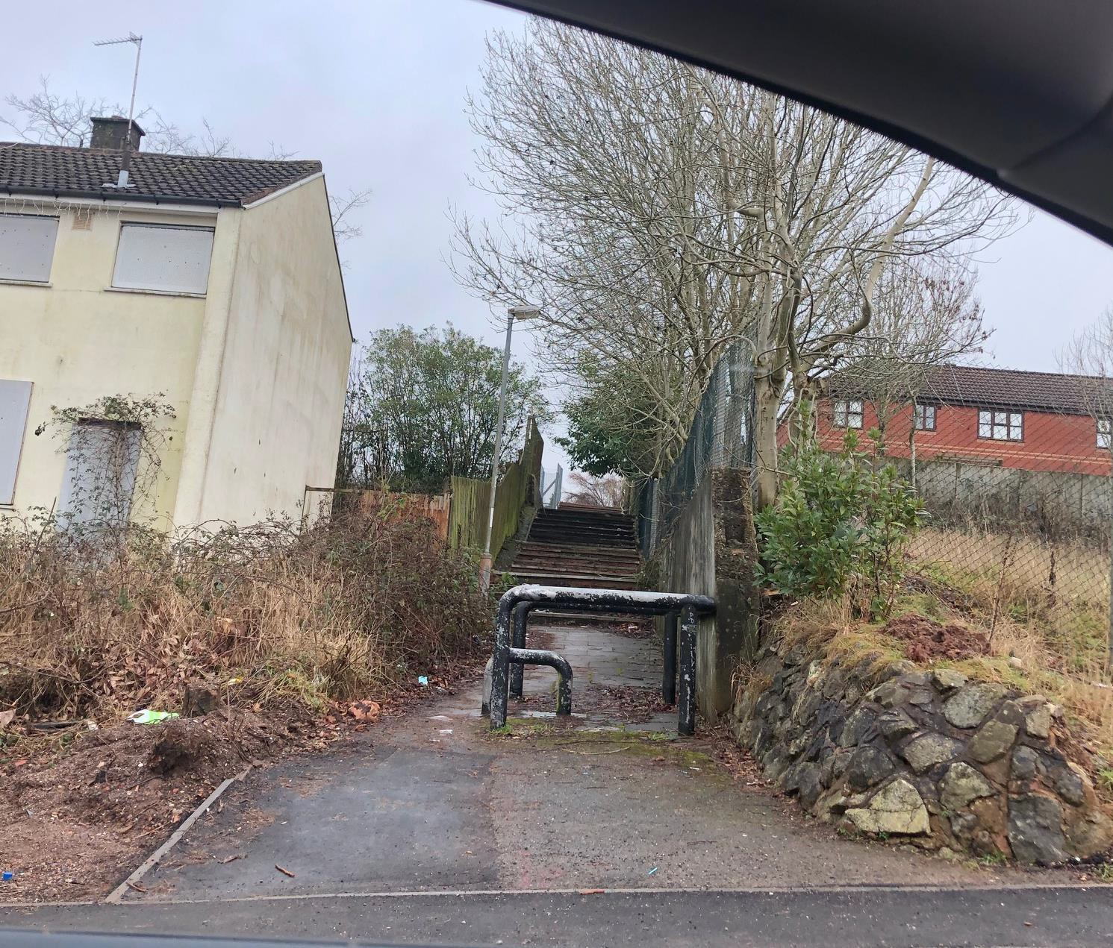
Photo 4: Gildas Avenue – pedestrian route to Little Hill Grove

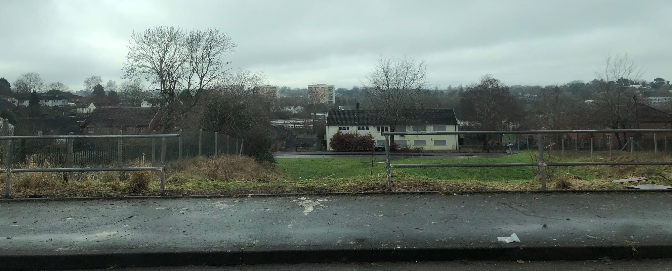
Photo 5: Gildas Avenue looking west

Location Plan
20
19
54
22
21
33
57
21
43
45
118
120
102
104
98
100
25
3
41
31
84
78
33
18
PINEWALL AVENUE
Vista Green

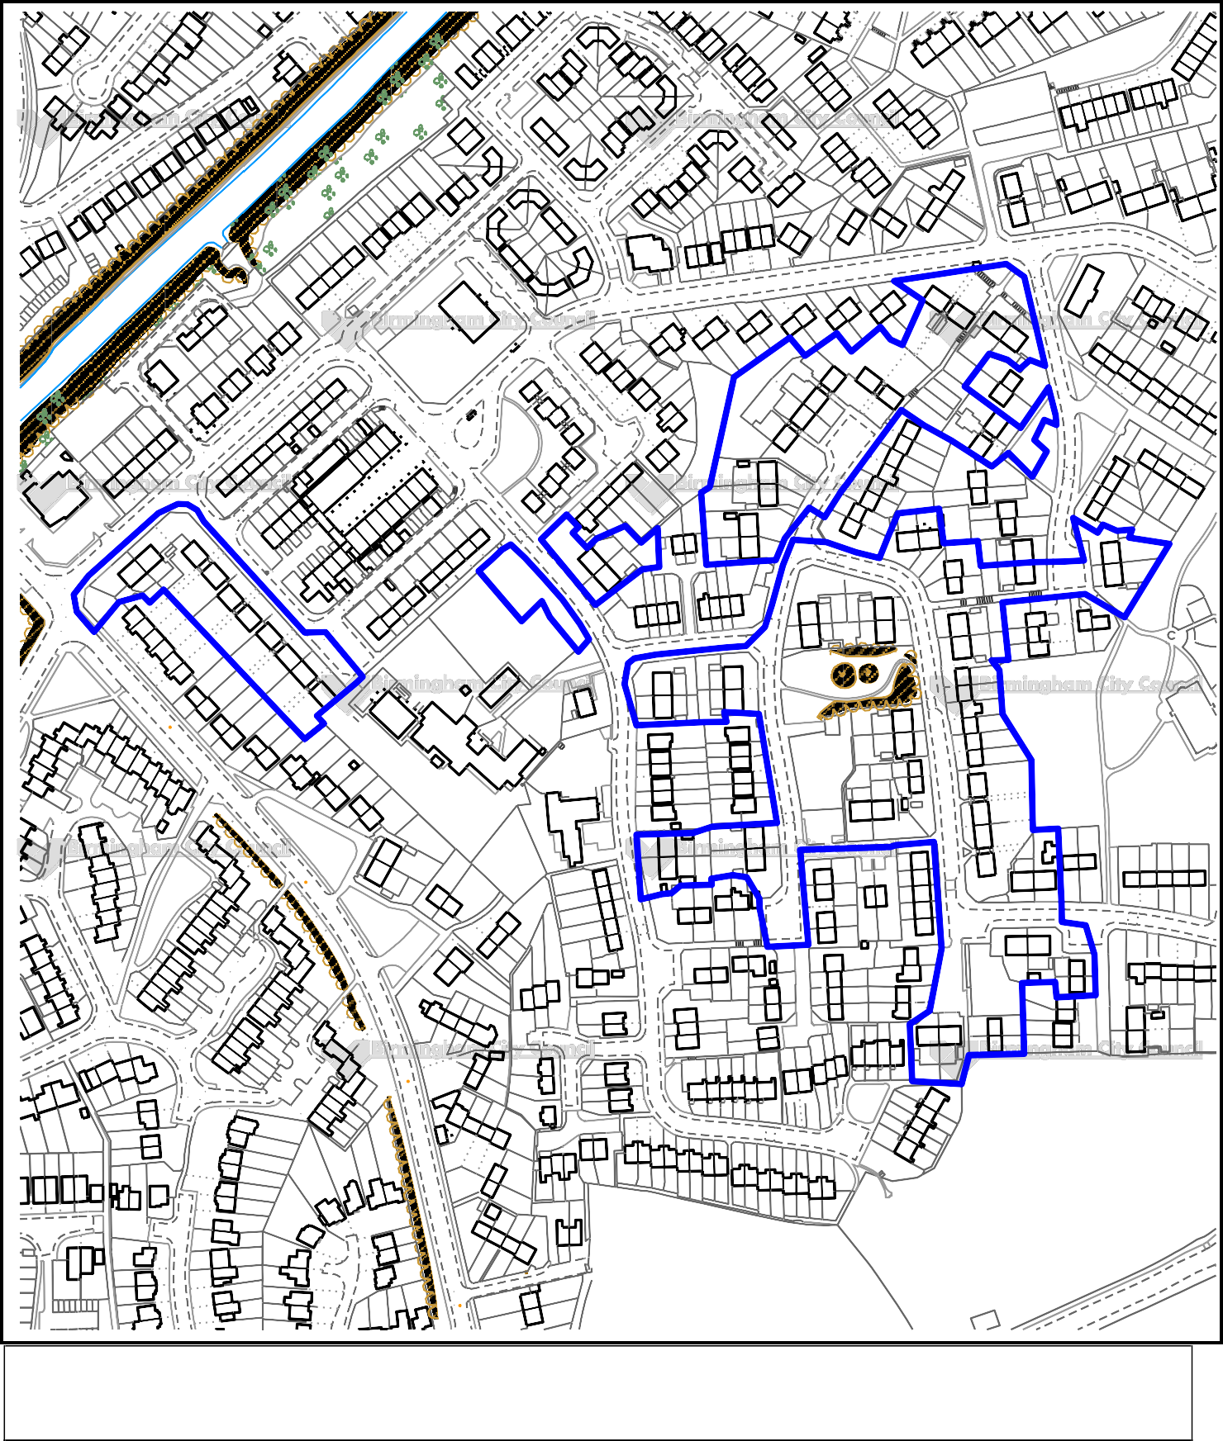
Health Centre
9
15
17a
11
17b
67
77
Vista Green
OWENS CROFT
41a
43
15b
51
5a
9a
7
15a
5b
3a
1b
53
3b
1a
15
9
25
11
37
53
43
39
10
14
11b
11a
9b
66
8
76
83
Worcester and Birmingham Canal
12
48
58
BROOKLEA GROVE
2
Path (um)
63 59
65 61
55
57
51
53
119
121
67
69
71
Sewer Outfall
81b 81a
5
109
85 83a

Shelter
38
1
1
2
99
95
97
HILLMEADS ROAD

30 1 to 12
2
70
62 62a
64
68
14 to 43
11
82
60a

El Sub Sta
7
60
7
5
1
3
26a

Speedwell Hous e Shelter
4
2a
2
LITTLE HILL GROVE
3
92
CANAL SIDE DRIVE
24
24b
26

Shelter
Little Hill Grove
16
20
52
4a
2d 4
PLECK WALK
85
4d
35
100
15
11
48
22
SISEFIELD ROAD
20
22b
7
1
11

M ass house
2
71
38
14
114
6
6
22
14
36
21 19
2
20
16
32
34
8 28
26
23
44
46
M
21 to 27
29
The Fold
10
FB
19
9
31
65 61

LB
BENTMEAD GROVE
76
78
32
34
72
74
59
40 44
42 46
57
38
44
1
3
18
5
7
48
1
3
29
25
31 27
32
34
37
FB
30
28
30a 30b 30c
67 63
28a

Play Area
36
16
54
56
SISEFIELD ROAD
53
55
80
49
51
47
63 59
65 61
86
88
50
7
5
37
33
96 100
98 102
22
24
BARRATTS ROAD
26 26a
26b

Sports Court
58
90
92
18
20

El Sub Sta
2
35
16b
86
88
150.2 m
37
104
43
82
84

St Paul' s Catholic Prim ary School
80
70
PRIMROSE HILL
51
16
80

Chy
78

The Arrow Walk Park
35
114
14
70
72
74
76

St Paul' s Churc h
82
84
86
88
33 35
37
27
33
GILDAS AVENUE
126 130
128 132
66
6 10
8 12
23 21
29
25

19
33 29
35 31
27 29
101
31 27
15 11
150.2 m
90
24
26
94
22
28
98
WARRENS END
15
39
37
25 21
27 23
138
140
19
136
134
11
25
30 32
15
100 100a
14
28
30
24
26
22
8
20
109
2
111
1
4
3
Wigland Way

168
162
GLENHILL DRIVE
104
HAWKMOOR
68
70
66
GARDENS
158a
142
15
142a 142b
16 16b
Gildas Avenue
11
72
112
52
34
44
38
1
9
11
1
38
40
42 46
44 48
20
18c
14
9a 9
7
15
119a 119 117a 117 115a 115
113
5
50 52
18 18a 18b
SM
HAWKMOOR GARDENS
8
ARRENS END
160
158
7
11 9

165.5 m
SISEFIELD ROAD
118
17
170
74
76
78
84
15
7
5
19
156 156a
154
144

12
61
124
178
8
151
133
16
143
121
11
72
68
21
10

10 12
132
PRIMROSE HILL
49
37
66
LONGDAL
BRIAR WAY
CROFT

167.6 m
9
134
29
1

This map is reproduced from the Ordnance Survey Material with the permission of Ordnance Survey on behalf of the Controller of Her Majesty's Stationery Office © Crown Copyright. Unauthorised reproduction infringes Crown Copyright and may lead to prosecution or civil proceedings. Birmingham City Council. Licence No.100021326, 2010

