Hello! Are you a childminder or a home educator?
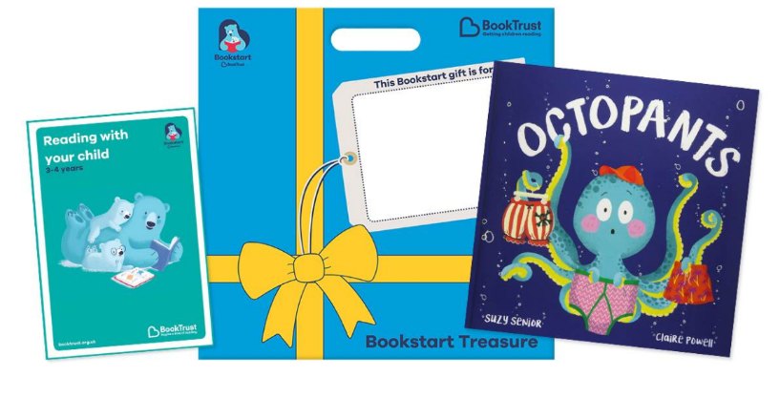
I
Packs are for the new school academic year, Sep 2021 to
Jul 2022
If that’s yes, then you can now order your Treasure Packs!
Then click this link!

https://www.birminghambeheard.org.uk/place/0eb4b6da

Sep-Oct delivery is Nov
Nov-Dec delivery is Jan
Jan-Feb delivery is Mar
Mar-Apr delivery is May
May to Jul – subject to availability

You do not need to order pack/s if the child also attends a nursery.

Children need to be aged 3-4yrs old in this school year.

Order…

If you’re not sure what Bookstart is or what you get in your Treasure Pack, you can find out more at: www.bookstart.org.uk. For information about Birmingham Bookstart, go here: What is Bookstart? | Bookstart | Birmingham City Council

Children should be gifted their pack before the end of the school year, July 2022.
Need help?
Contact us on bookstartbirmingham@birmingham.gov.uk or 0121 464 0692
This Photo by Unknown Author is licensed under CC BY-SA
If you need help or are unable to place your order as above, please contact us. There is further information on the following pages:
Orders and delivery | Bookstart | Birmingham City Council;
My child hasn’t had their pack | Bookstart | Birmingham City Council

