Hello! Are you a nursery*?
*That’s nurseries attached to a school, private, voluntary & independent
I
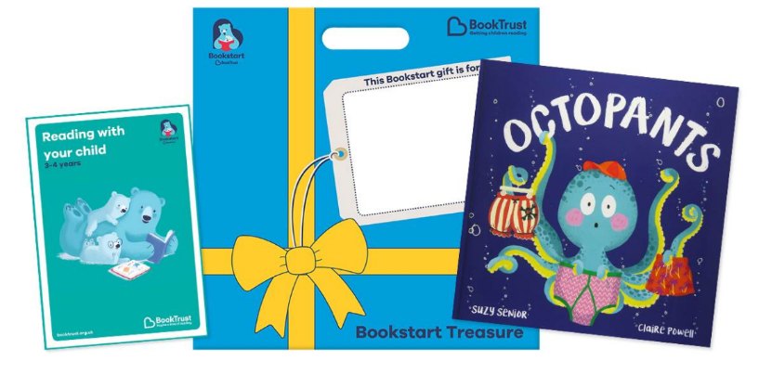
Packs are for the new school academic year, Sep 2021 to
Jul 2022
If that’s yes, then you can now order your Treasure Packs!

Then click this link!

https://www.birminghambeheard.org.uk/place/2109e396

Sep-Oct delivery is Nov
Nov-Dec delivery is Jan
Jan-Feb delivery is Mar
Mar-Apr delivery is May
May to Jul – subject to availability

Order for the whole year’s intake. Need a second order? Contact us.

Order…

Children need to be aged 3-4yrs old in this school year.

If you’re not sure what Bookstart is or what you get in your Treasure Pack, you can find out more at: www.bookstart.org.uk. For information about Birmingham Bookstart, go here: What is Bookstart? | Bookstart | Birmingham City Council

Children should be gifted their pack before the end of the school year, July 2022.

Need help?
Contact us on bookstartbirmingham@birmingham.gov.uk or 0121 464 0692
This Photo by Unknown Author is licensed under CC BY-SA
If you need help or are unable to place your order as above, please contact us. There is further information on the following pages:
Orders and delivery | Bookstart | Birmingham City Council;
My child hasn’t had their pack | Bookstart | Birmingham City Council

