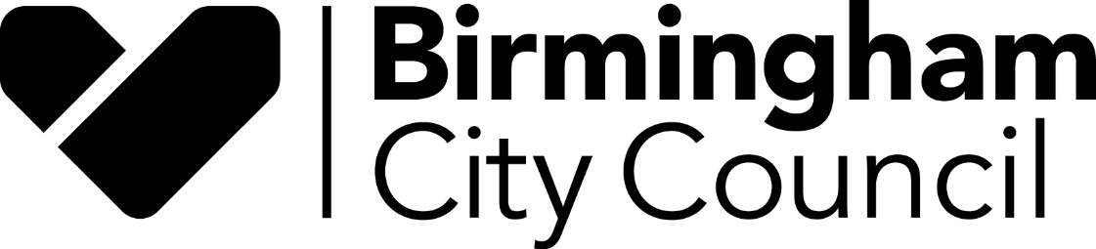

Report to: Schools Forum

Date 11th March 2021

Report of: John Betts, Interim Finance Business Partner (Education & Skills)

Title: Schools Forum – powers and responsibilities

Status For information

There have been occasions over the past year, during discussions around specific agenda items, when it has become apparent that there has not always been a shared understanding regarding the decision making powers of the Forum. This is understandable, as the governance and regulations surrounding aspects of education funding can be opaque. We discuss certain items that only apply to some categories of schools (for example, only maintained schools can vote on de-delegated items); other items require a decision by the Forum; whilst other items require consultation, but the decision remain with the Authority.
The Department for Education produces a useful summary of the powers and responsibilities of the Schools Forum, the Local Authority and the Department itself and this is attached as an annex.
The “status” of reports brought by the Authority to the Forum state whether the item is for decision, for information or for consultation. In addition, those entitled to vote on any particular item are identified in the report.
If the Forum can identify any further ways of making governance easier to understand (or better ways of discharging various roles and responsibilities), then the Authority will seek to implement those improvements.

