# 

**Report to:** Schools Forum

**Date:** 21 January2021

**Report of:** Lindsey Trivett, Head of Early Years, Childcare and Children’s Centres – Directorate for Education and Skills

**Title:** Early Years Rate Review 2021-2022 – Confirmation of final rates.

**Status:** For Information

1. **Purpose of the Report**

This report details the final outcome of the amendments to be made to the Early Years DSG Funding for the financial year 2021-2022 following confirmation of the funding allocations from the Department for Education. As previously reported, this has been aligned to allocations within the Central Government Spending Review recently announced that covers the period of one year only. The review and recommendations are therefore for just one year.

1. **Background Context**

A full report was presented to Schools Forum in December which outlined the context of the Early Years DSG and the work that the annual review had undertaken. This report supplements that as the initial allocations for the financial year 2021/22 have now been released by the DfE.

The allocations and subsequent rates proposed consider the HM Treasury further one-year settlement for 2021/22. The confirmed additional Early Years funding (£44m nationally) through the national formula for one-year only gives an increase on the hourly per child rate in the national formula of 8p for two year olds, and 6p for three- and four-year olds.

1. **Centrally Retained Funding**

The LA can retain a maximum of 5% of the EY block to support central functions. The full 5% on the current expected allocation would be £3.52m. This covers the costs of the EYCC central team and administering the termly headcount; Early Years Inclusion and Early Years QI and networks.

The report in December set out that the LA would look to incrementally increase the central retained percentage towards 5% with a view to reaching the full 5% in future years. The increase would therefore be spilt with increasing the rate to providers.

An increase the equivalent of 2p per hour will be added to the centrally retained element as shown in table 1. However, (see 4.1 below) we will also use this to fund the increase in deprivation supplements.

Table 1: Centrally Retained funding

picture of a table for Centrally Retained Funding

* ISEY has previously been counted in central retention when £0.75m of it is actually passed through to providers. In 21/22 the £0.75m will be included in the pass-through element.

1. **Rates to Providers**
   1. ***Supplements – Deprivation and Free School Meals.***

The report in December set out a recommendation is to maintain both supplements and apply an increase to the deprivation rate using the Consumer Price Index over the last 4 years. This can be confirmed as affordable within the allocation for 2021/22 (see above – this is also to be funded from the 2p notionally centrally retained, so that the full 4p increase can be added to the 3 and 4 year old base rate).

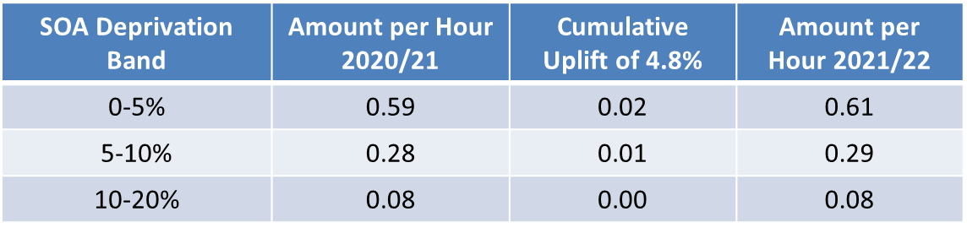

* 1. ***Base Rates for 3 and 4 Year Olds for Providers.***

A reminder that the 95% pass through amount also must take account of the funding allocated to ISEY, deprivation and Free School Meals. The importance of SEND continues to be recognised and the paper in December set out that the increased allocation of £1m in total from the EY block to ISEY will be maintained. £0.25m is accounted within the centrally retained element and £0.75m funds actual child placements in settings.

The national increase to the rate that is allocated to the Council by the DfE as part of the additional funding of £44m is 6p per hour for three and four year olds. The increase will be split to increase the amount retained centrally (2p per hour) with the balance used to increase the base rate (4p per hour). This will increase the rate for three and four year olds to £4.41 per hour.

The historical trend is identified in Table 2.

Table 2: 3 and 4 year olds base rate to providers

| Year | Maintained Nursery Schools | Schools with Nursery Classes | PVIs |
| --- | --- | --- | --- |
| 2016/17 | 6.20 +lump sum | 4.84 | 4.03 |
| 2017/18 | 4.24 + protection | 4.26 | 4.23 |
| 2018/19 | 4.29 + protection | 4.29 | 4.29 |
| 2019/20 | 4.29 + protection | 4.29 | 4.29 |
| 2020/21 | 4.37 + protection | 4.37 | 4.37 |
| 2021/22 | 4.41 + protection | 4.41 | 4.41 |

* 1. ***Rates for 2-year old’s – Straight in/out for all providers.***

This is based on a straight in/out basis to all providers.

The rate for two-year old’s will increase by 8p to £5.40 per child/hour in 2021/22.

1. **Recommendations**

That Schools Forum notes the financial implications of the updated DfE allocations which take into account the increases to the National Formula on the previous recommendations in December from Early Years Forum:-

1. An increase to the centrally retained amount equivalent to 2p per hour resulting in an amount of £2.7m. (4.2% including ISEY) – this to also be used to fund the increase in the deprivation factor
2. Maintain the amount allocated to ISEY of £1m noting that £0.25m is held within the centrally retained element.
3. Agree the funding rates to be applied to providers as set out for the next year in sections 4.2 and 4.3.