**DfE Statutory School Census – Summer 2021**

**FAO Head Teacher / School Census Contact**

|  |
| --- |
| **Key dates: Census date: Thursday 20 May | Return date: Monday 24 May** |

Every school in England has a statutory duty to submit School Census, each term, under Section 537A of the Education Act 1996

**OVERVIEW**

On 18 March DfE announced that they are temporarily varying their approach to funding local authorities (LAs) for the early years entitlements this financial year to give LAs and providers more certainty over their funding income, and LAs will be funded on a termly attendance count basis in 2021 to 2022.

For maintained settings, they intend to use the termly data from the 2021 summer term (and the 2021 Autumn term) school census to determine the early years block funding allocation for three and four year olds in school nurseries, maintained nursery schools and academies.

As the DfE don’t normally use the summer (or Autumn) term school census for early years funding allocation purposes, these censuses do not have the additional marker for ‘reason for funding’ for two year olds, or for children eligible for the early years pupil premium (EYPP), which is normally provided through the Spring school census.

Therefore, the DfE cannot identify from the summer (or Autumn) school census which children qualify for the national entitlements for the two year old entitlement or the EYPP. LAs have been advised to submit a termly data count in order to provide this information, which will also include a termly data count for children accessing the early years entitlements in non-maintained settings, such as private, voluntary and independent childcare providers.

As the summer term data will be used to determine the funding allocation for the early years entitlements, it is important to make sure your census information is accurately submitted and any additional data is provided to your early years contact at the local authority.

DfE changes

The on-going Impact of the covid19 pandemic has led to changes to existing items for summer census

Attendance details see sections 1.1.1-1.1.3

Exclusions see sections 1.2.2, 1.2.3, 1.2.4

Free school meals see section 1.4.1

Unusual circumstances – COVID-19 see section 1.4

School census team are still working from home but are now able to receive phone calls on their normal work numbers via Cisco communicator

**SECTION 1.1: New data items from Spring census 2021 onwards**

### **1.1.1 Total number of sessions attending approved educational activity**

### The total number of sessions a pupil has spent in attendance at an approved educational activity within the collection period.

### For all schools except nursery.

### The first collection of this data will occur in the Spring 2021 census.

See the [sessions possible](https://www.gov.uk/guidance/complete-the-school-census/data-items#sessions-possible) data item for full details.

### **1.1.2 Total number of sessions unable to attend due to exceptional circumstances**

### The total number of sessions a pupil was unable to attend due to an exceptional circumstance within the collection period.

### For all schools except nursery.

### The first collection of this data will occur in the Spring 2021 census.

See the [sessions possible](https://www.gov.uk/guidance/complete-the-school-census/data-items#sessions-possible) data item for full details.

### **1.1.3 Total number of sessions not attending in circumstances relating to coronavirus (COVID-19)**

### The total number of sessions a pupil was not attending in circumstances relating to coronavirus (COVID-19) within the collection period.

### For all schools except nursery.

### The first collection of this data will occur in the Spring 2021 census.

See the [sessions possible](https://www.gov.uk/guidance/complete-the-school-census/data-items#sessions-possible) data item for full details.

For further information, please refer to the [school attendance guidance for schools](https://www.gov.uk/government/publications/school-attendance) and [addendum: recording attendance in relation to coronavirus (COVID-19) during the 2020 to 2021 academic year](https://www.gov.uk/government/publications/school-attendance).

**SECTION 1.2 Changes to existing data items for 2020-21**

### **1.2.1 Termly attendance module**

### From Autumn 2020, data will be recorded and returned on all categories of school attendance, rather than just absence.

### The first collection of this data will occur in the Spring 2021 census.

See the [termly attendance](https://www.gov.uk/guidance/complete-the-school-census/data-items#termly-attendance) data item for full details.

### **1.2.2 Exclusion reasons**

### From Autumn 2020, changes include:

### extending the exclusion reason codes

### allowing up to 3 reasons to be submitted per exclusion

### The first collection of up to 3 reasons and new codes will occur in the Spring 2021 census.

See the [exclusions](https://www.gov.uk/guidance/complete-the-school-census/data-items#exclusions) data item for full details.

### **1.2.3 Exclusion collection period**

### Amended in line with attendance, with the start of Autumn 2020 Term set as 1st August 2020 and the end of Spring Term 1st April 2021.

See the [exclusions](https://www.gov.uk/guidance/complete-the-school-census/data-items#exclusions) data item for full details.

### **1.2.4 Additional exclusion reason added**

### To support the government’s response to coronavirus (COVID-19), an additional reason of ‘Wilful and repeated transgression of protective measures in place to protect public health’ has been added.

### For use from Autumn 2020.

See the [exclusions](https://www.gov.uk/guidance/complete-the-school-census/data-items#exclusions) data item for full details.

**SECTION 1.3 Deleted data items for 2020-21**

There are no deleted data items for the 2020 to 2021 school census.

### **SECTION 1.4 Unusual circumstances – COVID-19**

Schools must provide pupil level data for pupils who are recorded on the school admission register as at census day, irrespective of whether they attend school on that day. Therefore, pupils who are absent from school on census day, whether the absence is COVID-19 related or for other reasons, should be counted in schools’ census returns in the usual way.

Current funding allocation through the national funding formula (NFF) and the pupil premium is calculated based on the number of pupils on roll and is not affected by pupil non-attendance on census day.

However, the universal infant free school meals (UIFSM) funding stream and other data items are dependent on whether a pupil attends school on census day see below:

### **1.4.1 Universal infant free school meals taken**

The universal infant school (UIFSM) funding stream is dependent on whether a pupil attends school on census day.  
UIFSM uses the variable ‘school lunch taken’, which is collected in relation to pupils in years R, 1 and 2 (or aged 4-6 in year group X) and indicates whether a pupil has taken a school lunch on census day.

Where COVID-19 related absences occur and ‘school lunches taken’ are affected, a day and time when the situation is regarded as normal is to be substituted. Schools can use the next normal day, an earlier day in census week or another day that reflects the normal situation. Where other days or times are used, schools must record these for audit purposes.

However, there are some scenarios which do not qualify as an unusual circumstance and therefore pupils must be recorded as NOT having taken a school lunch:

|  |
| --- |
| * If the school kitchen is closed and the school have not offered any alternative provision; * Pupils who have changed their preference to bring a packed lunch * Pupils are absent for other reasons not connected to COVID-19. |

### **1.4.2 Year 11 and Year 13 leavers**

Guidance on year 11 to 13 exam cohort attendance and provision for the 2021 summer term can be found in annex B in the Covid 19 operational guidance on [gov.uk](https://eur01.safelinks.protection.outlook.com/?url=https%3A%2F%2Fwww.gov.uk%2Fgovernment%2Fpublications%2Factions-for-schools-during-the-coronavirus-outbreak%2Fschools-coronavirus-covid-19-operational-guidance&data=04%7C01%7Csandra.c.dawkes%40birmingham.gov.uk%7Cb7d3193ef05d4f3f168908d90a5117c8%7C699ace67d2e44bcdb303d2bbe2b9bbf1%7C0%7C0%7C637552165676189541%7CUnknown%7CTWFpbGZsb3d8eyJWIjoiMC4wLjAwMDAiLCJQIjoiV2luMzIiLCJBTiI6Ik1haWwiLCJXVCI6Mn0%3D%7C1000&sdata=gncB0pdChkD3RCd%2Fu3UXkKaMrykP5iab9Tsw2GZ0X5c%3D&reserved=0)

**SECTION 2: DfE Guides for School Census and COLLECT**

The DfE website which breaks down the school census guidance by school type and only includes information relevant for that age band of children. It can be accessed by clicking the link below:

<https://www.gov.uk/guidance/complete-the-school-census>

**2.1 COLLECT check your data**

The DfE website has a section called ‘check your data’ and contains the following topics to help you correct your data

Viewing your errors and queries

Correcting errors

Adding explanation notes for queries - ie notepad entries click on link below

[List of COLLECT queries and explanatory notes to help you complete the school census](https://assets.publishing.service.gov.uk/media/5cd5822840f0b6604efa74e2/Notepad_entries_2020_V1.0.ods)

COLLECT reports

Available COLLECT reports

Duplicate report: same UPN

Duplicate report: same person different UPN

Term-on-term checks

This part of the website can be accessed by the link below

<https://www.gov.uk/guidance/complete-the-school-census/check-your-data>

**2.2 DfE Secure Access Site**

The link below will direct you to the new DfE secure portal [**DfE Sign-in help screen**](https://services.signin.education.gov.uk/)

If you are experiencing any other issues with the Secure Access Site, please don’t contact the LA as this is a DfE system and we do not provide support. If you are experiencing issues with the site, then you can submit a DfE Service Request form using the link: [**service request form**](https://eur01.safelinks.protection.outlook.com/?url=https%3A%2F%2Fform.education.gov.uk%2Fservice%2FData-collections-service-request-form&data=04%7C01%7Csandra.c.dawkes%40birmingham.gov.uk%7Cbe415c6fb5e74f932f0c08d8b89b96f6%7C699ace67d2e44bcdb303d2bbe2b9bbf1%7C0%7C0%7C637462325712538947%7CUnknown%7CTWFpbGZsb3d8eyJWIjoiMC4wLjAwMDAiLCJQIjoiV2luMzIiLCJBTiI6Ik1haWwiLCJXVCI6Mn0%3D%7C3000&sdata=qBg3LqWuPqPl9UqVfVsnuW1tytNcuXYvS8LTHNw0ukk%3D&reserved=0)

**2.3 COLLECT User Guides**

To assist schools with using the COLLECT system to make a successful School Census return, the DfE have published [**COLLECT user guides**](https://www.gov.uk/government/publications/collect-guides-for-schools-and-local-authorities) on the School Census website.

**2.4 DfE video Guides**

**DfE video Guides** (Census preparation and funding) are available at the following link: [**https://registration.livegroup.co.uk/efa/ContentTabs/Category.aspx?ctid=242&cat=1593**](https://registration.livegroup.co.uk/efa/ContentTabs/Category.aspx?ctid=242&cat=1593)

**2.5 Summer Census COLLECT Familiarisation**

The ‘beta’ release of the 2020 Summer School Census ‘live’ COLLECT blade will remain available until 3 pm on **Friday 14 May 2021**. Please log onto the site in advance of producing Summer census to ensure you can upload a test file and check errors/queries in your current data. Completion of this process will make loading and correction easier and to ensure you are able to submit a final return in the live collection. This is particularly important for staff, new to School Census. The blade will then be removed and cleared out in advance of the start of the live collection on Thursday 20 May 2021.

**SECTION 3: Maximise Your Funding**

**3.1 Pupil premium funding**

It was announced in December 2020 that pupil premium allocations for most schools will now be based on data collected as part of the Autumn school census. This applies to all schools except for local authority maintained PRUs and alternative provision academies and free schools who will continue to be allocated funds based on information collected in the Spring school census. Details can be found [**here**](https://eur01.safelinks.protection.outlook.com/?url=https%3A%2F%2Fwww.gov.uk%2Fgovernment%2Fpublications%2Fpupil-premium%2Fpupil-premium&data=04%7C01%7Csandra.c.dawkes%40birmingham.gov.uk%7Cbe415c6fb5e74f932f0c08d8b89b96f6%7C699ace67d2e44bcdb303d2bbe2b9bbf1%7C0%7C0%7C637462325712508971%7CUnknown%7CTWFpbGZsb3d8eyJWIjoiMC4wLjAwMDAiLCJQIjoiV2luMzIiLCJBTiI6Ik1haWwiLCJXVCI6Mn0%3D%7C3000&sdata=56FocwQQ9scrGcT32gSeS27OuMgGkqZfFe76EYY46VE%3D&reserved=0)

**3.2 Used for funding marker**

Where a data item contributes to the school’s funding calculation, such items are marked [used for funding] with this appearing alongside the collection (school phase). The [used for funding] marker prompts schools that the marked data items need to be especially accurate, given that errors with these items may affect the school’s funding.

**3.3 How schools have lost funding**

I would like to stress the importance of completing an optical check on the data in your return and not rely entirely on DfE validation checks within COLLECT to identify errors, as there are certain errors that validation checks will never be able to identify, see example 1 and 2 below such as

**Example 1** Errors of omission i.e. if you exclude a child eligible for pupil premium

**Example 2** Data supplied is within a valid parameter range ie nursery pupils with funded/extended hours anything in the range 1 – 15 would be valid, if you record 5 hours instead of 15 COLLECT would accept this as valid.

**Impact on funding**

The two examples above have occurred on school census and as a result the schools concerned have lost thousands of pounds of funding. In example 2 above the school concerned only found out when they received their budget notification, but by that time the COLLECT blade had closed and the DfE will accept no alterations.

**SECTION 4: Early Years Provision**

**All Funded Children**

All children funded by early education entitlement **must have** a parental declaration (or equivalent) that has been signed, fully completed or updated for each term the child is in attendance at the provider. Sample parent declaration forms can be found in the EEE Provider Agreement on EYMIS. Providers can adapt the sample document to suit their provision or have in place the equivalent paperwork but **must** include as a minimum the information on the sample form.

Parent declaration forms will be requested in the case of any duplicate claims. If you are not able to produce a parent declaration or the equivalent of for review you may lose the funding as you will not have met the terms and conditions of funding.

Funding for the Summer 21 term is back to business as usual and will be based on attendance only – there are no flexibilities applied due to Covid. This means that you can only include and be funded for children on your Census that have started with you and have been attending your setting and are in attendance on headcount week as per the EEE terms and conditions of funding. You cannot include children on roll that have not been in attending.

**30 Hour Extended Entitlement Applications**

For children to access 30 hour extended entitlement places for Summer term 2021 parents must have **received their 30-hour code on or before 31st March 2021**. All existing applications that had a validity end date of 31.03.2021 must have been reconfirmed and have confirmation of successful reconfirmation before 31.03.2021 to ensure that the application is valid for Summer term 2021.

If parents applied or reconfirmed late in the month and did not receive their code by 31st March 2021, we will not be able to fund the place.

If parents are accessing the extended entitlement element from your provision you must validate the 30-hour codes on ECS. You need to do this before confirming a place with the parent to ensure that the application is eligible for Summer term. There are guides on EYMIS detailing how to validate a code. There is also a guide on EYMIS called ‘How to find your 30 hours code if you already have one’ which will help you understand a parent’s childcare service account if you need to offer them any help or guidance. Please note it is the parents’ choice where they take their extended entitlement not the provider’s choice. You must not specify which element of the funding is delivered at your setting.

If parents are having any issues with their accounts or applications, please signpost them to HMRC – 0300 123 4097 as we are unable to support with individual applications or account issues.

**2 Year Olds**

Any funded 2-year olds must have a 6 digit application / reference code that has been checked as eligible by the provider. If a code does not show as eligible but you know that the parent meets the eligibility criteria, you must email [NEF@birmingham.gov.uk](mailto:NEF@birmingham.gov.uk) quoting the code, the child’s name and DOB and stating specifically what evidence has been viewed to confirm eligibility – please do not attach any evidence to the email. The NEF team will then confirm by email if the application has been changed to eligible. Guidance is available on EYMIS.

**EYPP / FSM**

Any 3 and 4 year olds applying for EYPP or Free School Meals must have a 6 digit application / reference code that has been checked as eligible by the provider. If a code does not show as eligible but you know that the parent meets the eligibility criteria, you must email [NEF@birmingham.gov.uk](mailto:NEF@birmingham.gov.uk) quoting the code, the child’s name and DOB and stating specifically what evidence has been viewed to confirm eligibility – please do not attach any evidence to the email. The NEF team will then confirm by email if the application has been changed to eligible. Guidance is available on EYMIS.

**DAF**

DAF is a single payment made once per financial year. Only children aged 3 and 4 years are eligible, and the child must be in receipt of DLA. If a child attends two settings the parent must nominate which setting receives the payment. Parent declaration forms and guidance for DAF applications can be found on EYMIS. You submit your DAF claim with your census claim.

**EYMIS**

We recommend that you regularly access EYMIS for up to date documentation and guidance. EYMIS is the online database that we use to store all our guidance and information relating to Early Years. This includes information about EEE funding, including the Terms and Conditions, Parent Declaration Forms, DAF etc.

The log-on details are:

<https://www.ted-birmingham.org.uk/>

* Log in details **PVI2** (Capital letters **PVI** (the letter **i**) then the number **2**)
* Password **PVI2year** (Capital letters **PVI** (the letter **i**) then the number **2** and lower case **year**)

Click on **EY Info & Guidance** and then **Early Education Entitlement (EEE)**

**SECTION 5: Software and IT Support for Census**

**5.1 SIMS Users**

Software support is available from Entrust Education Technologies formerly Link2ICT **Tel: 303 5100**

For any updates on known software issues, software guides and upgrade information please check: [**https://link2ict.service-now.com**](https://link2ict.service-now.com)

**5.2 Facility CMIS / Could School (Progresso) Users**

Software support is available from Advance Learning **helpdesk: 0330 060 2199**

For any updates on known software issues, software guides and upgrade information please check [**https://customers.advancedcomputersoftware.com/login**](https://customers.advancedcomputersoftware.com/login)

**5.3 Scholar pack users**

Software support is available on **Tel: 01522 716049**

**5.4 Other MIS users**

If you do not use any of these MIS systems, please contact your software supplier or IT support for updates on software issues and upgrades.

**5.5 Perspective**

The school census team upload census reports to Perspective.

When we upload new data to Perspective the team will send an email to our census contact to let them know they have new data enquiries to investigate.

The chart below shows the folder structure where the school census team will upload your data.

**NB** If you don’t have any enquiries to resolve for a certain data item such as Duplicate Pupil Detected a folder won’t appear for you to access

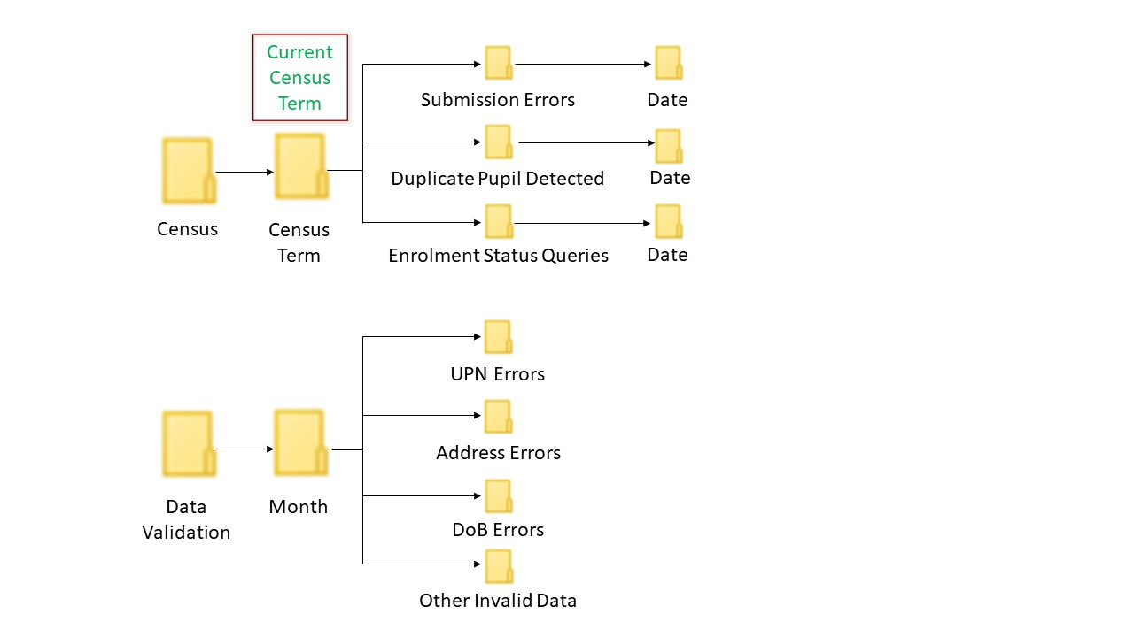

To log in to your **Perspective ‘Lite’** account visit: **[https://perspective.angelsolutions.co.uk/Perspective/Login.aspx](https://eur01.safelinks.protection.outlook.com/?url=https%3A%2F%2Fperspective.angelsolutions.co.uk%2FPerspective%2FLogin.aspx&data=02%7C01%7CSandra.C.Dawkes%40birmingham.gov.uk%7C89095b0f94d14d829ca008d85b089bf9%7C699ace67d2e44bcdb303d2bbe2b9bbf1%7C0%7C0%7C637359439812108504&sdata=r2%2B5L317qQ1FH%2FX6AAKMocLWTRNUtz4Ea%2BJJItfeIlY%3D&reserved=0)**

Perspective has a built-in forgotten password feature; the user name may be your school’s URN number (Ofsted reference).

For access related enquiries for Perspective please contact: [**schoolcensus@birmingham.gov.uk**](mailto:schoolcensus@birmingham.gov.uk).

**5.5.1 Setting up additional users**

Perspective Lite allows Head and Senior Leadership Team account users. You can set up users for sharing of data, or teachers who would like access additional tools.

To create a user, click on **Settings** and then select **Manage Users**. Then select **Create New User**.

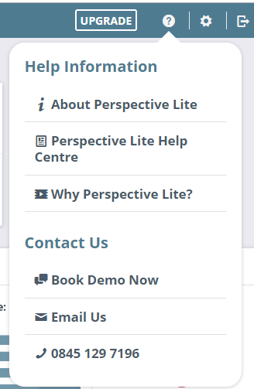

A detailed guide on how to do this is within the knowledge base of Perspective itself. To access, click on the question mark in the top right-hand corner, select ‘Perspective Lite Help Centre’ and then ‘User Management’

**5.5.2 Support**

The icon in the top right-hand corner of the screen provides you with the contact details of Angel Solutions.



(? Symbol); they should be contacted if you have any technical issues with Perspective Lite.

The cog symbol allows you to manage your account and change your password.

Email: [perspectivesupport@angelsolutions.co.uk](mailto:perspectivesupport@angelsolutions.co.uk)

Call: **0845 129 7196**

**NB Entrust Education Technologies formerly Link2ICT does not support Perspective Lite**

Please can I take this opportunity to thank you all in advance for your efforts in completing the upcoming Spring census.

Kind Regards



Sandra Dawkes

Education Data and Intelligence

Education and Skills Directorate, Birmingham City Council

Tel: 0121 303 8842

Email: [SchoolCensus@birmingham.gov.uk](mailto:SchoolCensus@birmingham.gov.uk)