Time is running out! Deadline to apply to the European Union Settlement Scheme is 30/06/2021
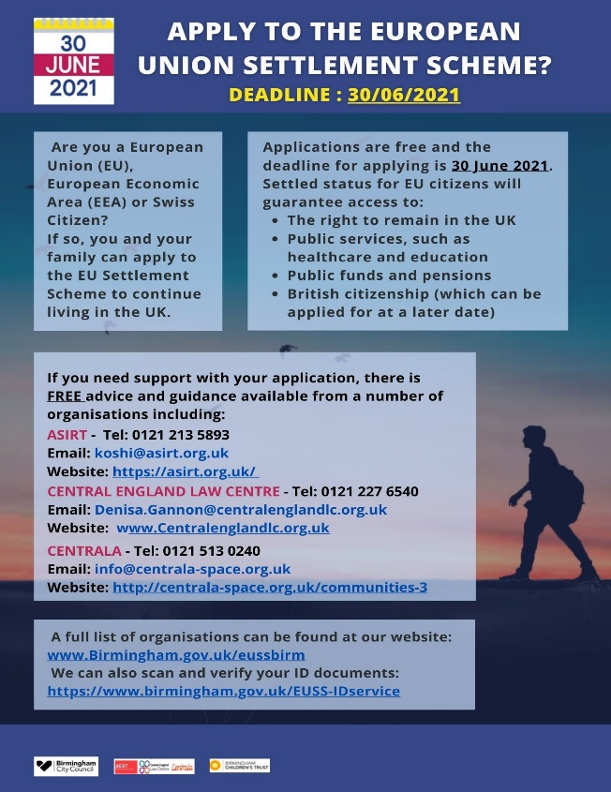
The deadline to apply to the scheme is the 30th June 2021. There are still many families with children in schools in Birmingham who can apply to the scheme who haven’t. We need to ensure that all eligible families know about the scheme and know where to get information and support about how to apply before the deadline of 30th June 2021.
People from European Union (EU), European Economic Area (EEA) or Swiss Citizens may need to apply to the EUSS to continue to live and work in the UK.

The following specialised local organisations in Birmingham have been commissioned to assist people with applications, their advice and support is FREE
ASIRT | Tel: 0121 213 5893  Email: koshi@asirt.org.uk  Website: https://asirt.org.uk/
CENTRAL ENGLAND LAW CENTRE | 0121 227 6540  Email: Denisa.Gannon@centralenglandlc.org.uk  Website: www.Centralenglandlc.org.uk
CENTRALA | Tel: 0121 5130240  Email: info@centrala-space.org.uk  Website: www.centrala-space.org.uk

In addition, for general information and a full list of organisations that provide assistance go to our website www.Birmingham.gov.uk/eussbirm
We can also scan and verify ID documents that are needed for the application: https://www.birmingham.gov.uk/EUSS-IDservice
Please download the attached leaflet and disseminate throughout your schools to staff and in information sent to parents.

