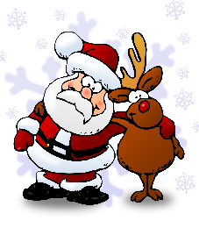
Can you add to our Christmas Word List?

Think of a Christmas word for each letter! We have started you off with Bauble.
Fill in as many as you can for your chance to be entered in our prize draw to win a £5 book voucher!
Please email your entry to childrens.library@birmingham.gov.uk. Good Luck!

A | N
B = Bauble | O
C | P
D | Q
E | R
F | S
G | T
H | U
I | V
J | W
K | X
L | Y
M | Z

Please provide your
Name:
Library card membership no. starting D:
Contact phone number and/or email address:

You must be a member of Birmingham Libraries and aged 16 or under. Closing date: 31st December 2020. Winners will be notified by 31st January 2021.
@LoBChildren’s

