

**Version date: 07/10/2020**

**Regulation & Enforcement**

# Planning Application – Air Quality Assessment & the CleanAir Zone

**Introductory Section**

Birmingham plans to introduce a Clean Air Zone (CAZ) covering all roads within the A4540 Middleway Ring Road (but not the Middleway itself) launching in 2021.

This note seeks to provide advice and guidance to applicants, agents and consultants seeking to introduce development within or on the boundary of the Clean Air Zone.

Applicants should also review Policy DM1 ‘Air Quality’ in the [[Publication Version of the Development Management in Birmingham Development Planning Document](https://www.birmingham.gov.uk/dmb/examination)](https://www.birmingham.gov.uk/downloads/file/16775/csd3_dmb_publication_version_regulation_19) which should be read in conjunction with the [Council’s proposed minor changes to the policy](https://www.birmingham.gov.uk/downloads/file/16776/csd4_schedule_of_proposed_minor_changes) and have been submitted to the Planning Inspectorate for Examination.

Expectation with regards to AQA within / around the CAZ

The basic expectation is that applicants will consider the information that is readily available on the CAZ and from BCC air quality monitoring, referencing that information when undertaking relevant air quality assessments.

Available Information

General information relating to the Clean Air Zone may be found at:

<https://www.birmingham.gov.uk/info/20076/pollution/1763/a_clean_air_zone_for_birmingham>

<https://www.brumbreathes.co.uk/>

The air quality and traffic modelling reports may be downloaded from the following sites:

<https://www.birmingham.gov.uk/info/20076/pollution/1763/a_clean_air_zone_for_birmingham/5>

<https://www.birmingham.gov.uk/downloads/download/2347/clean_air_zone_caz>

The Development Management in Birmingham DPD can be accessed here: <https://www.birmingham.gov.uk/info/20054/planning_strategies_and_policies/1861/development_management_in_birmingham_submission>

Advisory

It is highly recommended that consultants consider the following information:

* Ascertain if their development was considered in the forecasting stage – see pages 8-10 (page numbering) in the following report for developments considered: Transport_Model_Forecasting_Report_Draft_for_FBC_Draft_Final.pdf

Appendix 1 lists the major developments considered and Appendix 2 presents these geographically

* Identify nearby pollutant concentrations from the dispersion modelling results – see table D1-1 for modelled sites (complete with northing and easting) in the following report: aq3_-_birmingham_caz_fbc_report-_air_quality_v3_4-12-18
* Contextualise the proposed development in line with the traffic and AQ modelling data, including any additional pollutant burden that may be generated as a consequence of the development.
* Consider any actual pollutant concentrations from BCC Local Air Quality Management monitoring as published in our Annual Status Reports available for download at:

<https://www.birmingham.gov.uk/downloads/download/1488/air_quality_annual_status_report>

* Consider any other relevant monitoring data e.g. from real time monitoring stations, available from:

<https://www.brumbreathes.co.uk/info/2/homepage/29/air-quality-birmingham>

Any technical information e.g. AQA submitted in support of an application within the CAZ area or on the boundary of the CAZ which does not reference the CAZ in context to the development proposal will not be accepted.

Appendix 1 – List of Major Developments considered in CAZ Modelling

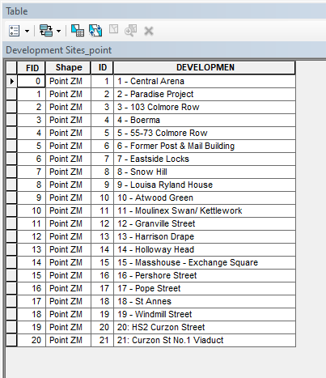

Appendix 2 – Geographical plot of Major Developments considered in CAZ Modelling

