Ka socota Birmingham iyadoo Jaceyl ku dheehan
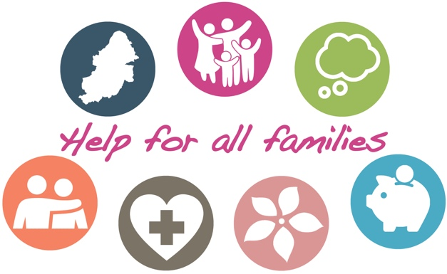

Waxaan dhammaan mareynaa waqti adag ee Covid-19 iyo xayiraadda. Qoysas aad u badanna xaaladu kama fududaan doonto xilliga lagu jiro fasaxa xagaaga, waana sababta aan u joogno in aan ka caawinno. Halkani waxaad ka heleysaa adeegyada iyo taageerada ay fidiyaan isu-kaashiyadeena ee ugu isticmaalka badan, oo nolosha xoogaa yar fududeyn kara....
- Koorso waalidnimo oo internetka ku baxda. Waxaan horey u sii bixinney qarashka ku baxaya waalid kasta oo Birmingham ku nool in uu helo koorsada waalidnimada. Keliya geli furaha gelitaanka oo ah “COMMUNITY” kana gal si aad u hesho bogga halka ugu koreysa. Waxaa jira koorsooyin loogu talagaley waalidka, xannaanayaasha iyo awoowayaasha/ayeeyooyinka caruurta laga bilaabo markey uurka gallaan ilaa iyo 19. Ka baro sida cunugaagu u koro, helna talooyin ku saabsan sida dabeecadahooda loo maareeyo.
- Taageerada caafimaadka maskaxda (Mental health support). Xilliyadan adag waa in aynu daryeelnaa caafimaadka maskaxdeena. Da'yarta u dhexeysa 11-25 jir waxa jira goleyaal, hageyaal iyo la talinno laga heli karo Kooth. Haddii ilmahaagu 0-25 u baahan yahay taageero, la xiriir Pause adiga oo wacaya 0207 841 4470 ama email. Dadka waaweyn waxaa ay taageero ka heli karaan MIND ayagoo wacaya 0121 262 3555. Amaba haddii loo baahdo caawimaad degdeg ah wac Forward Thinking Birmingham kana wac 0300 300 0099.
- Caawimaad dhaqaale. Haddii shaqo la'aan kugu dhacdey, amaba aad la tacaaleysid cunnada amaba kirada waxaa jira adeegyo kaa caawin kara. Local welfare provision ayaa farqi weyn ku sameyn kara haddii aad dhibaato ku jirtid aadna u baahan tahay cunno, shidaal amaba alaabaha cad ee aasaasiga ah. Discretionary Housing Payments ayaa suurtagal ah in ay kirada kaa caawiso. Waxaa kaloo jira food banks oo ka jira dhammaan Birmingham oo u jira in ay ku caawiyaan.
- Xadgudubka guryaha. Dumarka iyo caruurta ay saameysey xadgudubka guryaha fadllan eeg hagidda ama si qarsoodi ah ula xiriir Birmingham and Solihull Women’s Aid. Ragga, fadllan la xiriir Respect.
- Dhibaatooyinka maandooriyaasha iyo khamriga. App cusub, oo qarsoodi ah oo la yiraahdo Staying Free ayaa laga heli karaa Android iyo Apple. Adeegso furaha “birmingham11” si aad u gasho adeega qarashkiisii la sii bixiyey. Si aad qof ula hadasho soo wac Change Grow Live.
- Taageerada murugada tacsida. Waa waqti aad u xanuun badan in qof gacaliye ah geeriyoodo — waxaad caawimaad ka heli kartaa in aad soo wacdo 0121 687 8010 amaba halkan Cruse.
- Caawimaadda hore ee qoysaska. Haddii qof kasta oo ka tirsan qoyskaaga uu u baahan yahay caawimaad dheeraad ah, ugana baahan yahay adeegyada bulshada amaba kooxaha bulshada, fadllan la soo xiriir voluntary sector local leads. Waxaan haynaa toban meelood oo kugu xiri karta taageerada dhammaan magaalada.
Haddii aad ka welwelsan tahay cunug, fadllan soo wac Birmingham’s Children's Advice and Support Service kana soo wac 0121 303 1888. Xaaladaha degdegga ah, oo ay ku jirto ku xadgudubka caruurta, kala xiriir Booliska 999. Waxaad kaloo la sheekeysan kartaa Booliska.

