

**Trees Background Note**

**July 2020**

This note has been prepared to support the Development Management in Birmingham Development Plan Document.

**1. Planning Policy Context**

1.1 The Town and Country Planning Act 1990 (Part VIII, Section 197)2 recognises the importance of trees and charges local planning authorities with a specific ‘duty’ in relation to their preservation and planting. Subsequent sections (up to and including Section 214) provide the powers and details surrounding Tree Preservation Orders (TPO), and Trees in Conservation Areas.

1.2 Paragraphs 170,171, 175 180 and 181 of the National Planning Policy Framework is explicitly clear that the planning system and the decision-making process in relation to planning applications must protect and minimise the impact upon ecological networks on a broad level whilst also enhancing the local natural environment.

1.3 Trees are given specific protection through paragraph 170(b) and 175(c). On a general level, ancient woodland is considered to be an “irreplaceable habitat”, and thus emphasising the significant importance attached to these areas. Furthermore, aged and veteran trees and ancient woodland are now specifically protected under the notion of; “presumption in favour of sustainable development”, therefore, development that involves the loss of aged and/or veteran trees or ancient woodland should be refused. In addition, all benefits of trees and woodland (including economic) should be protected and enhanced, even on the scale of simply recognising the beauty and character that natural capital provides.

1.4 National Planning Practice Guidance provide further detail to the NPPF and the most significant chapters concerning trees are Natural environment’, ‘Tree Preservation Orders and trees in conservation areas’ and ‘Air quality’.

1.5 The Birmingham Development Plan (adopted 2017) contains relevant policies relating to trees and landscape, notably PG1 ‘Place-making’, TP7 ‘Green infrastructure network’, TP98 ‘Biodiversity and Geodiversity’. In particular, TP7 states that *“the City Council will also seek to conserve and enhance Birmingham’s woodland resource (collectively known as ‘The Birmingham Forest’).”*

1.6 The “Birmingham Urban Forest” is the combined canopy of all trees in Birmingham - an asset in providing a visual aesthetic and backdrop for development but more importantly a vital resource to aid adaptation to climate change and mitigate against some of those effects.

1.7 Of equal importance to trees and landscape are the heritage policies in the BDP. TP12 ‘Historic Environment’ sets out how the Council will value, protect and enhance archaeological remains, historic buildings, townscapes and landscapes, and includes locally significant assets and their settings in addition to designated and statutorily protected features.

1.8 Furthermore the BDP recognises the important contribution green infrastructure can make to reducing the effects of climate change through policies TP1 ‘Reducing the City’s carbon footprint’ and TP2 ‘Adapting to climate change’. This includes the retention and planting of trees as tools for; urban cooling, shading, flood risk management and ecological sustainability.

**2. Birmingham Tree Policy Review (2018)**

1.1 On the 4 April 2017, the City Council resolved to develop a new tree policy for the city and in particular explore a more sophisticated method for valuing trees and determining appropriate replacement. A cross party Task Group was set up to review the existing tree policy which was adopted in 2009 and support the development of a revised cross directorate tree policy for the “Birmingham Urban Forest”.

1.3 This report was presented to full Council on the 6th February 2018 (EBD23) and all of it recommendations were agreed. Recommendation R09 states:

*That a new supplementary funding system utilising a grading system which places a monetary value on the visual amenity of trees as well as their replacement cost (such as CAVAT) be adopted; and that in addition the recommendation to establish a Birmingham Tree Bank be urgently explored. Together these would provide an additional source of finance to support the proactive management and development of new planting opportunities and green infrastructure in Birmingham; something that could be overseen by the new Birmingham Forest Group (R11). The tree valuation process agreed on shall be considered for adoption within the Development Plan Document (DPD) and the research undertaken be considered as the evidence base for that emerging policy.*

***2.* Capital Asset Value for Amenity Trees (CAVAT)**

2.1 As part of this work a number of alternative methods of financial valuation were examined. These are set out in detail in the report entitled ‘Birmingham Tree Policy: a report from to Overview and Scrutiny’ full Council on 6 February 2018 (EBD23). CAVAT (Capital Asset Value for Amenity Trees) was chosen as the preferred method as it provides a basis for managing trees in the UK as public assets rather than liabilities. It was designed not only to be a strategic tool and aid to decision-making in relation to the tree stock as a whole, but also to be applicable to individual cases, where the value of a single tree needs to be expressed in monetary terms.

2.2 It complements other tools of arboricultural analysis. So far as possible it draws upon objective evidence and published data, but also relies on expert arboricultural knowledge and in some cases assessments that are specific to CAVAT. Because CAVAT is specifically designed as an asset management tool for trees that are publicly owned, or of public importance, it expresses value in monetary terms, and in a way that is directly related to the quantum of public benefits that each particular tree provides. Applied to the tree stock as a whole it enables it to be managed as if it were a financial asset of the community. Applied to single trees it both values the subject tree and allows a comparison to be made with the value of other public trees. CAVAT complements other forms of assessment of trees’ amenity.

2.3 CAVAT takes the replacement value approach, extrapolating from known planting costs and adjusting for a short series of relevant factors. Spreadsheets are freely available to assist practitioners. The assessment has been refined to allow the final value to reflect realistically the contribution of the tree to public welfare through tangible and intangible benefits. Furthermore, the functional value of the tree factors in the local population density to represent its role in the amelioration of a particular locality. In the case of damaged or destroyed trees, a compensatory value is calculated.

2.4 CAVAT is widely used now by many Local Authorities to establish a replacement value to enable realistic replacement and/ or compensation to be achieved in relation to:

* Development control/ management functions;
* Management decisions, including for trees subject to TPOs, or in conservation areas;
* Assist in legal proceedings, (for example to advise a court as to the value of a tree, either publicly or privately owned, in proceedings following it having been illegally removed or damaged, or in planning enquiries or appeals)l and
* Management of the tree stock, to allow agreement as to adequate funding of replacement planting.

2.5 The Full Method is used in situations when a more detailed and precise assessment of the value of trees as individuals is required. The use of CAVAT will be a last resort as the Council’s preferred position will always seek to ensure the retention of trees.

2.6 CAVAT sets out to assess the monetary value of a tree by calculating a unit value for each square centimetre of tree stem based on the average tree cost and using that figure to produce an average cost for each centimetre of trunk diameter. For the purposes of assessing the monetary value of the trees, they must be considered as individuals using the Full Method. The Community Tree Index (CTI) factor for Birmingham is calculated to be 125% for its population density, as sourced from Office of National Statistics.[1]

2.7 Given its links to public sector organisations and recognised weight in matters of planning, appeals and court proceedings, the CAVAT approach represents the Council’s preferred method for calculating tree values.

2.8 Where on-site replacement planting is not achievable, a financial contribution to off-site tree planting will be sought through a Section 106 Agreement to secure delivery. Any new replacement tree planting funded through S106 will occur within the ward of the development site. Where canopy cover is particularly deficient against the city’s target of 25%, s106 contributions may be spent in these particular wards. A Tree Board will be set up and this body will agree planting sites and report recommendations for expenditure to the appropriate cabinet member on an annual basis.

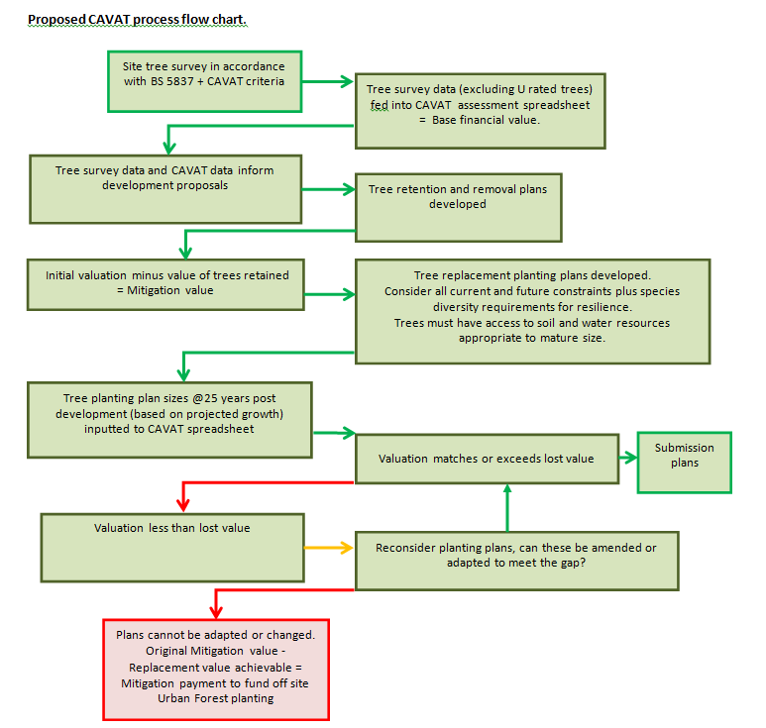

**3. Emerging Tree Strategy**

3.1 The Council’s current Tree Management Strategy (2009) is in force but where recommendations from the Tree Policy Review (2018) have been implemented, these supersede those parts of the document. Once all the recommendations of the Tree Policy Review (2018) have been implemented (75% complete), a new Tree Strategy document will be produced, replacing the Tree Management Strategy (2009). This document will be the central reference point for all policy and advice related to trees and tree management practices (including the trees affected by highway works and footway crossings).

**4. Birmingham Design Guide**

4.1 The Birmingham Design Guide is currently being prepared and will be launched for public consultation in October 2020. It will provide detailed design guidance to aid decision making and help applicants in the design of their proposal, streamlining all existing city-wide design guidance into a single document.

4.2 The document comprises of a Design Principles document and five City Manuals. The Design Principles document outlines the design criteria that development must align with. Further guidance on how to achieve these requirements is provided in the corresponding City Manual.

4.3 The Principles and corresponding Manuals comprise:

* Birmingham ID
* Streets and Spaces
* Green Infrastructure and Landscape
* Living and Working
* Efficient and Future-ready

4.4 The Design Guide recognises Birmingham’s green assets as intrinsic elements of a sustainable and human focused city, which must enhance and grow with it. As such, it encourages development to create landscaped focused development that aid the health and well-being of users; contribute to climate change mitigation; support wildlife; and contribute to cleaning the air.

4.5 A key component of the landscape is the retention (where appropriate) and planting of trees. The Design Guide will provide advice as to how future planting of trees and tree protection should be addressed via the planning process and the considerations that need to be taken into account before, during and after development. It also seeks to promote best practice for the incorporation of existing and new trees and landscaping within developments and their integration into the design process at the earliest stage. The emerging Design Guide and Tree Strategy will be aligned, and will support and add detail to proposed policy DM4 ‘Landscaping and Trees’ in the Development Management in Birmingham Doucment.

1. <https://www.ltoa.org.uk/documents-1/capital-asset-value-for-amenity-trees-cavat/125-national-community-tree-index/file>