**Transition workshop guide Day 1 (3 hours in total)**

Introductions (30 minutes);

* Ground Rules
* Aims and introductions
* Ice breaker

Psycho-education (50 minutes)

* What is transition
* Effects of COVID19
* What is anxiety (and how this links to school transitions)?
* Where does it come from?
* How the brain works

Break – 20 minutes

Identifying anxiety (1 hour)

* What worry feels like
* School related triggers activity

Reflections (20 Minutes)

* Quiz
* Reflections
* Feedback

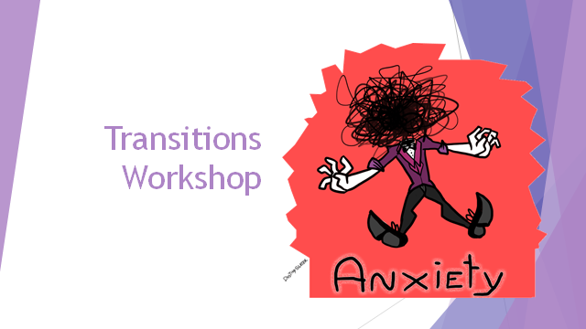

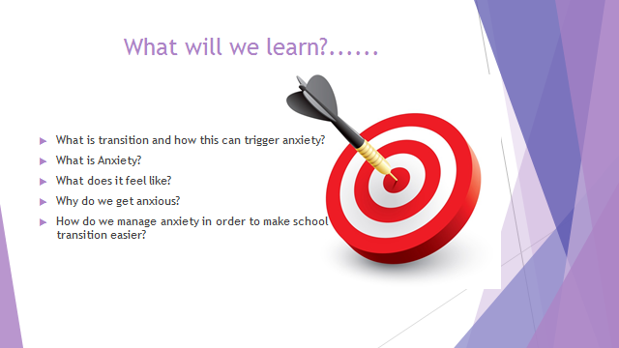

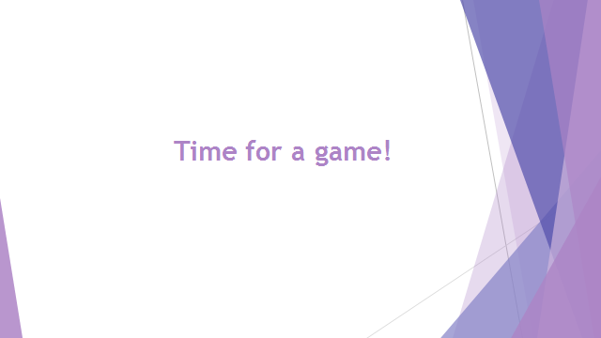

**Change - Ice Breaker Activity**

**Resources**: 4 chairs, 5 playing cards, 5 pencils, 5 Rulers, 5 Rubbers (items are interchangeable where necessary, as long as you have 5 of each item). Dependent on group sizes you may want to increase the number of chairs and how many of each item you have.

This activity will need to take place in a hall or open area.

**Time**: 10min

**Aim**: For young people to realize that sometimes change is necessary in order to succeed. Not all change is bad and sometimes we have to implement change while thinking on our feet.

**Activity**: have 4 chairs in each corner of the room. On the chair place one of each item. Split the young people into teams of 4 / 6 (Larger groups will need more chairs and more items). The aim of the game is to get all 5 of one object onto your chair. In their teams before the game starts, they will need to decide what item they are going to collect. One at a time they must run to another chair and pick up ONE item and then place it back on their own chair. The next person will then have a turn. Team members are not allowed to block or get in the way of other teams taking objects off their chair. First team to collect all their items win.

This game may be over really quickly, or it may last a long time. Encourage the teams to discuss in their groups what changes they may need to make to their tactics in order to do better next time.

**Q**: What worked well in your teams? What didn’t?

**Talk**: Change is a part of life, we can’t avoid it, however we can learn to adapt and grow because of it. Throughout this game everything around you was changing all the time and you all needed to make choices on how you were going to deal with that. Some of you may have found it made you feel uneasy, and that’s ok. Others may have thrived in an ever-changing environment. The important thing to remember is every single one of you got through it. Change is a part of life, we can’t avoid it, however we can learn to adapt and grow because of it.

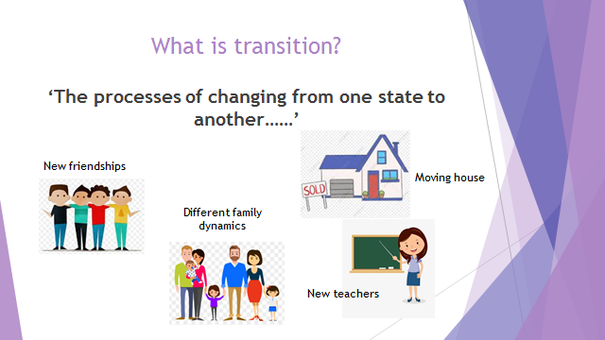

‘The processes of changing from one state to another,’ which means we will experience transition in many stages of our lives. This may be moving house, falling out with friends and joining a new friendship group, family dynamics changing or starting a new school.

This transition can be hard for some kids for a lot of reasons, it can bring a lot of uncertainty, there is often a lot of change and overall a sense of unfamiliarity which can feel really unsettling when compared to the situation you have just left.

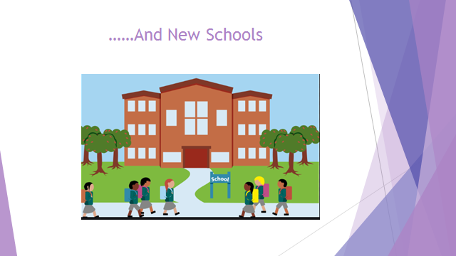

School transition is challenging in different ways for most children, what does the group think children worry about most when moving up to secondary school? (Encourage group discussions)

Research has shown that those listed below are the most common worries associated with school transition (feedback to the group);

* Doing homework
* Being late for school
* Changing schools
* Not getting good grades.
* Being smaller or much larger than other children
* Being left out of a group
* Not getting along well with teachers
* Not being good enough at sports
* Separation from the family

Acknowledge how consistent these worries were throughout the group and encourage them to reflect on this. You could perhaps ask them to raise their hand if they have worried about the worry each time a new one is read out or alternatively you could ask them to stand up/sit down to reflect whether or not they have been affected.

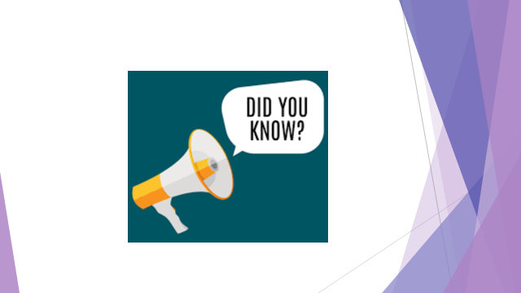

Hit them with the facts;

Worrying is a common phenomenon in children aged 8 – 13 years.

Between 5 and 10 children in every 100 children have anxiety problems.

Stress among children is estimated to have increased 45% over the past 30 years.

So it is completely normal that you may be feeling some of these anxieties, especially because as a year group you have all had to manage the additional changes caused by COVID 19. In order to understand and come to terms with these changes, it’s important we learn what COVID 19 is;

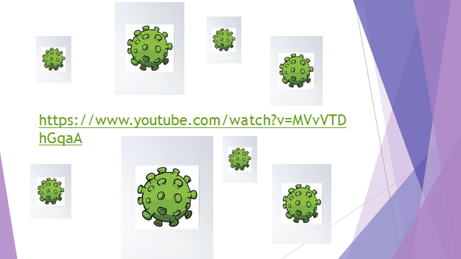

Play Youtube Clip (reference the fact that this clip is American and their advice was to keep 1 metre apart but the advice in the UK is 2 metres)

Schools had been closed now for many months because of COVID-19 and this meant things were really different for a while;

-You were doing your work at home

-You were only allowed out for limited times of the day

-You may not have been able to see family members

-And things probably felt really strange for a while.

But, after a while, you probably got used to life in lockdown, and that is something you should try and remember when school seems overwhelming, soon it will feel like the norm. If you can adjust to a global pandemic, then you will adjust to secondary school just fine.

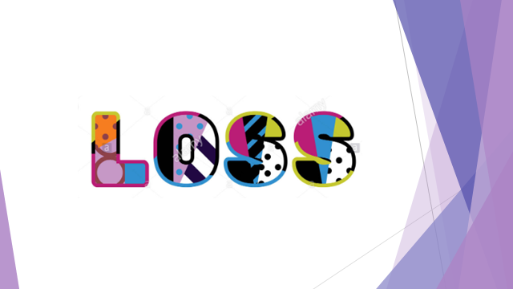

COVID 19 didn’t just change a lot of things but it also took away a lot of things; most children when they transition to secondary school get to say goodbye to their teachers, they get to have one last lesson in their classroom, they get to say farewell to their classmates, they get to do fun things as a group like go on school trips and have leavers assemblies….

…..as a group you wouldn’t have had the chance to do a lot of these things and that can feel really difficult. The sensation you may feel when you think about these things can be described as loss. Most children experience loss when they transition school because something they once had won’t be there anymore, but for your year group, this feeling of loss may be even more apparent.

At this point it may be helpful to get the children to contribute some of their experiences i.e. the things they really felt they missed out on. Acknowledge and validate these feelings.

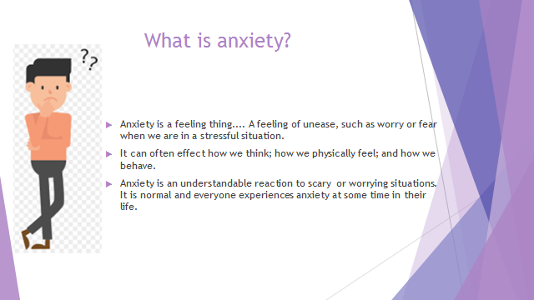

Read points off slide

An important thing to remember is that Anxiety is not dangerous. It may feel uncomfortable and make us feel like something is seriously wrong with our body, but it doesn’t last long, it is temporary, and will eventually decrease!

Sometimes these feelings can come on for what seems like no reason at all. That’s also normal. It happens to lots of adults and lots of kids but there are things you can do to make it go away and usually it passes quickly.

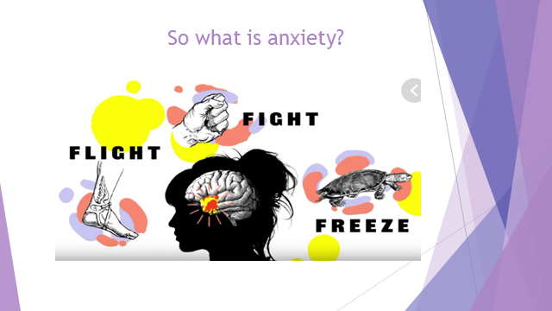

Humans are highly advanced beings and most of the time we aren’t even aware of all the systems that are constantly working to enable us to function in the world we live in.

One such process is our response to threats – as a species, it is an incredibly useful advantage and is something that was developed thousands of years ago, during the time when cave men and women were in existence. This was a time when humans came into constant threat with large predators, putting their lives at risk on a regular basis. The body developed a natural response to this danger in order to maintain survival. We now refer to this response as ‘fight, flight or freeze.’

This is a bodily response your brain will initiate to any **perceived** threat; during this reaction, certain hormones like adrenalin and cortisol are released, speeding the heart rate, slowing digestion, shunting blood flow to major muscle groups, and changing various other autonomic nervous functions, giving the body a burst of energy and strength. This enables us to either **fight** our way out of that danger, **flight** (or run away) from the danger or **freeze** into shut down mode in order to maintain our safety.

This is a bodily response your brain will initiate to any **perceived** threat; during this reaction, certain hormones like adrenalin and cortisol are released, speeding the heart rate, slowing digestion, shunting blood flow to major muscle groups, and changing various other autonomic nervous functions, giving the body a burst of energy and strength. This enables us to either **fight** our way out of that danger, **flight** (or run away) from the danger or **freeze** into shut down mode in order to maintain our safety.

As human’s have evolved, we don’t face the same kind of life threatening situations as our ancestors, but our fight-flight-freeze response has remained with us. For some people however, their response is being activated inappropriately. This is all determined by the level of threat **perceived** by the brain. For example, one person’s brain may determine that rollercoasters are extremely dangerous and life threatening activity that warrants a fight-flight-freeze response, whereas other people’s brains may determine rollercoasters as a fun, safe and exhilarating activity that does not require this response.

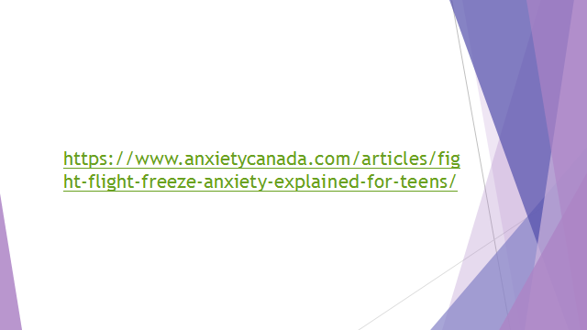

Play Youtube video

As humans have evolved, we no longer face the same kind of life threatening situations as our ancestors, but our fight-flight-freeze response has remained with us. For some people however, their response is being activated inappropriately. This is all determined by the level of threat **perceived** by the brain. For example, one person’s brain may determine that rollercoasters are extremely dangerous and life threatening activity that warrants a fight-flight-freeze response, whereas other people’s brains may determine rollercoasters are a fun, safe and exhilarating activity that does not require this response.

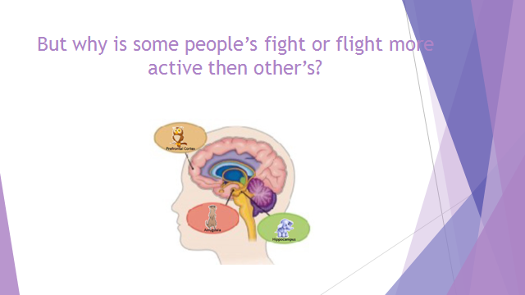

When learning about anxiety, there are 3 major parts of the brain you will need to know about... the Amygdala, Hippocampus and prefrontal cortex, illustrated in this diagram.

However, throughout this workshop we will be calling them the meerkat, the elephant and the owl.

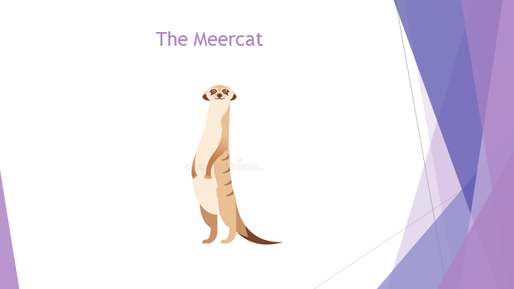

**Amygdala** – The amygdala is one of the first parts of our brain that develops, even before we are born, and is connected to our survival. This is what initiates our fight- flight-freeze response and indirectly controls our heart rate, breathing and temperature control.

We refer to this part of the brain as the Meerkat as it is always on the lookout, tense and needing to keep us safe.

It does not understand words but only reacts to things like facial expressions and tone of voice and situations that are unfamiliar or have the potential to be scary.

We should not need to use our Meerkat in our day to day life due to the lack of danger, however, if we have had anxious starts in life or bad experiences, we may use them more than other people.

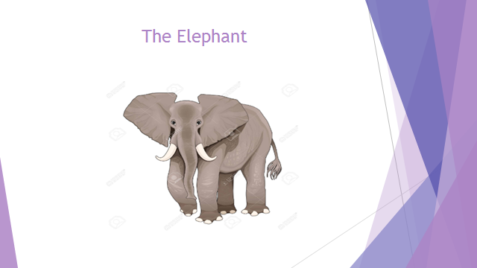

**Hippocampus** - The next part of our brain that grows both before and after we are born, plays a key part in emotional memories e.g. how things, people and experiences make us feel. This is an important part of our brain but is not very intelligent; it is associated with the senses.

This can be thought of as our Elephant.

 It never forgets and has a special relationship with the Meerkat reminding it of memories associated with dangers, stress and anxiety.

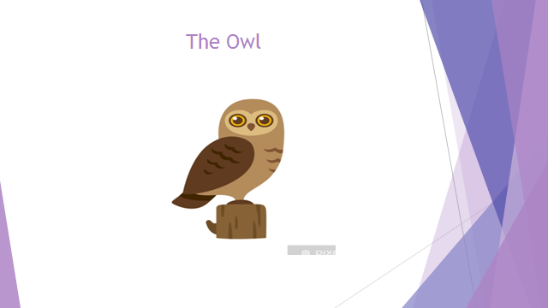

**Prefrontal Cortex** - This part of our brain is connected with our logic, reasoning, language and social skills. It does not finish developing in men until their 30s and in women until their late 20s.

This can be thought of as our Owl. It is intelligent, calm, all-seeing and has good social and problem solving skills.

Our Owl regulates us. The owl talks to the meerkat and elephant and helps them to know that fight or flight is not needed.

**BREAK- 20 MINS**

Identifying anxiety (1 hour)

***What anxiety feels like (30 mins);***

Resources: For this activity you will need the ‘When you are worried where do you feel it?’ worksheet, some pens and some flipchart paper.

Aim: The aim of this activity is to expand the children’s own understanding of their anxiety and specifically how it feels for them. Only by recognising vital warning signs and cues that are unique to them, are they able to know how and when to manage these feelings. It is also designed to help the children understand that although their anxious presentation may be unique in some ways, in other ways it may be very similar to the other children in the workshop, something they will hopefully take comfort from.

Instructions: Invite a discussion in pairs around what anxiety feels like to them; the easiest way to get them to think about this clearly is by encouraging them to picture themselves back in the most recent anxious moment they had, (perhaps it was right before this workshop) and try and remember exactly what they were feeling in that moment. Then ask the groups to feed back to the wider group and document their bodily sensations on the flipchart. Allow the children some time at the end of the activity to document their own sensations on the ‘when you are worried where do you feel it?’ worksheet for them to take away with them.

**When you are worried where do you feel it?**

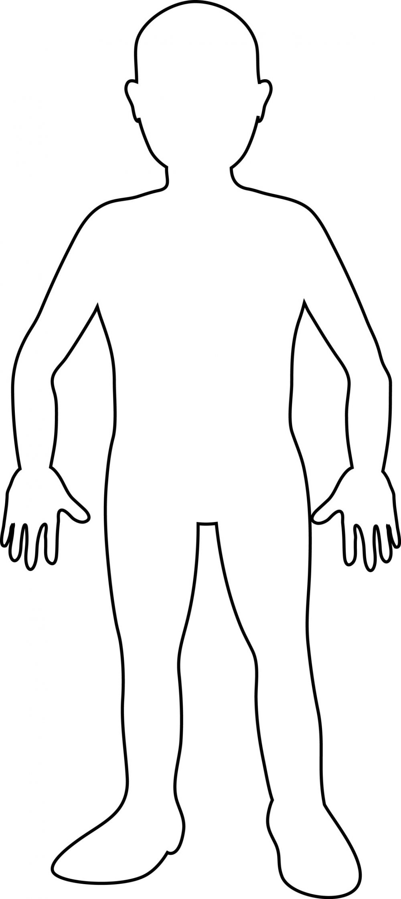

***Individual triggers (30 mins)***

Resources: For this activity you will need a flipchart, some pens and the ‘Anxiety Thermometer.’

Aim: The aim of this activity is to further build the young person’s knowledge of their own anxiety, but also to help them start to work out the triggers for their emotions so they are able to intercept and manage these emotions as early as possible.

Instructions:

Encourage the group to share what makes them anxious (school related or not) and start to document these on the flipchart. Draw attention to the shared triggers but also the ones not as commonly shared; ask those who don’t share the worry to explain why this does not impact them and what they do to cope.

Look at recognising the onset and different levels of anxiety using the ‘Anxiety Thermometer’ worksheet and relating it to where it is felt in the body by looking again at the ‘When you are worried where do you feel it?’ worksheet to show how anxiety builds and discuss where it could be addressed before it gets out of control.

**Anxiety Thermometer**

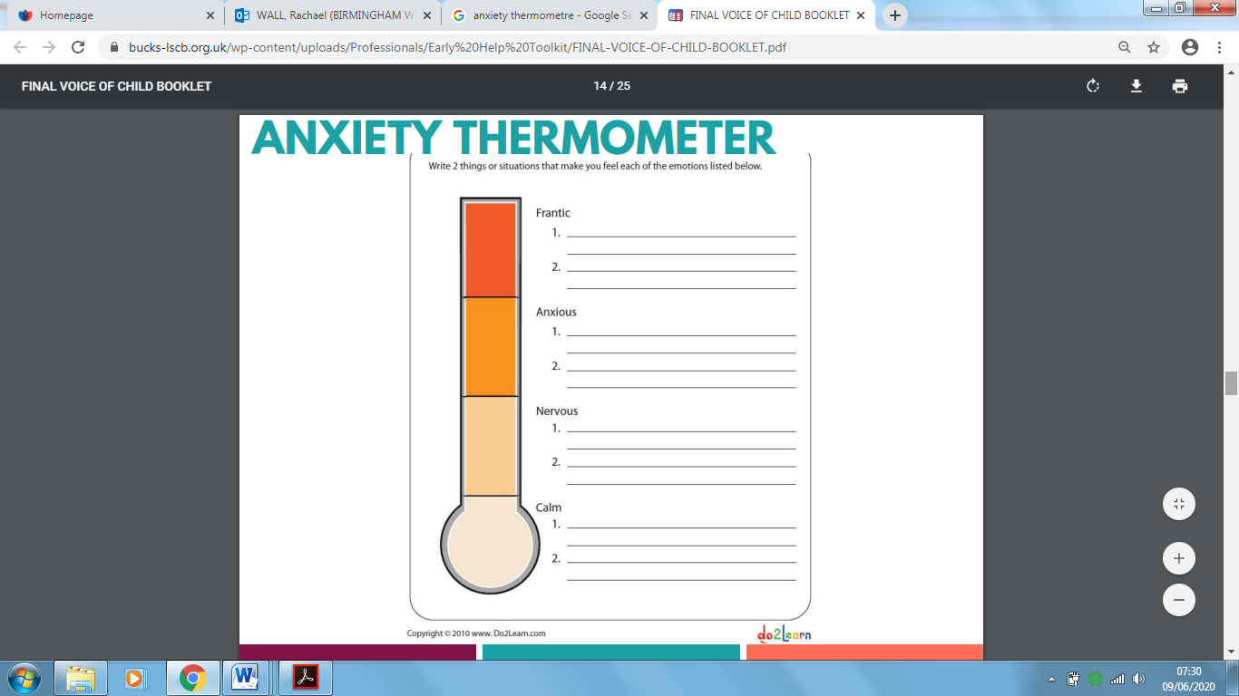

**Reflections/Closing exercise (20 Mins)**

Resources: Quiz/Reflections

Aim: the aim of this part of the workshop is to help consolidate the children’s learning as well as gain important feedback on how the workshop has been (which can be considered before implementing day two).

Instructions:

Hand out the feedback sheet and ask them to answer the questions

Go through the quiz questions; this can be done in a game show style where they have to push metaphorical buzzers, they can work in teams or individually and write down their answers or even just shout out as a group.

1. How many years ago did fight or flight develop?

* Hundreds of years ago
* Thousands of years ago (CORRECT ANSWER)
* Ten years ago?

1. What is fight or flight designed to help us do?

Answer: React to the danger by either running away or fighting

1. Which part of the brain has control over fight or flight?

Answer: The Meerkat

1. Which part of the brain holds all of our memories and experiences?

Answer: Elephant

1. Who does the elephant pass on these memories and experiences to?

Answer: The Meerkat

1. What is the owl supposed to do?

Answer: He’s supposed to talk to the meerkat and help it understand that fight or flight is not needed.

1. Do people who struggle with their anxiety have lazy meerkats or active meerkats?

Answer: Active Meerkats

1. Do people who struggle with their anxiety have lazy owls or active owls?

Answer: Lazy owls

1. Fight or flight is just our body’s way of trying to keep us safe? True or False

Answer: True

Transition Workshop Feedback sheet

On a scale of 1- 10 please rate how enjoyable this workshop has been- 0 being unenjoyable and 10 being enjoyable

0 1 2 3 4 5 6 7 8 9 10

On a scale of 1- 10 please rate how helpful this workshop has been- 0 being unhelpful and 10 being helpful

0 1 2 3 4 5 6 7 8 9 10

Please tell us what has been positive about today’s workshop

________________________________________________________________________________________________________________________________________________________________________________________________________________________________________________­­­­­­________________________

Please tell us what you would change about today’s workshop

________________________________________________________________________________________________________________________________________________________________________________________________________________________________________________________________________­­­­­______

**Transition workshop guide Day 2 (3 hours in total)**

Welcome back (15 minutes)

* Welcome back activity

Management techniques to calm the thoughts (45 minutes)

* Thought re-structuring
* Mindfulness

Break (15 minutes)

Management techniques to calm to body (30 minutes)

* Exercise
* Muscle Relaxation
* Breathing exercises

Distraction techniques (45 minutes)

* Grounding
* Self-soothe boxes

Closing (30 minutes)

* Care plan
* Reflections
* Feedback

**Welcome back; Failure - Ice Breaker Activity- The impossible Hole**

Resources: paper with holes and 2p coin or similar alternative (round counters)

Pre-Session Prep: You will need enough sheets of paper for each child. A5 works well. On each sheet of paper, you will need to cut a hole in the middle. This will need to be a fraction smaller than a 2p coin or your alternative. If you are using 2p then trace around a 1p coin, this is the perfect size Make sure this works before and is the right size before doing the rest.



Hole in your paper smaller than your coin

Aim: To understand that sometimes we will fail and that’s ok. However, we always need to be patient with ourselves and kind to ourselves. By learning that failure isn’t the end of the world it can help us succeed.

Instructions: Once each pupil has the resources required for this task give them the basic instruction that they are to get the coin, through the hole without forcing it or ripping the paper. They will get frustrated with this task by thinking it’s impossible (even though it isn’t).

The Answer: Fold your sheet in half and half again creating a cross in your paper (make sure the cross goes through the middle of the hole). Lay it back out flat, put your 2p coin on the paper and then pinch it length ways and bring your hands together so that all four corners start to come together at the top (demonstrate how this trick works)

Talk: Sometimes we might fail at things and that’s ok, as long as you give it your best shot. If you are struggling don’t let this make you give up all together. Ask for help and guidance on what you are struggling with. Often others can help you and if they don’t know the answer then you can learn together.

***Managing the anxious thoughts (45 Mins)***

**Take your thought to court (30 mins)**

Aim: The aim of this exercise is to help the young person start to apply logic and reasoning to their thinking in the hope they will eventually change their perspective.

***Version 1***

Instructions: Present a hypothetical “worry thought” to the group (or use a worry that was identified during the first half of the workshop in the triggers activity) and then split the room in two- one side being arguments for and the other being arguments against. Give each team an allocated time slot to come up with either arguments that justify the anxious thought, or arguments that contradict the anxious thought.

Example:

Anxious thought; ‘I won’t make any friends’

Label these as the meerkat thoughts

Arguments for may include;

My closest friend from primary school has gone to a different school

I’m not very confident and have always struggled to start conversations

Arguments against may include;

Although my closest friend isn’t here I still have a number of good friends from my primary school

Even if I am shy others may not be; they might start conversations with me

Label these as the owl thoughts

I know people who are far less sociable than me who have always managed to make friends in secondary school (siblings for example) so why shouldn’t I?

Everyone is in the same boat; everyone wants to make friends so people will be making extra effort

I am a good person and there’s no reason someone wouldn’t want to be friends with me

***Version 2***

Rather than getting the young people to come up with the arguments and present them in a debating manner, you could pre-prepare all of the arguments and get the young people to decide whether they are for or against. They could stick them on two halves of a wall or they themselves could move to opposite sides of the room to reflect their opinion.

Tip: Encourage the young people to think about the difference in how their bodies would feel in response to the different styles of thinking; they should recognise that the arguments for would lead to a fight or flight response whereas the arguments against should help them remain calm. Also try and get them to link these thoughts to the owl i.e. the experiences they may have had in the past and why this has led to particular thinking styles.

Outcome: This exercise should end up with far more arguments against than for (if your hypothetical anxious thought is illogical) forcing the young people to realise their reactive emotional thoughts are not always helpful and learning to control them in turn changes their physiological responses and they then act differently.

Resources for the young people to take away: Take your thought to court worksheet

**Mindfulness Techniques (15 mins)**

Aim: Mindfulness aims to help the individual be present and in the moment. It’s a technique that will help the young people have control over their thoughts and it trains the mind to stay in the here and now by focusing on present moment, whilst calmly acknowledging and accepting thoughts, feelings and bodily sensations.

***Version 1: Mindfulness eating***

We can do anything mindfully and this version demonstrates how simple daily activities such as eating can be done in a mindful way.

Resources: Chocolate! (large chocolate buttons are best)

Instructions:

Step 1. Allow each child to take a piece of chocolate

Step 2. Ask them all to place the chocolate on their tongues and press it to the roof of their mouths

Step3. Encourage them to close their eyes, relax and refrain from chewing the chocolate. They should spend their time focusing on all of the sensations associated with this chocolate i.e. how it tastes, how it melts, how it smells etc.

Step 4. Whilst doing this they should be encouraged to clear their minds of any thoughts unrelated to the chocolate as much as possible, and place all of their focus on the chocolate alone.

Step 5. Once their chocolate has completely melted they can open their eyes and should reflect as a group on what that experience was like for them (they should have all tasted the chocolate far more intensely than they usually would have)

Step 6. Encourage them to think of other ways they could incorporate mindfulness into their daily lives.

***Version 2: Mindfulness Imagery***

Not only can mindfulness help us be aware of our present moment, it can also be used to help us transport back to a point in our lives that, by revisiting, would also create a sense of calm and peace within us.

Instructions:

Step 1. Start by asking the young people to pick a memory that evokes lots of positive emotions for them, it doesn’t have to be recent but it helps if they have a good detailed recollection of that day

Step 2. Tell them all to find a comfortable spot, close their eyes and ask them to begin taking deep breathes in and out through their noses

Step 3. Encourage them to imagine they are back in that moment; recall what they can see around them i.e. who they were with, where they were, the things they passed by etc. If they drove or walked somewhere in this memory, can they re-enact the route in their mind?

Step 4. Recall any particular sounds, smells or tastes they may have experienced in this memory in as much detail as possible

Step 5. Focus on what they felt in that moment; the temperature around them, the movement of their body, the clothes against their skin… and the emotions they felt; encourage the young people to notice and these emotions return and allow themselves to enter that positive emotional state.

Step 6. Just allow the young people to be in the moment.

Outcome

The young people should be far more attuned to their body and should have started developing the skills needed to become more present and mindful in their daily lives

**Management Techniques to Calm the body (30 Mins)**

**Exercise (10 mins)**

Resources:For this exercise you will need a laptop with access to youtube and the technology to project the screen if you have a larger group. Alternatively you could use the ‘Joe Wickes Exercise cards’ provided.

Aim: The aim of this activity is to help the group realise the benefits of exercise on their anxious symptoms; it is hoped by getting them moving they realise how exhausted their muscles become (which would be a great way of burning off anxious energy) but also how distracted from their worried thoughts they are.

Instructions:

Explain that this exercise serves as an emotional release. Chemicals released in the brain during the course of exercise create a sense of wellbeing and happiness. Then play Joe Wicks video of 5 minutes exercise and invite participation. If you do not have access to the internet then use the worksheets provided.

<https://www.youtube.com/watch?v=d3LPrhI0v-w>

After the exercise explain that your breathing rate and heart rate both increase when you become anxious. You can learn to reverse these increases by systematically relaxing your tense muscles and/or deliberately slowing your breathing. Relaxing in this manner will help you to maintain control.

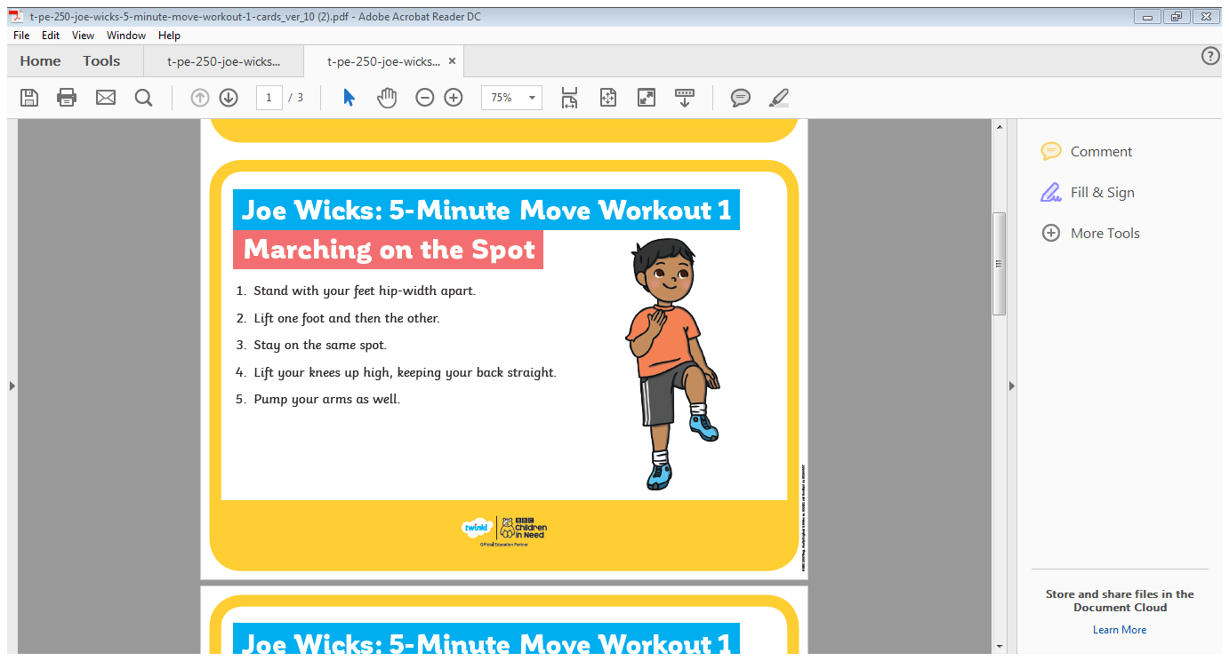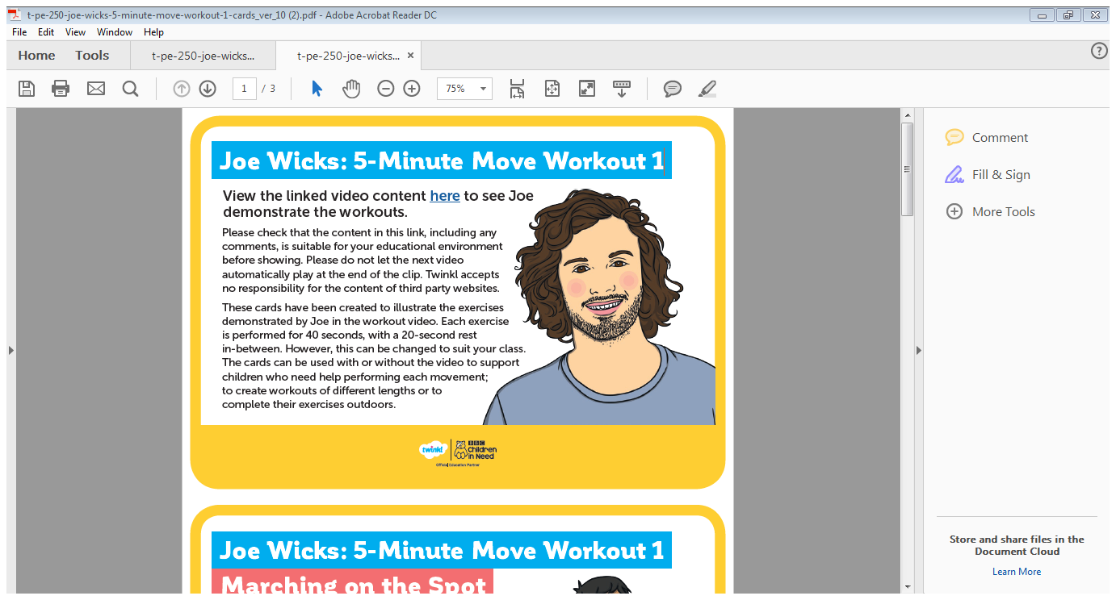

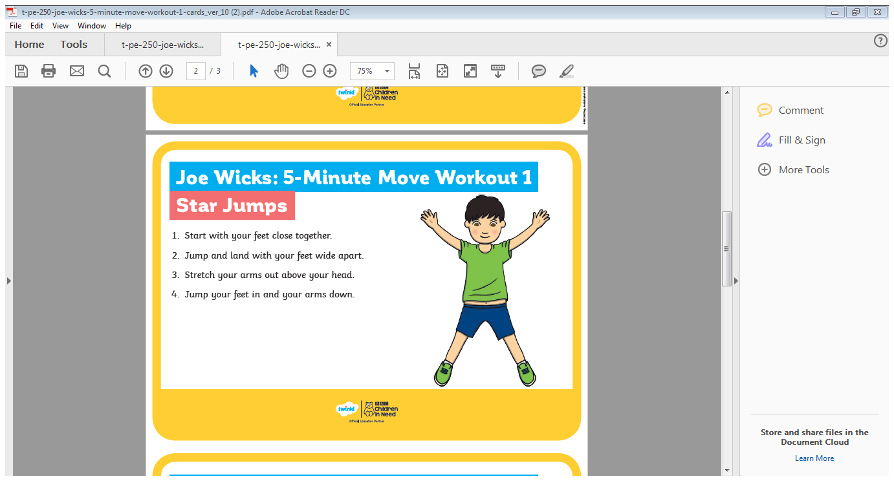

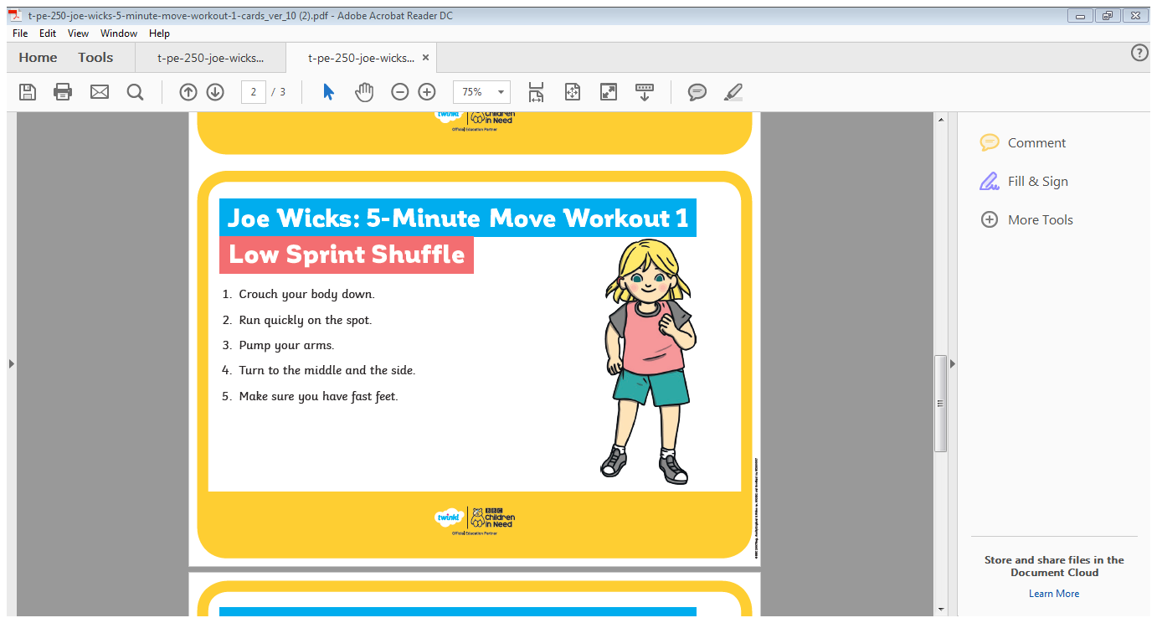

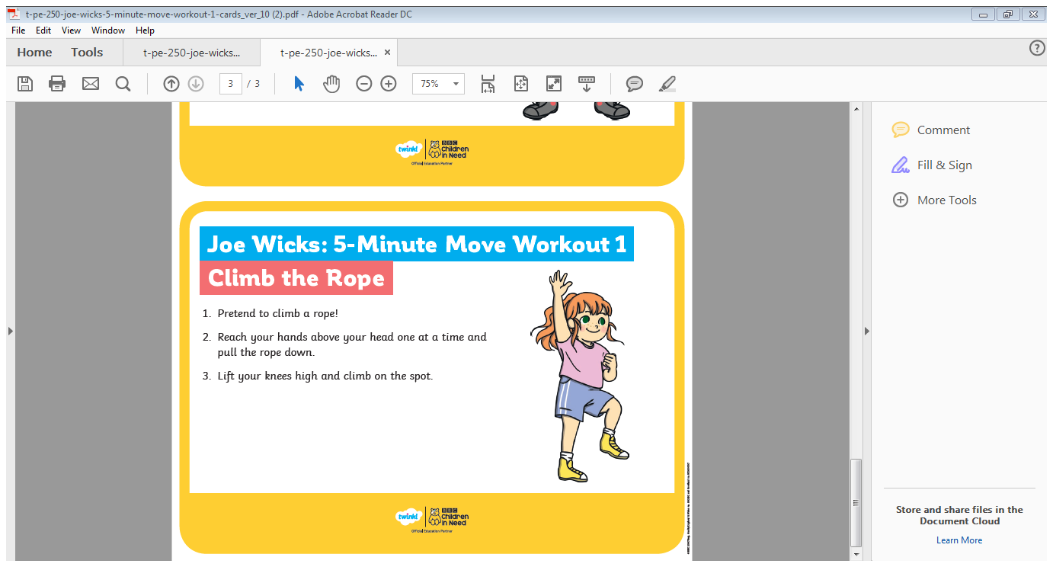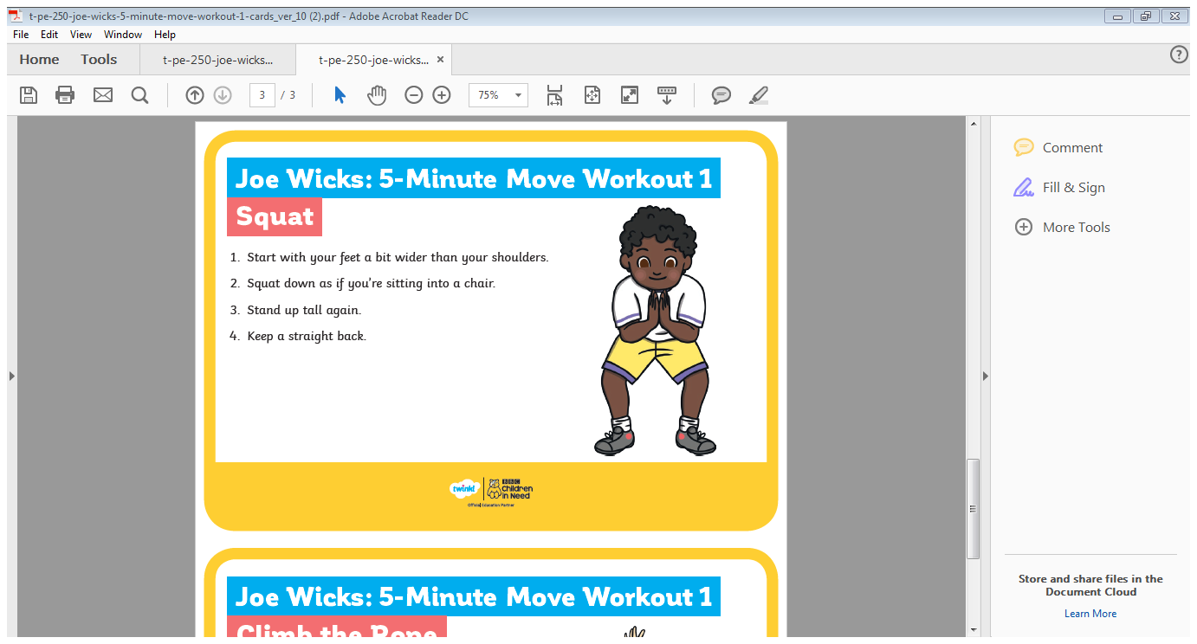

J

**Breathing (10 mins)**

Aim: The aim of this exercise is to help the group learn that they are able to be in control of their bodily responses when anxious and in turn are able to reverse the effects of fight or flight.

Instructions: Encourage the children to find a comfortable spot and either close their eyes or place their head in their arms. Choose one or more of the breathing techniques below and follow the scripts. Alternatively split the group into small groups of 6 giving each group a different technique to try. Encourage them to feed back the effects to the group.

**ABDOMINAL BREATHING**

When we are stressed, our breathing becomes increasingly shallow and limited to the chest. Take a moment to notice where in your body your breath starts and ends. Now place your hand on your stomach and take a deep breath through your nose, all the way down into your abdomen. Exhale fully and slowly, using your stomach muscles to push out the last of the air. Repeat this pattern, imagining your stomach as a balloon that inflates with the in breath and deflates with the out breath.

**VISUALISATION**

As you deepen your breath, imagine your inhale washing over you like a gentle wave. Imagine your exhale taking with it any stress, tension and negativity. Try breathing in a calm colour such as blue, imagine this spreading throughout your body, then visualise any tension or anxiety leaving your body as a red mist or black smoke as you exhale.

**LION’S BREATH**

Kneel on the floor in a comfortable position. Take a deep breath in through your nose. Exhale forcefully through the mouth, opening it as wide as you can, sticking your tongue out, stretching it as far down towards your chin as you can. Vocalise ‘ha’ as you do this. Relax your face as you inhale again and repeat.

**BREATH FOCUS**

Bring your full attention to your breath. Notice each breath as it enters your nostrils, travels down to your lungs and expands your stomach. Notice how the inhale is different from the exhale. The air may be cool as it enters your nostrils and warm as it leaves. Allow yourself to be completely with your breath as it flows in and out. If your mind wanders, simply notice this, then gently bring your focus back to the breath. Remember your breath is an anchor you can return to whenever you need it.

**ALTERNATE NOSTRIL BREATHING**

Sit down in a comfortable place, lengthening your spine and opening your chest. Use one of your fingers to close your right nostril and inhale slowly through your left nostril. Hold for a moment whilst you move your finger to close your left nostril. Now inhale again, then hold the breath whilst you move your finger to recover the right nostril and breathe out through the left. Repeat this pattern.

**LENGTHEN YOUR EXHALE**

Exhaling activates the parasympathetic nervous system which acts to calm the body down. Try taking a thorough exhale, pushing all of the air out of your lungs. Let them fill up again naturally before again elongating the time you take to breathe out. Repeat this pattern, ensuring that the out breath always lasts a little longer than the in breath.

**ALTERNATE NOSTRIL BREATHING**

Sit down in a comfortable place, lengthening your spine and opening your chest. Use one of your fingers to close your right nostril and inhale slowly through your left nostril. Hold for a moment whilst you move your finger to close your left nostril. Now inhale again, then hold the breath whilst you you move your finger to recover the right nostril and breathe out through the left. Repeat this pattern.

**LENGTHEN YOUR EXHALE**

Exhaling activates the parasympathetic nervous system which acts to calm the body down. Try taking a thorough exhale, pushing all of the air out of your lungs. Let them fill up again naturally before again elongating the time you take to breathe out. Repeat this pattern, ensuring that the out breath always lasts a little longer than the in breath.

**BREATH FOCUS**

Bring your full attention to your breath. Notice each breath as it enters your nostrils, travels down to your lungs and expands your stomach. Notice how the inhale is different from the exhale. The air may be cool as it enters your nostrils and warm as it leaves. Allow yourself to be completely with your breath as it flows in and out. If your mind wanders, simply notice this, then gently bring your focus back to the breath. Remember your breath is an anchor you can return to whenever you need it.

**Muscle relaxation (10 mins)** Aim:When you’re stressed or anxious your muscles can become tight and tense. This exercise helps you notice tension in your body and relax your muscles.

Instructions:

Step 1. Play calming music - <https://www.youtube.com/watch?v=6xDyPcJrl0c>

Step 2. Encourage the group to lie down or sit with their backs straight and their feet on the floor. Ask them to close their eyes or focus on a spot in the distance.

Step 3. Ask them to start by clenching their toes as much as they can for a few seconds then releasing them. Encourage them to notice the difference between the two feelings.

Step 3. Whilst matching this to their breathing, ask them to tense their muscle as they take a deep breath in, and relax as they breathe out.

Step 4. Ask them to move up their body to their thighs, then stomach and all the way to their shoulders and hands, clenching and relaxing each muscle in turn. Allow them time to notice any parts of your body that feel tense, tight or tired. Repeat as many times as needed.

Step 5. Give the group a moment to relax, then ask them to slowly and gently begin to move their fingers and toes. Ask them to stand up slowly when they feel ready.

Managing anxiety trough distraction (45 Mins)

**Grounding (15 Mins)**

Resources: Grounding PowerPoint presentation and each child will need ‘Senses Grounding’ worksheet and a pen

Aim: Distraction techniques are a way of helping children cope with painful or difficult emotions. They can be used if a child is in pain or discomfort (physical or emotional). The aim of distraction techniques is to take the child’s mind off the uncomfortable feeling or situation by concentrating on something else that is happening. Grounding basically means to bring your focus to what is happening to you physically, either in your body or in your surroundings, instead of being trapped by the thoughts in your mind that are causing you to feel anxious. It helps you stay in the present moment instead of worrying about things that may happen in the future or events that have already happened but you still find yourself going over and over them in your head.

Instructions:

Use the powerpoint slide and notes to introduce what grounding is. Then play the youtube link included in the slide which explains a particular grounding technique that utilises the senses. Once the video is complete, ask the group to complete their worksheet in silence, trying to focus only on their senses. Encourage them to be conscious of any other non-related thoughts that may enter their head and make an effort to clear their minds.

Tip: The group should be encouraged to be quiet during this exercise so they can really stretch their range of hearing.

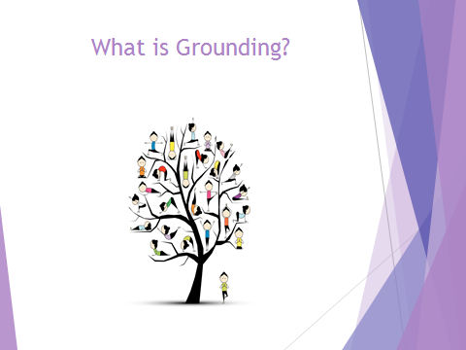

When your mind is racing, grounding brings you back to the here-and-now and is very helpful in managing overwhelming feelings or anxiety. It is a great way to calm down quickly.

Grounding basically means to bring your focus to what is happening to you physically, either in your body or in your surroundings, instead of being trapped by the thoughts in your mind that are causing you to feel anxious. It helps you stay in the present moment instead of worrying about things that may happen in the future or events that have already happened but you still find yourself going over and over them in your head.

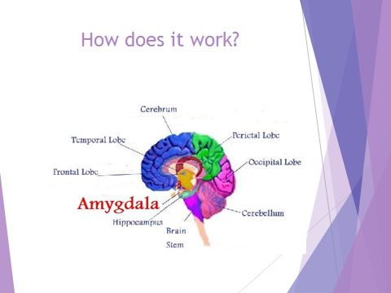

When we start to think about something stressful, our amygdala (meerkat), goes into action. As we now know the amygdala, simply put, is the part of our brain that is responsible for our emotional responses, especially fear. It is great for preparing for emergency events but sometimes it kicks in to action and detects a threat where there really isn’t any.

Here is a typical process; we have a negative thought about a situation (remember a thought doesn’t necessarily mean it is real), our amygdala says “emergency! emergency!” and initiates changes in our body such as increased muscle tension, rapid heartbeat and faster breathing (link this back to the what worry feels like activity they did on day 1). The amygdala then interprets these body changes as further evidence that something is actually wrong which of course further activates it and creates a vicious cycle where you become more and more anxious and physically and emotionally overwhelmed.

Thankfully, we can use grounding techniques to break out of this vicious cycle. By re-focusing on the body and what you’re physically feeling, you get out of your head and divert your mind away from anxious or stressful thoughts and into the moment that you are present in (activating our owl).

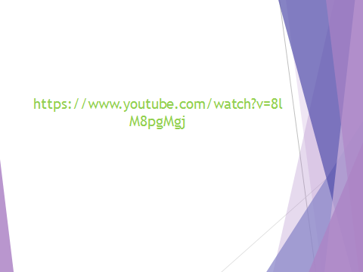

Play youtube clip

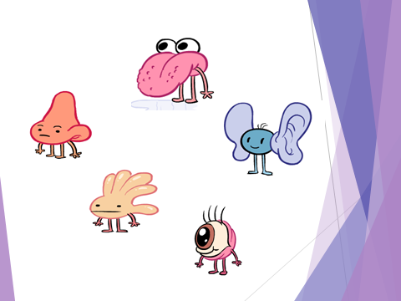

Hand out the grounding sheet on the next page and allow the group time to complete this activity

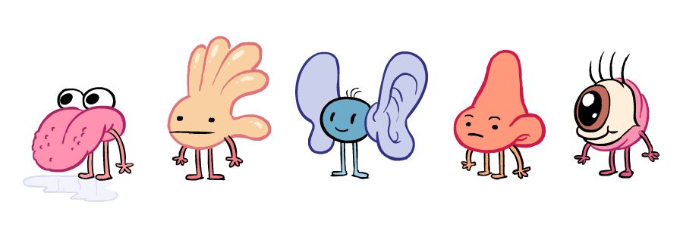

Identify 5 things you can see;

1.

2.

3.

4.

5.



Identify 4 things you can feel/touch;

1.

2.

3.

4.



Identify 3 things you can hear;

1.

2.

3.



Identify 2 things you can smell;

1.

2.



Identify 1 thing you can taste;

1.

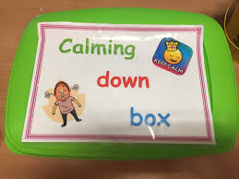**Self-soothe Box**

Aim: The aim of a self-soothe box is to distract and soothe in times of stress. It originates from DBT (Dialectical Behaviour Therapy) and addresses the need to manage and tolerate distress. Children are not born with self -control so they are going to need to keep learning and developing the skill to emotionally regulate.

Instructions:

Identify a suitable container (shoe box, Tupperware etc.,) and allow the group to spend time decorating this however they wish. Whilst they are decorating, generate discussion around the sorts of items that can go into these boxes; these should be things that make them feel calm. It is best to identify items that engage their 5 senses, some examples are listed below

**Touch**

* Favourite Toy
* Soft materials
* Stress ball
* Pom Poms
* Hand Cream
* Feathers, soft brush
* Play-doh

**Smell**

* Scents that evoke happy times
* Lotions or oils (you will need to be careful with younger children!)
* Fragranced erasers and stickers

**Vision**

* Some photos
* Pictures/postcards of calm
* Funny Pictures
* Mindful colouring

**Sound**

* A favourite story
* An audio of special voices
* A meditation
* Music
* Animal or nature sounds

**Taste** (for teenagers and older only)

* Gum
* Lollipop
* Snack

Resources for them to take away: This list has been provided on the next page so it can be printed and given to the children to help them fill their self-soothe boxes at home.

**Touch**

**Self-soothe box ideas**

* Favourite Toy
* Soft materials
* Stress ball
* Pom Poms
* Hand Cream
* Feathers, soft brush
* Play-doh

**Smell**

* Scents that evoke happy times
* Lotions or oils (you will need to be careful with younger children!)
* Fragranced erasers and stickers

**Vision**

* Some photos
* Pictures/postcards of calm
* Funny Pictures
* Mindful colouring

**Sound**

* A favourite story
* An audio of special voices
* A meditation
* Music
* Animal or nature sounds

**Taste** (for teenagers and older only)

* Gum
* Lollipop
* Snacks

**My Transition Care Plan**

The people who are going to support me to do this are……..

The techniques I want to develop further are….

My top 3 management techniques are….

This usually happens because of……..

I now know my anxiety is building when I notice my early warning sign which is……..

Transition Workshop Feedback sheet

On a scale of 1- 10 please rate how enjoyable this workshop has been 0 being unenjoyable and 10 being enjoyable

0 1 2 3 4 5 6 7 8 9 10

On a scale of 1- 10 please rate how helpful this workshop has been 0 being unhelpful and 10 being helpful

0 1 2 3 4 5 6 7 8 9 10

Please tell us what has been positive about today’s workshop

________________________________________________________________________________________________________________________________________________________________________________________________________________________________________________­­­­­­________________________

Please tell us what you would change about today’s workshop

________________________________________________________________________________________________________________________________________________________________________________________________________________________________________________________________________­­­­­______