**Effort - Ice Breaker Activity**

**Resources**: N/A

**Time**: 5 - 10min

**Aim**: To talk about the importance of effort and how it helps you be the best you can be.

**Q**: Has anyone ever learnt a new skill?

(feedback from the group about what skills they may have learnt)

**Talk**: Anyone who has ever learnt a new skill has had to put in effort to achieve that goal. It does not matter if it was learning to play the piano or a new football trick each of those skills requires effort. Effort is defined by a vigorous or determined attempt. So, with this in mind I have a challenge for you all.

**Activity**: Who can hold the squat position for the longest?

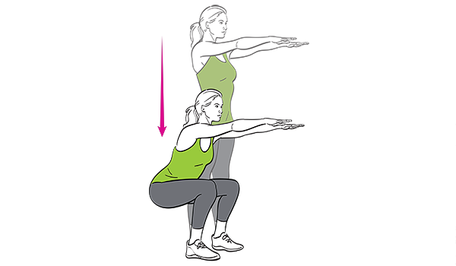Get everyone to pretend like they are sitting on a chair with their arms out in front of them

Whoever holds this position the longest wins!

**Talk**: Most things in life that are worthwhile achieving take effort. It doesn’t matter if you didn’t hold the squat for the longest. If you gave it your best shot and tried your hardest that’s all that matters. Don’t give up just because something is hard. By trying your hardest you can become the best version of you that you could possibly be.