

**Report to: Schools Forum**

**Date: 22nd June 2020**

**Report of: John Betts, Interim Finance Business Partner (Education & Skills)**

**Title: 2019/20 Schools Reserves**

1. **Purpose of the Report**To inform Schools Forum of the level of school balances as at 31st March 2020 (excluding academies). Schools were informed of their balances through the School Noticeboard week commencing 15th June 2020.
2. **Breakdown**

2.1 As at 31st March 2020 the cumulative net school balances for BCC maintained schools is £51.6m. The breakdown by sector is set out in the table below together with the 2018/19 position.

**Table 1 – Schools Reserves Analysis**



*The 2018/19 figures has been adjusted to only reflect the remaining maintained schools*

2.2 It is to be noted:

1. Total net school balances have increased by £0.393m from 2018/19
2. The number of schools in deficit has stayed the same at 40 (16.8% of the total number of LA maintained schools) and the cumulative value of deficits has increased by £1.927m to £9.164m.
3. Since 2014/15 the trend on net school balances (excluding academies) has been:

|  |  |  |  |  |  |  |
| --- | --- | --- | --- | --- | --- | --- |
| Financial Years | 2014/15 | 2015/16 | 2016/17 | 2017/18 | 2018/19 | 2019/20 |
| £m | 55.795 | 57.921 | 52.841 | 49.118 | 47.365 | 51.641 |

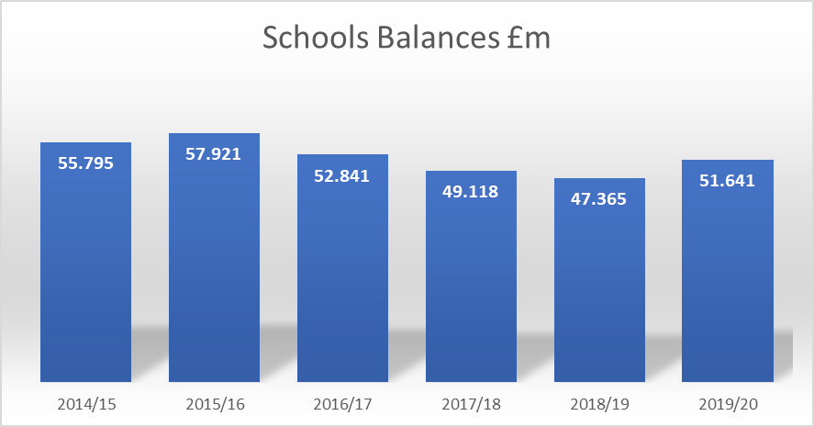

1. **Schools in Deficit**

In the case of schools in deficit or showing an adverse trend, the data will inform the work already being done by Birmingham City Council to identify schools causing financial concern and support / work with those schools. The Council is increasingly concerned at the escalating level of deficits across the sector and is seeking an increased role for the School Forum working jointly with the Council to manage and control the level of deficit. An action plan has been developed to take a range of actions to seek to reduce the level of deficit and a representative is being sought from School Forum to join the Council’s Schools Finance Governance Board. Further reports on the deficit position will be brought to the School Forum during the year.

1. **Schools in Surplus**

4.1 For schools in surplus above the recommended levels, the reported figures do not factor in any legitimate commitments and plans the schools have (or not) that will be a further call on the balances. The intention therefore, as last year, is for audit to conduct a review of a sample of schools with high surplus balances and those that have moved into significant surplus and seek satisfactory explanations from the schools concerned before deciding whether any clawback is warranted.

4.2 Schools have been reminded of the requirement to complete the Surplus Balance Analysis proforma and present to their Governing body meeting as soon as possible.

**5. Birmingham City Schools Control of Surplus Balances Policy**

5.1 In November 2019 Schools Forum approved :

1. the implementation of Birmingham City Schools Control of Surplus Balances Policy which was included in the November 2019 Schools Forum papers.
2. that the policy is incorporated into the Birmingham Fair Funding Scheme of Delegation.
3. that the policy is implemented in the current financial year 2019/20 and applies to balances held at 31st March 2020.

5.2 Schools Forum at that meeting also noted:

1. that on Policy on the control of surplus balances paragraph 2.2: ‘Surplus balances held by schools, as permitted under the Fair Funding Scheme of Delegation, are subject to the following’: it was suggested to add ‘in excess of recommended levels’ after ‘surplus balances’
2. the final decision would be made by the Director of Education and Skills with the full involvement of the Finance and Governance Group.
3. Appeals to be put writing to the Chief Finance Officer
4. Any balances clawed back will be used to offset deficit balances paid by the Council under directed Academy Conversions. Any alternative use of clawback funding will be subject to discussion with the School Forum.

5.3 Birmingham City Council will still look at 2019/20 surplus balances in excess of recommended levels but will take into account Covid-19 before taking further action.

1. **Recommendations**

6.1 School’s Forum to note the level of school balances as at 31st March 2020.

6.2 To nominate a representative from the School Forum to join the Council’s School Finance Governance Board.