How to connect your Wi-Fi printer at home
- Open Windows search by pressing Windows Key + Q.
- Type in "printer."
- Select Printers & Scanners.
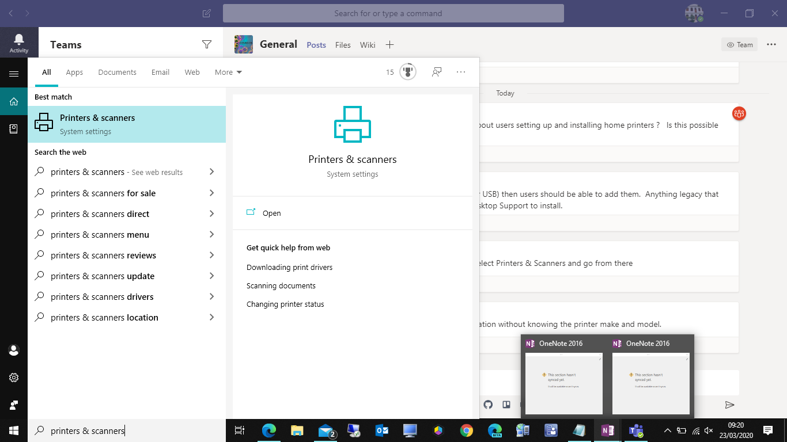
- Turn on the printer.
- Refer to the manual to connect it to your Wi-Fi network. ...
- Hit Add a printer or scanner.
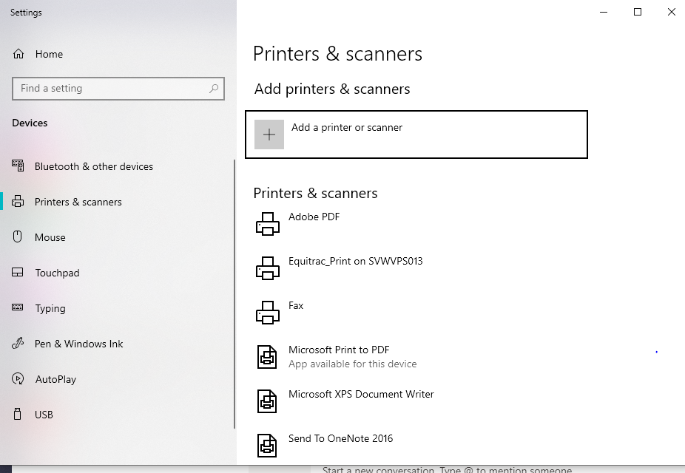

- Select the printer from the results.
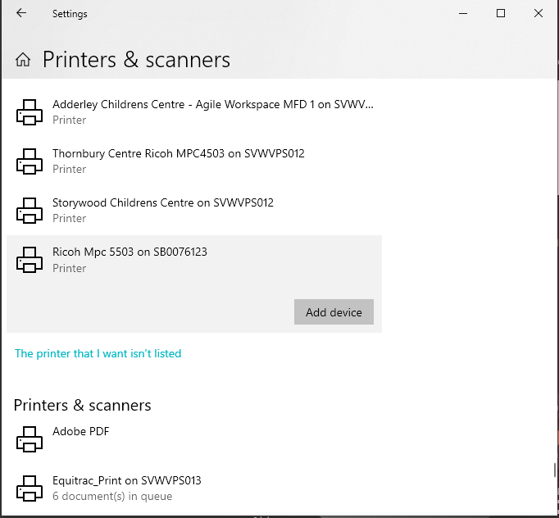
- Click Add device.
- If your printer is not listed, then click on “the printer that I want isn’t listed”
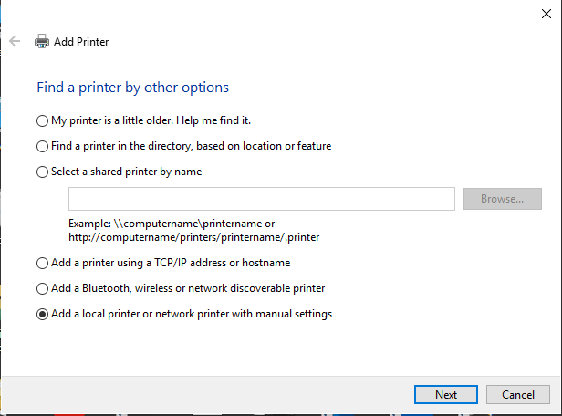
- Select “Add a Bluetooth, wireless or network discoverable printer” or “Add a local printer.., then select your printer.

