**Information, Technology & Digital Services**



**IT&D Portal Guide**



**Accessing the IT&D Portal**

**The IT&D Portal Homepage**

**Logging a Network Password Reset**

**Logging an Application Password Reset**

**Logging a Support Request**

**Tracking Progress**















**Accessing the IT&D Portal**

To access the IT&D Portal click on the IT&D Portal icon on your desktop 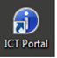.

Use your Network User ID and Password to Login.

If the icon does not appear on your desktop – please call the Service Desk on 464 4444 to arrange an install



**The IT&D Portal Homepage**

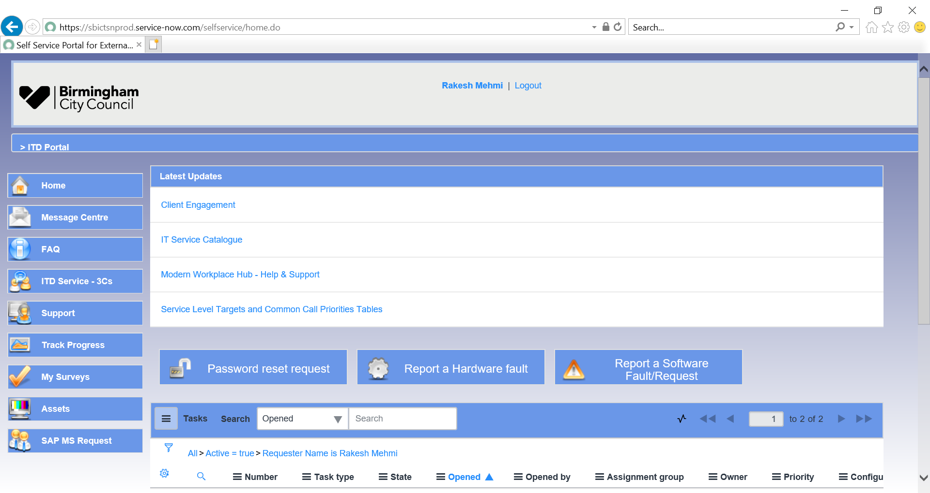

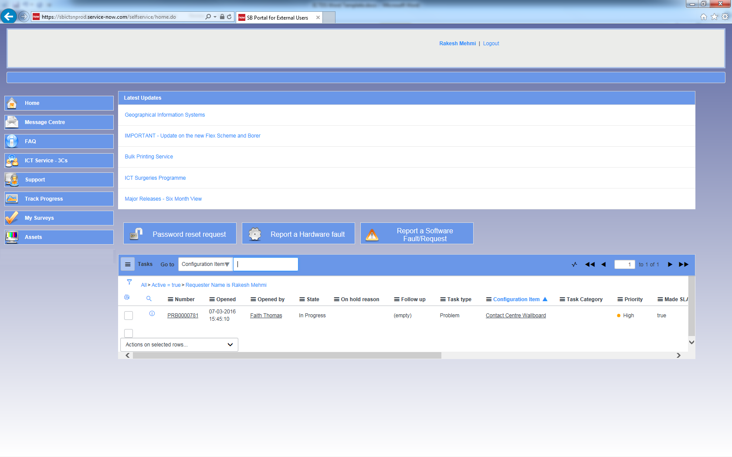

Find your asset manager and view assets assigned to you

Let us know your thoughts on our service

Keep up to date with existing tickets and browse closed tickets

Log Password Resets, Faults and tickets using appropriate forms

Log Compliments, Complaints and Comments

Useful support and guidance on common IT issues

Information on any service changes and directorate specific news

Will return you back to the Homepage at any point



**Logging a Network Password Reset**

**SUPPORT MENU >> PASSWORD RESET >> PASSWORD RESET REQUEST**

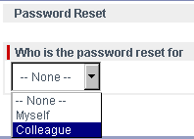

**1**

Note that Network Password Resets cannot be self-submitted. From the drop down menu select “**Colleague**”

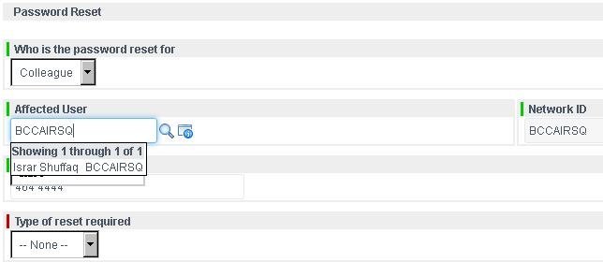

Locate the colleagues’ details by searching form them in the “Affected User” field. Note that you can either enter in the **Network ID** or search using the colleagues’ **full name**.

Note that using the 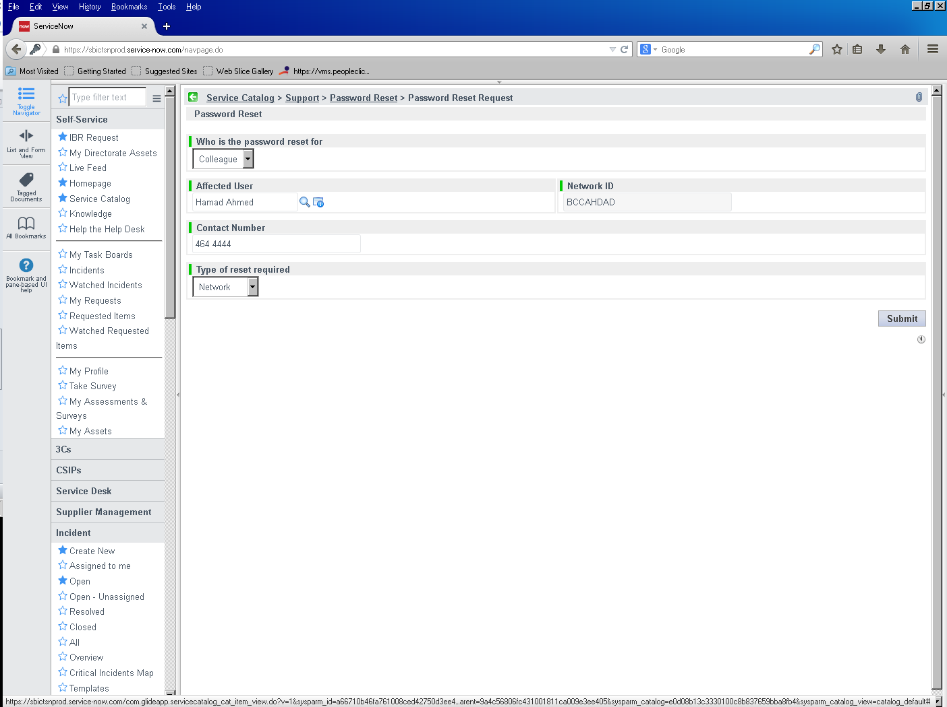 icon will display all contacts and is searchable for the appropriate colleagues’ details

**2**

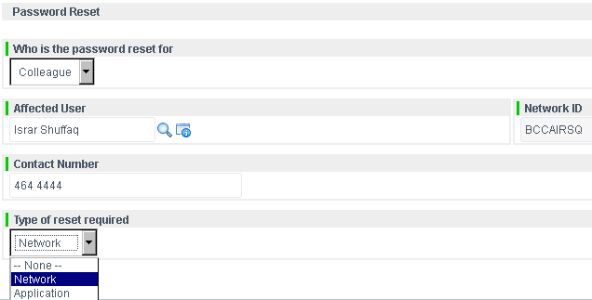

**3**

Once you have located the colleagues’ details; the Network ID and Contact Number will auto populate. Please confirm and if required amend the **Contact Number** for the colleague

**4**

In the “Type of reset required” Select **Network**



**Logging an Application Password Reset**

**SUPPORT MENU >> PASSWORD RESET >> PASSWORD RESET REQUEST**

**1**

Note that Application Password Resets can be self-submitted. From the drop down menu select “**Myself**”. Please confirm and if required amend the **Contact Number** for yourself

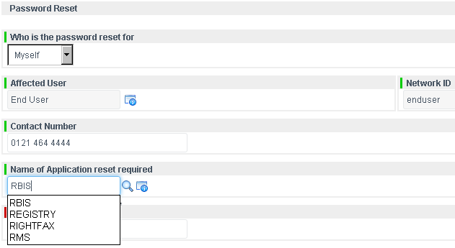

**2**

Locate the **name of the application** you require the password reset for by typing this in

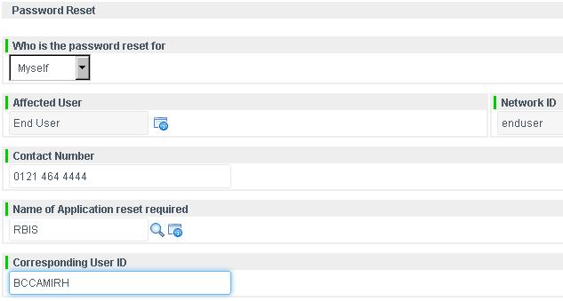

**3**

Enter in the **corresponding User ID** for the application (the User ID used to log into that application)

**4**



Click on “**Submit**” to complete the request



**Logging a Support Request**

**SUPPORT MENU >> *SELECT THE APPROPIATE SUPPORT FORM***

**1**

In this scenario we will be raising a request for Outlook Support. Note that should multiple users be affected by the issue then please contact the Service Desk rather than use IT&D Portal

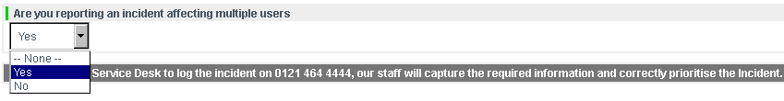

The form will pre-populate your name and contact details – If you are reporting this on behalf of somebody else, please change the affected user as appropriate. Please confirm and if required amend the **Contact Number**

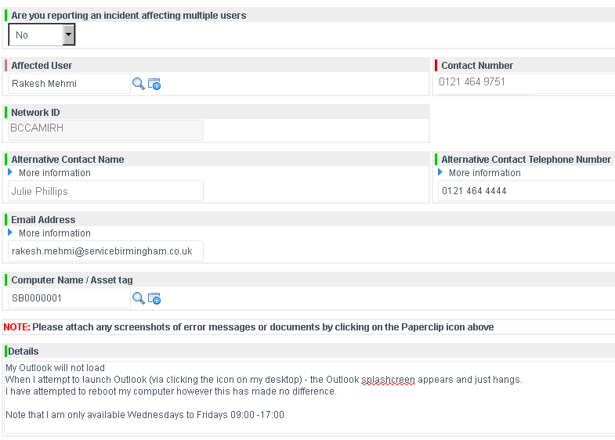

**2**

Enter an alternative contact name and number

**3**

As we are reporting an Outlook issue please enter the affected user’s corresponding **email address** and **computer name/asset tag**

rakesh.mehmi@capita-ICTDS.co.uk

In the “**Details**” field please provide as much detail as possible of the fault including details of any error messages.

Please also supply details of your availability (days and times).

If you have any screenshots of errors or documents relating to the fault you can add them by clicking on the  icon the top right corner of the form.

Click on “**Submit**” to complete the request.

**4**





**Tracking Progress**

**TRACK PROGRESS MENU**

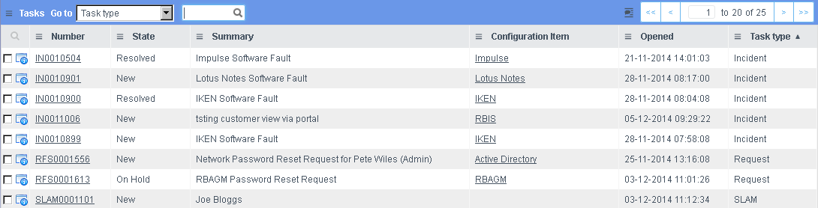

**1**

Select a ticket reference number

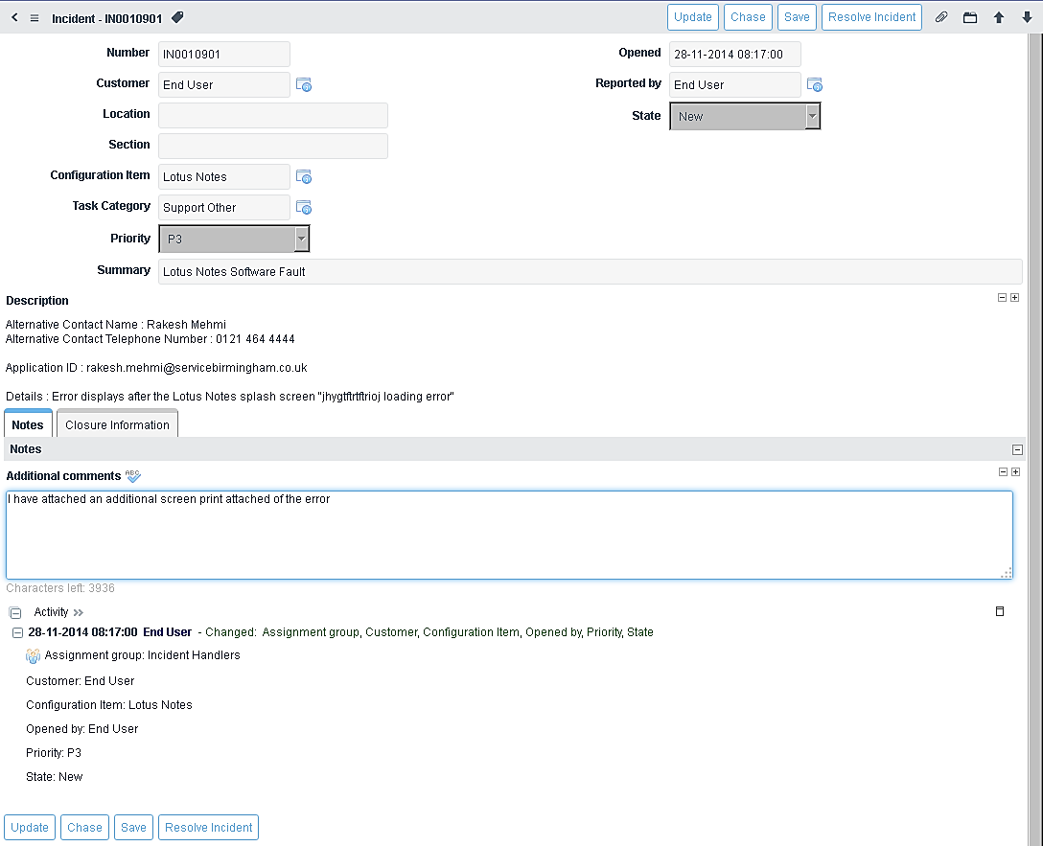

The **Notes** tab displays details of any activities undertaken/history of the ticket. Should you need to add any additional comments use the field below, and click on “**Save**”

The **Closure Information** tab display resolution details of the ticket (useful when monitoring closed tickets)

**2**

To add further information to a ticket use the “**Additional Comments**” field and then click on the “**Save**” button



**3**

To chase the ticket, click on “**Chase**” (this will send an alert to resolving team)



To save any changes made to a ticket (i.e. once you have added additional comments) click on “**Save**”



Resolved the issue...No longer a problem? Click on “**Resolve Incident**”



**For More Information**

**CONTACT US:**

**IT&D Service Desk**

**0121 464 4444**

