**Headset setup:**

Plug and Play will recognise the device. Once you have plugged the headset in you can:

**Adjust the volume:**

1. Click on the sound icon in the toolbar (next to the date and time)

cid:image001.jpg@01D5FD07.51B78E00

2. Adjust sound accordingly

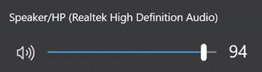

**Adjusting your mic output:**

1. From your start menu click on the setting icon

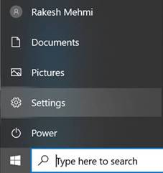

2. Click on System

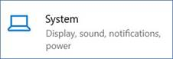

3. Select the Sound option from the left-hand side menu:

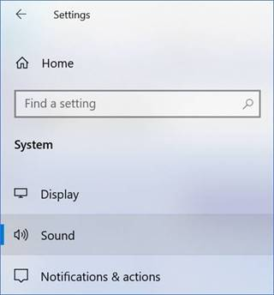

4. Under Input Click on Device Properties

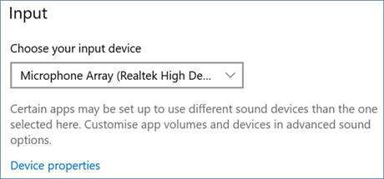

1. Adjust the mic volume and test:

