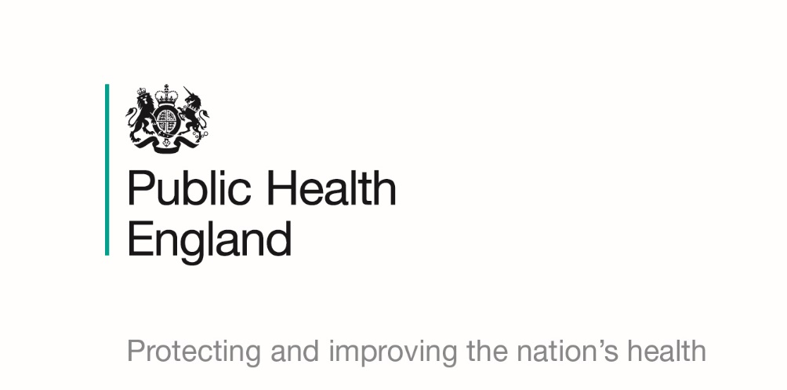

Public Health England (PHE) West Midlands has advised the council that in the last few weeks there has been an increase in outbreaks of diarrhoea and vomiting in the community in general.

Viral outbreaks of diarrhoea commonly referred to as norovirus is a common virus in the winter months which causes vomiting and diarrhoea. It spreads more easily in closed or semi-closed environments which mean that those attending schools are highly susceptible to the virus. Good hygiene and infection control measures as detailed below can limit the transmission of viral infections:

- Parents/carers of children that are ill whilst at school should be contacted and requested that they come to collect their child from school
- Affected children should be isolated, if possible from their class mates until collected by their parents/carer.
- Symptomatic staff and pupils should not return to school until they have been free of symptoms for 48 hours
- Staff movements between classrooms and joint class activities in school, eg assembly should be restricted.
- Good hand hygiene should be enforced for all pupils and staff. A hand-washing programme should be put into place that encourages children to wash their hands at the start of the school day, after using the toilet, after play, before and after eating, and encouraging parents to let their children wash their hands at the end of the school day.
- Liquid soap via a soap dispenser should be made available and there should be a plentiful supply of paper towels.
- A 48-hour exclusion period is advised in current clinical guidance; however, preference may be to practice a 72-hour exclusion period.
- Disposable aprons and gloves should be worn when cleaning touch points, cleaning and disinfecting toileting a child or cleaning up vomit or diarrhoea. Staff should wash their hands after the removal of gloves or aprons.
- Soiled children’s clothing should be sealed in a plastic bag to go home. It should not be washed on site.
- The frequency of toilet cleaning should be increased, eg clean after each break time and after a child has been sick or had diarrhoea. It is recommended that regular checks are carried out on the cleanliness of the toilets. The use of a hypochlorite-based solution should be used. Schools are advised to follow the HSE guidance on risk assessments around use of bleach products.
- Touch points, eg taps, toilet flush handles, door handles, should be cleaned regularly with a hypochlorite (bleach based) solution 1,000 parts per million. Read manufacturer’s instructions and do not use on fabrics and carpets.
- Toys used by the children should be washed and if possible disinfected. Soft toys should be machine washable; hard surface toys are more easily washed and disinfected.
- Stop sand and water play, use of play dough etc and communal sharing of food in cookery lessons.
- Group visits in and out of school should be stopped until 48 hours after the last person has stopped having symptoms.
- Visitors to the school should be postponed or if their visit is necessary then they should be informed of the outbreak and any control measures in place.
- Food should be either prepared by canteen staff or brought in by a child and consumed by that child only, ie no sharing of food.
- If your school experiences a larger than expected absenteeism rate usually greater than 10% you can contact Public Health England PHE for more information.
- Enclosed with this letter is a Norovirus Toolkit you may wish to use to assist you in minimising the impact of this illness in your school.
https://www.gov.uk/government/publications/health-protection-in-schools-and-other-childcare-facilities

