*********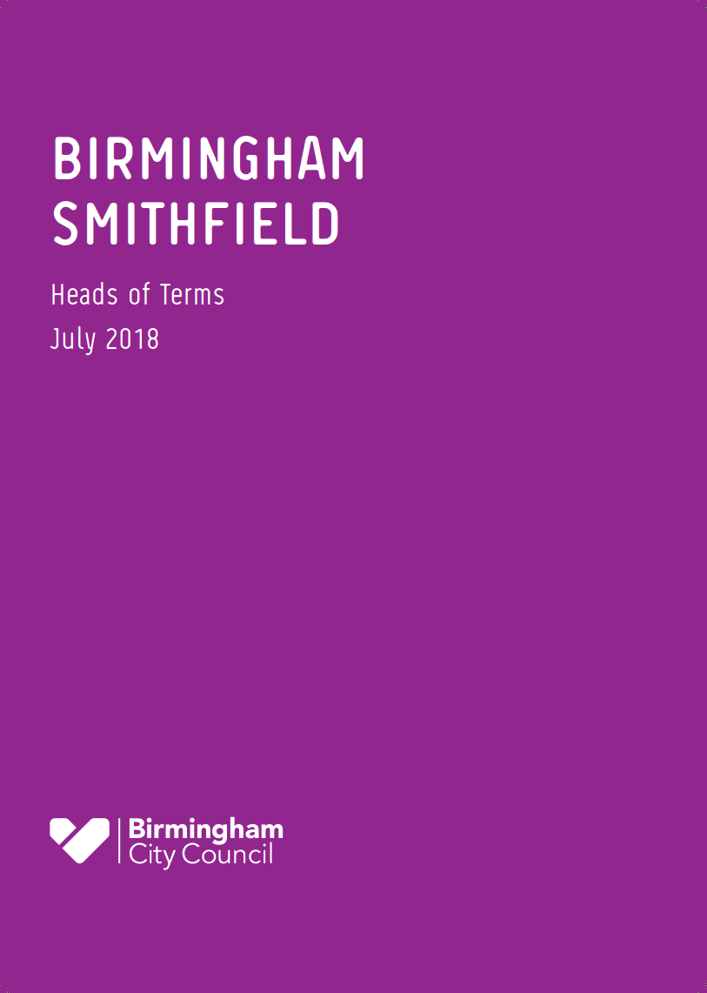***



BIRMINGHAM

SMITHFIELD

Market Design School Competition Information for Primary Schools

September 2019

Market design School competition information

# introduction to the competition

In January 2019, Birmingham City Council announced Lendlease as the preferred development partner for Birmingham Smithfield. Lendlease are a leading international property and infrastructure group with operations in Australia, Asia, Europe and the Americas. The vision of Lendlease is to create the best places; places that inspire and enrich the lives of people around the world.

Birmingham Smithfield is a once in a generation opportunity that will drive the City’s international standing and reputation, delivering over 2,000 new homes, a new festival square, a new community park, new family leisure attractions and a new market area.  As Birmingham enters an unprecedented period of growth and development, Birmingham Smithfield will sit alongside the Commonwealth Games, and wider regeneration of Perry Barr, and High Speed 2 as key projects that will define the city’s future.

A key part of the Birmingham Smithfield project is to maximise the opportunities that the project will create for jobs, skills and education and create a legacy for the city. Lendlease together with Birmingham City Council are committed to ensuring that young people benefit from this project and are able to be involved from the very start.

The Birmingham Smithfield site has, for over 800 years, been the home of Markets and earned the city its name “City of a thousand trades”. Therefore, one of the most important and significant parts of this project will be the creation of a new Market that will become a destination in itself. This Competition is for primary schools to engage with the project through a Market Design challenge. We want participation in this competition to benefit pupil’s learning and support curriculum areas such as English, Mathematics, History, Science, Art and Design and Geography to name a few.

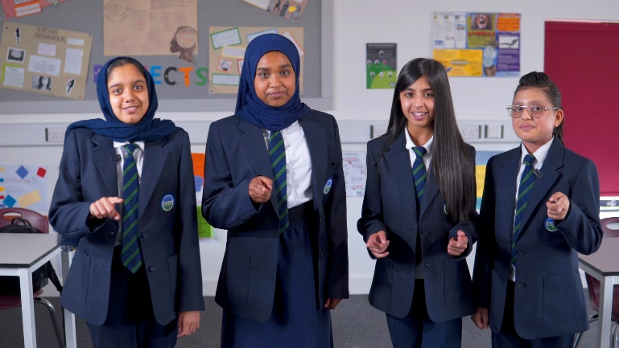The Birmingham Smithfield project team have worked with students from Bordesley Green Girl’s School (pictured right) and Holte Secondary School (front page) to produce the launch film which details the background of the Markets and invites Year 5 pupils from all Birmingham Schools to take part and submit their entries.

We have included some key information about the Birmingham Smithfield project and the history of the site area at Appendix 1, which will help students understand what the project is about and why the history of the Market area is important when creating their designs.

Competition ENTRY DETAILS

Given Birmingham’s rich history in relation to the Markets, this competition is based around the opportunity to help us deliver a Market which is fit for the future and appealing to children and young people.

We would like you to use the information in this pack, along with your own research to produce a design for the new Market area. We want the designs to be ambitious and create something new, exciting and unique which will showcase the new Birmingham Markets as world class.

What you need to do

# Step 1

Show the Birmingham Smithfield Launch Film to your Year 5 students. The film has been designed by students to introduce the project and competition to young people and to help them understand what the competition is about from a young person’s perspective.

This is the link to the film: [https://youtu.be/06d2mmaCw_k](https://nam05.safelinks.protection.outlook.com/?url=https%3A%2F%2Fyoutu.be%2F06d2mmaCw_k&data=02%7C01%7CRita.Patel-Miller%40lendlease.com%7Ca9dee3a4c4c849535d3d08d73157b282%7Cbc0c325b6efc4ca89e4611b50fe2aab5%7C0%7C0%7C637032125034683566&sdata=fLv2DB%2F%2B1UR7EKjT5VyFiba%2BeKWXOLexki1uTvmSouI%3D&reserved=0)

# Step 2

We would like Primary School pupils to think about what a new Market could look like and capture their ideas in a painting, drawing or a collage of images.

Identify young people who want to participate in the competition to produce a painting, drawing or a collage of images to show their ideas of what the new Market could look like and what it should offer in terms of products and produce.

The students will need to consider the following criteria when creating their designs:

|  |  |
| --- | --- |
| Building | We are looking for new, bold, creative ideas that will make the Market area unique, interesting and iconic, What could the Market building look like? |
| Stalls | What stalls and features could there be? Could there be a theme for the stall designs linked to the history of the area and the different communities in the city? |
| Colours | What colours and designs should be included in the Market area and building? Could these be linked to the history of the Birmingham Smithfield site? See information about the History of the area at Appendix 2 |
| Attractions | What attractions could there be to make it a fun and enjoyable place to visit? What features can we include that will attract young people to the Market? For example this could be activities or performance space |
| Digital Technology | How can digital technology be used to make the Market more exciting and modern for young people? |
| Sustainability | How can the design of the Market save energy and minimise waste and how can we make it more environmentally friendly? |

# Step 3

Select your team to enter in the Competition for your school and complete the entry form attached. Submit your entry together with your design, drawings or model **by 5pm on 8th November 2019** by email to [hello@Smithfield-Birmingham.com](mailto:hello@Smithfield-Birmingham.com) or hand deliver to Lendlease, The Colmore Building, 20 Colmore Circus, Birmingham, B6 4AT marked for the attention of Rita Patel Miller.

Competition Rules

* Each School will be limited to one entry from a team of students
* The students have to be from Year 5
* The team can consist of a maximum of 8 students only
* The size of the drawing or collage will need to be a minimum of A3 size and a maximum of A1 poster size.
* You can create a digital design, up to 3 drawings, crafts design or a collage
* You can use craft materials to create your ideas
* You have to complete an entry form to explain your design to us in 1000 words, so that we can understand your idea
* You will only be able to submit up to 1 drawings, painting or collage as part of your entry alongside your entry form.
* You have to submit your entry form and drawings by email to:

[hello@Smithfield-Birmingham.com](mailto:hello@Smithfield-Birmingham.com) or post/hand deliver your drawings/model to Lendlease Offices at The Colmore Building, 20 Colmore Circus, Birmingham B6 4AT marked for the attention of Rita Patel Miller by 5pm on the 8th November 2019 – any late entries will not be accepted.

* All team members will need to confirm if they have parental consent to be photographed or filmed through the whole process of the competition by ticking the consent box on the Entry Form.
* Lendlease reserve the right to change the timescales of the competition at any time, including extending the deadline for entries

# The Prize

The winning entry will receive a financial contribution for technology of their choice for their school. This will be agreed with Lendlease.

The team from the winning school will also be invited to be part of a ‘Young Market Design Group’ which will help Lendlease to ensure that the new Market remains an inviting place for children and young people in the city and to see how some of the winning ideas could be incorporated into the final design of the Market. The Lendlease project team will work closely with the students supporting them through mentoring and guidance on both a one to one and a team basis.

# The Judging Process

Once all entries have been received, they will be scored and evaluated for shortlisting as finalists. Once this process has been completed, we will notify all schools of the shortlist.

The finalist’s entries will be displayed for a final judging panel at a venue (TBC) in Birmingham in November 2019 where the winner will be announced at a finalist’s event hosted by the Leader of the Council, BCC officers and Lendlease. The shortlisted finalist’s entries will be exhibited prior to the event for public viewing.

The Judging Panel for the winning school will include representatives from both Birmingham City Council and Lendlease.

Councillor Ian Ward, Leader of Birmingham City Council and Lendlease will award the prize to the winning school at the finalist event on 14th November 2019.

Please contact us if you have any questions about the competition by emailing:

[hello@Smithfield-Birmingham.com](mailto:hello@Smithfield-Birmingham.com)

APPendix 1: PROJECT INFORMATIOn

# 1.0 birmiNgham smithfield

Birmingham Smithfield is a once in a generation opportunity that will drive the City’s international standing and reputation. As Birmingham enters an unprecedented period of growth and development, Birmingham Smithfield will sit alongside the Commonwealth Games, and wider regeneration of Perry Barr, and High Speed 2 as key projects that will define the city’s future.

**Figure 1.1** Wider context of development in Birmingham

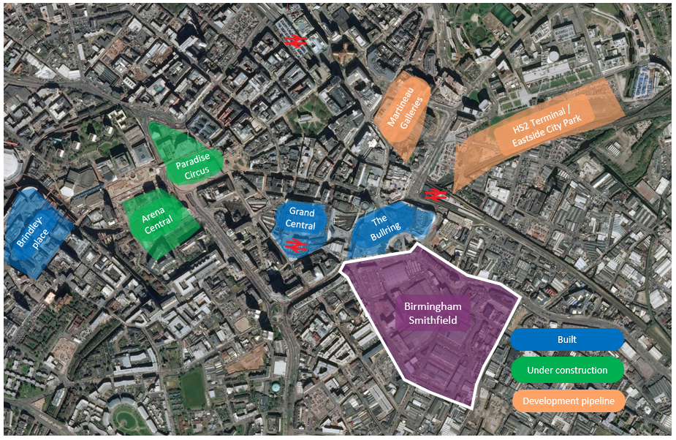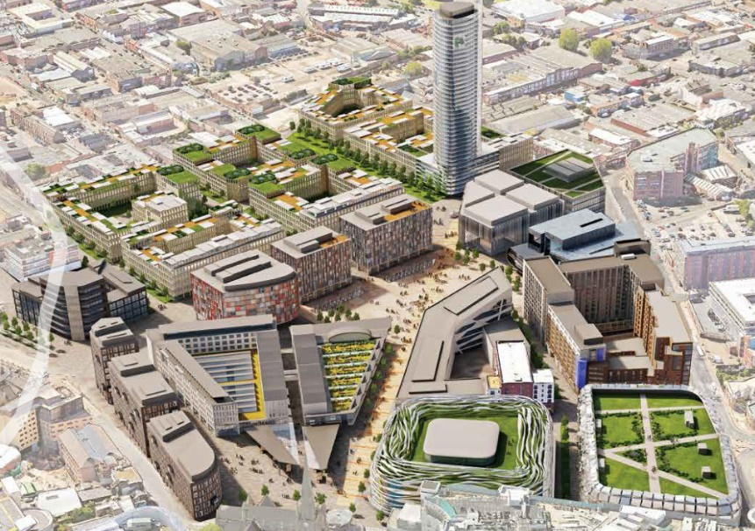

**Figure 1.2** Indicative Masterplan

The shared vision for Birmingham Smithfield is to create a major mixed-use urban quarter that will include a new home for the City’s valued historic Bull Ring retail markets, a family destination that includes a unique leisure and cultural offer, independent retail and business space, a major new public square, integrated public transport and more than 2,000 homes with a public park and community facilities.

The plans for Birmingham Smithfield sit within the context of the City’s strategic masterplan for the city centre. The Big City Plan, which is the City’s strategic masterplan for the city centre provides the principles for redevelopment of the site.

The 17-hectare site will be redeveloped bringing new jobs, homes and vastly improved infrastructure through:

* improved connectivity with the integration of the metro, bus routes and prioritisation of pedestrians and cyclists
* significant strengthening of the Centre’s authentic character with high quality public squares, spaces and public art
* major diversification of our economic base with new destination leisure, cultural facilities and a new home for the retail markets; and
* a new residential neighbourhood with over 2000 new homes.

One of the most important components for this scheme is the creation of a new destination retail market. The site has, for over 800 years, been the home of markets and it is fitting that the creation of a new home for those retail markets will be at the forefront of the redevelopment. There is a commitment to deliver the Market as part of the first phase of the scheme with a new multifunctional building that will bring the markets to life throughout the day and evening and maintaining its role as an important source of goods for local communities.

The development of Birmingham Smithfield will also secure socio-economic benefits for the people of Birmingham, including:

* engaging with local suppliers in the development and operational phases of the scheme to source significant percentage of goods and services locally
* creating training and employment pathway opportunities for local residents throughout the delivery of the project, and in particular targeting areas of high unemployment and groups facing disadvantage and supporting schools, colleges and universities; and
* building capacity by supporting community organisations with resources and expertise in areas of the city with the greatest need.

# 3.0 History of smithfield

Smithfield is central to the foundation of Birmingham. The site had been the location of a market long before it was granted a Royal Charter in 1166, this recognition was decisive in creating the medieval market town and city we know today. All the City’s early history is etched into the site - the markets, the moated Manor of the de Birmingham family, the remains of which still lie under the site, and St Martin’s Church where the de Birmingham family’s medieval tombs can still be seen.

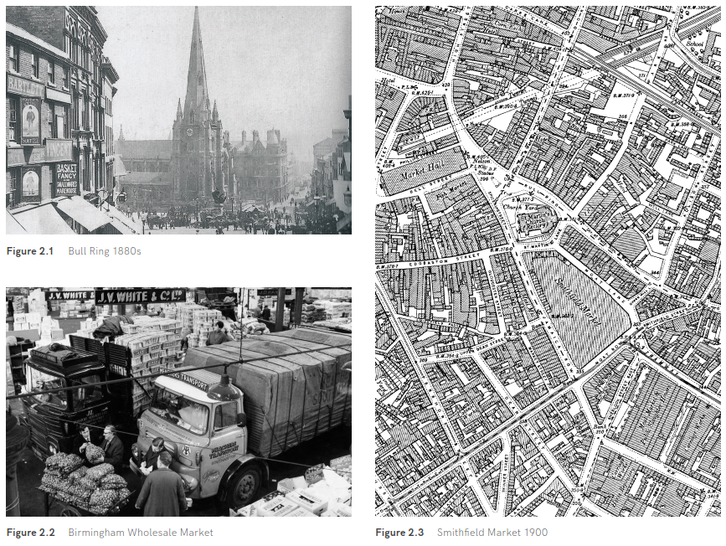

# 4.0 The markets

Birmingham was granted city status in January 1889, and at this time over a thousand trades were practised within the City making everything from brass to toys and jewellery to buttons. This diversity was very unusual, as most cities specialised in one or two trades, and so it was nicknamed ’The City of Thousand Trades‘ and the ‘Workshop of the World’. The timeline overleaf gives an insight into the City’s continuous link to trade and markets.

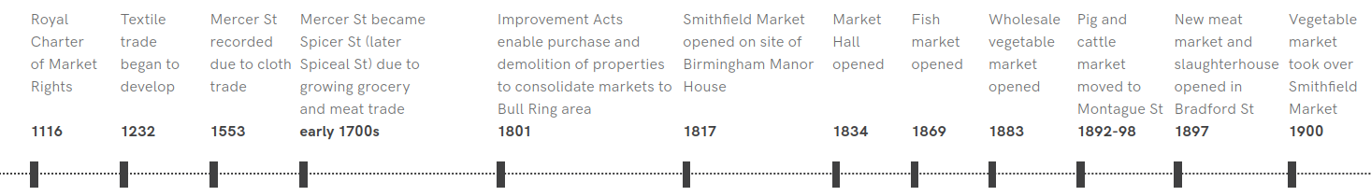

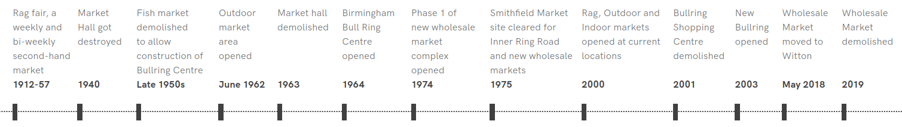

The Wholesale Market

By the mid-twentieth century, increasing congestion in the markets area, coupled with the demolition of the Fish Market for the construction of the Bull Ring Centre in 1958 and the increasing inadequacy of the Smithfield and City Meat markets, led to the development of a new wholesale market complex. The first phase of the market buildings opened in February 1974, and the wholesale markets traded on the Smithfield site until May 2018, when they moved to new purpose-built premises at The Hub in Witton.

This move has enabled c.8.5 hectares of the Smithfield site for redevelopment, creating an opportunity to repair the severance created in the city by the construction of the 1970s wholesale market and catalyse the regeneration of the wider southern gateway area.

The Markets Today

The Market was incorporated into the Bull Ring Shopping Centre in the 1960’s, relocating to its current location in 2002. There are currently three separate markets, across two buildings and an outdoor area - The Indoor Market, The Rag Market and the Open Market, providing over 108,000 sq. ft of trading space to approximately 500 individual traders.

|  |  |  |  |  |  |  |
| --- | --- | --- | --- | --- | --- | --- |
| [Image result for open market birmingham](http://www.google.co.uk/url?sa=i&rct=j&q=&esrc=s&source=images&cd=&cad=rja&uact=8&ved=2ahUKEwjzqpvL-pncAhUNZVAKHXxABHsQjRx6BAgBEAU&url=http://www.geograph.org.uk/photo/708018&psig=AOvVaw3nJgEPF3KYjbNYMIPXWGjN&ust=1531498334874557) |  | Image result for birmingham open market |  |  |  |  |
| Figure 3.1 The existing Open Market |  | Figure 3.2 The existing Open Market |  | Figure 3.3 The existing Rag Market |  | Figure 3.4 The existing Indoor Market |